Choosing a Bow
Written by Sir Toen Fitzwilliam

OK, so we’ve talked about how to make some cool arrows, now let’s look at how to choose the bow that you’re going to like to shoot. Again, this is really for the beginning archer and or fighter/archer who don't get out on the "line" very much. If you've been shooting for several years, I'm sure you already have a bow, but maybe you're in the market for a new one. This article is for you then. I've written this article based upon my own experience and the experience I've had to draw on from other archers here in Calontir. Many opinions are different than mine and I don't promise to have the "right" way, but this stuff does work.

This is intended as a continuation of a short series of articles on Calontir/SCA archery, so keep looking for more information.

The varying types of bows – In the world of archery there are many different types of bows. I hope this can help you when trying to choose what type of bow you may want to try and how to inspect the bow to use on the archery line. Just remember that what type of bow you choose is entirely your choice, so take some time and enjoy shooting with different types of bows until you get a feel for what you like and what you want. Authenticity is a BIG plus in our Society too, so you might want to give that some thought. Enjoy!

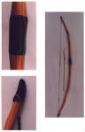
Longbow – The Longbow is often referred to as the “English” Longbow or the “War Bow” and was viewed, in period, as a very dangerous weapon in the hands of a master. A longbow was pretty popular in almost all of our period, so this would be an easy bow to carry no matter what period you are in. This bow is approx. 5-6 feet in length and is usually straight when unstrung. A typical longbow is “D” shaped, that is to say flat toward the target and then curved toward the shooter in the shape of a capital ‘D’. Depending on how the bow is made, this is also one of the more difficult bows to master due to its size and “kick” when you release the string.

This and the “short bow” are typically the types of hand-bows that we in Calontir try to encourage people to eventually get and start shooting for authenticity.

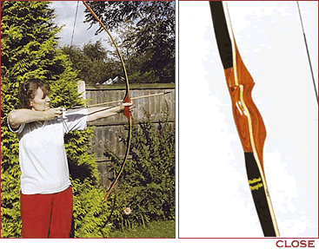
Flat bow – The flat bow is a type of longbow that is typically shorter than a longbow and is without the “D” cross-section making a “flat” limb (except for the grip, of course). This bow is typically lighter and does not “kick” as much as a true longbow. This is a good alternative to the longbow and is pretty easy to shoot.

Bush bow – this is very similar to the Flat bow, but is just a little shorter. It is called a ‘bush bow’ due to its design to be able to go into the “bush” to hunt with. It is smaller and lighter so that it can be carried easier when hunting.
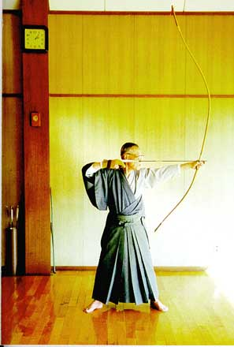
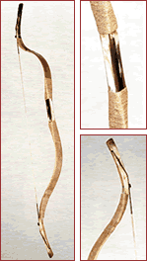
Japanese Long Bow – (specialty item, +2 hit bonus) – this is a very interesting version of the longbow. This bow was designed to be shot from horseback, so instead of having the grip in the middle of the bow, it is closer to the bottom of the bow. The bow is typically 6 foot long or more. This is a difficult bow to master, but a fun one to watch someone shoot properly (or improperly).

Re-curve – The re-curve bow is the most prevalent on the archery line. This bow is a straight bow with a slight curve at the top and the bottom. Re-curves come in all shapes, sizes (usually around 5-6 feet in length) and colors and are made out of all sorts of different composite materials. Very little “kick” when releasing the string and a lighter pull makes the re-curve a very popular bow for beginners and technical shooters.

Short Bow – A short bow or “horse bow” is a smaller version of the re-curve and is seen in many period documents. The short bow often has VERY pronounced curves at the top and bottom (almost seeming to curl in on itself when unstrung) and is generally light and no longer than 3 feet in length. Due to the shortness of the bow and the nature of the curl this can be a difficult bow to shoot, but is definitely worth the experience.

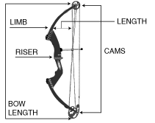
Compound – A compound bow is similar to a re-curve but is molded in such a way as to always be in the “strung” shape. A compound bow has “cams” (roller like mechanical devices) on the top and bottom of the bow to assist with the pull of the bow. As the shooter pulls the string back, the “cams” roll down toward the shooter eventually “breaking”. When the cam breaks, the string pull resistance becomes much easier to pull and easier to hold. This is a very popular bow for modern day hunters and can be set to a very great pull weight. These bows are NOT PERMITTED in Calontir SCA archery practices or on the archery line.

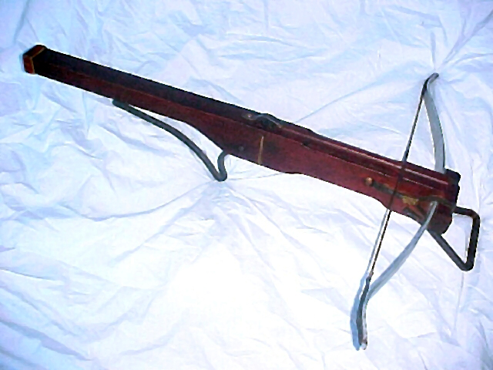
Crossbow – A crossbow is a bow that is becoming more and more prevalent on the line in Calontir. A crossbow is fired much like a shoulder fired rocket, from a shoulder position looking down the quarrel toward the target. A crossbow string is set or “cocked” by means of a mechanical device such as a winch or simply by pulling or pushing the string onto the release mechanism. A quarrel (arrow) is placed on a “shelf” in front of the cocked string and then released by means of a mechanical “trigger”. Crossbows are often very powerful and are fun to shoot. Crossbows are also difficult to master, but when shot by a master can be deadly accurate. Crossbows also come in various shapes and sizes with different release mechanisms that are all period. I encourage everyone to at least take an opportunity to try one of these, they are great fun.

How to inspect – Inspection of a new (or old) bow is fairly easy.
- Look down the length of the bow to see if any of the limbs are twisted. A twisted limb can cause the string to come off after or during shooting and can cause a hazard, so you want to watch for that (read BAD). Also have the shooter pull back their string and look for any twisting or cracking.
- Inspect the bow for any splintering or any damage to the bow itself. A crack or splinter may indicate that the bow is on its last limb (pardon the pun) and needs to be retired.
- Inspect the string for any cuts or unraveling. Unraveling can usually be fixed by some string wax, but a cut or damaged string needs to be replaced before shooting.
- If the bow has an arrow rest, check it out to make sure it’s seated well and won’t fall off or catch the string.
- When inspecting a crossbow, check the string to make sure it is seated well.
- On Crossbows, check the firing mechanism to make sure everything is working properly and is not loose or a danger to the shooter.
- Check the prod on a crossbow to make sure it is also seated well and there’s not much “play” in its movement. Ideally you will want a crossbow with no movement in the prod at all.

Mostly it’s just common sense. Just remember that a bow is like any other tool that you would use. You will want to take care of it and protect it from the elements as you would anything else that’s valuable. When in doubt, contact a marshal on the line and they will be happy to look at it for you.

Choosing the right bow for you – Choosing the right bow for you is a very personal decision. Choose something that you can hold and pull the string. A lot of the time, you want to think about draw length (this is the length from the hand that is holding the string to the hand that is holding the bow when drawn); whether you are left handed or right handed and what poundage (draw weight) you are comfortable with shooting for an extended period of time. On more period bows (longbow and shortbow) you may also want to think about whether you need an arrow rest (a notch cut out of the bow or a piece of plastic attached to the bow to rest your arrows on when shooting). On crossbows you may want to consider the pull weight, the size of the stock and the release mechanism that you would prefer. Many release mechanisms are based on the roller nut (a roller type mechanism that holds the string and then is released by the “trigger”) or the push pin (a pin that pushes up into the crossbow thereby pushing the string off of the resting point).

Something else to consider when you first get your bow is nock point. A nock point is a small brass ball that is placed on the string above, below or on each side of the arrow nock to mark where you want to place the nock of your arrow. Based on your shooting preference, you can choose whether you are more comfortable shooting below your nock point, above your nock point or simply setting your nock between the two points.

If I’ve forgotten anything or missed something, please find me on the field or on the line and let me know. There are many different techniques to finding a bow and shooting archery, these are my opinions and how I do it. Archery doesn’t have to be intimidating, with a very little bit of equipment, you can be off and shooting in no time.

PS – We have a lot of VERY talented archers in Calontir, take some time to meet them and ask questions, that’s how we all learn. They can even teach you how to make arrows (see my arrow making article) and how to make strings. Have fun and be safe!

