Calontir Herald’s Handbook

Third Edition
[updated 2014]

This Page Intentionally Left Blank
From the Gold Falcon Principal Herald

Greetings to one and all!

I would like to thank all those individuals who give of their time and efforts in the service of heraldry for the Kingdom of Calontir and the Society. Whether it’s through an aspect of vocal heraldry (making event announcements, handling camp cries, doing court); field heraldry (calling rounds, directing participants, announcing winners); pageantry (presenting combatants & consorts, helping with display, holding heraldic competitions); book heraldry (creating devices, documenting names, running consulting tables, providing commentary); ceremonial & protocol heraldry (researching period grants, writing scroll text, keeping an Order of Precedence); silent heraldry (assisting those with hearing impairments) or through support of those involved in an aspect of heraldry…the kingdom would not run as smoothly without your endeavors

This is the third edition of the Calontir Herald’s Handbook published for both heralds within the kingdom and other individuals interested in the various aspects that the art and science of heraldry takes within the SCA and in Calontir specifically. We hope that all will find this publication to be a valuable resource.

As the SCA’s knowledge of heraldry continues to develop there come changes to the standards and policies that heralds need to be aware of. Readers of this handbook will note some changes from previous editions, so whether you are new to heraldry, or are a more experienced herald, please take the time to read through the handbook to acquaint yourself with the material that it contains.

In Service to Crown, Kingdom and Society,

Mistress Jadwiga Marina Majewska, Gold Falcon Herald

Disclaimer
.
This is the Calontir Herald’s Handbook, a publication of the Calontir College of Heralds of the Society for Creative Anachronism, Inc. presented for informational purposes. It is not a corporate publication of the Society for Creative Anachronism, Inc., and does not delineate SCA corporate policies. In many places it does delineate Calontir College of Heralds policies

Credits
Some of the material present herein which was written for earlier editions of this handbook has been edited where the facts have changed or concepts have needed clarification. Editors, authors (past and present), commenters, consultants and proof-readers of this handbook have contributed to the overall work, and include: Gawain of Miskbridge [Gold Falcon Emeritus, Green Anchor Herald], Mikhail Nikolaevich Kramolnikov [Gold Falcon Emeritus, Culuerene Herald], Madoc Arundel [Gold Falcon Emeritus, Shrike Herald], Christopher Amber [Gold Falcon Emeritus, Gold Penguin Herald], Lyriel de la Foret [Gold Falcon Emeritus], Andrixos Seljukroctonis [Lanner Herald], Suzanne de la Ferté [Silent Herald], Gotfrid von Schwaben [Red Hawk Herald Emeritus], Dorcas Whitecap [Batelier Herald], Ines Alfón [Saker Herald Emeritus, Blanch Tyger Herald], Odierne Lion [Condor Herald], Einarr Grimsson [Red Hawk Herald Emeritus, Saker Herald], Rohese de Dinan [Red Hawk Herald], Roberto Carlos Dominguez [Talon Herald Emeritus, Buteo Herald], Pipa Sparkes [Herald-at-Large], Gunnar Thorisson [Vert Hawk Herald: Armorial Herald], Herman von Mandel [Blue Hawk Herald Emeritus, White Hawk Herald Emeritus], Ermenrich von Duisburg [White Hawk Herald Emeritus], Johanne of Fisher Gate [Sea-Sheep Herald], Briana Etain MacKorkhill [Purple Quill Herald], Modar Neznanich [Saker Herald Emeritus, Eyas Herald Emeritus, Purple Falcon Herald Emeritus, Habicht Herald, Volk Herald Extraordinary] and Jadwiga Marina Majewska [Gold Falcon Herald, Saker Herald Emeritus]
© 2010, 2011, 2012, 2013, 2014 Calontir College of Heralds, Society for Creative Anachronism, Inc.
The original contributors retain the copyright of their articles.

This Page Intentionally Left Blank

Table of Contents

I. Structure of the Calontir College of Heralds . . . . . . . . . . . . . . . . . . . . . . . . . . . 1
College of Arms and College of Heralds 3

II. Duties of a Herald . . . . . . . . . . . . . . . . . . . . . . . . . . . . . . . . . . . . . . . . . . . . . . . . 7
Administrative Duties 9
Duties of a Local Herald 11
Group Herald’s Records 15

III. General Information . . . . . . . . . . . . . . . . . . . . . . . . . . . . . . . . . . . . . . . . . . . . . . 17
Armory of Calontir 19
Herald’s Attire 29
Why Register? 31
Blanket Permission to Conflict 33
Heraldic Wills 35
Event Management – So You Want to Have a Heraldic Symposium 37

IV. Vocal Heraldry: Overview . . . . . . . . . . . . . . . . . . . . . . . . . . . . . . . . . . . . . . . . . . 41
Vocal Heraldry 43

V. Vocal Heraldry: Announcements & Camp-Cries . . . . . . . . . . . . . . . . . . . . . . . 47
Event (Announcement) Heraldry 49

VI. Vocal Heraldry: Field & Tournament Heraldry . . . . . . . . . . . . . . . . . . . . . . . . 53
Field Heraldry 55
How to Be Heard and Understood or Projection 101 for Field Heralds 65
Tournament Heraldry 102 67
Calontir Field Heraldry 69

VII. Vocal Heraldry: Court Heraldry . . . . . . . . . . . . . . . . . . . . . . . . . . . . . . . . . . . . . 71
Court Reports 73
Court Heraldry: A General Overview 75
On Being White Hawk 83

VIII. Book Heraldry: Consulting on Names and Armory . . . . . . . . . . . . . . . . . . . . . 85
Running a Consulting Table: Physical Set-Up 87
Running a Consulting Table: Item check-List 89
Consulting with a Heraldic Client 91
Choosing a Name & Creating a Persona 95
Creating a Heraldic Device 103
Research Questions for Developing a Persona 111

IX. Book Heraldry: Documentation . . . . . . . . . . . . . . . . . . . . . . . . . . . . . . . . . . . . . 115
How to Document a Name (to within an inch of its life) 117

X. Book Heraldry: Submission Process . . . . . . . . . . . . . . . . . . . . . . . . . . . . . . . . . . 131
A Look at the Submission Process 133
For Submitters: Heraldic Hints for Submissions 137
Saker Herald Office Manual 141

XI Book Heraldry: Commentary and Conflict Checking. . . . . . . . . . . . . . . . . . . . 147
The Art of Effective Commentary 149
“But I don't have any books!” Commenting without Sources 153
Basic Conflict Checking 155

XII. Protocol Heraldry: Ceremonies and Pageantry . . . . . . . . . . . . . . . . . . . . . . . . . 165
Use and Display of Branch (Group) Arms 167
Processionals 169
On the Giving of Favors & Tokens 171
Uses for Heraldry 173
Collars of Estate 175
Use of Ermine Spots and Ermine Fur 177
Augmentations of Arms 179
Heraldic Titles 181

XIII. Protocol Heraldry: Awards and Order of Precedence . . . . . . . . . . . . . . . . . . . . 183
Awards of Calontir 185
Award Recs: What They Are, Why They Are Done and How To Do Them 189
How to Create an Order of Precedence 195

XIV. Silent Heraldry . . . . . . . . . . . . . . . . . . . . . . . . . . . . . . . . . . . . . . . . . . . . . . . . . . . 203
Silent Heraldry: Lesson 1 – Introduction 205
Silent Heraldry: Lesson 2 – Basics 213
XV. Courtesy and Graces . . . . . . . . . . . . . . . . . . . . . . . . . . . . . . . . . . . . . . . . . . . . . . 225
General Protocol and Etiquette 227
Interacting with the Royalty 231

XVI. Heraldic Education . . . . . . . . . . . . . . . . . . . . . . . . . . . . . . . . . . . . . . . . . . . . . . . 237
Frequently given Answers (That Are Wrong) 239
Heraldic Myths: Clearing Up Misconceptions Involving SCA Heraldry 241
Examples of Furs 257
Engrailed vs Invected 259
Embattled vs Bretessed vs Embattled-Counter-Embattled 267
Examples of Some Triangular Divisions & Charges 269
Marshalling in Heraldry 273
Heraldic Terms 277

XVII. Ceremony Text . . . . . . . . . . . . . . . . . . . . . . . . . . . . . . . . . . . . . . . . . . . . . . . . . . . 323
Sword Oath 325
Investiture of Crown Prince and Princess 327
XVIII. Appendices . . . . . . . . . . . . . . . . . . . . . . . . . . . . . . . . . . . . . . . . . . . . . . . . . . . . . . 329
Heraldry Websites 331
Heraldry Mailing Lists 333
XIX. Forms . . . . . . . . . . . . . . . . . . . . . . . . . . . . . . . . . . . . . . . . . . . . . . . . . . . . . . . . . . 335
Agreement to Serve Form 337
Calontir Court Report Form 339
Heraldic Consultation Sheet 341
Herald’s Quarterly Report Form 343
Herald’s Domesday Report Form 347
Examples: Permission to Conflict Letters (given to one submission) 353
Examples: Blanket Permission to Conflict Letters (given for ALL submissions) 355
Examples: Heraldic Wills 357
Petition for Registration of Group Name 359
Petition for Registration of Group Device 361
Petition for Registration of Group Badge 363
Calontir Transfer Form 365
Name Submission Form 367
Branch (Group) Name Submission Form 369
Device Submission Form 371
Badge Submission Form 373

This Page Intentionally Left Blank
Section I

Structure of the Calontir College of Heralds

This Page Intentionally Left Blank

College of Arms and College of Heralds

There are two classifications of Heraldic Colleges within the SCA. At the Society level there is the College of Arms (CoA). The Laurel Sovereign of Arms (Laurel) is the principal heraldic officer of the Society and the head of the CoA. Laurel handles the administrative duties of the Society Heraldic Office and is responsible for fostering the study and practice of heraldry, establishing rules and making determinations regarding names, armory, titles and geographical designations for use in the Society. Assisting in this endeavor is the Pelican Sovereign of Arms (Pelican) who handles name submissions and the Wreath Sovereign of Arms (Wreath) who handles armory submissions. The CoA is further comprised of the Principal Heralds of all the kingdoms, staff heralds and commenters appointed by Laurel, as well as other heralds recommended by the Principal Heralds. The purpose of the CoA is to assist Laurel in studying medieval heraldic usage, developing heraldic rules for the Society’s use and reviewing items submitted for registration.

Each Kingdom has its own College of Heralds (CoH). These Colleges are composed of individuals within the kingdom who serve as heralds and pursuivants for the local groups and the kingdom.

Calontir College of Heralds

The Calontir College of Heralds is comprised of the Gold Falcon Principal Herald who is head of the CoH, various kingdom-level deputy and staff positions, all group heralds along with a variety of senior-level heralds and heralds-at-large. The purpose of the Calontir College of Heralds is to meet the heraldic needs of the kingdom and its populace, advise the SCA College of Arms on heraldic matters and to promote the pageantry of the medieval age within the SCA through ceremonies and heraldic display. A listing of the titled positions within the Calontir CoH with a brief description of duties involved follows.

Principal Herald

Gold Falcon Herald: Principal Herald of Calontir
Oversees all other kingdom heraldic staff and all group heralds/pursuivants within the kingdom as well as the heralds-at-large/pursuivants-at-large. Responsibilities include overseeing the area of Court Heraldry for the kingdom; normally heralds Coronation Court and Crown Tourney Court; organizes any Grand March as required; heralds the finals of Crown List and is in charge of seeing the kingdom’s heraldic needs are met.

Kingdom Heraldic Deputies and Staff

Purple Falcon Herald: Drop Dead Deputy
Herald designated to step into the principal herald position if the Gold Falcon Herald has to step down unexpectedly. This position is selected by the Gold Falcon Principal Herald. The Crown may also choose this individual to be the designated successor to the position when the current Gold Falcon Herald completes their term or prefer to open the Principal Herald position for applications.

Saker Herald: Submissions Deputy
Herald in charge of the kingdom submissions process; publishes letters of intent; collects and disburses funds associated with heraldic registration; maintains kingdom archives of submitted & registered names, devices, and badges; arranges for consulting heralds for Lilies War and other Crown events on an “as required” basis. These duties may be performed by this herald or a member of their staff.

Eyas Herald: Deputy in Training to Succeed Saker Herald
Herald being trained in the intricacies of the kingdom submissions office. This position is designated to step into the submission herald position once the Saker Herald competes their term or if the Saker Herald has to step down unexpectedly. This position is selected by the Gold Falcon Principal Herald with input from the Saker Herald.
Habicht Herald: Heraldic Education & Protocol Deputy
Herald in charge of heraldic education; oversees the instruction of members of the College of Heralds of Calontir and ensures the minimum expected knowledge levels are met; coordinates with Royal University of Scyr Hafoc (RUSH) for inclusion of heraldry classes in their curriculum; provides protocol information. These duties may be performed by this herald or by a member of their staff.

Batelier Herald: Field Heraldry Deputy
Deputy in charge of field heraldry; arranges List heralds for Crown List, arranges field heralds and camp criers for Lilies War and other Crown events on an “as required” basis. These duties may be performed by this herald or by a member of their staff.

White Hawk Herald: Personal Voice Herald for the King & Queen
Provides vocal/court services to TRMs and arranges for court heralds when unavailable. Responsible for ensuring a Court Report from each of TRMs courts is provided to the Clerk of the Precedence, the Gold Falcon Herald and the MEWS (even if White Hawk does not do the court). This person may be selected by TRMs and approved by Gold Falcon or TRMs may ask Gold Falcon to provide such.

Falconet Herald: Personal Protocol Herald for the Prince & Princess
Acts as advisor to the Prince/Princess. Responsible for providing heraldic and protocol information to the Royal Heirs. This position has been created to assist first-time Royalty. This person may be selected by TRHs and approved by Gold Falcon or TRHs may ask Gold Falcon to provide such.

Lanner Herald: Ceremonies Deputy
Herald responsible for maintaining the ceremonies used throughout Calontir, primarily for creation of peers and the coronation of kings and queens; but may archive any formal ceremony used in an official capacity. This position works closely with their Known World counterpart. These duties may be performed by this herald or a member of their staff.

Red Hawk Herald: External Commenting Deputy
Herald responsible for Calontir commentary on other kingdom's submissions. Commentary of this type is a requirement by the Society Herald’s Office for a kingdom to stay in good standing. These duties may be performed by this herald or a member of their staff.

Kite Herald: Northeast Regional Deputy
Herald responsible for overseeing the heraldic activities of these groups/members in the region of these current/former branches: Axed Root, Coeur d'Ennui, Deodar, Flinthyll, Heraldshill and Shadowdale.
[Previously included: La Grande Tente, Loch Meadhonach, NoMountain and Riverwatch.]
Heraldic reports from these branches should be sent to this regional deputy.

Sparrow Hawk Herald: Northwest Regional Deputy
Herald responsible for overseeing the heraldic activities of these groups/members in the region of these current/former branches: Carlsby, Crescent Moon, Dun Ard, Lonely Tower, Lost Moor and Mag Mor.
Heraldic reports from these branches should be sent to this regional deputy.

Harrier Herald: Central Regional Deputy
Herald responsible for overseeing the heraldic activities of the groups/members in the region of these current/former branches: Amlesmore, Aston Tor, Bellewode, Cum an Iolair, Forgotten Sea, and
Loch Smythe. [Previously included: Ivory Keep and Lost Forest.]
Heraldic reports from these branches should be sent to this regional deputy.

Buteo Herald: Southeast Regional Deputy
Herald responsible for overseeing the heraldic activities of the groups/members in the region of these current/former branches: Calanais Nuadh, Oakheart, Standing Stones, Three Rivers and Wyvern Cliffe.
[Previously included: Burj al Mudirah, Gryphon's Keep, Merkiborg, Ridge Haven and Riverhold.]
Heraldic reports from these branches should be sent to this regional deputy.

Gerfalcon Herald: Southwest Regional Deputy
Herald responsible for overseeing the heraldic activities of these groups/members in the region of these current/former branches: Bois d'Arc, Crystal Mynes, Grimfells, Spinning Winds, Vatavia and Westumbria.
[Previously included: Golden Sea, Moonstone (formerly Fyren-Ar) and St Clayre.]
Heraldic reports from these branches should be sent to this regional deputy.

Blue Hawk Herald: Clerk of the Precedence Deputy
Person responsible for maintaining a record of all awards, titles, and court proceedings, and publishes the Kingdom Order of Precedence.

Vert Hawk Herald: Armorial Deputy
Person responsible for maintaining the Kingdom On-Line Armorial.

Goodhand Herald: Silent Heraldry Deputy
Person responsible for organizing Silent Heraldry volunteers (folks proficient in sign language willing to do courts and other activities). Knowledge of sign language is not required but is helpful.

Kestrel Herald: Publications Deputy
Herald in charge of publications; responsible for maintaining, updating and publishing the Heralds Handbook, administrative forms (other than submission and reporting forms), functional aids and other publications relevant to the conduct of heraldry.

Purple Quill Herald: Assistant to the Principal Herald
Person noted as Staff Assistant to the Gold Falcon Herald. Duties and responsibilities vary from each Principal Herald’s tenure.

Historian: Kingdom History Deputy
Person responsible for maintaining the Kingdom Histories.

NOTE: Some of these positions, such as Kestrel, Eyas, Lanner, Goodhand, Batelier, Purple Quill, etc may not be filled at certain times, depending on the desires of the current Gold Falcon Herald in assigning responsibilities amongst the Heraldic Staff. The position of Falconet Herald may not be filled if the Prince & Princess prefer not to have or does not need a personal heraldic advisor. White Hawk may also be left vacant if the Royalty prefers to handle Royal Courts with local heralds rather than having a specific personal herald.

Branch Heralds
These are the heralds who hold the office of Herald for a SCA group. Their job is to assist local members with obtaining names and armory and providing the local group with service in the areas of event heraldry, field heraldry, court heraldry, etc. A branch herald may have a title as Calontir allows a group of any size to register a title for their herald or they may likewise simply have their herald use “<Group Name> Herald”.
By tradition in Calontir, when registering a heraldic title a barony would register the title with the designator Pursuivant and other groups would register the title with the designator Herald. The current list of groups with registered heraldic titles is:

Baronies
Hippogriff Pursuivant - Three Rivers Baronial Herald
Fountain Pursuivant - Forgotten Sea Baronial Herald
Caltrop Pursuivant - Vatavia Baronial Herald
Cabochard Pursuivant - Coeur d'Ennui Baronial Herald
Anser Pursuivant - Lonely Tower Baronial Herald
Gemshorn Pursuivant - Mag Mor Baronial Herald

Shires, Cantons, etc

Talon Herald - Cúm an Iolair Group Herald
Sea-Sheep Herald - Aston Tor Group Herald

Herald-at-Large
This is a term used in Calontir to refer to any active herald who does not hold a heraldic office for a group, their kingdom or the Society. It is used interchangeably with the term pursuivant-at-large. It is the job of heralds-at-large to assist local groups and the kingdom offices with service in the areas of book heraldry, event heraldry, field heraldry, court heraldry, etc.

Individual Heralds with Titles
It is possible for an individual to have a personal type heraldic title that is granted permanently to them. Traditionally there have been three basic categories of personal type heraldic titles; the Emeritus Title, the Individual Title and the Herald Extraordinary Title (although a recent Laurel-Sovereign-of-Arms have changed this). See the section on “Heraldic Titles” under Protocol Heraldry: Ceremonies and Pageantry for more detailed information. A list of heralds throughout the SCA with titles can be seen at: http://www.modaruniversity.org/Titled.htm

Section II

Duties of a Herald

This Page Intentionally Left Blank

Administrative Duties
The reporting schedule for heralds in Calontir is as follows:

Local heralds have quarterly and Domesday reports due on the following schedule:
1st Quarter – 15th of April
2nd Quarter – 15th of July
3rd Quarter – 15th of October
4th Quarter – 15th of January
Domesday – 15th of January

Local heralds should retain a copy of all reports in their files and copy them to their Seneschal and/or Baronage. Copies should then be sent to the Regional Deputy for your area. They are as follows:

Kite Herald: Northeast Regional Deputy: Axed Root, Coeur d'Ennui, Deodar, Flinthyll, Heraldshill, and Shadowdale.

Sparrow Hawk Herald: Northwest Regional Deputy: Carlsby, Crescent Moon, Dun Ard,
Lonely Tower, Lost Moor and Mag Mor.

Harrier Herald: Central Regional Deputy: Amlesmore, Aston Tor, Bellewode, Cum an Iolair, Forgotten Sea and Loch Smythe.

Buteo Herald: Southeast Regional Deputy: Calanais Nuadh, Oakheart, Standing Stones, Three Rivers and Wyvern Cliffe.

Gerfalcon Herald: Southwest Regional Deputy: Bois d'Arc, Crystal Mynes, Grimfells, Spinning Winds, Vatavia and Westumbria.

Local Heralds should use the Herald’s Quarterly Report Form for their quarterlies and the Herald’s Domesday Report Form for their end-of-year reporting. A Quarterly Reports is an overview of the last quarter’s activity of the office. The Domesday report is an overview of the last year’s activity (usually compiled from the quarterly reports) along with a general assessment of the state of the office and any hopes/plans for the next year. Report forms are found in the forms section of this handbook and online at: http://calontir.sca.org/herald/index.html
Regional Heralds have quarterly and Domesday reports due on the following schedule:
1st Quarter – April 30th
2nd Quarter – July 31st
3rd Quarter – October 31st
4th Quarter – January 31st
Domesday – January 31st

Regional Heralds reports are sent directly to Gold Falcon. They should consist of an overview of the reports that the office has received along with copies of each local report. The Domesday report is a written overview of the last year’s activity and any comments or plans for the next year.

Deputy Heralds (other than Regionals) are asked to make semi-annual overview reports of their offices activities during the previous months. These reports should be in writing directly to Gold Falcon and are due July 31st and January 31st.

Gold Falcon has quarterly and Domesday reports due on the following schedule:
The end of May
The end of August
The end of November
The end of February
Domesday – February 15th

These reports are sent directly to the Laurel Sovereign of Arms. Quarterly reports should include a current warrant roster of heralds in the Kingdom, as well as an overview of activity in the Kingdom. The Domesday or Annual report is an accounting of all heraldic activity in the Kingdom for the previous year as well as plans for the upcoming year and should include a current warrant roster. Copies of these reports are also sent to Their Royal Majesties, Their Royal Highnesses (if applicable) and the Kingdom Seneschal. Since all heraldic funds in Calontir are handled through the Exchequer’s Office, all financial reports come from there.

Duties of a Local Herald
by Modar Neznanich
The duties required to be completed by a local herald can vary. Factors that affect these duties include
the rules and customs placed by the Society Herald's Office, the Kingdom Herald's Office
and needs of the local group.
A local herald should always check with their Kingdom superiors to be sure
they are cognizant of all required duties designated by their Kingdom.
First Responsibility:
The one thing you should do immediately upon becoming the new herald for a group is to contact your kingdom superiors (regional herald and Gold Falcon Principal Herald). Inform them of your SCA name and the name of your SCA group and state that you are the new group herald. Supply them with your modern name, full mailing address, telephone number and email address (if applicable). Additionally, tell a bit about yourself. How much do you know about heraldry? What books and other heraldic resources do you have access to? This will allow them to know what assistance to begin providing. Finally, ask questions. Inquire about any recent rule changes, submission price changes and report deadlines.
General Overview of Basic Duties:
There are two main areas that are handled by the local herald's office. These are Vocal Heraldry and Book Heraldry. Vocal Heraldry can be broken down into four sections: Event Heraldry, Field Heraldry, Feast Heraldry and Court Heraldry. Book Heraldry consists of working with submissions of heraldic devices, badges, and names. Additionally it can involve forays into advice on heraldic display and on protocol.
Involving the areas of Vocal Heraldry and Book Heraldry are required duties and suggested duties. Required duties ones that a local herald –must– see are taken care of. Suggested duties are additional activities that can enhance the heraldic experience, both for the local herald and the group's populace.
Required duties:
1) Herald local meetings/events. This involves announcing to the assembled populace any important messages or information they need to know. If this is done at a large site, it may require the herald to go to several different spots and repeat the announcements to ensure that everyone is made aware of them.
2) Herald local tournaments. This involves acting as field herald. This is usually done for fighting tournaments, but other kinds of tourneys may require similar services. Specific procedures vary widely, depending on local customs, but basically this entails announcing to both the tournament participants and the assembled audience who is to report to the list field now, who should be preparing for the next round, and who is in line after that. The declaration of the winner is sometimes done by the herald and sometimes by the fighter marshal in charge. Before the tourney begins, check with the marshal to determine how this is to be handled.
3) Herald local feasts. This generally involves two things: A) announcing to the assembled feasters when the next course is arriving and what it consists of. [It is best to meet with the feastocrat (head cook, feast steward) prior to the serving of feast and making a list of the courses, and a set of signals to let you know when to announce the next remove] and B) announcing any performers when it is time for them to perform.
NOTE: There are occasions when the Baronage and/or Royalty may wish to present an award at feast. This is generally treated like a mini-court.
4) Herald local courts. This usually involves standing behind or next to the seats of the Baronage and/or Royalty and calling forth from the assembled populace, those requested. This is most times followed by the reading of the text on the scroll of the award being given. Another duty sometimes involved in heralding a court is the reading of oaths being administered or received. This usually requires the herald to advance to the side of those participating in the oath and quietly reading the text to them in a slow manner for them to recite aloud.
NOTE: It is possible for Baronage and/or Royalty to bring a personal herald with them to do court. However, it is the responsibility of the local herald to check and be sure how the Baronage and/or Royalty wish to handle the heralding of court. Whichever method is used, the local herald is still responsible for filing a Court Report.
5) Make regular reports regarding any heraldic activity in your group to the Kingdom. In Calontir this is done quarterly plus a year-end report (Domesday). Check with your Kingdom superiors for the exact deadline of these reports.
6) Make court reports regarding any Kingdom level awards given at local events. This is a list of the recipient's name, the award received and what the award was given for. At the top of the list should be the group's name, the event's name, the date and the names of the Royalty presenting the awards.
7) Maintain an Order of Precedence for the group. This is a listing of which members of your group have received which awards and the dates they received them.
8) Assist group members with research/development of names and devices and preparing submissions. This involves consulting with the local populace on the design and creation of arms and persona names, conducting conflict checking of local submissions, ensuring that the local populace understands the current Rules for Submission that affect their submissions, acting as a collection point for the local submissions, working with the local Exchequer to ensure the proper exchange and payment of funds for submissions and forwarding submissions and payment to the Kingdom level.
9) Maintain the local group's heraldic files. This is a collection of the submissions turned in by group members. These files should include registered elements, elements in process and elements that were returned due to problems/conflicts.
10) Maintain the local group's heraldic library. Depending on funding, need and availability, this may be a few items or several boxes of items.
Having Help:
These duties represent a large amount of responsibility and work. However, the local herald is not required to do all the work themselves, but to see that the work is done. To this end, it is recommended that a herald (at any level) establish a staff to assist in the completion of duties, if at all possible.
When establishing a staff, remember that not everyone is a vocal herald AND a book herald. Many people are better at one than the other, or are more interested in one than the other. Try to match the skills and interests of people with the tasks needing done.
NOTE: The local herald is responsible for reports, even if the activity is being handled by a member of their staff.
Suggested additional duties:
1) Set up a consultation table at events. Invite the heralds of other groups to assist you. Offer to run or assist at a consulting table at their events, if you are attending.
2) Promote heraldic display and pageantry. This can include organizing and/or assisting in the construction of armorial regalia, such as banners, baldrics and tabards. This should be done in conjunction with your Arts & Sciences officer.
3) Volunteer yourself and urge others to volunteer as a field, court or book herald at other events you attend. This courtesy will assist you in finding volunteers to help you at your group's events.
4) Educate others about vocal heraldry and/or book heraldry. This can be for members of your own group, or of other groups. (This will hopefully give you a pool of people to add to your heraldic staff.) This education can be by one-on-one discussions or more formal classes.
5) Write heraldic articles for your local newsletter. The subject of these articles (and classes) can range from, "These are the Basic Heraldic Terms" to "Here's the Secret to Better Voice Projection" to "Here's How to Run a Consulting Table." Or create a heraldic Word search game or find heraldic trivia to submit to the local newsletter. All are fun things to get members of your group thinking about heraldry.

This Page Intentionally Left Blank
Group Herald's Records
compiled by Modar Neznanich

The herald for a local group should retain a series of records of heraldic activities that have gone on in the group during their tenure and pass them on to their successor. (If there are times when the branch does not have a group herald, the seneschal should retain the records until such time as a new group herald is found.) What records should be retained in these files? The files should include:

A copy of every heraldry report filed/sent to the regional or kingdom herald offices.

A copy of the group's Order of Precedence (OP) compiled at the end of each year.

A full copy of the submissions paperwork for every submission the group herald has sent in. Ideally there should be a separate file folder with this paperwork for each group member who has sent in a submission.
A copy of each piece of armory registered by a group member and a notation of name registration for each member who has registered a primary name, alternate, household name, etc. (This paperwork may be a photocopy from the kingdom armorial, a copy from the appropriate LoAR, a copy of the submission forms given to the local herald by a member who has sent in their own forms, etc.) Again, ideally there should be a separate file folder with this paperwork for each group member who has sent in a submission.

A copy of every piece of correspondence received about group submissions (this may be printed copies of emails).

Copies of any financial forms, reports, etc utilized by the group herald’s office.

An up to date list of the heraldry and name books that are owned by the group, if any.

This Page Intentionally Left Blank
Section III

General Information

This Page Intentionally Left Blank

Armory of Calontir
Following are depictions and blazons of the armory (devices & badges) utilized by Calontir.

  Kingdom of Calontir  Arms Registered January 1984  Purpure, a cross of Calatrava, in chief a crown, within in bordure a laurel wreath Or |   Queen of Calontir  Arms Registered October 1984  Purpure, a cross of Calatrava, in chief a crown Or, within a wreath of roses lying as on a bordure argent
  Crown Prince of Calontir  Arms Registered March 1985  Purpure, a cross of Calatrava and in chief a  crown within a bordure Or, overall a label throughout argent |   Crown Princess of Calontir  Arms Registered October 1984  Purpure, a cross of Calatrava, in chief a crown Or, within a wreath of trillium flowers lying as on a bordure argent
  Order of the Boga Fyrd  Badge Registered May 1990  Sable, on a pile embattled between two strung longbows, strings to center, argent, a cross of Calatrava purpure |   Order of the Boga Hirth  Badge Registered May 1990  Per chevron embattled sable and argent, in pale two strung bows in saltire argent and a cross of Calatrava purpure
  Fyrd of Calontir  Order of the Iren Fyrd  Badge Registered October 1982  Sable, on a pile embattled between two spears in pile argent a cross of Calatrava purpure |   Hirth of Calontir (Huscarls)  Order of the Iren Hirth  Badge Registered October 1982  Per chevron embattled sable and argent, two battleaxes in saltire argent and a cross of Calatrava purpure
  Order of the Golden Calon Swan  Badge Registered October 1987  Purpure, a swan naiant Or |   Order of the Calon Lily  Badge Registered July 2001  Per pale purpure and Or, a fleur-de-lys within a bordure counterchanged
  Order of the Torse  Badge Registered December 1980  (Fieldless) A torse with mantling in alternating bands  of purpure and Or |   Order of the Calon Cross  Badge Registered May 1990  Or, a cross of Calatrava within a bordure purpure
  Order of the Leather Mallet  Badge Registered October 1982  Purpure, on a pale dovetailed argent three  leather mallets proper |   Order of the Silver Hammer  Badge Registered October 1996  Sable, a smith's hammer a bordure argent
  Order of the Sword of Calontir  Badge Registered October 1982  Sable, a sword inverted, the hilt and quillons a cross  of Calatrava, within a bordure argent. |   Order of the Queen's Chalice  Badge Registered May 1989  Purpure, a chalice Or, charged with a  Cross of Calatrava purpure
  Order of the Keeper of the Flame  Badge Registered October 1996  Or, a flame purpure |   Calontir War College  Badge Registered May 1990  Purpure, masoned Or
  Kingdom of Calontir [Symbol of the Army]  Badge Registered July 1988  Purpure, a falcon striking within a bordure Or |   King's Compaignie of Archiers  Badge Registered October 1984  Purpure, a cross of Calatrava above three arrows reversed fesswise in pale Or
  Kingdom of Calontir Brewers Guild  Badge Registered April 2002  Purpure, an amphora Or and a bordure argent. |   Calontir Cooks Guild  Badge Registered April 2007  Purpure, a cross of Calatrava and on a chief Or,  three cooking pots purpure
  Kingdom of Calontir: Kestrel College  Badge Registered July 2001  (Fieldless) On a falcon close contourny purpure a cross  of Calatrava Or |   Equestrian Guild of Calontir  Badge Registered April 1990  Purpure, a horse rampant to sinister argent  between three crosses of Calatrava Or
  Royal University of Scirhafoc [Main Badge]  Badge Registered March 1985  Purpure, on a pale between two hawk's lures Or a crane  in its vigilance sable |   Royal University of Scirhafoc [Alternate Badge}  Badge Registered January 1998  Or, on a pale purpure three hawk's lures Or
  Royal University of Scirhavoc [Alternate Badge}  Badge Registered January 1998  Per pale Or and purpure, two cranes in their vigilance respectant counterchanged |   Royal University of Scirhafoc [Alternate Badge}  Badge Registered October 1996  Or, a crane in its vigilance a bordure purpure
  Royal University of Scirhafoc [Alternate Badge}  Badge Registered March 1997  Argent, on a pale between two crosses of Calatrava azure a crane in its vigilance Or |   Calontir Waterbearers Guild  Badge Registered January 1990  Azure, on a two-handled jug fesswise reversed argent, distilling a goutte d'eau charged with a  goutte de larme, a cross of Calatrava azure.
  Kingdom of Calontir  Badge Registered September 1985  Argent, a bat-winged bison volant sable  A black demo-bison named Argent is  a Totem-animal of Calontir. |   Clerk of the Chancery  Badge Registered February 1986  Sable, in pale a beardless man's head affronty  and two pens in saltire Or
  Order of the Iren Feran  Badge Not Registered  Sable, on a pale embattled between a spear and  an axe argent a cross of Calatrava purpure.  Given to folks of other kingdoms  making them members of the Calon Army. |   Order of the Falcon’s Heart  Badge [Registration in process]  (Fieldless) A falcon reguardant sustaining a scepter  topped of a cross of Calatrava bendwise sinister Or.
  Order of the Eo Fyrd  Badge Registered October 2011  Sable, on a pile embattled between two broken  snaffle-bits in pile argent a cross of Calatrava purpure. |   Order of the Eo Hirth  Badge Registered October 2011  Per chevron embattled sable and argent, two chamfrons argent and a cross of Calatrava purpure.

  Kingdom of Calontir: Ensign  Badge Registered April 1984  Purpure, a cross of Calatrava Or.  This may be used by any member of the populace  of Calontir. When flown as a banner or used as heraldic display it denotes allegiance to the  Kingdom of Calontir.  This may also be used by recipients of an Award of Augmentation. Many recipients use this if the field  of their heraldic device is a metal (Or or Argent). |   Kingdomn of Calontir: Standard Augmentation  Badge Registered February 2008  Purpure, a cross of Calatrava and a bordure Or.  Many recipients of an Award of Augmentation use this if the field of their heraldic device is a color (Azure, Gules. Purpure, Sable or Vert).

Bardic College
Badge Registered April 2011
(Fieldless) In pale a falcon rising sustaining a harp Or.
Herald's Attire
compiled by Modar Neznanich, Jadwiga Marina Majewska & Briana Etain MacKorkhill
Traditions and law vary from Kingdom to Kingdom concerning the attire a herald may wear. In some Kingdoms a herald has to obtain a certain rank before they are allowed to wear a tabard, although a baldric is okay for any herald at any rank in any Kingdom. In Calontir, a herald or pursuivant of any rank may wear either a baldric or a tabard.
The most common symbol used for the heralds in the SCA has been the insignia of the crossed gold trumpets. [Vert, two straight trumpets crossed in saltire, bells to chief, Or.] Although some places are switching to using the arms of the group (which emulates historical practice). Many are utilizing both. For baldrics, a green sash with the gold cross trumpets and a small shield with the group arms beneath it. For tabards, the front and back are composed of the group arms, with the sleeves being green with gold crossed trumpets on it. In Calontir, any of these practices may be utilized.
It is important for vocal heralds to wear some kind of distinguishing garb to make them highly visible. (This is doubly important when heralding in combat situations!) So whenever you are performing the duties of a herald, but especially during formal tournaments and other occasions of "high estate" such as courts, you should have on your "greenwear". There is something satisfying in seeing heralds "in uniform," both for the heralds and for the populace.
Another useful piece of heraldic "regalia" is a staff. Although not required, it can be extremely useful. It can be pounded on the floor, or waved in the air after a cry of "Oyez" to get attention, and it lends dignity to the herald. It can also be used as an emergency marshalling staff, should you be "overrun" at a tourney. However, a staff can get in the way when you are juggling a set of index cards on the tourney field, so the decision on whether to utilize one or not, is up to each individual herald. A good heraldic staff is usually between five and six feet tall. It can be made from a natural piece of wood or made from a manufactured piece (such as a two-inch dowel used for stair railings). Some heralds use plain staves, other will decorate them to add to its appearance and overall effect. It can be decorated with green and gold ribbons, painted (plain or with designs), carved or have bells attached. Historically, a herald carried a white baton, many times with a knob on the ends.
Another important accouterment is a pouch with index cards, pens, pencils, etc. If you always carry a few of these items with you it can help avoid a last-minute panic.
Some suggestions for making heraldic paraphernalia:
The baldric is the easiest to make. This is a simple green sash with crossed gold trumpets on the front. Additionally, your group arms can be added underneath the trumpets. It is a long rectangular piece that is usually worn from the left shoulder to the right hip, and pinned there. While some people will make these out of velvet or satin for a fancier appearance, it is suggest that you use a sturdy and washable material instead, such as broadcloth or trigger.
A simple type of tabard is simply two yards of cloth, approximately shoulder width, sewn at the top with an opening for the head. A slight curving of the neckline is recommended, and ties at the side can help hold it in place when worn. The simplest are made of green cloth with the gold crossed trumpets on the front and back. In many areas, heralds use the device of their group instead. When a group’s arms are used, many will then add cap sleeves that are green with gold crossed trumpets on them.. (The cap sleeve is a semi-circle with the straight edge sewn onto where the front and back pieces are sewn together at the shoulder.)

This Page Intentionally Left Blank
Why Register?
compiled by Modar Neznanich, Jadwiga Marina Majewska & Briana Etain MacKorkhill
One of the questions that a herald may be asked is, “Why register?” Since it costs a fee, it’s only natural for people to inquire why they need to register their SCA name and/or armory. First and foremost, realize that no one is –required– to register their name or their heraldry. But there are some good reasons for doing so.

The primary reason for registration is Social Courtesy. The SCA is a polite and honorable society. We attempt to enrich our organization, add to its ambiance and extend respect to all. Registration assists in this by having one’s name and armory added to the official rolls. This in turn allows the Crown, heralds and scribes to know what to call you and how to spell your name should you be granted an award. Additionally, registration allows you to be entered onto the Kingdom’s Armorial (Roll-of-Arms) thereby adding to the pageantry. And then there is the fact that registering shows you are committing yourself to the SCA and the ideals it is striving for. Because recording heraldic information is a period concept, the SCA strives to provide an opportunity for members to participate in that area, through the registration process.
The secondary reason for registration is to Safeguard. Registration includes SCA-wide protection, meaning that no one else in the SCA can register exactly the same name or armory that you have. It also means that your name and heraldic design will be checked to make sure that you don’t infringe on someone else’s design accidently, thus saving you from claiming to be someone you’re not. Imagine a situation where you’ve been in the SCA for ten years and have been using a heraldic design, but never got around to registering it. Over the years you’ve placed the design on a lot of your things. Then one day while visiting another kingdom you see someone displaying a banner with your design on it. Upon investigation you discover this other gentle has recently registered the design, not knowing of you. You are now in the situation of having many items that you will need to change or replace because that design belongs to someone else. Registration is designed to prevent such things from happening. And yes, this has happened…safeguard yourself by registering.

The tertiary reason for registration is Education & Assimilation. By consulting with the heralds, researching valid heraldic designs and locating proper name documentation, a gentle can find themselves discovering aspects of the Middle Ages that they can utilize to maintain the authentic look and feel which enhances the SCA experience. Additionally registration may be a gentle’s first glimpse into the area of heraldry. This peek may lead to heraldry becoming an area of interest for them to learn about and participate in.

Side-Notes:

1. A fairly common misconception of new members, that heralds should be aware of, is the belief that if you are a paid member, you have registered your name (because the Registrar’s office asks for a person’s SCA name and the membership card they receive has that name on it). Of course it is not the case that paying one’s membership fee and getting a membership card means one has registered their name. The SCA Registrar will put any name you write on your membership form on your membership card. But the name Registrar and the phrase “registering a name” makes it sound like they should go together…hence part of the confusion. However, the Herald’s Office has a reciprocal arrangement with the SCA Registrar's office: heralds don't accept membership applications and fees; and the Registrar doesn't register people's names and armory. This works out very well for the offices involved, but can sometimes confuse new members.

2. A person does not have to be a paid member of the SCA to register a name and/or armory. Any gentle may submit whether they are a paid member or not. HOWEVER, because the College of Arms' filing system is based on SCA Names and not real-world names, to submit armory (device and/or badge) a submitter must either have a name register or be submitting a name along with the armory.

This Page Intentionally Left Blank
Blanket Permission to Conflict
compiled by Modar Neznanich & Briana Etain MacKorkhill

What is a Blanket Permission to Conflict? This is when a gentle grants permission to the SCA College of Arms to allow other SCA members to register an item that would conflict with an item they have previously registered because it is very similar. This consent only gives permission to register items that are close to, but not exactly the same as, the item they have registered. So no completely identical registration would be possible.

Why would someone wish to grant such permission? Because their perspective of uniqueness is not as stringent as the rules the SCA College of Arms has set. For example, by current SCA College of Arms precedent concerning names, Alianora de Grey would conflict with Eleanor the Gray. The given name Alysaundra conflicts with Alissende; Cairistiona conflicts with Christina; Ealasaid conflicts with Elzasif;
and so on. If the bearer of a name does not feel variants of their name would be too close and intrude on them having name uniqueness, they can –and should– grant blanket permission to conflict with their name. For many folks, as long as there is at least one letter different between names, they feel name uniqueness is maintained.

Additionally the concept of name uniqueness is an artificial one found only within organizations like the SCA. In the historical world as well as the modern world, there were many people who shared names in common. Thus some gentles in the SCA feel that there is no need to have any sort of name uniqueness, that to do so takes away an aspect of periodness.

Blanket Permission to Conflict can also be granted for heraldic devices and badges a person has registered. Again the question of why someone would want to provide such permission comes up. Well as an example, by current SCA College of Arms precedent concerning armory, “Per pale gules and argent, an estoille sable” conflicts with “Per fess Or and azure, an estoille sable”. To many folk visually there is quite a bit of difference between the two designs because one has a background split left and right while the other is split top and bottom and the background tinctures are completely different. However by the SCA Heraldic Rules for Submission which is based on how (later-period) cadency differences were determined, only one difference is granted between the two, no matter how many changes are made to the background.

For many people, as long as there is at least one visual different between heraldic designs, they feel armory uniqueness is maintained. If the bearer of a particular piece of heraldry does not feel that variants of their design with only one difference does not intrude on them having armory uniqueness, they can –and should– grant blanket permission to conflict with their design.

Now, several reasons why some may want to grant such permission have been given. But realize that many people like having very unique names and/or armory. There is nothing wrong with that. While gentles should be made aware of the option to grant Blanket Permission to Conflict so they can decide if they would like to, they should not be pressured to give such permission. The choice is up to each individual to make. One of the wonderful things about the SCA is that there is room for many visions.

Examples of forms for Blanket Permission to Conflict as per Appendix D of the Administrative Handbook of the CoA follow.

Blanket Permission to Conflict
For Name
I, [Name], known in the SCA as [Society name] waive the full protection of my registered name "[Registered name]". I grant permission to any future submitter to register a name that is (not identical to/at least a syllable different from) my registered name. I understand that this permission can be withdrawn by written notice to the Laurel Sovereign of Arms, but that conflicting items registered while it is in force will remain registered.
[Date] [Signature of [Name]]
For Fielded Armory
I, [Name], known in the SCA as [Society name] waive the full protection of my registered armory "[Blazon of registered armory]". I grant permission to any future submitter to register armory that is (not identical to|at least one countable step different from) my registered armory. I understand that this permission can be withdrawn by written notice to the Laurel Sovereign of Arms, but that conflicting items registered while it is in force will remain registered.
[Date] [Signature of [Name]]
For Fieldless Armory:
I, [Name], known in the SCA as [Society name] waive the full protection of my registered armory "[Blazon of registered armory]". I grant permission to any future submitter to register armory that is not identical to my registered armory. I understand that this permission can be withdrawn by written notice to the Laurel Sovereign of Arms, but that conflicting items registered while it is in force will remain registered.
[Date] [Signature of [Name]]
Note that a blanket permission to conflict will under no circumstances allow the registration of identical names or armory.

Heraldic Wills
compiled by Modar Neznanich & Briana Etain MacKorkhill

One of the areas that few people think about is what will happen with the names and armory they register once they are no longer on this mortal earth. Heralds should make sure that folks are aware that they have the right to determine what happens to their registered items. It’s possible that some people will not be concerned with the matter. For others, however, they will have a specific desire about how the issue should be handled. For these gentiles, they need to be made aware of the regulations concerning Heraldic Wills.

The Administrative Handbook of the College of Arms of the SCA in section IV.G. states:
Heraldic Wills - The owner of any registered item may execute a heraldic will, which is a statement of transfer that specifically transfers registered items to another at the owner's death. (See Appendix D for a standard form for a heraldic will.)
1. Any person may designate a heraldic heir. The heraldic will must bear the Society and legal name of the owner, be signed by the legal name of the owner, adequately describe the item(s) being transferred by the heraldic will, and adequately identify (include both) the legal and Society (where appropriate) name of the person who is authorized to accept transfer of the item(s). The owner need not transfer all registered armory or registered names to a single recipient upon the owner's death, but may allocate names, arms and badges to different persons.
2. The heraldic will may be filed during the lifetime of the owner, in which case the owner sends a copy of the will to the principal herald and to the Laurel Sovereign of Arms; or after the death of the owner, in which case the "heraldic heir" must include the original or a certified copy of the heraldic will with the transfer submission. In either case, the submission must be included in a letter of intent. If the heraldic will is registered with Laurel before death, it may be altered at any point up to the owner's death by executing a new heraldic will.
3. Upon the actual death of the owner, the designated heir may ask for a transfer of the item(s) willed to that designated heir. The submission is handled as any other transfer, except that instead of the letter extending the transfer and accepting the transfer, the submitter notes the existence of the heraldic will and the death of the prior owner.
The new submitter must establish personal entitlement to use any restricted or reserved element contained in any armory transferred.
4. If, upon the death of the owner of registered items in the Society, no heraldic will has been located, then the Personal Representative/Executor or the residual property heirs of the owner under the laws of the state of the owner's death have the right to give permission to conflict, release the items, or transfer the items as these heirs deem appropriate.
5. If a heraldic will is registered with Laurel Sovereign, the person designated as heir may register a cadenced version of the armory without needing to obtain further letters of permission to conflict from the owner. If the owner changes the heraldic will, the new heir may also register a cadenced version, but may be obligated to obtain permission to conflict from the former designated heir just as they would from any other person with conflicting armory.
6. If more than one person designates the same person as heraldic heir to their devices, the heir may display, but not register, these devices quartered and differenced.
A couple of standard forms for a heraldic will as per Appendix D of the Administrative Handbook of the CoA follow. Note that portions (such as the general release of an item) may be taken out if it does not apply.
Heraldic Will Sample #1
I [Legal name of owner], known in the Society for Creative Anachronism, Incorporated (SCA) as [SCA name of owner] leave to [legal name of heraldic heir], known in the SCA as [SCA name of heraldic heir, if any] my (name/armory) registered in the SCA, ([name to be transferred]/blazoned as [blazon of armory to be transferred].
I [Legal name of owner], known in the Society for Creative Anachronism, Incorporated (SCA) as [SCA name of owner] release the following names and armory registered to me in the SCA [insert list of all names or armories to be released]
[Date] [Signature of [Name]]
Heraldic Will Sample #2
I [Legal name of owner], known in the Society for Creative Anachronism, Incorporated (SCA) as [SCA name of owner] wish to make the following determinations to my name(s) and/or armory upon my death as below:
[select options as desired; items may be split amongst multiple people or released entirely]
- transfer to [legal name of heraldic heir], known in the SCA as [SCA name of heraldic heir, if any] my [name/armory] registered in the SCA, [insert name or "blazoned as [insert blazon of armory]].
- release the following [name/armory] registered to me in the SCA [insert list of all names or armories to be released]
[Date] [Signature of [Name]]

Event Management – So You Want to Have a Heraldic Symposium
by Baroness Briana Etain MacKorkhill
What is a Heraldic Symposium?
While this type of specialty event is many times called a Heraldic Symposium, it is by tradition usually a Heraldic AND Scribal Symposium. There are several reasons these two activities are associated together including the fact that it is the heralds who read the scroll texts of the awards that the Royalty present. Additionally, many times it is a research herald who crafts the text that the scribes will utilize in the wonderful, beautiful scrolls they will create. In some kingdoms, the officer who is in charge of overseeing scroll production falls under the office of the kingdom herald. And, in some kingdoms, the Principal Herald of the kingdom must verify any coat-of-arms placed on a scroll and/or sign the scroll along with the Crown. Thus the two activities are linked.

A Heraldic & Scribal Symposium is an event where classes are taught on a variety of topics that center on heraldry and the scribal arts. Additionally, there will be round-table discussions, keynote presentations and displays dealing with this focus. There will also be informal gatherings of participants to discuss matters and possibly merchants with wares suited to the symposium’s theme.

Running a Heraldic & Scribal Symposium
Your group is discussing holding a Heraldic & Scribal Symposium and you had to leave the room for a moment. When you get back, you discover that you are now the autocrat of the event. What do you do?

First, don’t panic. Being autocrat is not really all that hard if you remember a couple of things:

Organization is your friend…

Organization is the key to a less stressful event. There is never an event that goes off without some little thing going wrong. The trick is to make sure that the situation is handled quietly and quickly.

AND you don’t have to do everything yourself!

Others in the group can do some aspects and actually are eager to help – they just don’t know what to do to help. Delegate. Have lots of deputies. This applies to a kingdom-level symposium, but even more so if it is a Known World symposium. Some areas to consider having a deputy for include: troll coordinator (organizes check-in table needs), class wrangler (schedules classes), transport wrangler (organizes rides if you have guest instructors flying in), A&S display coordinator (organizes display of scrolls & heraldic items), food liaison (assists attendees with finding local eating places), proceedings editor (handles creation & distribution of proceedings of a Known World symposium) and site steward (to handle spills, site problems, etc). For each activity the symposium will have, try to have someone local to oversee that particular aspect. This does two things: first it allows people to fill those positions and thereby gain experience if they have not autocrated before and second it splits up the work so no one is overwhelmed and overworked. Additionally, some deputy positions may want to recruit a staff of people to assist them, so the work is spread out over the course of the symposium.

Authorization
First and foremost, check with the Kingdom Principal Herald about hosting the event. Whether this is for a kingdom-level symposium or a Known World symposium, approval should first be obtained from the Principal Herald as they are the person who is responsible for heraldic activities in the kingdom. Additionally, the Principal Herald may have certain requirements that need to be met to have the symposium. To host a Known World Heraldic and Scribal Symposium (KWHSS), some kingdoms require additional approval by the Kingdom Seneschal and/or the Crown. The Principal Herald may prefer to be the one to contact these individuals, or may leave it up to the autocrat; check with the Principal Herald to determine how they wish to handle this aspect. Also realize that for a Known World symposium, you have to “get all your ducks in a row” then create a bid that is presented to the SCA College of Arms. The Laurel Sovereign of Arms and staff will review all bids and select one for the next KWHSS.

Date
Check the Kingdom calendar for an open date well in advance. This should be at least 6 months in advance for a kingdom-level symposium and a year in advance for a Known World symposium. Once a possible date is determined, check with the Principal Herald to verify that the date is good with them. Nothing would be more embarrassing than having a heraldic symposium on a date when your kingdom’s heraldic representative cannot be present. Once a date is confirmed, have your seneschal contact the Kingdom Reeve to see about reserving the date for your event.

Budget
Check with your exchequer about approximate cost. Consider how many people may attend, then use that number multiplied by an average site fee cost and that will give you what you can go up to in renting a site. Example: say you figure that about 100 people attend and your site fee is $8. That means that your site cost should not go over $800. Less is much better. Try to also bear in mind that non-members are always charged an extra $3 so you don’t want it to become too expensive.

Site selection
When considering potential sites, be sure that your site has all the accommodations that you need to adequately meet your needs. Some basic needs are:

A large common room for people to meet and gather in between taking classes, so they can talk and interact with one another. Hallways are really not adequate for this.

Determine if you want to have an inn or even a feast after the day’s activities. If you are going to need to have kitchen facilities, it is best to take that into account before settling on a site.

Adequate number of bathrooms and changing areas if possible. It is surprising how often this basic need is overlooked.

If you are going to offer classes, you’ll need classrooms. Open air areas are not good for use as places to have classes. Sound does not travel well in such spaces, making teaching and discussion difficult; people just going by are a distraction and utilizing any sort of audio-visual equipment is extremely difficult. So be sure to have enough rooms to handle the number of classes you want to present. When checking out sites, if you are presented with extremely large spaces, see if the site has a means of dividing the area up into make-shift classrooms such as with folding/sliding walls or moveable temporary wall sections.

Having merchants is a wonderful plus to a symposium. If you are going to have folks merchanting, make sure there is adequate space for them to set up with room left over for gentles to be looking at the wares and other people still be able to get by them. Nothing is worse than having merchants squeezed into narrow hallways which participants use to get between classes and things becoming bottle-necked as some people are looking at wares and others are trying to quickly get to their class.

Find out if the mundane authorities have any special requirements on the site usage. When to pick up and deliver the key and site rental money, time to be finished, any alarms that need to be set, how to set the temperature controls for heating or air conditioning, any limitations on certain floors such as no boots, food or drinks, etc. Be extra sure to check about whether alcoholic beverages are allowed on site, many a site has been lost because of this last one.

Be sure and set aside a nice room for a privy chamber for the Royals, if They are going to be in attendance. It is actually best if you can have one for Their Majesties and one for Their Highnesses if possible. Remember that They are often going to be very busy and will need a local liaison to coordinate court (if it’s a kingdom-level symposium) and other activities. It is also suggested that you contact Their chamberlains prior to the event for food allergies and other special needs that They might require. Providing lunch for them is customary and a real touch of class. They work very hard to keep our dream alive and this is a small way to express your appreciation that They chose to attend your event. Along these lines, it is also a good idea to provide close, reserved parking spots for the Royals and have some people ready to help carry the heavy thrones and other regalia that They bring with Them.

You have a site now, what’s next?
Once you have settled on a site, there is still more to be done. This is the time to work out a rough schedule of the day’s planned activities. As new activities are determined, be sure you have a deputy to oversee it. As time goes on, check in regularly with your deputies and get progress reports on setup and any materials needed for the activities. If someone needs help, be sure they know that all they need to do is let you know. Keep notes as to the progress from each so that you know that each aspect is covered. Some areas are easier to set up than others, so be sure and ask for volunteers to help each deputy. This really pays off when the day rolls around and you have everything under control.

Approval
Now that you’ve got a date, arranged a site, determined a budget and a preliminary schedule, present the information to the Principal Herald for final approval. For a Known World symposium bid, make sure you’ve met all the requirements the SCA College of Arms has. Information on this can be located on the Society Herald’s webpage at: http://heraldry.sca.org/heraldry/laurel/kwhsart.html

Filling Out the Classes
Once you have approval (or had your bid accepted in the case of a Known World symposium) it’s time to get instructors to teach classes, discussion leaders to head up round-table talks and possibly a keynote speaker. Consider asking for time in court at events to announce you are looking for instructors. Also make use of any e-lists your kingdom may have for heralds, scribes and general announcements to ask for teachers. Utilize the SCA-wide herald’s list SCAHRLDS to announce the need for teachers also. This is good for kingdom-level symposiums as well as Known World symposiums because gentles from neighboring kingdoms may wish to come teach. Also talk to heralds and scribes at events you attend and se if they would consider teaching a class or two.

As classes come in, work on developing tracks or areas of focus in particular classrooms. For example, having a series of vocal classes all in Room A, a series of name research classes in Room B, classes geared to new heralds in Room C, classes geared to new scribes in Room D, and so forth. Try not to schedule classes on similar topics against each other.

Do not schedule anything against the Principal Herald’s opening event address (if applicable) or against a keynote speaker’s presentation or against a heraldic roadshow.

About 4-5 months prior to your event
Remember that to be an official Kingdom event, the event flyer must run in the kingdom newsletter for 2 months prior to the event. If this is not met, the Crown may not be able to hold court and hand out awards, a real disservice to all your hard working members. Additionally, the more times your event is advertised in the kingdom newsletter, the more attendants you’re likely to get, thus making your event more successful. So the flyer must make the newsletter deadline for submission, which is 2 months prior to the first month that you want it to run in. There is a cost to run your flyer so be sure to check for the most current fees and submission deadline.

Some points to remember about your flyer:
• Use a clear font for text on your flyer so when it is reproduced, people can still read it.
• Include clear directions to the site from all points in the kingdom.
• Try to include a brief idea about the theme and a tentative schedule of activities.
• Make the date, site address and site fee prominent on the flyer.

About 1 month prior to your event
Check in with all your deputies and see if they have any questions or last minute problems.

Night Before
Setting up the site the night before is ideal. Before moving tables and chairs into the configuration that you want to utilize, carefully map out where everything was when you arrived. I cannot stress this enough. Sites really appreciate the thoughtfulness of leaving the site the way you found it. This also allows you the opportunity to go through everyone’s responsibilities and checking off that each is covered. Remember, those attending your event are not acquainted with the site as you are. Make lots of signs. Make them legible and large, at least 8x11 for each room. This helps you too, because then people don’t have to ask a local for directions all the time and you can attend to your day’s duties.

Day of the Event
On the day of the event, there are some key responsibilities that many forget to think about. Make sure that doors that are supposed to be locked stay that way and those that should be unlocked get unlocked first thing. I always try to be on site at least 1 hour before the doors are scheduled to open for an event because there is always some last minute thing that needs attending and it allows you a chance to get organized and ready to take on the day. One other responsibility needs to be shared with all the members of your group: police the bathrooms during the day. Be sure that supplies are ready to be replenished as need.

Once the doors open, the event takes on a life of its own. That doesn’t mean that you can just sit back and do nothing. No way. It means that all your preplanning will fall in place and you can tend to the “now” things - the small things that can pop up no matter what.

Well prior to court (if there is a court), ask the chamberlain for either Their Majesties or Their Highnesses if you might be added to the court agenda to address the populace. Thank the Royalty for attending the event, thank all the populace for attending the event and thank your deputies and helpers for all their help. This public acknowledgement is not only courteous, but it helps get your group members recognition.

After the Event
The event is over. Time to go home? Not just yet. Cleanup crews need to restore the site to the way it was before you took it over. Use the maps that were made for each room to reset the chairs and tables. Be sure to vacuum or sweep each room. Take any trash out to the dumpsters and replace the liners with fresh ones. Check the site over for any lost & found. Be sure to clean up the bathrooms and turn off lights when you are finished with a room/area. If the kitchen was used, clean it thoroughly. Try to leave the site cleaner than when you got it. It is the SCA way.

Lastly, be extra sure to thank all your deputies and helpers again for all their hard work. A well-run event is not just the effort of the autocrat but all the people who have contributed to make an enjoyable event for all who attended.

Section IV

Vocal Heraldry: Overview

This Page Intentionally Left Blank

Vocal Heraldry
compiled by Modar Neznanich, Jadwiga Marina Majewska & Briana Etain MacKorkhill
Vocal or voice heraldry is the art of passing information to the populace via cries, shouts and projection. Vocal heralds have many areas they can participate in. Among the vocal heraldry activities are the focuses of:
A. Event heraldry (making general announcements)
B. Field heraldry (calling competitors to the list field(s), announcing round match-ups, etc.)
C. Feast heraldry (announcing courses, introducing entertainment, etc.)
D. Court heraldry (acting as the Voice of Royalty, calling people into court, reading awards, etc.)
Getting started in Vocal Heralding
If you are interested in getting started in voice heraldry, once you get to an event ask for the vocal herald in charge. Inform them that you are new, but interested and would like to team up with a more experienced herald to learn. They should be able to pair you up with someone to act as a "mentor" or "teacher." It is suggested that you have 3x5 cards at the ready to write down any information you might not remember. This is a necessary teaching device. Do not be embarrassed to use it. Even experienced and senior heralds will have such cards ready, just in case. Watch closely what the experienced herald does and feel free to ask questions. When it finally comes your turn to try, ask the experienced herald to stand close by and afterwards to offer advice on what you can do to improve. You’ll discover that learning this aspect of heraldry is easy and fun, and that soon you’ll be off on your own, providing a valuable service to the SCA.
General Advice
These tips refer to doing any kind of vocal heraldry.
1. Projection
To be a good vocal herald the primary requirement is the ability to be heard, understood, and maintain your voice over long periods of heralding. To accomplish this you need to be able to project the way actors and singers do.
A main factor in good projection is posture. By standing straight, with your stomach in and head up, you allow your diaphragm to do most of the work. The diaphragm is composed of a wall of muscles under your lungs. As with any muscle group, exercise (practice) tones the muscles. The only way to avoid abusing your larynx is by using your diaphragm to push the air from the bottom of your lungs upward. Additionally you get the advantage of creating a resonating chamber with this method, which in turn helps your voice carry. The air flow through your vocal cords (actually the vocal folds - the long, narrow, rounded flaps of tissue in your larynx is what gives vocalization to your words). It is very important for a vocal herald to master breath control.
Another factor of projection is timbre or pitch. Timbre is created by the vocal folds. The rate of vibration of the folds is what causes different sounds and pitches. Shouting causes these muscles to tighten and strain. It is important while heralding to keep your voice in its normal range, using the regulation of air to produce the volume. Varying your pitch too much can seriously damage your voice. While it is true that lower timbres have more carrying power, individuals with higher pitched voices should not strain themselves to attain the lower tones. Difficulty in maintaining your normal pitch while projecting is a sure sign your vocal folds are getting tired.
Besides yourself, there are factors that can affect your projection. Primarily these are clothing and the environment. For good projection, it is very important that you are able to expand your diaphragm and lungs. Restrictive clothing such as snug Elizabethan tunics or tight Tudor bodices may look beautiful, but the confinement that it does to your body restricts your airflow. This in turn will result in projection that carries less.
The environment can also affect your projection. If you are in a building with good acoustics, then you can project well, with little effort. On the other hand, if you are doing heraldic crying outdoors, you have to deal with wind and terrain. To help you project better, try to stand on high ground and tilt your head a little higher. This will cause your voice to carry farther around you. Usually, you should direct your announcements to the largest group of people (avoiding turning your back on the Crown). If there is wind, try to keep it to your back and use it to help carry your words.
Work on developing your projection between events, by trying several projection exercises.
Exercises for Projection
a) Take a deep breath, pulling in your stomach to lift the diaphragm. Slowly let it out until you feel you have no air left in your lungs, still keeping your stomach tight. Repeat this several times. Now, do the same thing while saying vowels sounds. Say "ah," holding it as long as you can. Repeat using "ee," and then with "ai", then with "oh", and finally "oo." If you rest your fingers just under your ribcage you can feel your diaphragm muscles working. If you don't, you're doing it wrong.
b) Have someone stand two feet from you and speak in a normal voice. Then ask that person to step ten feet from you and project the same announcement to them. Next, ask them to move back forty feet and project the announcement to them there. This teaches control and helps you develop pronunciation skills as well.
c) Lie on your back. Pull in your stomach muscles and lift your diaphragm. Place a small glass of water on your stomach. Let your breath out slowly so as not to spill the water.
2. Articulation
A very important part of projection is articulation, the ability to pronounce words with clarity, intelligibility, and distinctiveness. It doesn't do any good to hear the sounds a herald makes if the words can't be understood. There are two basic approaches to articulation in the SCA, which are generally referred to as Precision speaking and Rhythmic Chant speaking.
Rhythmic Chanting speaking is a system used to create a melodic flow of words. The herald practically sings the announcements, rolling words together for musical effect. Such heralding is a joy to hear, but frequently difficult to understand.
Precision speaking reflects normal speech patterns, emphasizing clarity of pronunciation and accenting stressed syllables. This technique requires that you speak more slowly, making it easier for your audience to understand.
3. Pronunciation
As a vocal herald you will be called upon to pronounce names from a variety of linguistic origins. It is impossible for one herald to know all the different language patterns from which the members derive their personas. So while a herald should always try to pronounce names correctly, don’t get upset if you do make a mistake. Everyone makes them. Simply apologize, go on, and try to get it right next time.
But beyond concerning themselves with having to pronounce a variety of names, vocal heralds have to concern themselves with being precise in their pronunciation of normal words as well. It does no good for the populace to hear the herald slur the announcement "Amorinaspectaquartaten." What the people need to hear is the herald say, "Armor inspection at a quarter to ten." To assist in this, it is recommended that vocal heralds do a few exercises before they make announcements.
Exercises for Pronunciation
a) Warm up your throat and face muscles by pursing your lips hard, then quickly pulling them back into a tight-lipped grimace. Repeat this several times. (You should start to feel a slight tingle in your lips.) This warming exercise will help you pronounce words more clearly and correctly
b) Another loosening exercise is to open your mouth as wide as you can, as if you are yawning. After you do this, bring your lips together as you thrust your jaw forward. Repeat a few times. Then move your lower jaw from left to right several times. (But be careful not to move too far to one side or the other. You can strain the muscles and ligaments if you do.)
c) Next, stand up straight, and using good posture, breathe slowly and deeply and then vocalize the vowel sounds. They are all throat sounds and will help warm up those muscles. First "ah, ah, ah," then "eee, eee, eee," then "ai, ai, ai," then "oh, oh, oh," and finally "oo, oo, oo".
d) Finally, to prepare for those front-of-the-mouth sounds, stand up straight, and using good posture, breathe slowly and deeply and then vocalize these sounds: "da, da, da," then "fa, fa, fa," then "la, la, la," then "ma, ma, ma," then "pa, pa, pa," then, "ra, ra, ra" and finally "ta, ta, ta."

This Page Intentionally Left Blank
Section V

Vocal Heraldry: Announcements & Camp-Cries

This Page Intentionally Left Blank

Event (Announcement) Heraldry
compiled by Modar Neznanich & Roberto Carlos Dominguez
This involves announcing (crying) to the assembled populace any important messages or information they need to know. If this is done at a large site, it may require the herald to go to several different spots and repeat the announcements to ensure that everyone is made aware of them (this is called Camp-Crying).
Make someone the "Herald in Charge of Announcements".
Whether this is you or someone you select, this person will be the central coordinator for the cries that are made at the event. If possible work with the event autocrat to have a Herald’s Point for announcements set up (preferably away from any heraldic consulting area so the two are not confused with one another). Have all the announcement heralds who wish to assist at the event report to the announcement coordinator. The coordinator will take down all the information for announcements to be made and pass the info on to the heralds who cry the event. Whether these announcements are made as they arrive or at preset intervals, will depend on the size and type of event and local customs. The coordinator must make sure to remind the heralds to make the announcements in enough positions that the entire site is covered. The coordinator may also be asked to keep a list of those who have business to conduct at court and what the business is, to present to the Baronage and/or Royalty (or Their Chamberlain).
When someone comes to Herald’s Point and asks that an announcement be made, the coordinator (or whoever is taking the information) should be sure to get the activity, along with any relevant time and/or place for the activity. This will help avoid confusion.
As a vocal herald you will be asked to make announcements of various kinds. The majority of these requests are going to be event announcements that pertain to the activities of the event or deal with safety issues. Normally these requests are made by the Crown, the event autocrat, or group officers. It is clear that some of these announcements must be made right away without question. If someone's infant has run off, you should drop what you are doing and announce it immediately. If the Crown requests you to announce something, you do it (if there are scheduled cry times, ask Them if the announcement needs to go out immediately or if it should wait for the next scheduled time).
While the heralds are willing to serve, there are cases where one must take into consideration the content of the announcement, who is asking for the announcement, and possibly have to decline to make the announcement. For example, at the Lilies War, while it will be announced that Midnight Madness will occur at a specific date where all merchants are having sales (this is a general event cry)…announcements for individual merchants are not done. The reason for this is that if the heralds do a cry for one merchant, they are obligated to do so for each individual merchant. There are simply too many different merchants to make doing such cries practical time-wise plus it would over saturate the listening populace to the point that they would cease to hear the important informational announcements. Plus, it should be noted that the heralds are public servants of the Society, not advertisers or “pitch men”.
If you feel uncomfortable about the appropriateness or timeliness of a requested announcement, politely inform the person you need to check with the autocrat/announcement coordinator when they wish general announcements to be made. Then do so. This gives you a chance to express your concerns with a colleague or higher-up on what to say and how. If it is determined that the announcement should not be made, it is better for people in authority to refuse or delay it. However, such occasion should be very rare.
Once you have decided to make an announcement, what should you do? First, get the attention of the populace. This is the most overlooked part of effective speaking. Face as many people as possible, take a deep breath from your stomach/diaphragm and begin with the customary Oyez (OOH-YAY) Cry. The usual litany is, "Oyez! Oyez! My Lords and Ladies, pray attend.” or some variant thereof. If you have a staff, and the footing allows such, you can additionally tap your staff to call for attention. Make sure that the crowd is quiet before you start your announcement. This can (unfortunately) take a little bit of time. If needed, repeat the opening attention phrase clearly and insistently until you have the crowd's attention. If you rush into the body of the announcement, you frequently will get drowned out by people either "helpfully" screaming "Attend the herald!" or mumbling to their neighbor what you just said. In either case, the message gets missed. Once you have people’s attention, then begin the announcements.
When you make your announcements, always be sure to speak very slowly and very clearly. If you talk at a normal rate, but just louder, your voice will muddle with space. People right up next to you (and indeed yourself) will hear your voice with no problems, but people farther away will not understand what you are saying. If you, instead, speak in slow, concise sentences as you project, people 50 to 100 feet away will hear you as if you were right there with them. This is very important as many indoor sites will have areas that “eat voices” and many outdoor sites will have people in tents, around walls, etc. If you feel you need additional pointers on voice projection, find the Batelier Herald or another experienced vocal herald and ask for tips.
Some kingdoms have the custom of phrasing the body of announcements "forsoothly," using many catchwords in place of the regular words for mundane objects (far-speaker for telephone, fire-chariot for car, soul-stealer for camera, etc.). They feel that doing so helps add to the ambiance as well as delivering the message. However, as this can many times be confusing for newer members, out kingdom tends toward using straightforward Modern English. Better that the announcement be clearly understood, than anything else.
It is recommended that a vocal herald have a watch with them and if any of the announcements involve informing the populace about a specific time, that the herald let folks know what the current time is (simply finish the announcements and state, “It is currently X o’clock.”). At the end of your announcements and notice of current time, thank the audience for listening to you. You are, with necessity, interrupting people’s day to get them to listen to what you have to say. They don’t have to. You are asking people to be courteous to you, so you should end with a proper level of courtesy and thank them for their attention.
While event announcing is majorly making proclamations (for the autocrat/event official, the Crown, etc.), at camping events it can include making the "Morning Wake-Up Call". The "Morning Wake-Up Call" involves making a round of the camping areas, greeting the populace, announcing that the event activities will be beginning soon. Check with the autocrat for what needs to be included in the morning announcements and what time the call should be made. The difference between this and normal event announcing is that people are asleep when you begin. Because of this, it is important that the herald doing the "Wake-Up Call" does it slowly, clearly and in as simple and logical a manner as possible. Make sure to give enough "lead intro" into the announcement to guarantee that people are awake enough to hear the announcement. A sample cry:
"Good Gentles, I greet you this fine morning. The time is eight a.m. and this is your wake-up call. The autocrat requests that all vehicles be removed to the parking area. Morning court will be held at nine-o’clock in front of Their Majesties' Pavilion. Armor inspection will begin at ten-o'clock at the list field located by the large gold tent facing the south point. Thus end the morning announcements. Thank you."
Many heralds dislike event announcing because they find it boring, but there are ways to make it less tedious. Add a little "patter" to the announcements. Or make the announcements a group effort by getting multiple heralds and do the announcing in parts. Two ways of using the multiple herald cries are the "Echo Announcement" and the "In Part Announcement". The Echo Announcement involves the first herald makes the first part of the announcement, then the second herald repeats that, followed by the third, and so on. When all have repeated the line, you move on to the next. An example of this is:

First herald: |  | "Oyez, Oyez, Oyez, Pray attend to an important announcement from the autocrat."
Second herald: |  | "Oyez, Oyez, Oyez, Pray attend to an important announcement from the autocrat."
Third herald: |  | "Oyez, Oyez, Oyez, Pray attend to an important announcement from the autocrat."
First herald: |  | "All vehicles must be moved to the parking lot by eight-o'clock."
Second herald: |  | "All vehicles must be moved to the parking lot by eight-o'clock."
Third herald: |  | "All vehicles must be moved to the parking lot by eight-o'clock."
The second method, the In Part Announcement, is for each herald to take a different line. Such as:
First herald: |  | "Oyez, Oyez, Oyez. Pray attend to these important announcements."
Second herald: |  | "All vehicles must be moved to the parking lot by eight-o'clock."
Third herald: |  | "Armor inspection will begin at ten-o'clock at the list field."
First herald (again): |  | "The archery tournament will begin at ten-thirty."
However the announcing is done, it is important that the details of the announcements are clear.
Another aspect that you will encounter is when members of the populace approach you about making a presentation to the Crown. If they are available, direct the requester to either the herald in charge of court or a chamberlain of the Crown. If this is not possible, you should take down the name of the presenter and presentation information (what it is and what it’s being presented for <personal gift, regalia, largesse, etc>). Then pass this information on to the herald who is in charge of court (or chamberlain) as soon as possible.
Because of the possibility of receiving these requests, it is suggested that you should carry 3x5 cards and a pen at all times.
Last, but not least…and this is true whether you are doing small event, camp crying, or any other form of vocal heraldry: Take water with you, be it bottle, canteen or a mug. If people offer you water – ACCEPT IT. Keep your vocal cords lubricated, so that you don’t do damage to yourself. Also, do not accept any sugary, syrupy, alcoholic or caffeinated drinks. This includes coffee, beer or soda. You might think they are refreshing at the time, but after that fifth cry you will feel the regret, physically. Keep the water going in and your voice will work for you much better.

This Page Intentionally Left Blank
Section VI

Vocal Heraldry: Field & Tournament Heraldry

This Page Intentionally Left Blank

Field Heraldry
compiled by Modar Neznanich, Jadwiga Marina Majewska & Briana Etain MacKorkhill
This involves acting as a field herald. This is done usually for fighting tournaments, but other kinds of tourneys may require similar services. Specific procedures are widely variant depending on local customs. But basically this entails announcing to both the tournament participants and the assembled audience who is to report to the list field now, who should be preparing for the next round, and who is in line after that. The declaration of the winner is sometimes done the herald and sometimes by the knight marshall in charge. Before the tourney begins, check with the marshall to determine how this is to be handled.
Make someone the "Herald in Charge of Combat".
Whether this is you or someone you select, this person will be the central coordinator for the tournament heralding. Have all field/tournament heralds report to them. They will work closely with both the Marshall in Charge (MiC) and the Minister/Mistress of the List (MoL). Remind the heralds that the MiC has the final word on all matters dealing with the tournament, even those relating to heraldry. Remind the tournament herald coordinator that they should get with the MoL before things get started and ask them to put phonetic spellings on the list cards (along with the actual spellings) so that the field heralds can "get the names right". Remember that some of your help may not be as familiar with the correct pronunciation of some names as you are. However, do not get in the way of the MoL. If they are not willing to get the phonetic spellings, or to let the herald get them and place them on the cards, then you will have to do without. However, most MoLs are very friendly and helpful and will be delighted to assist if approached in advance. The exact arrangement of what is to be announced and how, will vary depending on the size and type of tournament being held and the customs of the group or kingdom the event is held in.
If you are the Herald in Charge of Combat:
1. Before the list, check with the MoL. Make sure they know who you are.
2. Find out the format of the lists (both for your information and that of the other heralds). Be sure that all the heralds working the tourney are familiar with the format. Possible formats are:
Single elimination: This is the simplest form of list. In this style, the fighters are paired off in twos, the victor from each pairing going on to the next round, fighting the other winners (the losers are eliminated) and so on until finally only one remains.
Double elimination: Similar to the above, except that the loser of each pairing is given a second chance. When a fighter has lost in two pairings, that fighter is eliminated from the tournament.
Round Robin: In this style, each fighter is paired once against every other fighter in the list once.
Two out of Three: This can be a modification of any of the above styles of list (one can have single elimination--two out of three; double elimination--two out of three, or round robin--two out of three). Instead of the winner of each competition being determined by winning once, the fighters instead fight the best two of three. Note that this is different from double-elimination in that, in double-elimination, a fighter is eliminated by losing in two different pairings in two different rounds; in two out of three, the winner of a pairing is determined by more than one "fall."
You should also find out is if Byes will be fought or unfought and whether they are destructive or non-destructive. If there are an odd numbers of fighters in a round, a randomly chosen fighter remains unpaired. That fighter is said to have drawn a "Bye." In some styles of list, the Bye fighter goes unmolested into the next round. Because this allows one fighter to be at an advantage, that fighter is sometimes made to fight against a champion who is not in the tournament. If the fought Bye is non-destructive, this is simply to tire the fighter out. If the Bye is destructive, then if the fighter loses, it is the same as if the loss was to a participant in the tourney.
Another aspect to find out is if there are retained deaths in the final rounds. In a tourney where deaths have accumulated (Double elimination and Round Robin), some fighters may enter the final round with more deaths than others. Because this places one fighter at a disadvantage, sometimes all deaths are declared to be set to zero and the final round is fought on an even footing.
Finally, determine if there will be a Round Robin finish. Since in a single or double elimination tourney an odd number of fighters may enter the final 2 rounds, it is sometimes decided to end these with a round robin finish. Rather than drawing a bye for the final round, the remaining fighters will fight round robin until one remains. This may also involve retaining deaths (if this was double elimination).
3. At the first opportunity, make the call for heralds to assist.
4. At this point, make a roster of candidates and arrange the schedule to keep fresh heralds on the field. (When making up a schedule, keep in mind the factors of who has a strong voice, how long their voices will last, how much experience they have, etc. Many coordinators consider eight fights, give or take, a good number to have each herald cry.)
5. Make sure that the heralds known approximately when in the tourney they are needed and who they follow.
6. Arrange for runners for the list cards (can use the next herald up).
7. Arrange for novices to have teachers close by.
8. Once the list has started, tend to heralds on the field. (Keep water around. If they sound tired, pull them.)
If you are a field herald (assisting the Herald in Charge of Combat):
1. Field heralds should be familiar with the rules of combat.
2. Remember that the marshal is in charge of the field. (This includes the heralds.)
3. Be on the field only to do heraldic duties (call the round, introduce the match/salutes, announce the winner.) Otherwise you should position yourself just off the field.
4. Pay attention to what is happening on the field.
5. Wait for the marshal to indicate the victor before announcing it.
6. When standing off the field, do not block the MoL's view.
7. Never react to anything that happens in the course of combat. It is considered inappropriate for a herald on duty to call a point of chivalry or to cheer one fighter.
8. It is also considered inappropriate for a herald on duty to discuss or make judgmental comments from the sideline to those nearby, even in conversation.
9. Be prepared to call for a chiurgeon should the need arise. Know where the closest one is.
10. If there is more than one fighting field being run at the same time (and hence several heralds making announcements), be polite and never make your announcement while another herald is speaking. Wait until they are finished, then begin your announcement.
An example of field heraldry
There is a basic formula that field heralds follow. This includes:
Opening the Tourney
Announcing the Order of Combat
Calling the Entrants to the Field
Performing the Salutes
Announcing the Victor
A scenario of a formal-style tourney might run as follows (but remember that specifics will vary by law and custom from Kingdom to Kingdom):
The herald(s) introduce themselves to the MiC and MoL. The herald(s) receive the set of cards grouped by matches for the round. (The MoL may ask you to mark the winner and loser of each match on the cards.)
To start the tournament, the herald assigned the first round announces the opening of the tourney. For example:
"Oyez, Oyez, my Lords and Ladies, good gentles all, here begins the Golden Falcon Tournament.”
Be sure to address the royalty or ruling nobility first, if such are present.
At the beginning of a round the herald for that round calls all the fighters to the center of the field and announces the pairings for the round. For example:
"Oyez, Oyez, Good Gentles pray attend. The matches for the first round of the Golden Falcon Tournament are as follows: First match, Sir John the Smith meets Her Ladyship Lucia of Venice. Second Match: His Lordship Martin the Gray meets Lord William Williamson. Third match Lady Olga Ragnardottir meets the Gentle Robert Black."
Continue in such vein until all the matches are announced. Then say, "This round will be fought <name the weapons form that has been determined>."
Let the fighters clear the field. Check with the Marshal in Charge and see if they want full salutes or the abbreviated form. If there are several competitors, the shortened forms of salutes may be used until the last rounds. Ask the Marshal in Charge if they are ready for the fighters to be called. When the Marshall in Charge is ready, then say:
"To the field please, Sir John the Smith and Her Ladyship Lucia of Venice. Your Lordship Martin the Gray and Lord William Williamson please be arming. Lady Olga Ragnarsdottir and Robert Black, please be preparing to arm." If possible, aim the announcements toward the individuals whose names you are calling.
When the two fighters position themselves on the field, you say:
"In this match Sir John the Smith (indicate the fighter) doth meet Her Ladyship Lucia of Venice (indicate fighter)." It is most appropriate to introduce the fighter of higher rank first.
"Good fighters, please salute the Crown."
"Please salute the one for whom you fight this day (or whose favor you bear)."
"Please salute your worthy opponent.
"Pray heed the marshal." (or, at the marshal's command, or My Lord Marshal the field is yours)."
Then get off the field!
(But stay nearby, close to the edge of the field -- but out of the way of the MoL.)
When the match is over, wait for the marshal to indicate the winner. Then return to the field and say:
"Victory to <title> <name>" or " <Title> <name> is victorious."
Then call the next three matches. Also, indicate on the cards (if the MoL has asked) who won or who lost the bout just completed and return the cards to the MoL.
This procedure continues until the end of the round at which time, after announcing the victor, the herald announces: "This ends the first round of combat."
A helpful warning for beginners
You might be tempted to "ham it up." After all, many people consider heralds to be jokesters who are always ready with a quick quip. We advise that "hamming it up" be done with caution, only around people you know, and only once you know the basics. There is a fine line between kidding someone you know and insulting someone you don't. As a beginner, you will have enough to think about just following the litany.
Tricks to the field heraldry trade
1. Who’s who?
Frequently you will encounter pairs of fighters whom you have never seen (especially if you are new or are helping to herald outside your local area). Who is who is something to be aware of before you start to announce the fight (although you'd be surprised how easy it is to forget to find out). At the end of the fight, when the victor is to be announced, you need to know which fighter is which so that you can indicate toward them when you announce the winner.
The first thing to do to help this problem is simply to be observant. If one fighter is wearing a white belt and gold chain and the other is not and one fighter is titled "Sir," your problem of deduction is solved. Likewise, if a fighter's arms are displayed on her shield and the arms cant (allude to) that fighter's name, your problem is likewise solved. But such is not always the case. When in doubt, ask someone. The marshal(s) most likely are aware of which fighter is which, and can tell you. Also, there is no shame in asking the fighters themselves which one is which. [Pick the friendlier looking of them to ask, of course.] It is necessary to ask only one fighter; one can deduce the other. Most fighters don't mind being asked who they are if you are unfamiliar with them. They do mind if you get it wrong later, so ask and then try to commit it to memory.
2. How do you pronounce that name?
A related problem is knowing how to pronounce the name of a combatant. Many names are not necessarily pronounced as they are written. As previously stated, hopefully before the tourney begins the Herald in Charge of Combat for the day will meet with the MoL and ask that phonetic spellings of names are put on the list cards along with the regular spellings. If this is not possible, then you need to be prepared to do some investigating if necessary. If you feel a name may be a problem (it looks very hard to pronounce when you read it on the list card), ask the fighter in question. Again, it is not offensive to ask. Actually it shows that you are concerned. However, should you mangle some fighter's name and there is a groan from the crowd, take it in good humor. You have plenty of company; every herald has been in the same situation. All you need do is take the fighter aside later and tell him how sorry you are that you mispronounced his name and try to correct your mistake next time. (Do not make a public apology. Why? A herald stopping an activity to publicly announce their mistake and apologize is more distracting and embarrassing to everyone concerned (especially to the injured party) than is simply allowing the matter to drop until you can address it privately.)
3. Lady Fighters
Note above that the litany for the Salutes said: "Please salute the one for whom you fight this day (or whose favor you bear)." This is probably the form that will get you into the least trouble if one or both of the fighters are Ladies. This discriminates against none and therefore will keep you from getting in trouble, by saying, "Salute the Lady whose favor you bear." or such similar address. That way, no one will be offended.
Be aware of gender-specific phrases and switch to neutral phrases. If you don’t get into this habit early, you will one-day slip up and embarrass both yourself and a good gentle who is fighting.
4. Ranks and Titles
On the field, fighters may be announced by either their title and name, or their honorific and name. These are (ranked high to low):
Title |  |  |  | Honorific
King |  |  |  | His Majesty
Queen |  |  |  | Her Majesty
Prince |  |  |  | His Highness
Princess |  |  |  | Her Highness
Duke |  |  |  | His Grace
Duchess |  |  |  | Her Grace
Count |  |  |  | His Excellency
Countess |  |  |  | Her Excellency
Viscount |  |  |  | His Excellency
Viscountess |  |  |  | Her Excellency
Baron |  |  |  | His Excellency
Baroness |  |  |  | Her Excellency
[Knight] |  | (Use honorific only) |  | Sir (male or female), Dame (female)
Master at Arms |  | (peerage in fighting, but not a knight) |  | His Excellency (some kingdoms)
Mistress at Arms |  | (peerage in fighting, but not a knight) |  | Her Excellency (some kingdoms)
Master |  | (peerage but not in fighting) |  | His Excellency (some kingdoms)
Mistress |  | (peerage but not in fighting) |  | Her Excellency (some kingdoms)
[Grant-Level Award Holder] |  | (male) |  | His Lordship or The Honorable Lord
[Grant-Level Award Holder] |  | (female) |  | Her Ladyship or The Honorable Lady
Award-of-Arms Holder |  | (male) |  | Lord
Award-of-Arms Holder |  | (female) |  | Lady
Non-Award Holder |  | (male or female) |  | Gentle or Good Gentle
In deference to their ranks and stations, it is considered polite to announce the combatants in order with the highest ranked fighter first. Thus, one would announce "Duke William combats Lord John," rather than the other way around. The fighter's titles may be listed on their cards or not. The names may be in order or not. If not, speak with the MoL, and see if they can be so arranged.
5. Getting the fighters’ attention
Frequently, it is much more difficult for the fighters to hear you than it is for the populace. A fighter in a tourney may be distracted. They may already be armored up and have a helm on (which makes hearing difficult). You need to address calls to the field and the reading of the order of combat to the fighters in particular. Thus, one might start reading the order of combat by saying:
"My Lords and Ladies, FIGHTERS PRAY ATTEND. The order of combat for round one is as follows:"
When reading the order of combat, to avoid confusion, make sure that the pairs are delineated properly. Thus one should say:
"FIRST FIGHT, Count Gawain Wainwright VERSUS Sir John the Smith (pause)
"SECOND FIGHT, Lady Olga Ragnarsdottir VERSUS Gentle Robert Black."
Note the emphasis on the FIGHT/VERSUS formula. This helps to make the pairings clearest. In this way, you won't have Sir John the Smith coming up to ask you when it is that he fights Lady Olga Ragnarsdottir.
6. Second calls to the field
When a fighter does not answer a call to the field, a second call is usually in order. Make sure to ask the marshals or even the List Mistress before giving a second call to the field. There may be rules in place for that tourney regarding how many calls to the field will be given before a contestant is disqualified. As well, it is good politics to make sure that you are not overstepping your bounds.
7. Keeping things running quickly
One of the functions that a herald can perform is to help keep the lists running quickly. To save time, the litany of salutes are sometimes shortened or dropped entirely after the first round of combat. Note that the MiC should be consulted before doing this. When short on time, the herald should always be conscious of how long he is out on the field. You should be watching the field so that you get out onto the field to call the next fight as soon as the marshals indicate a victor in a match. Also, when you are finishing the introduction of the fighters, you can be backing off the field, so that when the litany "At the marshal's command you may begin" is finished, you are off the field and the fighting may truly proceed without any further delay. You'd be surprised how much time can be saved by this simple act. Of course, don't rush through the announcements that you do make: that might make them sound offensively hasty. Simply attend to time management.
8. Keeping the crowd informed and interested
Frequently there is something which the fighters should know about the format of the lists (such as whether byes are to be fought and by whom, whether in a double elimination tournament the final round is to be fought round robin, etc.) These things are of keen interest to the spectators as well, so you should make an effort to announce them as the opportunity arises during a round. You could say, for example, when announcing the order of combat for the round, " Lady Olga Ragnardottir combats the Gentle Robert Black, His Lordship Martin the Gray combats Lord William Williamson, Her Ladyship Lucia of Venice has drawn the bye which will be fought by Sir John the Smith."
A nice touch is to announce the end of the round, "This ends the X round" so the crowd and fighters know there's a break.
Usually at the beginning and the end of a tournament is when the general populace pays the most attention to a tournament. So it is natural that at these times the most pageantry is added to the tournament. In some kingdoms they will blazon the arms carried by the combatants. This is usually done only in the first round, and in the final bout. This takes some preparation on the part of the herald in charge, but adds much to the ceremony of the event. For example, when the fighters are introduced, you would say:
"In this combat, His Lordship Martin the Gray, bearing the device Or, a wolf rampant sable, does combat with Lord William Williamson, bearing the device Azure, a sword proper between a pair of flaunches Or."
As you get to the end of the tourney, the crowd tends to sit up and pay attention. This is natural. As the tension builds (especially in an important tourney), you should allow "a bit of the showman" to appear. In the final round, you might emphasize the importance by saying something like:
"In this, the final round of this fifth Annual Golden Falcon Tournament, His Lordship Martin the Gray combats Her Ladyship Lucia of Venice."
Of course, as the crowd starts to pay attention, they are expecting more of the herald, too. Especially at the end, use your best dramatic voice. If you sound bored, the crowd will be bored.
9. Some points of diplomacy
It is important to verify the customs and laws of your kingdom concerning the specifics on policies. What are presented here are suggested guidelines, based on factors involving many Kingdoms.
It was once the tradition for a herald to announce when a fighter committed what was termed an act of chivalry, such as giving up the use of a shield when the opponent has lost one arm, and so on. There arose many arguments and controversies about whether an "act of chivalry" should be noted publicly at all. It is a sufficiently touchy subject that it is suggested that you never announce when a fighter has given up the use of a weapon in response to his opponent, except if the ruling noble asks that it be announced (and then, of course, do it). If the crowd applauds such an act then let them.
If the announcement is to be made at all, say something like: "Sir John the Smith has voluntarily relinquished the use of his shield." This is a less partisan way of stating the truth without getting into the dicey question of what constitutes a "Chivalric" act. After all, what one man may judge as chivalry, another may see as showboating or even blatant stupidity.
Announce the victor of a fight (not the loser). The usual litany says: “Victory to X.” If you ever change your litany for announcing combats, be sure you use such a form. It is better form to accentuate the positive. The last thing that the herald needs is a defeated fighter feeling that the heralds publicly shamed them further by announcing the loss.
Further, the herald must in all ways be quite careful when announcing fights and fighters to avoid favoritism. Under no circumstances should the herald be seen as applauding a victory on the field unless he does so for all fighters. Never, ever, announce such a sentiment out loud, such as: "Victory, and a good thing too." The herald is in a public position. Play favorites and you will build resentment. True, most heralds are tactful and diplomatic and would never purposefully say something hurtful, but even if it was only meant in jest, be careful: tempers run hot on the fighting field.
A point of mechanics: announce the winner only when a marshal indicates who it is (prompt a marshal from off-field if necessary). The marshals should indicate the victor of a fight by pointing their staves at the victor, but if they don't and there is any doubt in your mind, ask the marshals: "M'lord Marshal, is there a victor?" and get them to indicate one before coming out onto the field. Fighters sometimes take a very long time to die. Fighters may double kill each other with one dying in a second and another ten seconds later. Fighters may take a blow, fall down, consult, think about it and get back up again. If you have watched fighting as a spectator, you know that strange things can happen. For some reason, it always is particularly ironic and embarrassing for the herald to announce victory of the wrong person (and people are always trying to catch the herald in a mistake), so always be sure of who has won before announcing.
10. Safety on the fighting field
On the field, first and foremost, the herald's concern should be for safety - yours and others. Watch out for the following:
While the fight is in progress, make sure you are outside the list field. Let the marshals guard the field (with the rare exception that during melees, you may be asked to be a "side marshal" outside the field).
Never turn your back on the fighting; charges and overruns happen (especially during "team" fighting or melees). You never know what sort of armored battlewagon could be bearing down on you. If you have a herald's staff (it is heartily recommend that you have one) be prepared to use it to protect your body while getting out of the way.
Remember that the field marshals have primary control over the fighting field. For this reason, the herald should almost never call "Hold" or otherwise instruct the fighters on the field. It is for this reason that the herald should never say "Lay on," as this phrase is reserved to the marshals to tell the fighters to begin fighting. If a herald calls a "Hold," it is always for the purpose of preventing impending disaster. If that armored knight is about to squish the one-year-old who just crawled onto the field or if that knight's faceplate just flew open while a sword shot is flying toward her, yell "Hold" with your best herald's voice. In all other cases, such as observing a broken piece of armor on a fighter, the best policy is to call the attention of the marshals and allow them to deal with the fighters. The herald should never call "Hold" for any other fighting actions on the field such as a fighter dropping a weapon or a fighter on his knees falling to the ground. In truth, most heralds would not be tempted to call a "Hold" at all except for those heralds who are also fighters and so know of the conventions on the field.
Also, at times the marshal or fighter will call a hold to "calibrate" blows or to ask each other where a shot was seen to land. Even though the herald may be a keen spectator, he should not offer an opinion during such discussions (if he is on the field at all, which he probably shouldn't be) unless asked directly by the fighters.
In conclusion, leave controlling the fighters on the field to the marshals unless you have a very good reason: it makes for good safety and good politics.
11. Work with the MoL
In field heralding, the herald works closely with the Minister/Mistress of the Lists (MoL), the gentle who runs the List Table. It is necessary to get the already completed cards back to the MoL as quickly as possible so that the results can be recorded and the next round drawn. Usually the next herald up (or trainee or volunteer) is used to "run cards" to the MoL. If no such person is assigned, make sure that the job gets done: either draft someone or be conscious of delivering them yourself between fights.
The system currently in use in Calontir is:
The MoL will give you 3 sets of 2 cards, each card containing the name of one fighter (sometimes along with a phonetic spelling of the name). The top set are “Called to the field”. The second set are “Arming”. And the third are “Preparing to Arm”. This lets the fighters know when their next bout is. The easiest way to keep these in order is to offset the pairs such as placing the top set in a horizontal position, the second set vertical to that and the bottom set horizontal again. Keep them in these positions as you read them.
After starting the current bout, return the cards to the List Table so they can arrange the next set.When the current fight is over, announce the winner and, having gotten the next set from the List Table, call the next set of cards.
There may be some variance depending on the size of the field and if it’s a Crown tourney List.
Just as an FYI, there are a couple of other card systems used by other kingdoms. So you know about them, the following information is presented:
Card system one:
In the first card system, each card contains one fight (the names and titles of both fighters plus a fight number) as shown below:
1) Duchess Mary Smith | 2) Lord Eric the White | 3) Sir John the Smith
Count Gawain Wainwright | Robert Black | Lord William Williamson
When a winner is determined, the herald circles the winner's name on the card (you should always have a pen ready for this purpose) and the card is returned to the MoL table. In this way, the MoL is informed of the victor of the fight (if they are unable to hear the announcement).
Card system two:
A second system now in use in some Kingdoms. It is easier and faster to use for the MoLs, but is slightly harder on the heralds. This system bears some explanation. In this card system, each name is listed only once on one card. Each fight is indicated with the identifying letter of the fighter's opponent for a given round. For instance:
Fighter A | Fighter B | Fighter C | Fighter D
1. B Won  2. D | 1. A Lost | 1. D Lost | 1. C Won  2. A
When using this system, make especially sure that the cards are in order with the two combatants of a particular match consecutive. Cards are traditionally returned to the MoL with the victor's card atop the loser's.
How to Be Heard and Understood
or
Projection 101 for Field Heralds
by Countess Lyriel de la Foret

Since the field herald’s job is to convey information, whether it be general purpose announcements or getting the fighters to the list on time, the first thing necessary is to get their attention. This is not easy—events are often spread all over if the weather is nice outside, or noisy if crowded indoors. The key to making yourself heard is not to yell, but to project your voice. Projection, simply put, is making your voice carry as far as possible with the least amount of effort.

The key to projection is to breathe from your diaphragm. If you have ever taken singing or acting lessons, you are familiar with this idea. Your diaphragm is the large muscle located under your ribcage, and to project, you must force the air from your lungs by actively pushing with this muscle. The harder you push, the more sound you can make.

Here is a way to tell if you are using your diaphragm correctly. Stand in front of a mirror that you can see yourself in at least down to the waist. Breathe in deeply. If your shoulders moved up, you are probably only using the top part of your lungs. With your next deep breath, try to keep your shoulders from moving, and pay attention to your rib cage. When you feel it expand, you are getting a truly deep breath. When you exhale, again concentrate on your ribcage and pushing the air out rather than letting it escape.

Practice makes perfect. Start in your basement or some other large room, and start softly, then see how loud you can become. If you feel your facial muscles tense up, or your throat muscles tensing, you are not projecting but yelling. By doing so, you will lose your voice faster and will find it more difficult to be understood. After you are comfortable inside, go outside and practice (it helps to have someone standing a short distance away to give you feedback on how you’re doing).

Now that you have learned how to project, you can be heard. But this doesn’t mean that you can be understood! The sounds you are making must make sense to those who are listening, or they will not get the information you’re trying to convey. Two rules will help you here: first, you need to enunciate, and second, SLOW DOWN!

Enunciation is another technique singers and actors learn; it just means to speak very clearly. Be sure that you are not slurring your words or dropping letters as we tend to do in informal speech among friends. Open your mouth wide when making your announcement, and exaggerate the words slightly, as if you were talking for a tape recorder. One way to accomplish this is to exaggerate the “long” vowels in the sentence, as in, “Oooooooyeeeeeehz, gooooooood geeeehntles.” Your mouth is like a sound studio and you need to use it to shape the words as well as you can.

Slow down! I’m not kidding! Even if you do not talk fast usually, you must slow down considerably when making your announcement. The sound waves you are making have to travel a long distance to their destination and can get garbled on the way if you talk too fast (the waves will start overlapping). Speak as if you are explaining something to a difficult person who seems to have trouble understanding you. Although you will sound slightly silly to your own ear, you will sound very clear to those around you. Again, practice enunciating and speaking slowly with someone to critique you. You will get the hang of it in no time!

This Page Intentionally Left Blank

Tournament Heraldry 102
by Countess Lyriel de la Foret

Heralding at tournaments can be one of the most rewarding aspects of heraldry. You are not only getting the fighters to the field but acting as a sort of sportscaster for the people gathered to see the fighting and for the list table to help them keep track of the tournament. Here are some tips for dealing with the personnel and getting the fighters to the field on time.

The Mystery of the Cards: The listmistress or her assistant will hand you a set of cards. Don’t panic! The cards should be in sets of two and represent the fighters who are to report to the field. The topmost pair should be on the field first, the second set next, and so on. Placing the cards between your fingers in order helps to keep them straight. I am right-handed, and usually place the first set between the thumb and pointer finger of my left hand, the second set between my pointer finger and third finger, and the third set between the third and fourth fingers. (I often also place a fourth set between the fourth finger and my pinkie; this is a personal preference so that I am ready if something unexpected happens). When the fight is over, return the cards to the person at the list table, with the winner on top.

Announcing the fighters: When calling fighters to the field, read the top two cards (you can move them with your right hand when reading them, but put them back between your left thumb and pointer finger). You may announce these gentles as “On the field” or “Would X and Y please report to the list.” The next set of combatants are announced as “Arming” (this is like being in the ‘on-deck’ circle) and the last set are announced as “Preparing to arm.” Our fighters have learned to listen for those particular phrases and may get confused if they are not used, so be careful. And don’t forget to keep the cards in order!

Doing the “Honors”: When the fighters are on the field and ready to begin, you may step forward and “do the honors.” This is a sort of formal way of presenting them to the Crown, the populace, and each other. By tradition, this is done at least during the first complete round of any tourney, and often throughout small tourneys, or those that are highly formal, such as Crown Tourney. The exact order and wording are not set in stone, save that one always salutes the Crown first. The usual litany is as follows:
1. My Lord(s)/Lady(ies), do honor to the Crown of the Kingdom of Calontir (wait for them to do so, and do so with them as a sign of respect);
2. Salute the populace gathered here this day (wait);
3. Do honor to that gentle who inspires you on this field (wait);
4. Salute your most noble opponent (wait);
5. Pay heed to the words of your marshal (get out of the way).

You may announce the winner after the bout has ended, and proceed to the next set of pairings.

Notes: You should always speak with the marshal and list table personnel prior to the tournament, or with the herald who preceded you on the field, to find out how best to work with them. For instance, some list tables have a person specifically to deal with giving you the cards and getting them back; some marshals prefer to announce winners themselves, etc. And always make sure the winner is actually determined before announcing it; if the marshals and/or the fighters are discussing it, hold off until you get a clear signal. If more than one field is being used at the same time, DO NOT start announcing until the other herald is finished—this will let both of you be heard instead of neither. Don’t be afraid to ask the fighters how to pronounce their name if you are unsure; most of them appreciate your efforts to get it right. It helps to listen to other heralds pronouncing them if you are coming in as a relief herald.

This Page Intentionally Left Blank
Calontir Field Heraldry

by Baron Christopher Amber, OP

In most normal tournament situations, there are four announcement duties the herald will have to deal with. They are as follows:
1. Calling To The Field: The bringing forward of current combatants and the warning of future pairings. These calls should be made smoothly and simultaneously. At some tourneys, the herald’s call will be accompanied by a visual representation, or “List Tree”.

A. Fighters in the immediate Combat: “Now on the Field <or> Calling now forth to this Field of Combat <or> A & B, enter now into the List <or> Would A & B Please take the Field”
B. Fighters waiting to Combat next: “Arming should be C & D”
C. Fighters two Combats away: “Preparing to arm, E & F”

2. Presentation Of The Fighters To The Populace: When announcing the identity of the fighters, it is important to make clear to the populace which is which. Use terms like “left” and “right” instead of “dexter” and “sinister”. Be prepared to blazon the fighters’ arms on sight, even if you have to use plain language instead of “heraldese”. If the fighters are using different weapons forms, you may identify them by the weapons they are carrying.

“Upon this side of the Field, A, bearing a red shield with two white wolf’s heads facing each other; and Upon this side of the Field, B, fighting with glaive”. If the fight is a Bye fight, it is also advisable to inform the crowd which fighter is fighting “In Earnest” and will advance further, and which is fighting as the “Bye” and merely offering a test of skill.
3. Administering Of Honors (Or Oaths): In some lists, the herald is responsible for the oaths. In others, the marshal may take responsibility. (Keep in mind that the field belongs to the marshal and to the master/mistress of the list, and we are there to assist them.)

“Do both Combatants Stand Ready?”
“Then Salute the Crown of Calontir <or> the Representative of the Crown of Calontir <or> the Tournament’s Sponsor” (gesture in the direction of said individuals if they are not in the immediate vicinity and recognizable to the fighters).
“Salute the One whose Favor You Bear <or> Who inspires You this Day <or> the Good Gentle for Whom You fight”
“Salute the Crowd here Assembled <or> the Populace gathered to watch You fight <or> the Populace here gathered”

“Salute Your Most Noble and Worthy Opponent <or> Honorable Comrade at Arms”
“Now Attend the Words of the Marshal <or> Heed the Marshal’s Commands <or> Pay Heed the Marshal”

(In Later Rounds of the Tournament it may be Requested that the Fighters only be Reminded of Their Oaths.) “Remembering those Oaths You have Sworn <or> Oaths You have Attested to <or> Honors You have Done”

4. Announcing Of Victors: In some cases, the populace will have no idea who won the fight. In other cases, you will be barely heard over the cheers. One thing to keep in mind is that the fighters frequently discuss blows that are in question. While the fighters are engaged in conversation, the populace is left wondering what is happening. Following a discussion, it is advisable to explain to the populace the resolution - especially if it results in the loss of a limb or in an outright victory.

“Lord Bugbear has voluntarily surrendered a leg”

“Sir Baumgartner acknowledges a previous head blow. Victory to Lord Persimmon”
For the final victory: “Victory to <or> The Victor of that Bout <or> The Victor, A” (If this was a Bye fight, it is proper to Announce who won and who will advance, especially if they are not the same person)

Protocol Notes:
Many newer, and some older, members of this organization are uncomfortable with how they should address other members of various ranks in the SCA. They are also concerned with who you bow to, how Brass Hats are titled, and how you treat the Crowned Heads of our Society (providing of course they didn’t take the easy way out and faint).

Forms of Address

Milord, Milady: Everyone from the newest visitor to the oldest peer
Lord, Lady:Holders of Award of Arms, Award of Arms bearing Awards or higher
Your Lordship/Your Ladyship: Holders of Grants of Arms, Grant of Arms bearing Awards

Beyond This Point Reverances, or Bows, Are Very Appropriate
Your Excellency: Barons & Baronesses <both Court and Territorial> (6 pearls on their coronet), Viscounts & Viscountesses (8 to 16 pearls, or silver embattled coronets, depending on kingdom), Counts & Countesses (embattled coronets)
Your Grace: Dukes & Duchesses (strawberry leaves on their coronet)
Your Highness: Princes & Princesses, or higher (unique, but less flashy coronet)
Your Serene Highness: Princes & Princesses of Principalities (unique, but less flashy coronet)
Your Majesty: Kings & Queens Only (unique and flashy crowns)
Master/Mistress: Members of the Order of the Laurel, Order of the Pelican, or Masters at Arms (unadorned white baldric)
Sir, Dame: Knights (unadorned white belt) <at this writing, however, there are very few Female Knights wishing to be addressed as Dame>

On The Subject Of Crowned Heads
It is very good form to arise and reverence the Crowned Heads of your Kingdom (both Their Majesties and Their Highness) and await the bid to relax when Their Presence is recognized. The Crown has both a physical Presence and an Aura of Presence. This Aura is considered to be a ten foot radius around TRM, TRH and the Thrones (whether occupied or not). An individual should not violate the Aura of TRM or TRH without invitation from same.
Section VII

Vocal Heraldry: Court Heraldry

This Page Intentionally Left Blank

Court Reports
by Jadwiga Marina Majewska & Modar Neznanich

A court report is a listing of the presentations (both from the Crown to members of the populace and from the populace to the Crown) done at a particular court.

NOTE:
In the Kingdom of Calontir, the herald doing Court is responsible for turning in a Court Report.
(This is in addition to all other reports sent in by other individuals.)

Court reports should be taken and filed with the Kingdom Clerk of the Precedence by several individuals, including the local group herald, the Royal Chamberlain or White Hawk Herald on behalf of TRMs and the herald doing court (if different from the local herald). This multiple filing helps assure that nothing gets missed when updating of the Order of Precedence occurs.

Local Group Responsibilities

When a Court is held in a group's area, the local group is ALSO responsible for a Court Report being filed.
If the local group has a herald, it is the responsibility of that office. If a local group does not have a herald, the responsibility falls to the group's seneschal. (The herald and/or seneschal does not have to take the notes themselves, but should make sure that someone is taking Court notes, so they can send in their report.)

Timeliness

It is -preferred- that Court Reports be filed within the week following the Court, if at all possible.

Court Report Forms

A court report does not have to be done on an official court report form, but the listing of information does need to provide: Name of Event, Name of Hosting Group, Modern Location Name, Date of Event, Names of Royalty present, Name of Individual receiving or giving presentation, SCA group of individual (if known), What the presentation is, Reason for presentation (if noted) and if it is to the Crown, whether it is a personal gift to Them, regalia, largess or donation to a Kingdom fund, etc.

Blank court report forms can be found in the Forms section of this handbook. Use as many copies of the report as needed to provide information about all the activities that occurred at the court being reported on.

Where to send Court Reports

Once the Court Report is created (listing all awards given), copies of it should be sent to:

Principal Herald of Kingdom (i.e. Gold Falcon Herald in Calontir)
Kingdom Clerk of the Precedence (i.e. Blue Hawk Herald in Calontir)
Their Royal Majesties
Their Royal Highnesses (if currently applicable)

Additionally, if items of value or monies are presented to the Kingdom, a copy should also go to the Kingdom Exchequer/Treasurer.

Finally, file a copy of the Court Report in your group's records.

This Page Intentionally Left Blank

COURT HERALDRY: A GENERAL OVERVIEW
compiled by Modar Neznanich, Jadwiga Marina Majewska & Briana Etain MacKorkhill
This usually involves standing behind or next to the seats of the Crown (or other Ruling Nobles such Territorial Prince/Princess, Baronage, etc.) and calling forth from the assembled populace, those requested. This is most times followed by the reading of the text on the scroll of the award being given. Sometimes this duty can include the reading of oaths being administered or received. This usually required the herald to advance to the side of those participating in the oath and quietly reading the text to them in a slow manner for them to recite aloud.
NOTE: It is possible for the Crown to bring a personal herald (such as White Hawk Herald) with them to do court. However, it is the responsibility of the local herald to check and be sure how the ruling Nobles wish to handle the heralding of court.
The most important part of heralding any court is proper planning. You need to know what is going to go on at court, and in what order, so that the court proceedings will flow smoothly, with a minimum of effort for all concerned. While there is no "one true way" to herald a court, here is a checklist of steps that you as the court herald can use as a basic guideline. This will list things that you need to think about and plan for to help insure that court will run smoothly.
Before the event
If you are fortunate enough to know in advance that you will be heralding a court at an event, you may want to get in touch with the Crown ahead of time and find out what Their plans are. If They already know what Their court business is going to be, then you can offer to make a list of it and work up a preliminary order in advance of the event, which can save both you and Them time on the day of the event.
If the Kingdom’s Principal Herald is also going to be in attendance, you should also check with them to see if they wish to assist with handling court business.
Day of the event
If you will be heralding a court, or think you might be heralding a court at an event you will be going to, make sure that you take a notebook or covered clipboard, something to write with, your herald's tabard and appropriate clothing, especially comfortable shoes.
Check in with the Crown early in the day. Even if They already know that you are going to be Their court herald, it lets Them know that you are on site and at Their disposal. Tell Them where you can be found during the day to see if They know yet what the schedule for court is and when They want to get together with you to set up court. If They don't yet know what the schedule is going to be, don't worry about it but check back with Them occasionally so that when They do decide to start working on court They will know where to find you. Again, work with the Kingdom Principal Herald if applicable.
When you know that the time to start preparing for court is near, make whatever clothing changes you might be planning to make before you start any of the preparations; you won't have time later. Most important is to wear comfortable shoes!

1 1/2 to 2 hours before court
Get together with the Crown/Coronet and get the list of Their business for court (if you had not previously done so). This includes all awards, proclamations, etc. You need to make sure to cover the following details:
For any awards being given out, are the scrolls (promissories), tokens, etc. taken care of?
Have the scrolls all been signed? By both of the Monarchs?
Check the wording of the scrolls that you will be reading to make sure that the texts are correct. The scribes should have taken care of this, but you should double check. Also, make sure that you can read the writing on the scroll. If needed, make a "plain copy" of the text to read.
For any proclamations, etc., find out if They will be making the proclamation themselves or whether they want you to do it. You should always offer, perhaps even suggest (if you know that your voice is more up to the task than Theirs), but never insist.
For anybody whose name is being read for any reason, make sure that you know how to pronounce it correctly. If neither you nor the Crown is sure of how to pronounce it, get somebody to find out (surreptitiously, of course). Remember that nothing takes away from the special moment of getting an award like having your name mangled!
Find out if there will be anyone else holding court. If this is a baronial court and the King and/or Queen are there, do they wish to hold court? If this is a kingdom court, will the local baron and/or baroness be holding court within the royal court? If so, you will need to contact Them and see if arrangements for Their court need to be made. The Crown may choose to sit court (but not hold a Royal court) at a baronial court, or the Baronage may do likewise within a Royal court. These details will need to be determined ahead of time.
Make sure that both Nobles have been consulted about business for court. If only One sits down with you to make the list of Their business, you may want to check with the Other to make sure that They don't have some other business that didn't make it onto the list. The royalty should be in communication with each other so that this wouldn't be necessary, but this isn't always the case.
Ask if They will have any opening words to say at the beginning of court (words of welcome, etc.). You don't need to know what they will be; this is just so you will remember to leave a spot on the agenda for them to do it.
Find out if you need to have a copy of the Book of Ceremonies on hand at court.
When you have the Crown's business, thank Them and tell Them that you will get back together with Them when you have collected business from the populace. Now review the Court's business to get an estimate of how long you think it will take in relation to how long you have for court. If you are short on time, you may need to ask that less pressing business from the populace be handled at another time.
Make an announcement (or have one made) that you are taking business for court from the populace. Make sure the announcement is made to all parts of the site; people in the kitchen are just as likely to have business for court, but much less likely to hear an announcement. Choose a location where people can come to you that is conspicuous (so that people can find you easily), but not where you, or the line of people waiting to talk to you, will be in the way. If you have not already done so, put on your herald's tabard so that you can be easily recognized.
When taking items of business from the populace, find out exactly what each item of business is: if it is a presentation, find out what is being presented; if it is an announcement, find out what is being announced; etc. You are not being nosy: it is your job. If people are reluctant to give you a full explanation, politely but firmly tell them that you must know the exact nature of the business in order to put it on the court agenda. Explain that this is to save the Crown, the populace, and/or the presenter from the embarrassment of an inappropriate presentation in court, as has occasionally happened in the past. If you are unsure about whether something is appropriate or not, check with a more experienced herald or have the presenter discuss it directly with the royalty before adding it to the court agenda.
An exception to the above rule is made in the case of such people as kingdom officers or the autocrat. If they tell you that they, in their official capacity, have business before the crown, that is sufficient.
Note also that, in some Kingdoms, anything given to the crown in court is considered to be regalia (and thus belonging to the kingdom), whereas personal gifts should be given at some other time, such as when the royalty are sitting in state. This is the general rule for courts in those kingdoms, although exceptions have been made.
If there is anything that sounds like it will take a long time, you may want to suggest that it should be shortened or done at another time entirely, depending on how tight your schedule is. Anything that is a performance of any kind (i.e. a song, poem, skit, etc.) should be cleared directly with the Crown before putting it on the court agenda, since these things can take a lot of time and are almost always better done outside of court.
Make sure you know exactly who is to be called up, and how they wish to be announced. For example, if the Kingdom Seneschal wishes to make an announcement, does he wish to be called up as "The Kingdom Seneschal" or by his name and title? Also, make sure that you know the correct pronunciation of all names. Write them down phonetically so that you will be able to pronounce them later: how they are really spelled doesn't matter.
If an announcement is being made, ask if the person wants to come up and make the announcement themselves or have you make it for them. If the person wants to make the announcement themselves, remind them of the necessity to make themselves heard by the entire hall. If they don't have a strong voice, you may wish to encourage them to let you make the announcement.
Five minutes before you are through collecting court business from the populace, make another announcement that is a "last call" for business.
When you have collected all of the populace's court business, go back and find the royalty and ask to sit down with them and order the business for court. Some royalty will want to be very involved with this process, and others will ask you to do it yourself and then present it to them for their approval. In either case, these are some general guidelines for setting up the order of court:
If the royalty wishes to address the populace, this should always be the first item of business, unless They have specified otherwise.
After the "words of the Crown" (if any), the next item(s) should always be any envoys or ambassadors who have requested an audience.
Once these two requirements have been met, in general, court should build from lesser matters at the beginning to greater matters toward the end. Thus, you should try to schedule lesser awards and simpler presentations toward the beginning of court, with greater awards and more elaborate presentations toward the end (and any peerages should always come last, unless the Crown specifically directs you otherwise).
Court should have an interesting mixture of activities in order to keep people's interest. Don't put all the awards in one place and all the presentations in another - mix them in together. Not only does this make the court more interesting, but it also makes the flow of people in and out of court easier.
If there is more than one of an award being given out, find out if there is a particular order or grouping that the royalty wishes to use. While it is generally desirable to call up only one person at a time to receive an award, there are times when two or more people will be called up to receive the same award (such as a lord and lady who are a couple).
The royalty will probably want to know something about what the items of business from the populace are. If a presentation is to be a surprise, you can describe it in general terms, such as: "The Barony of XYZ has a presentation." If They want to know more, you can say something like: "They wish it to be a surprise for Your Majesties, but I have checked it out and it is an appropriate presentation for court." (You did remember to do that, didn't you?) If They still insist on knowing what the presentation is, you must tell them, even if the surprise will be spoiled. Remember that these are guidelines only and that ultimately the royalty has the final say. Here, again, you can suggest, you can remind, but only They can insist!
Take care of any other last minute details with the royalty, which might include such things as: Find out if They will be processing in or will begin court seated. Also, find out if They will be recessing out at the end of court. If there are any "scripted" parts to court (e.g. an award ceremony), in which the royalty has a part, make sure that They know what their parts are and that They have a chance to review them. If you are at all unsure of any name pronunciations, especially those of the monarchs themselves, or anything else about the monarchs' wishes for court, now is the time to ask. Find out how long you have until court (important!).
If you did not do so while arranging court with the royalty, write up the final agenda that you will use to conduct court. This may consist of rewriting the entire agenda, or merely writing numbers by the items in the order that they will be used. What method you use will depend on your personal preference and the size of the court. However, it is important that someone else be able to read and understand your agenda, in case they should have to assist you.
By now, someone will probably have come running up to you with some piece of business that they just have to get into the court agenda, and they didn't hear the announcement, and, and...
Evaluate the business that they have just like the ones you had before. If it really is something that needs to be done in spite of its late arrival (and how much it needs to be done may depend on how full your agenda already is), then adjust the agenda in an appropriate place, making sure to tell the royalty about it before court. If there are any questions, have that person talk directly to the royalty.
15 minutes before court
If there is going to be another person helping you with court, such as a scribe or another herald to keep track of the scrolls and hand them to you at the proper time, make sure that you get together with them and that they understand the agenda. Make sure that any award scrolls are in the order that they will be given out so that you can get to them easily when they are called for during court. Once again, make sure that you (and your assistant) can pronounce all of the names. Make sure you have a cup of something (non-alcoholic) to drink placed behind the thrones where you will be able to get to it during court.
Go back to the royalty and let Them know that you are ready for court to begin. If They did not arrange the order of court with you, have Them look over the order that you have come up with and approve it. Make sure that if you have been given any new items of business since you showed Them the agenda, that you inform the Monarchs of them now.
Ask if They want an announcement made to assemble the populace for court, or how long it will be until court.
When court is ready to begin
Whether you will be leading the royalty into court or will already be in position behind the thrones, if the royalty are processing in, wait until they signal that they are ready; then announce Them to the populace, such as:
"Oyez! Oyez! All rise and pay homage to Their Royal Majesties _____ and _____, King and Queen of Calontir." or "Oyez! Oyez! All rise and pay homage to _____ and _____, Baron and Baroness of _____," or something similar.
If there are others who are processing (other dignitaries, not the royalty's attendants), wait until the royalty have arrived at the thrones and are standing facing the populace, and then announce the next dignitaries. Repeat until all who are processing have been announced and come into court. Be careful not to announce the next processor(s) if the monarchs are still greeting the last ones. When all who are processing have done so, the royalty will take their seats.
Once the royalty are seated, open court with an announcement such as:
“Here opens the court of Their Calon Majesties.” or “Here opens the court of Their Excellencies <group name>.”
Or:
If the monarchs are beginning court already seated, open court with an announcement such as:
"Oyez! Oyez! Here opens the court of _____ and _____, King and Queen of Calontir" or "Oyez! Oyez! Here begins the court of _____ and _____, Baron and Baroness of _____," or something similar.
If they have not given their permission before now, ask (quietly) if the populace has the monarchs' leave to be seated. When They give permission, announce it to the populace.
Court
Conduct the court according to the agenda that you have prepared. Remember though, if the royalty decides to include some new item, or delete an item, or reorder things entirely, they have the right to do so, and it is up to you to cope with it the best you can. This is why having a well-organized agenda is essential in order to adapt to such changes.
Announce each person (or group) that is being called into court loudly and clearly. Be looking up at the populace, not down at your notes when you do so. Not only does this help you to project better, but it keeps you from yelling into the monarchs' ears.
As you scan the populace, if you do not see any activity that would indicate that the person was on their way, announce the name again. If there is still no response and the person is being called up for an award, ask the monarchs if they wish a representative called forward; if so, ask for a representative; if not, go on to the next item. If the called person shows up later, let the royalty know and then call them forward at the next available opportunity.
For presentations: After the presentation has been made, announce to the populace what has been presented -- however, be careful not to step on the conversation between the royalty and the presenter(s). You may wish to use a little poetic license in your description of the presentation, for example: "A gift of fruit of the vine" sounds better than "They gave them a bottle of wine." (Just don't get carried away and get "cutesy").
For awards: No matter how many awards are being given, each one is very important to the person who is receiving it: treat each one accordingly. Read an Award of Arms scroll with the same reverence that you would read a Peerage scroll. Remember that for many people, an Award of Arms is the only award that they will ever receive, so you should never spoil their moment by treating it as "just another Award of Arms."
Award Scrolls: As each award is approaching on the agenda, let the person who is handling the scrolls know whose scroll you are about to need, so that they will have it ready (or if you are handling them yourself, get it ready). There will usually be an opportunity to do this sometime during the preceding item of business.
When each item of business has been completed, and the person(s) involved are withdrawing, you should go ahead and announce the next item. This helps keep court from dragging on unnecessarily. Make sure that you do not make an announcement that no one will be able to hear because the hall is still buzzing loudly from the last thing that happened. Wait until you will be able to be heard, then go on with court.
Pay attention to the royalty. Especially, watch and listen for Them to say something to you; They may not turn Their heads toward you before They do. Most often this will be to ask you what is coming up next, or how much of court is left.
When you are through with court business:
When all of the items of business on the agenda are complete, inform the royalty and ask Them if They have any further business, even if They had told you previously that They would have none. This gives Them the chance to say any last minute things to the populace that They may have thought of. It also saves you from the potential embarrassment of announcing that there is no further business, only to have the royalty interrupt you to say that there is.
When the monarchs are finished, announce “There being no further business, this closes the court of Their Majesties Calontir.” While the royalty is processing out, loudly announce the following proclamations the populace will respond to: “Long live the King!”, “Long live the Queen!”, (If applicable) “Long live Their Highnesses”, (If court was held in a Barony) “Long live <Group Name>!” and finally “Long live Calontir!”
Later: (After Court)
Check back with the royalty to make sure that there were no problems with the way that you handled court, so that you will know better next time (don't be upset by any criticism - learn from it!). This is especially true if it is the first time you have heralded for these monarchs.
Make sure that someone has kept track of the awards that were given, so that a list can be sent to the Principal Herald (or appropriate Deputy Herald). Sometimes the royalty Themselves will do this, sometimes They will have someone else doing it. If not, it becomes your job!
As was said before, these are merely guidelines for what you need to do and think about in heralding a court - there is no one true way to do it. Each court, and each set of royalty will have different requirements, but this checklist should give you a good idea of what the basic elements and procedures are for heralding court at either the kingdom or baronial level.
Court Reports
If you act as herald-in-charge of a court, you must send a Court Report for that court (usually within a week of the event) to the Kingdom Principal Herald (Gold Falcon Herald), Kingdom Clerk of the Precedence (Blue Hawk Herald) and TRMs. The herald-in-charge of an event is usually the herald of the group in which the event is held. If a Crown court is held at a local event, even if he did not herald the court, the local herald still needs to send a Court Report for the court which took place. Redundant Awards reports can't hurt. It only insures that nothing is forgotten. Be certain that the event name and date is on the report.

This Page Intentionally Left Blank

On Being White Hawk
by Ermenrich von Duisburg

White Hawk has the interesting responsibility of being “Their Majesties’ Herald” during Their reign. What this entails has never been set in stone. This article is here not to define the duties for permanency, but rather to outline what someone coming into the position of White Hawk Herald can expect based on my time in the position. These include what I feel I did right and what I would change if given the chance to do it again. No two reigns are the same, so be prepared to make the position fit the Crown.

My thanks to Lady Kathalyn Nimet and HL Brigida von Munchen for their insight and proofreading.

Some duties of White Hawk might include:

- Whatever the Crown assigns. In the end your job is to do what They want. If your job involves juggling three anvils during court while reading a text in Swahili, start cracking the language books and building up your arm strength. Make sure to sit down with Them and figure out what is expected of you during Their time as Crown. This can also be a good opportunity to figure out what tone They want to set for court and their feelings on what events They want you at and who else They want to see heralding Their courts.
- Keep the Crown informed. If you have someone else heralding an event, let the Crown and Their Chamberlain know. Don’t surprise them with who will be running court or (worse yet) with last minute news that you will not be there.
- Make sure every court is covered for Their reign. This does not mean that you must herald every court. Far from it. I suggest printing off a list of the events that They will be at and begin finding heralds a month in advance. You should make sure to be at all Kingdom Level events (Coronation, Crown Tourney, etc). Even events you are at do not need to be heralded by you. Your position puts you in the seat of controlling who does court for approximately six months. Make sure that others get the opportunity to do one of the greatest jobs there is in the Society. (OK so I am a little biased.)
- Train new court heralds. As stated above, White Hawk can control who heralds courts. Getting new people involved is vital to what we do. You should also avoid shoving a new person into the role. I suggest having new heralds assist you. Allow them to sit in on court prep so they can see the behind the scenes preparation and then have them stand up in court with you. If the person feels pretty confident, you can also have them take over for a bit by reading a scroll or making an announcement. This gives them the opportunity to test out their voice and it saves yours for later. I also found battlefield courts at events are a grat learning tool. The new vocal herald gets to practice opening, running and closing a ten minute court.
- Court reports. If there is one bane to my heraldic existence it is paperwork. How I hate paperwork. While White Hawk is not a paperwork intensive position, what little that exists is vital. If you can make it all six months without TRMs asking for an overdue court report, you can consider your time as White Hawk a resounding success. If someone else heralded a court have them send you the court report and then you can forward it on to the proper people. Make sure anyone who heralds a court knows that a court report is expected within a reasonable time frame (a week is more than enough). A copy of the report should be sent to TRMs, Their Chamberlain, Blue Hawk Herald, Gold Falcon Herald and the Kingdom Exchequer (the amount of money given to the Crown during court needs to be reported, so make sure to get this figure following court). If you hear no response, assume no mistakes and post it on the Calon List. Those on the list usually enjoy knowing what awards they missed and it also allows one last major fact check. More information on doing court reports (and the form itself) can be found at http://www.modaruniversity.org/CourtReports.htm

- Coordinate with the Royal Scribe. Knowing what scrolls are needed/available will help make sure that the Crown always has the scrolls They need. White Hawk gives you the perfect opportunity to find new scribes among your local group and get them involved in pre-prints. You may also be asked to help write or find people willing to write GoA and Peerage scrolls.
- Check the OP. Every now and again a person will get an award they have already received. This can be avoided by White Hawk double-checking potential award recipients on the OP (Order of Precedence) or by making discreet calls to people who would know. This involves some foreknowledge from the Crown in advance, but can help in making sure that people receive the accolades they earned…but not the same one twice!

Things to avoid. So now that I have filled your mind with things to do, here is a handy list of things not to do:

DO NOT
1) Do every court at Lilies! Calontir has several great and wonderful vocal heralds. Lilies War is (in my
humble opinion) the greatest place to be the court herald. It is also one of the most taxing. You are
almost guaranteed every court to be over an hour. That is a long time to be standing and projecting.
Add that to the half dozen or so battlefield courts that can happen and you will have one pooped out
White Hawk. If the Crown insists that you do them all, you can politely ask that you add one more
herald to the rotation.
2) Not wear pants to court…I know it’s a double negative, but there you have it. Bare knees are not
fashionable for a herald. (Or so I have been told after Lilies XXII)

Section VIII

Book Heraldry: Consulting on Names and Armory

This Page Intentionally Left Blank

Running A Consulting Table: Physical Set-Up

If at all possible, separate the area for the consulting table from Herald's Point.
Herald's Point is where the populace goes to request announcements to be made, arrange business for court and for field heralds conducting tournament cries. The Consulting Table is where the populace goes to receive assistance in creating and submitting persona names and devices. By separating them, it prevents confusion by keeping the populace from going to the book heralds inquiring about announcements or court business or inquiring about names and devices from the vocal heralds. This allows the heralds to work more efficiently as they are in an area prepared for the work mode they are in, whether it is vocal work or book work. All in all, it helps keep everyone a bit saner.

If possible, locate the Consulting Table in the same place as Merchant's Row.
This works well, as it allows the populace to discover that a Consulting Table is available. It helps the heralds working the table as it keeps them from being "off in a corner" where no one realizes they are there until the end of the day when they are packing up the books. It helps the merchants because, as people go to speak with the heralds at the Consulting Table, they pass by the merchant area and tend to browse while waiting their turn to talk with the heralds. All in all, a good deal for everyone. Note, however, that because of the expense of the reference books used for heraldic consulting, they need to be protected at all costs. If Merchant's Row is located in an outdoor setting, please make sure a sun-fly or other covering is provided (by either the autocrat or you) along with one or two tables and chairs (for heralds and for clients). If Merchant's Row is indoors, the table(s) and chairs should be sufficient.

Signage
Make certain that the heraldic locations are well marked with signs and/or banners. This just makes it easier on everyone. If you use banners, it also adds to the medieval ambiance.

This Page Intentionally Left Blank

Running A Consulting Table: Item Check-List

Recommended Items

File folders Blank paper
Submission forms Pens/pencils
Crayola Classic Markers Drawing tools (compass, ruler, circle template)
Latest LoARs Templates of frequently used charges
Large boxes for storing books in Doodle/scratch sheets
(plastic ones or cardboard lined with trash bags) (pages with small blank shields on them)

Recommended Heraldry Books and Articles
Pictorial Dictionary of Heraldry (PicDic) by Bruce Draconarius & Akagawa Yoshio
Copy of the Rules for Submissions of the SCA College of Arms
http://heraldry.sca.org/heraldry/laurel/rfs.html
Copy of the Administrative Handbook of the SCA College of Arms
http://heraldry.sca.org/heraldry/laurel/admin.html
Glossary of Terms as used by the SCA College of Arms
http://heraldry.sca.org/heraldry/coagloss.html
SCA Armorial & Ordinary
The Oxford Dictionary of English Christian Names by Withycombe
A Dictionary of British Surnames by Reaney & Wilson
Complete Anachronist pamphlet #22, Heraldry, by Arval Benicoeur & Marten Broeker
One or more from this set of books:
A Complete Guide to Heraldry by Fox-Davies
Heraldry by Bedingfeld & Jones
Boutell's Heraldry by Boutell
One or more from this set of books:
The Dictionary of Heraldry by Foster
Heraldry: An Introduction to a Noble Tradition by Pastoureau
Heraldry: Customs, Rules and Style by Neubecker
One or more from this set of books:
A Glossary of Terms Used in Heraldry by Parker
An Heraldic Alphabet by Brooke-Little
A Dictionary of Heraldry by Friar

Suggested Heraldry Books and Articles
Copy of the article: Heraldic Myths
http://www.modaruniversity.org/Myths.htm
Copy of the article: Frequently Given Answers That Are Wrong
http://heraldry.sca.org/laurel/wrong.html
List of Reserved and Prohibited Charges
http://heraldry.sca.org/laurel/charges.html
Argent Snail's Insta-Boing Check-list
http://heraldry.sca.org/laurel/boing.html
List of Books Which Photocopies are Not Needed From
http://heraldry.sca.org/heraldry/laurel/admin.html#APPENDIXH
List of Names Sources to Be Avoided in Documentation
http://heraldry.sca.org/heraldry/laurel/admin.html#APPENDIXF
Notebooks with copies of name articles from the Academy of Saint Gabriel
http://www.s-gabriel.org/names/
Suggested books include:
A Dictionary of Irish Place-Names by Adrian Room
Ainmean Chloinne: Scottish Gaelic Names for Children by Peadar Morgan
Apellidos Castellano-Leoneses by R. P. Gonzalo Diez Melcon
Deutsches Nameslexikon by Hans Bahlow
Deutschland Geographiche Namenwelt by Hans Bahlow
Dictionnaire Etymologique des Noms de Famille et des Pre noms de France by Albert Dauzat
Dictionnaire Etymologique des Noms de Lieux de la France by Albert Dauzat
Dizionario dei cognomi italiani by Emidio De Felice
Dizionario dei nomi italiani by Emidio De Felice
Etmologisches Wuurterbuch der Deutschen Familiennamen by Josef Karlmann Brechenmacher
Irish Names by Donnchadh O’ Corrin & Fidelma Maguire
Les Noms de Personne sur le Territoire de L'Ancienne Gaule du VI au XII Si by Marie-Thse. Morlet
Mittelhochdeutsches Namenbuch by Adolf Socin
Onomasticon Anglo-Saxonicum by William George Searle
Our Italian Surnames by Joseph G. Fucilla,
Place-Names of Scotland by James R. Johnston
Sloinnte Gaedheal is Gall: Irish Names and Surnames by Patrick Woulfe
The Concise Oxford Dictionary of English Place-names by Eilert Ekwall
The Old Norse Name by Geirr Bassi Haraldsson
The Surnames of Ireland by Edward MacLysaght
The Surnames of Scotland by George F. Black
Welsh Surnames by T.J. Morgan & Prys Morgan.
Consulting With A Heraldic Client
by Modar Neznanich & Briana Etain MacKorkhill
There is no One True Way ™ to do heraldic consulting, but there are certain aspects that heralds should keep in mind which will make doing heraldic consulting more rewarding for both clients and the heralds.
Listen. The single greatest key to successfully consulting with someone is listening. By listening then asking the right questions, you will be able to determine how to best approach assisting your clients.
Be diplomatic. How you present information is very important. Inform but don’t talk down to a client. Diplomacy helps make for a good rapport with the client which in turn allows you to more easily get information from them. It also makes you (and heralds in general) look good plus if it becomes necessary to inform the client they cannot have something they want, it makes it easier for them to accept the news. When giving bad news about a name or armory concept, do so in a manner that is gentle so you do not offend or hurt anyone. Many times people have a lot of themselves wrapped up in a name or armory element, especially if they’ve been using it for some time. Explain why something has a problem; never just tell a client something won’t work with no reason as to why. Try to offer solutions to the problem, if at all possible.
Be honest. If you don’t know an answer or aren’t sure about something, let the client know. Offer to find the answer (talking with other heralds, research for information, etc). No one knows everything and clients understand this. But if you let them know that you’ll find the answer to their question and get back to them, they will be grateful. Likewise, if you need to refer them to a more experienced herald or one with knowledge in a specific area, don’t hesitate to let them know that. Your candor will be appreciated.
Be timely. If you do have to seek out answers to client questions or have promised to complete submission forms, etc…make sure that you complete the tasks in a reasonable time frame.
Be open-minded. Remember that everyone has different tastes. That includes preference on name types/cultures and styles of heraldic designs. For example, you might favor early period Saxon culture and very simple heraldic devices but if a client comes to you and wants a late period name and/or a complex design for their coat-of-arms, then you should be sure to set aside your preferences and work to get the client the time period and style of name/heraldry they want. Realize that different folks are interested in different levels of authenticity. While it’s fine to suggest period style in names and armory, if the client prefers a style that meets the rules but is less authentic, they are within their rights to choose such. There’s room for all.
Avoid being pushy. Always remember that choosing a name to be called by or selecting a heraldic design to be associated with is a major choice. For many folk this can take some mulling over. Never get impatient with a client and try to force them to make up their minds about a choice. If they need it, allow them to go away from a consult to think things over and return at a later time to continue a consultation. Realize that for some people, this may occur several times before they feel comfortable with the fit of a name or a design. Another area that heralds have to be careful about is promoting favorite ideas. As researchers and designers we often will come across a name or a design that we think is very wonderful and will of course offer it as a suggestion to a client during our consultation. This is fine…IF the choice is then left up to the client to say whether they like it or not. A herald should not pressure a client to accept any particular name or motif.
Don’t be overly sensitive. When working with clients a herald will offer many suggestions that the client will reject. If a client states they don’t like a suggestion, it should not be taken as a personal affront. The client is merely trying to find a proposal that fits with the image they are developing for themselves. Because many times the client is developing the image during the consultation, it may take some time and effort to hit upon the imagery the client can associate with. Don’t think that because a consultation takes a long while, that it means the herald is not doing a good job…it’s quite the opposite. A long consult means the herald has taken as much time as needed to supply the client with an opportunity to define and refine the image they want to develop for themselves via name and/or heraldic device. Another thing to remember is that sometimes a client will go and talk with other heralds after an initial consult. This is not a bad reflection on the original consulting herald, but merely the client getting comfortable with their choices and seeking information. The client may seek out other heralds because the original herald is not around when a question comes to their mind. It may be because they are hoping another herald might think of an alternative concept. All heralds are part of the same team; one working to assist folk in selecting names and armory for themselves. Whoever assists a client, whether it’s a single herald or several heralds along the way, has helped enrich the Society.
Be professional. There are several parts to this, the first of which is to be welcoming. The manner in which you serve clients reflects not only on you but all heralds. Clients should know that you are happy to be helping them. Remember to treat all clients equally and that it should be first come, first served. Nothing is more insulting to a client than to be patiently waiting their turn and have someone jumped ahead of them merely because the other person is a friend of the herald or because the other person has a higher rank. Additionally, make sure to avoid making derogatory comments (either verbal or non-verbal) concerning name suggestions, device ideas, etc. that the client may present. Just because your interest and knowledge as a herald lies in the onomastic and heraldic arts, it does not mean that a client will be aware of the intricacies of the genre, or even the basics. That is why they are coming to you for assistance. Realize that even if an offered suggestion is truly awful that actions such as eye-rolling, sighing, smirking or laughing presents a negative image of you and other heralds to a client and will cause them to be less open to helpful suggestions. A good line to begin with, when you are presented with a suggestion with major flaws, is something like:
“We can certainly use aspects of this, but we’ll need to do some changing to meet current rules.” This lets the client know you are going to help them meet the guidelines needed and are not totally rejecting their ideas.
Remember, as a consulting herald, you are there to serve.
Ask questions. When doing consulting, asking certain questions can help steer you toward suggestions to present to the client. Be sure to take notes as you get answers to your questions, so you can refer back to the information. If it’s name consulting that you’re doing, find out if the client has a particular name in mind or a particular culture in mind. If it’s just a particular culture, you can direct them toward books and articles with names on that culture. If it’s a particular name, you can assist them with finding which cultures have the name elements. Additionally, ask if they are interested in a particular time period, so you can help them determine if a name was used during that age. As you are looking up potential names, ask the client why they’ve selected a particular name element or a particular culture. Sometimes the response will entail the client talking about their persona story. While a persona story cannot be used for documentation purposes, it can give insight into cultures they are interested in and knowledge of what level of authenticity they are seeking.
When doing armory consulting, if the client already has some ideas, ask why they chose the colors they did and why they chose the objects they did. This helps you determine what they are trying to represent for themselves. If the client does not have any beginning ideas, some good starting questions to ask are:
Of the five heraldic colors (red, blue, green, black, purple), what is the client’s favorite?
Of the five heraldic colors (red, blue, green, black, purple), what is the client’s second favorite?
Of the two heraldic metals (yellow/gold, white/silver), what is the client’s favorite?
Does the client like either of the fur types (ermine, vair)?
What are the client’s favorite critters (animal, monster, bird)?
What are the client’s favorite medieval objects (bell, ship, castle, star, plant, etc.)?
Does the client like any of the fancy/complex lines of division (embattled, wavy, indented, etc.)?
Does the client like any sort of field division (per fess, per chevron, etc.) or ordinary (pale, fess, chief, etc.)?
What areas of history does the client find interesting?
What got the client interested in joining the SCA and what activities are they involved in?
Does the client collect anything?
Be sure to listen carefully to the answers given. Ask what the tinctures and objects represent to the client. Sometimes a client will mention that “long ago they wanted X but were told they couldn’t have it”. And while it’s possible that X specifically would not be registerable, it might be possible to modify that X into something that would be registerable. All the information gathered from asking questions can be used by the herald to puzzle out design ideas to suggest to the client. When an idea is rejected, ask if there’s a particular part the client didn’t like or a part they did like. These clues let the herald further refine the pool of ideas to get closer and closer to a design the client will like.
Also, when consulting feel free to utilize forms, hand-outs and articles (such as found in this handbook) to show to clients to help them understand various heraldic aspects, particularly concerning names and armory.

This Page Intentionally Left Blank
CHOOSING A NAME & CREATING A PERSONA
by Modar Neznanich
What is a Persona?
A persona is the fictional person you wish to have been, had you lived during the period of time the SCA covers (Pre-17th Century).
Creating a persona takes some thought, a bit of time and a little research…but deciding who to be is the single most important process you will go through when first joining the SCA. This will be the name you are known by to all your SCA friends, and the background on which to develop many of your SCA activities.
Steps to Developing a Persona
1. Choose a Culture
To be able to select a SCA name for yourself and begin creating your persona story, you should first decide what culture you desire to be from. There are many means useable to determine what culture you ought to choose. Some people look at the clothes worn by many cultures throughout various times and establish a selection based on what clothes they want to wear. Other people will think about what activities and crafts they are interested in and base a decision on the cultures known for expertise in those areas. Still others will investigate their personal lineage and choose the background of their family heritage as their SCA culture. Yet others will pick their SCA culture based from a historical interest in a particular society. Whatever means you choose to use is quite acceptable.
2. Decide Upon a Time Period
This can be fairly easy if you already know there are certain styles of garment or armor that you like and want to create. Or if there is a particular historical occurrence you want your character to have been around for. Otherwise you will need to do some basic research into the various time periods of the culture you have selected and see what appeals to you.
The reason you need to select a culture and time period first is that it’s easier to determine what names were in use at a particular point and place. If you choose a name first then you may find it difficult to fit with the culture you like. This in turn means you might have to settle for trying to shoehorn it into whatever culture you can manage. Not an ideal situation…it’s better to decide upon culture and time first and save yourself a headache.
3. Select a Name
Once you have selected the culture and time period you wish to take on for your persona, you are ready to select a name for yourself. Each culture had its own naming practices, or manner in which names were given. To fit into the persona you are creating, you should investigate the culture, read history on the area and see what kind of names people associated with that era utilized. It is best to be as authentic as possible when selecting a name, because your name and persona are the foundation upon which your activities and accomplishments will be based. The research you do to learn about names can also open doorways to activities and points of interest for you to investigate in developing your persona history.
Your kingdom’s heraldic corps has name resources available to assist gentles in selecting names.
Don’t hesitate to utilize your local, regional and kingdom heralds.
4. Take the Name for a Test Drive
Try using a name for a while. Write the name down and have your friends pronounce it. Do you like the way most people pronounce the name? Does the name lend itself to joking comments and if so, are you comfortable with that? Do you find it easy to respond when hearing someone call you by that name? Are a large number of folks in your local group already using that name element, making confusion of who is who possible? All of these are factors to consider before making a final choice on a name.
5. Fleshing Out the Details
Once you’ve settled on a name, how much further you develop your persona is up to you. You already have the most basic of personas…name, culture and time period. You can stop there. For example, you may simply be Mary Smith, a 13th century English woman. Or you can focus your persona on who you are in context of the Current Middle Ages of the SCA. For example, you may simply be John FitzWilliam hailing from the Barony of Forgotten Sea, member of the House of the Red Sword and a member of the Calontir Brewers Guild. The choice of focus is yours.
Or, if you so choose, you can begin to add particulars to the persona story. Your character’s history can be fairly simple, consisting of your SCA name, the time and place your persona is from, and a few facts such as occupation, social status and general family information.
Your persona’s life story can also be more complex and include a variety of factors such as: area/time of birth; languages spoken; occupation & craft skills; behavior/manners; pursuits/hobbies; weapons skills; travels; significant events during life (both historical and personal) and area/time of death. To accomplish creating a more multifaceted persona will take time and research. But do not feel pressured to develop a complicated story right away. You can start slow and add more details to the chronicle as you go along.
Begin by discovering who some of the historical notables from your time period were and read about them. This will give you a sense of happenings in the world during the lifetime of your persona. And it may spark a new area of interest as well. Additionally, there are questions that you can use in your research to assist you in developing a very detailed history. Examples of a few of these questions are:
Would your persona have been literate in your chosen culture/time-frame?
What type of money did people of your culture/time-frame use?
How does your persona personally obtain goods (food, drink, clothes, etc.)?
How did people of your culture/time-frame tell time?
How did people of your culture/time-frame keep track of days?
What type of clothes does your persona normally wear?
What type of clothes does your persona wear for special occasions?
What were the eating habits of people of your culture/time-frame?
What does your persona eat in a normal day?
What types of wildlife live in your persona's area?
What kind of religion and religious duties would be required of your persona?
What does your persona know of history/science/medicine/geography?
How did people of your culture/time-frame deal with trade?
Concerning a Name
The best source to use when trying to find a first name is a book written about names that gives dates for the names. (This can include books written in foreign languages; all that is required is to find the name, followed by a date. If in doubt, copy the page and talk with your kingdom’s heralds. They can assist in verifying the reliability of the information for you.)
History books are a good source for information on historical figures…however note that many authors use modernized or Anglicized forms of the names. An example would be the name, King Charles of Spain. Charles is the English form of the Spanish name Carlos. Carlos is the name that he actually used. Historians tend to prefer to use conventional modern spellings so that readers will be able to identify the name more easily. Thus, when using a history book, check any prefaces or Author's notes/introductions to see if the author discusses how they treated names in the book.
Books on period church records, parish rolls, consensus lists, or tax rolls are excellent sources.
No matter what culture or time period, there is a basic make-up to names. Each name is composed of a minimum of a first name (also referred to as a given name) and a last name (sometimes referred to as a byname or a surname). Some names can have more parts (middle names), but all require at least these two parts. You will need to select at least a first name fairly soon so that other SCA members know what to call you. The rest of the name can wait, if needed, until you've done more research/determination of your persona.
People were given last names to distinguish them from other people in the area with the same first name. These last names are generally known as either bynames or surnames.
Bynames were last names given to an individual, not a family, which were not passed from generation to generation. They were given by convenience and circumstance, not by birth. They were designators that were usually straightforward, chosen by the neighbors/family for the individual, not selected by the person themselves.
Surnames were last names that a family took and passed on to their offspring, generation after generation. Many surnames originated as bynames that the family kept. Surnames started in the 1300's in Western Europe and were in general use throughout most of Europe by about 1500.
Last names (whether a byname or a surname) fall into four basic types: relationship, occupational, locative and epithet.
Relationship names are last names that denote being connected to a family. Examples of such names are: Larsson (Norse for Lar's son); mac Domhnaill (Scots for Domnall's son); Haraldsdottir (Norse for Harald's daughter); Ivanovna (Russian for Ivan's daughter) or Mastroguilio (Italian for Guilio's servant).
Occupational names are last names derived from an occupation. Examples of such names are: Chapman (English for merchant); Cooper (English for a maker of barrels); Shumacher (German for shoemaker); Giardino (Italian for gardener).
Locative names are last names that denote a particular place or general area (usually based on the person's place of origin). Examples of such names are: Ursula of York (English for "from the town of York"); al-Maghrebi (Arabic for "North African"); von Bayern (German for "Bavarian" or "of Bavaria"); "du Nord" (French for "from the north") or della Torre (Italian for "from the tower").
Epithets are not really true names but phrases or terms which describe a characteristic of the person. (Although over time some epithets did develop into surnames.) Epithets can represent a physical characteristic, a character trait or even an event in a person's life. Examples of such are: Barbarossa (German for "redbeard"); Heppni (Norse for "prosperous, lucky"); Knockwalledowne (English for someone who has knocked a wall down).
Last names that are relationship, occupational or locative in nature are fairly easy to locate. If you find a period example of a male name, you can use it as the basis for a patronymic (relationship-type last name based on using your father's first name). If you locate a culture's name for a particular occupation, it can (usually) be used as an occupational last name. If you determine a place that existed in period, you can be "from" or "of" that place. Be aware that you may have to make some minor grammatical changes to the name of the person, occupation or place when forming the last name, to be consistent with how a particular language/culture forms names. But for the most part, these last names are easy to find.
Epithets seem to be a very easy concept. After all, an epithet is merely a descriptive phrase added on after a first name. But they can be difficult to work with correctly. This is due to the fact that not every descriptive phrase is likely to have been used in period as a descriptive phrase. When looking for, or deciding on, an epithet, remember that epithets were not chosen by the individual but by the community. And the epithet was chosen for convenience, not for dramatic effect. You would likely find in a town two people named John the Tall and John the Short rather than John Wolfkiller and John Bloodyaxe. Also, as a rule, metaphors generally weren't used to describe people. To a medieval person, a last name like Drakenhand would not mean "He strikes with a dragon's hand." it would instead mean, "His hand looks like a dragon's claw." A wise person would have been called Thomas le Wyse not Thomas Quickmind.
There are many factors to take into account when doing something as simple as selecting your SCA name. But of all things the most important thing to remember is that you have help available. Most SCA groups have a herald's office with a staff waiting to help. Part of what they do is guide people in selecting names by providing information from books and lists of names compiled from SCA approved sources.
Helpful Hints
Be authentic/historically accurate in selecting your name. It makes the SCA experience more fun in the long run because it allows you to "get into" your persona better.
Do not name yourself after an actual historical personage, a legendary personage, a literary character, copyrighted character or favorite role-playing character. These names are problematic. Some are protected and will not be registered; others cannot be proven to be historically correct and cannot be registered. Avoid trying to be an elf, satyr, vampire or other fantasy character. The SCA is a medieval historical re-creation organization and your focus in names and activities should reflect this.
You may not take any title of nobility, or take a name that denotes a rank (i.e. Earl).
You should not use a name that would confuse you with someone already in the Society. For example, if there is already a person in the Society who has registered the name William the Baker, you should not go by the name William the Baker. (You won’t be able to register the name and folks may be confused when trying to determine who they need.) The heralds have a list of names already registered, called the Armorial, if you have questions whether about a name is already registered..
Names must include at least one given name and a last name [byname, surname or epithet. (i.e. John Longfellow or James the Tall)].
Realize that creating a fully authentic name requires more than selecting authentic name parts and “slapping them together”. Names in the Middle Ages were constructed differently from the way they are now. For example, the Gaelic name elements of Seán, Tomás and OCorcran are all dated to the 14th century; however combining them to create the name “Seán Tomás OCorcran” would not be correct, as Gaelic names did not utilize middle names until after the time span the SCA covers. In fact, this was the case concerning the use of middle names, confirmation names and compound surnames for most European cultures. It was only very late in period that a few cultures had them.
No more than two languages may be used in a name and you can only use two languages if the cultures that used them had interaction in period.
Keep the size of your name in perspective. As a guideline a name should probably not exceed 52 characters, including spaces.
A name should fit your persona. A Chinese courtier named Sven Larsson just wouldn't work.
Avoid using "Name Your Baby" type books for names. Most of them list modern names that are not medieval in style. Check at Heraldic Consulting Tables held during events for books that are good sources for names or with your local herald.
When looking for a specific name, don't get caught up on details of the meaning of a name. Most medieval names weren't given because of their meaning.
Know that in period, the spelling of names did vary, but not randomly. Names were spelled to reproduce their pronunciation, but the sound assigned to each letter also varied from one language to another. To correctly determine period spelling variations, you have to understand how the letters correspond to sounds. Examples are: In medieval German, the letters "V" and "F" were pronounced the same. So the medieval German name Friedrich was also spelled Vriedrich.
Naming/spelling/pronunciation "rules" are not universal. A common mistake is assuming that modern English pronunciation and spelling rules can be applied to medieval names. Modern English pronounces "y" and "i" the same in many words, but in Middle English and Old Welsh, they represent different sounds.
Note that the Bible is not the best source for period names. While some names such as Adam, John, Joseph and Mary were definitely used, most biblical names did not come into vogue until very late or post period.
Be aware that some first names in use today, were not always in use. Some names that are used as first names today were used only as last names in period. Other modern first names are misinterpretations of period records. Yet other names were used in period only to refer to legendary people, not real people. Still other names sound period but are modern inventions. Other names, such as plant names, flower names and gem names did not come into fashion until the 19th or 20th century. Just a few of the problematical names to avoid include: Amber, Bethany, Branna, Brenda, Bruce, Corwin, Corwyn, Daisy, Eilonwy, Fiona, Ginger, Heather, Iris, Ivy, Jasmine, Korwin, Korwyn, Liam, Megan, Pearl, Ruby and Sapphire.
Consider the possibility of having your persona be from a more unusual culture. In the SCA there are a large number of Norse/Viking, Scots, Irish and Welsh personas. These are followed closely by French, Italian and German personas. English, while once fairly popular, appears to no longer be one of the leading cultures that gentles select for their persona. While these cultures make up a large majority of the personas in the SCA, they by no means cover all the possibilities. Many areas/countries that existed in period are no longer in existence. Others are just often overlooked by people developing their personas. Consider being from Aragon, Asturia, Brittany, Burgundy, Naples, Navarre, Northumbria, Poland, Portugal, Provence, Russia, Savoy, or Switzerland. Or select a time period for a country that is rarely explored, such as late-period Icelandic/Norwegian or early-period Russian. Investigate the cultures of people who were Arab, Bavarian, Belgian, Bulgarian, Byzantine, Carolingian, Danish, Dutch, Flemish, Frankish, Kentish, Lombardian, Merovingian, Moorish, Neustrian, Ottoman, Persian, Romanian, Skioldung, Slavic, Swabian, Thuringian, Transylvanian, Visigoth or Yngling. Explore the possibilities.
Concerning Sources
When browsing books and websites for name information, one needs to be careful about the reliability of the sources. Quality of research and focus of use of name sources can vary greatly and thus their value can differ as well. It is due to this factor that the SCA currently does not accept information from genealogical websites and databases for documentation at this time. When considering a name list, the signs whether it is reliable or unreliable as a source of medieval names are:
Unreliable
1. No dates.
2. No list of sources where the author found the names.
3. The title of the list includes the word baby.
4. There is a meaning given for every name.
5. Languages of origin are given with unscholarly terms like Teutonic or Celtic.
6. There is no variation in the spelling of names, i.e. every William is spelled the same.
A list of some names sources to avoid can be found at:
Names Sources to Be Avoided in Documentation
http://heraldry.sca.org/laurel/admin.html#APPENDIXF
WWW Names Pages for Medievalists to Avoid
http://www.s-gabriel.org/names/arval/badpages.shtml
Reliable
1. Gives a clear identification of the source of each name.
2. Gives a clear identification of the date, language, and other contextual information about the source.
3. Gives an indication if any editorial work has been done (e.g., expanding abbreviations, standardizing
spelling, transcription conventions, if the original was not in the Roman alphabet).
Some webpages that are deemed acceptable for documentation of SCA names include:
SCA Laurel Sovereign of Arms Names Webpage
http://heraldry.sca.org/heraldry/laurel/names.html
[No copies needed from this site]
Academy of Saint Gabriel Medieval Name Archive
http://www.s-gabriel.org/names/
[Copy of article must be sent with submission]
Final Thoughts
A persona does not have to be stationary. It can change and grow with you. Don’t be afraid to change your name and/or culture and/or time period and/or persona story (even after you’ve had it for a while). This can be a small change or changing it totally. Many folks begin in the SCA with a particular focus or goal and as time passes that focus changes. This can result from discovering new interests that one gets involved in, finding out the original area of interest just “isn’t you” or wanting to mesh more closely with the personas of other folks you’ve become connected with. Do not let yourself be limited…feel free to change.

This Page Intentionally Left Blank
CREATING A HERALDIC DEVICE
by Modar Neznanich

One of the great aspects of the SCA is pageantry. Each of us can participate in this area by creating a heraldic device for ourselves, then utilizing that device for heraldic display. Nothing is more inspiring than seeing dozens of banners, shields, surcoats, dresses, boxes, tablecloths, tents, archery equipment, etc. all decked out in heraldic splendor. It adds to the medieval ambiance of events and make us fit more into our personas. Following are general guidelines to use when developing a heraldic device.

Some General Terms
Device - A heraldic design used to identify an individual.
Coat-of-Arms - What a heraldic device is called once the owner receives an Award of Arms
Badge - A heraldic design used to designate ownership.
Armory - A general term encompassing all heraldic designs (devices, coats-of-arms and badges).

Basic Heraldry Information
There are three tincture classifications: 1) colors 2) metals and 3) furs.
There are five colors: Azure (blue), Gules (red), Purpure (purple), Sable (black) and Vert (green).
There are two metals: Argent (silver or white) and Or (gold or yellow).
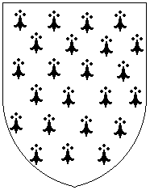
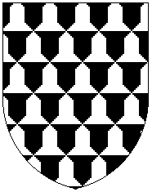
There are two basic fur types, of which there are tincture variations:
Ermine fur (metals with color spots & colors with metal spots)
Vair fur (bell shaped quadrants composed of equal parts color and metal).

The field is the background of the shield.
A charge is an object placed on the field.

Field Divisions

The field can be one solid color or it may be divided into sections. These sections lay next to each other not upon one another.


Per Fess Per Pale Quarterly Per Bend Per Bend Sinister Per Saltire

Per Chevron Gyronny Per Pall Per Pall Inverted Paly Barry

Lozengy Bendy Bendy Sinister Chevronny Checky

The lines used to create the field divisions can be plain (straight) or complex (follow a pattern).

Some of the complex lines available for use are:


Dovetailed Embattled Engrailed Indented

Invected Nebuly Potenty Raguly
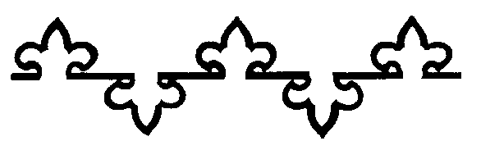
Rayonny Urdy Wavy Flory-counter-flory

Charges

Charges are the objects that lay on top of the field (whether it is one area or divided into sections).

Ordinaries are one of the primary types of charges used in heraldry. These are wide bands or sections of tinctures.
Most (but not all) of these can have other charges placed upon them.


Fess Pale Cross Bend Bend Sinister Saltire
 
Chevron Chevron Chevron Pile Pile Pall
Throughout Inverted Inverted

Chief Base Bordure Flaunches Chief Triangular Dexter Tierce

Sinister Tierce Dexter Gore Sinister Gore
Some ordinaries (if they are two-sided) can have additional small bands flanking them.

Pale Endorsed Bend Cotised Cross Cotised Chevron Cotised

Geometric shapes are a second key type of charges used in heraldry. Examples of these are:
■    ● ○
Delf Billet Lozenge Mascle Mullet Roundel Annulet

Creatures are a third central type of charge utilized in heraldry. There are three categories of creatures: beasts (actual animals such as boars, bears, bulls, birds, wolves, coneys, deer, fish, etc.), monsters (mythological critters such as unicorns, dragons, wyverns, griffins, sea-beasts, etc.) and humanoids (people, sea-folk, angels, etc.). These creatures are placed on the shield in specific, stylized positions.

      
Rampant Salient Sejant Statant Passant Couchant Dormant

 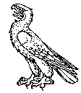     
Displayed Close Wings Addorsed Volant Segreant Naiant Erect

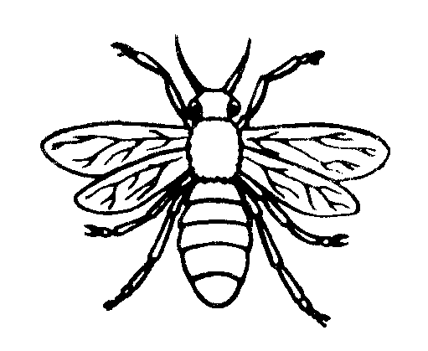
Tergiant Cabossed Couped Erased

Items and artifacts are the fourth main type of charge utilized in heraldry. This category includes, but is not limited to, objects such as weapons, armour, tools, musical instruments, clothing, towers, suns, crosses, flowers, ships, etc. Some picture examples are:

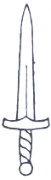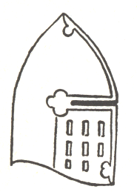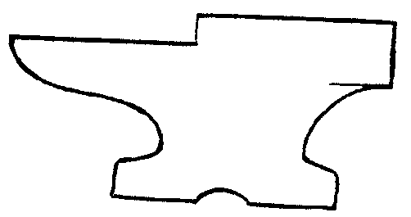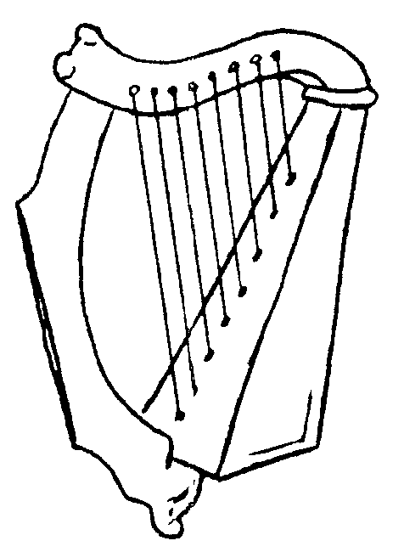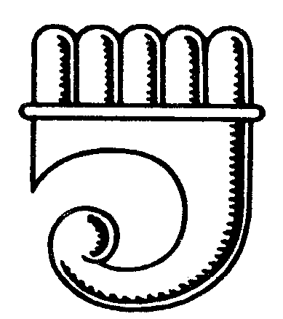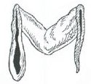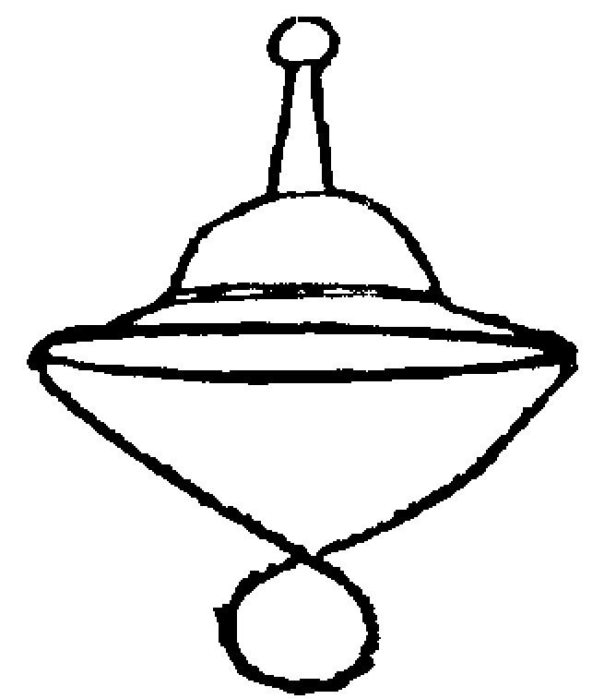
Sword Helm Anvil Harp Clarion Maunch Hat
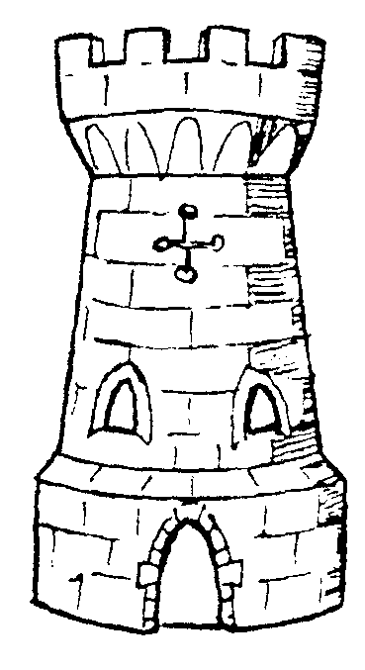    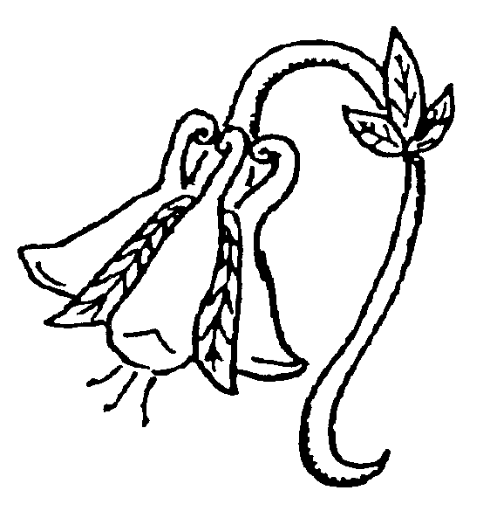 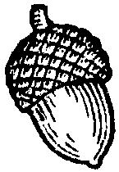
Tower Sun Key Cross Rose Columbine Flower Acorn
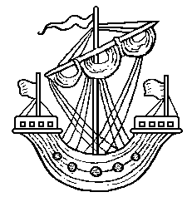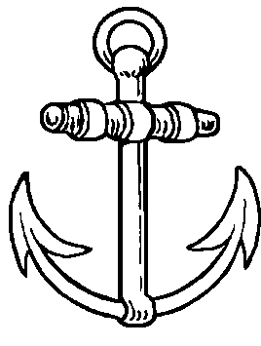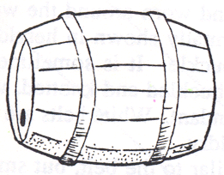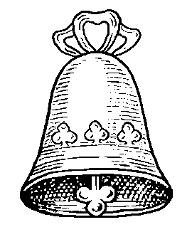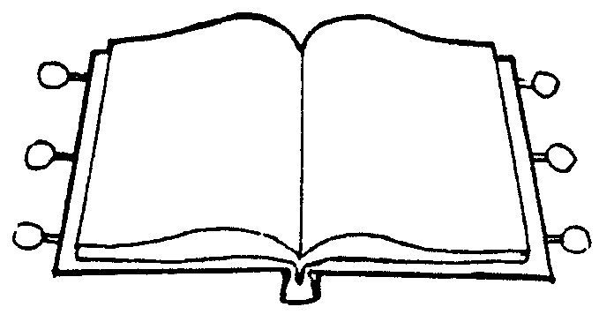
Ship Anchor Axe Barrel Bell Book

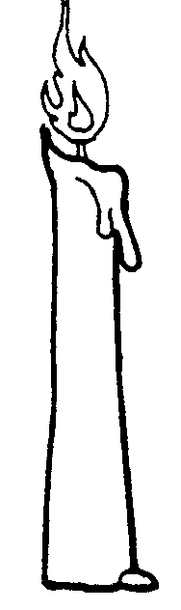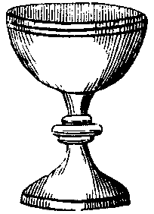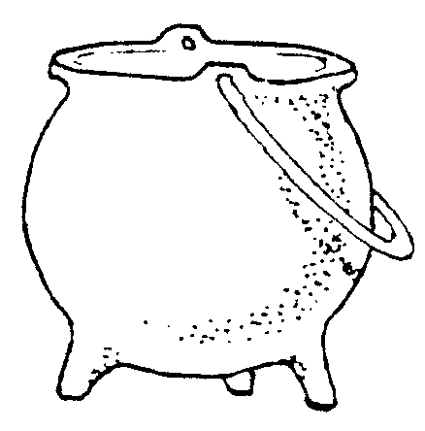
Candle Chalice Cooking Pot

NOTE: A lot of modern heraldry books and websites try to associate meanings with colors or objects in heraldry. For the most part this did not occur in period. What many of these sources are citing are concepts that were created during the revival of the chivalric age during the Victorian Era. In the Middle Ages and Renaissance the tinctures and charges selected were done so for significance to the bearer, not because a particular element had a particular meaning. Each person gave their own meaning to the elements they used.
A good example of this is the story of the symbol for the Sinclair family which is a gold rooster. Most people would look at a device with a yellow chicken on it and not consider it a very heroic symbol. However, as the story goes, the Sinclairs were at odds with a rival clan. They were marching off to a battle site and had to rest along the way and took shelter in a barn on the night before the battle. Somehow the rival clan learned where the Sinclairs were camped and planned to ambush the Sinclairs in the middle of the night. However, in their attempted ambush, the rival clan woke the farm’s rooster which crowed loudly, waking up the Sinclairs who were able to not only fend off the ambush, but defeat the rival clan so badly that the rival clan did not show up for the battle the next day. Taking the course of events as a sign of favor from God, the Sinclairs took the rooster as their symbol. They made it gold because gold was pure, just like God’s blessing on them. So to them, the symbol of a gold rooster is very heroic and a sign of blessing. To other folks the same object might not have the same meaning. Thus, folk who are creating a device should use charges that have a particular meaning to them, as any charge can have any meaning.

Style and Symmetry

The style of drawing for period heraldry was static and two-dimensional.
Charges were drawn to fill as much space as possible



In period the viewpoint of symmetry differed from the modern perspective.
Charges most commonly were all the same type and size and usually they all faced in the same direction.

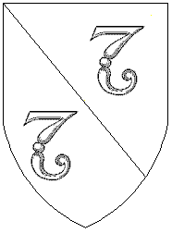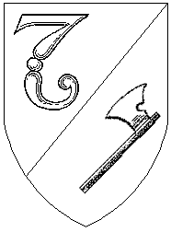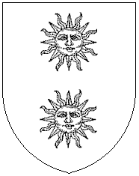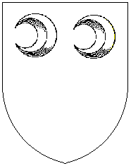
Medieval Modern Medieval Modern Medieval Modern

Many times a central charge was surrounded by smaller, secondary charges.
Additionally, ordinaries were often charged and/or surrounded by other charges.

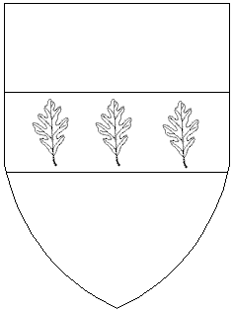

Another feature noted in period was the use of strewn charges (semy).



Restrictions.

So that everyone may have a heraldic design unique to themselves, devices cannot be too similar to one another. Therefore, if your heraldic design is too much like a design already registered you’ll need to make alterations to the design.

Additionally, certain charges are forbidden or restricted from use and there are some charges that are reserved for particular use.
Amongst the items that are forbidden are: swastika & fylfot <Nazi Party>, flaming cross (cross of fire or cross on a flame) <KKK>.

Amongst the objects restricted from use are: a cross couped gules on argent <Red Cross Symbol>, Papal Cross, Hand of Glory (hand on a flame or producing flames) and Tudor Rose (rose that is partial red and partial white).

Amongst the things that are reserved for special use are: crowns, coronets, charged escutcheons, charged cantons, laurel wreaths, white belts & baldrics, pelican in its piety, chapeau, chaplet of roses, two straight trumpets in saltire, orle/annulet of chain, wreath of roses.

Note: While chaplets and wreaths of roses are restricted, the use of single roses or multiple roses not clustered together is fine.

General Armory Guidelines

The basic rule of heraldic design is: When designing a device you may not place a color on a color or a metal on a metal. The "no color on color, no metal on metal” rule may be disregarded if a charge lays equally over two tinctures (one being a color and the other a metal) AND there is good contrast between all of the tinctures.

When using a fur, there must be good contrast between all components. The basic rule is: Do not put a fur whose major background tincture is a metal (such as ermine and erminois) on a metal and do not put a fur whose major background tincture is a color (such as counter-ermine and pean) on a color. If a fur is equally divided of a color and a metal (such as blue and white vair) make sure there is good visible difference with anything it lays on or lays upon it.

Devices are more likely to pass if they have a charge that is used less frequently. Some of the charges that statistically have been used less often in SCA registrations include: Abacus, Alembic, Alphyn, Anchor, Angel, Angles (fastener), Antelope (heraldic), Ape, Apothecary Jar, Arachnid (spider), Arch, Astrolabe, Bagpipes, Balance, Barnacles (horse clamp), Barrel, Basket, Bat, Battering Ram, Beehive, Bellows, Billet (solid rectangle), Bones, Book (usually open), Bottle, Brooch, Broom, Brush, Bucket, Bull, Caliper, Card Pique, Cartouche, Catapult, Cauldron (kettle), Centaur, Chair, Clarion, Clouds, Cock (rooster), Coffin, Collar (horse-collar), Comb, Comet, Cornucopia, Crampon (wolf hook), Crutch, Cushion (pillow), Delf (solid square), Dice, Door, Drinking Horn, Drum, Elephant, Enfield, Equatorium, Escarbuncle, Estoile, Ewer, Fan, Fasces, Fer-a-Loup (wolftrap), Fetterlock, Fireplace, Fish, Fleece, Fork, Fruit, Fungus (mushroom), Furison, Garb (wheat stack), Gore, Grenade, Grozing Iron, Gurges, Hautbois, Hedgehog, Hide, Horseshoe, Hourglass, Ink Bottle, Inkhorn, Insect, Key, Keystone, Knot, Krummhorn, Ladder, Lamp, Lantern, Level (plumb line), Lock, Lozenge, Lute, Manacle, Mascle, Maunch, Mill, Millrind, Mirror, Mortar & Pestle, Mouse, Needle, Nesselblatt, Net, Oar, Pavilion, Peacock, Pen, Pen Box, Pick, Pipe, Pitcher, Pitchfork, Printer's Ball, Psaltery, Quadrant, Quill of Yarn, Quiver, Retort, Rustre, Saddle, Satyr, Saw, Scissors, Screw Press, Scroll, Scythe, Seeblatt, Shave (currier's knife), Shovel, Shuttle, Sickle, Slea (weaver's tool), Snaffle-bit, Spindle, Spoon, Staple, Sunburst, Table, Trident, Triquetra, Trivet, Turtle, Tyger (heraldic), Wagon, Water Bouget, Windmill, Yak, Yale and Zephyr.

Devices that are more difficult to pass are ones that utilize a heraldic charge that is used frequently.
Some of these are: Bear, Bird-Eagle, Bird-Falcon, Bird-Hawk, Bird-Raven, Crescent, Dagger, Deer, Dragon, Escallop, Griffin, Hammer, Heart, Lion, Merfolk, Mullet (star), Rose, Ship, Sword, Tree (especially Proper), Unicorn and Wolf.

This is NOT to say that frequently used charges can't be used. Merely that you may have to "be adaptable" and willing to work with the heraldic design to get to use the charge you want. Many simple designs with the frequently used charges have already been registered.

HELPFUL HINTS
1. Remember that the style of heraldry striven for is bold, bright and distinctive as to be clearly identifiable.
(i.e. red lions, purple unicorns, green swords, etc).

2. Never use pale, pastel, or neon colors.

3. Try to use only 2 or 3 tinctures at most.

4. Try to use only 2 different types of charges/objects if possible.

5. Draw complex lines of division big and bold

6. Try to give a balance to the design.
7. Don't try to make a scene/pretty picture or tell your persona story on your device. This is not the style of
medieval heraldry.
8. Try not to place tinctures that blend together right next to each other (i.e. blue by black, green by blue,
gold by white).

9. Try not to use Proper as a tincture, where Proper means coloring a charge in its natural color (i.e. a tree Proper has green leaves and a brown trunk). The tincture brown was rarely used in period heraldry.

10. Concerning tinctures; in actuality purpure and vert were rare in period. Roughly 2% of arms had vert as their main color and less than 1% had purpure. Examples of both in the same device in period are unknown. Also note that colors such as bleu-celeste (sky-blue), brunatre (brown), cendree (cinder-grey), murrey (mulberry/purplish red), rose (pink), sanguine (dark blood-red) and tenné (tawny orange) are
post-period additions (after 1600).

11. Note that many folks want to show they are part of a couple with their heraldry and thus try to use identical colors and/or charges in their heraldry. Actually, in period practice, the use of identical colors and/or charges by a man and a woman identified them as brother and sister, not husband and wife. What was done in period to denote a couple as married was for them to display their heraldry together, side by side (with each having their own distinct design).

Historical Aspects of Armory
The origins of heraldic arms began in the late 12th century. Although the use of heraldry spread quickly, especially through Western Europe, there were many places where arms were not used at all. Therefore, while the use of heraldry grew, historically speaking, heraldic design grew in fits and starts. In areas where arms were inherited from one generation to the next, only a small number of new devices were designed in each generation. And new armigers wanted to associate themselves with the older, noble families, to legitimize their claims to nobility, so they copied the same (old) design styles into their own devices. This restricted the growth of new designs during most of the Middle Ages. There were a few cases of rapid change in armorial style. Perhaps the most classic example of this was in England after the War of the Roses. The Tudor kings adopted arms which were distinctly different from those used by their predecessors, so everyone would know that a new dynasty had taken charge. But these cases of sudden growth were few.

Is Heraldry for Everyone?
In the SCA, everyone is allowed to register a heraldic device for themselves. However, if a person has a persona from a time period before the late 12th century, or from a place that didn't use heraldry, then they have a decision to make. They can be faithful to their persona and not use arms, or they can follow Society custom and use arms (even though historically they wouldn't have them). Only they can make the choice; there is no right or wrong choice.

Research Questions for Developing a Persona
compiled by Modar Neznanich
SCA Persona: The fictional person you wish to have been, had you lived some time prior to 1600 A.D.
Also referred to as your persona story, it involves your SCA name and the history/background you create.
Many people want to develop a persona but are unsure where to begin. What information does one need to obtain to have a good persona story? Following are a series of questions collected from various sources designed to show what information most people consider necessary to develop a fully fleshed-out persona. These questions are by no means all-inclusive, but hopefully will present at least a good starting point.
If you want to grade yourself on how complete your persona story is, give yourself 2 points for each question you can answer, then consult the scoring charts at the end of the article.
1. What is your persona’s name?
2. What year was your persona born?
3. What is your persona’s native country?
4. What is your persona’s current country?
5. What are the climates of your persona's native and current countries?
6. What are the terrains of your persona's native and current countries?
7. In what city/town/barn was your persona born?
8. What city does your persona currently claim as "home"?
9. What are/were your persona’s parents’ names?
10. What are/were your persona’s parents’ occupation(s)?
11. Does your persona have any siblings and, if so, are any still alive?
12. Is your persona married?
13. What are the marriage customs and typical age of marriage for your persona's culture/time-frame?
14. What type of building does your persona currently live in?
15. With whom does your persona live?
16. Are there members of your persona's household that are not related to your persona
(servants/retainers, wards/fosterlings, guests, etc.)?
17. Were pets kept during your persona’s culture/time-frame? If so, what kind, if any, does your persona
have?
18. What is your persona’s occupation?
19. How old is your persona?
20. How long do people like your persona tend to live?
21. What is your persona’s ethnicity?
22. Who is your persona’s current employer?
23. Would your persona have been literate in your chosen culture/time-frame?
24. What level of education does your persona have?
25. Where/how was your persona educated?
26. What languages does your persona speak?
27. What units of measure were used by your persona’s culture/time-frame?
28. What type of money did people of your persona’s culture/time-frame use?
29. What kind of legal system exists in your persona’s culture/time-frame and who makes the laws?
30. What is the status of women among your persona’s culture/time-frame and can they own property
or conduct business?
31. What major events have occurred during your persona’s lifetime?
(Natural catastrophes, wars, revolutions, discoveries, etc.?)
32. Does your persona fight? If so, where did your persona learn to fight?
33 What type of armour and weapons were used by fighters in your persona’s culture/time-frame?
And how were such obtained?
34. List your persona’s skills and hobbies. For each, write down where your persona learned them.
35. What "class" is your persona? (i.e., royalty, nobility, merchant, middle, artisan, slave, etc.)
36. How widely has your persona traveled?
37. In what capacity has your persona traveled? (i.e., military, sailor, rich person’s hobby, etc.)
38. Who is your persona’s current monarch?
39. Who is the current Pope during your persona’s time?
40. What religion does your persona follow?
41. What kind of religious duties would be required of your persona?
42. How did people of your persona’s culture/time-frame deal with trade?
43. With respect to international relations, does your persona favor colonization, isolationism,
conquest/conversion, open trade, etc.?
44. How does your persona personally obtain goods (food, drink, clothes, etc.)?
45. How did people of your persona’s culture/time-frame tell time?
46. How did people of your persona’s culture/time-frame keep track of days?
47. What type of clothes does your persona normally wear?
48. What type of clothes does your persona wear for special occasions?
49. Are there any (sumptuary) laws restricting what your persona can wear?
50. What does your persona eat in a normal day?
51. How is food prepared and preserved in your persona’s culture/time-frame?
52. What spices were available to your persona and how expensive were they?
53. What were the eating habits of people of your persona’s culture/time-frame?
54. What are the cleaning/bathing habits of your persona’s culture/time-frame?
55. What types of wildlife live in your persona's area?
56. Name your persona’s favorite musicians/artists/dances.
57. What political figure/party/movement does your persona support?
58. Who is the most significant thinker of your persona’s time?
59. What does your persona consider to be the greatest social problem in their country?
60. What is most likely to cause your persona’s death?
61. What type of medical aid is available in your persona’s culture/time-frame and does your persona have
access to it?
62. List at least three of your persona’s goals in life. (Learn to write, become apprenticed to a craftsman,
visit the "big city", take over the family business, go to the Holy Land, usurp the crown, etc.)
63. What does your persona know of history/science/medicine/geography?
64. What’s the most striking scientific achievement of which your persona is aware?
65. Does your persona consider the Earth to be flat, round, or hollow?
66. Does your persona believe that the Earth revolves around the Sun or vice-versa?
67. What does your persona consider to be the causes of criminal behavior?
68. What does your persona consider to be the true measure of a man?
69. Who has most influenced your persona’s thoughts on these questions?
70. Did your persona’s culture/time-frame have heraldry?
SCORING
2 | - | 20 |  | points |  | § |  | You have an introductory persona story.
22 | - | 40 |  | points |  | § |  | You have a basic persona story.
42 | - | 60 |  | points |  | § |  | You have a solid persona story.
62 | - | 80 |  | points |  | § |  | You have an advanced persona story.
82 | - | 100 |  | points |  | § |  | You have a very advanced persona story.
102 | - | 120 |  | points |  | § |  | You have an extremely advanced persona story.
122 | - | 140 |  | points |  | § |  | You have a persona story with great insights into the medieval mindset.

Section IX

Book Heraldry: Documentation

This Page Intentionally Left Blank

How to Document a Name (to within an inch of its life)
by Tangwystyl verch Morgant Glasvryn [Heather Rose Jones]

Introduction
This booklet attempts to present in text form the subject of a class that I have given on several occasions. It is still very much in the developmental stages and I anticipate putting out seriously revised editions of it at some point in the future. The only excuse I have for publishing it in this rough form at this time is that people have asked for it.
The contents of this book are solely the opinions of the author. It presents the approach to the contents and formatting of name documentation that I have attempted to implement as the name-documentation coordinator for the West Kingdom letters of intent.
I have tried, in this guide, to make as little reference as possible to the Rules for Submission in current, past, or potential future form. This system sets up a continuum of documentability from the names that could have been plucked out of a period document to those that are simply a string of random words or sounds. Where the Rules have chosen to place the acceptability cut-off has varied considerably over the years, and individual kingdoms may choose to adjust it for their own uses. Unless we decide to throw out the requirement that names strive for medieval authenticity altogether, this system should not go out of date.

The Theory
This system is meant to be an approach rather than a set of hard and fast rules. For some names this approach will work easily, leading you quickly and efficiently through the various aspects of documentation. For other names this approach will constantly lead you into apparent brick walls. You will find yourself incapable of fulfilling the questions it wants you to answer. The first major factor in whether the documentation is easy or impossible is your available resources. Even the most authentic name cannot be documented in a vacuum. The second major factor is the inherent authenticity of the name. Given sufficient books of the right type, a period name will be easy to document while a non-period name will still be next to impossible. One of the advantages to using an approach that documents the "pattern" of the name is that it leads the researcher into a study of those patterns and does not depend on a (usually untutored) "instinct" for which names are authentic in structure and which are not.

Some Terminology
In the process of constructing this system, I have had to invent some new terminology, and even invent (or at least introduce) some new concepts. In my own usage I have not always been entirely consistent in the past (although not, I hope, to the point of unclarity), and may not be so in the future. The following definitions will be consistent throughout this guide but cannot be assumed to have a validity outside of it.
Name - This may refer to the entire submission or to a specific element within it. The difference should be fairly obvious, but when the latter needs to be clearly specified I will use "name element". In this latter sense, a name refers to any word or set of words that forms a complete and independent concept. Theodoric is a name (element), Theo- is not. A very important part of this definition is that by "name (element)" I do not mean a specific spelling of the item, but rather an abstract "name-as-a-concept". By this definition, Ellen, Elen, Elene, Elena, Ellyn, and Ellin are all considered the same "name". Any one of them could be used when referring to "the name Ellen", although my usual practice is to use either the submitted spelling or the "standard" spelling when referring to a name.
Name Form or Name Spelling - This refers to the exact spelling in which a name is being considered.
Standard (Modern) Form or Spelling - This will be the form that is considered "correct" in modern usage. Usually an entry heading in a name book will use this form. There may be more than one standard form, as with Anne and Ann. Frequently the standard modern form of a name is also documentable as period. The only time this phrase should be invoked is when you have not been able to find a dated period example. (In some reference books, the standard modern form is all that will be available, see below in the discussion of sources.)
Name Pattern - This refers to the way in which the different name elements are put together, both the types of elements and how they are combined, and the use of non-name words: prepositions, articles, etc. "Pattern" can also be applied to a subunit of a name when discussing its internal structure especially in relation to a parallel example. E.g., at Ashwood has the same pattern as at Oakley, both sharing the general structure at <tree type> <geographical feature>.
Document vs. Justify - When I use the word "document", I mean that you can find the actual name, spelling, or construction that is under consideration. When I say "justify" I mean that you can logically argue that it fits into an existing pattern of documentable examples.

What you want to say
The actual text of the documentation involves a simple five-point questionnaire. The rest of the system involves the ways by which you can answer those questions.

What is the nature of each name element?
Start by coming up with a broad, generic definition of each element. John Smith might be <given name> <occupational byname>. Ian MacDonald could be <given name> <patronymic byname>. Richard D'Acre could be either <given name> <locative byname> or at a deeper level <given name> de <city name>. Start with a broad category. You will need a more detailed definition or formula only if you can't document the name element itself and need to justify it on the basis of parallel examples.
The "nature" of the element also involves language, nationality, and gender. Gender is particularly relevant to given names and to relational terms (-son, Mac-, ferch, etc.). It can also be relevant if a language has gendered forms of adjectives or occupational terms. Language and nationality are related but not identical concepts. Nationality is often a function of the specific spelling of a name. The name John occurs throughout Europe, but the spelling John is specifically English. (Note again our defined use of "name".) The spelling of a name may belong to more than one culture, in which case it is valid to call it either one. Pick the one that is most relevant to the whole name. The spelling Isabella was used in both Spain and Scotland but if you're going to document it as Spanish for Isabella MacDonald then you'll have to go through the further effort to demonstrate the use of Spanish given names with Scottish surnames.

Is the name (element) period?
Once you have a working definition of each name element, then you can start looking for documentation. The definition comes first because it guides you in your search. For each element, determine whether the name (or word) is period in some form. This first step doesn't require that you pin it down too closely, just that you discover how successful your documentation is likely to be. This and the previous stage of documentation are when even awful baby-name books can be useful. At the very least they may give you a culture, a language, and perhaps say things like "invented in the 1940's". Don't stop here, but it doesn't always hurt to start here. The name-as-a-concept idea is essential at this stage because we aren't worrying yet about matching the exact spelling. Figure out what the "standard form" is likely to be and look there.

Is the spelling period?
Now we worry about specific spellings. Can you find your spelling in the target culture? With what dates? (Don't just pick one date at random if there are several. Get an idea of the whole range of time when this spelling was used.) If you can't find what you want in your target culture, can you find it in a related culture - one you have a hope of demonstrating compatibility with? (It doesn't do any good to document Kira as Russian if you plan to use it with a Basque byname.) Or can you interpolate the desired spelling from examples in the right time and place? (The techniques of interpolation are described below.)

Is the way that the parts are put together period?
Start with any name elements that consist of more than one word (ap Rhys, von Falkenstein, with the Sword). Do your examples document the whole phrase or only the primary word? If the latter, can you find parallel examples with the same underlying structure in an appropriate time and place? You needn't find von Falkenstein if you can find von <German castle name>. You needn't find with the Sword if you can find with the <tool or other everyday physical object>. This becomes particularly important when the element mixes languages or cultures. You won't likely have trouble documenting the phrase ap Rhys, but what if you want to use ap Ælfred? It might be considerably easier to find ap <Anglo-Saxon given name> than to hold out for finding ap Ælfred itself.
Finish by looking at the whole name; the types of elements, their combinations, their ordering. For example, all the elements of the name Regenweald Acleah Beorhthram are documentable as Anglo-Saxon. I can demonstrate the use of locative bynames (even with no preposition used) and of unmarked patronymics (i.e., using only a given name, such as Beorhthram). I can even demonstrate the use of the two types of bynames in combination. What I couldn't demonstrate was this particular order; every example followed the order <given name> <patronymic> <locative>. Again, culture can be an important consideration. If you have documented your given name as English and your surname as French, find an example for the appropriate time period with a similar combination. Ideally at this stage you will find an example of a whole name that is exactly parallel to the submission you are considering, only with different names and words plugged in. Less ideally you may have to settle for documenting various subsets without finding the whole pattern. For John ap Dafydd Smith you might have to settle for finding <English given name> ap <Welsh given name>; <Welsh given name> ap <Welsh given name> <Welsh occupational byname>; and <Welsh given name> <English occupational byname>.

Extra Credit: Can you postulate a time and a place where this name could have existed?
This is the acid test of a truly period name. From the documentation you have found, can you say, "This name could have existed in 15th century France." Or even more precisely, "This name could have existed in London in the first half of the 13th century." This is the goal we should be aiming for, although it can only occasionally be obtained (unless you're working backwards, constructing a name from elements that are documented from a particular time and place). This is the reason that you want to keep in mind the full range of times and places in which an element occurs, so that you can chose the ones that are most compatible with each other.

How you want to say it
As important as the information that you have discovered about the name is the manner in which you present it. Too often, valuable data is obscured by an unclear presentation. One common example of this problem is when documentation states, "X is a variant of Y which can be found in source Z." Now is X found in Z or is only Y found in Z? Or if you say, "According to Smith, a 6th century English king bore the name Alfred" the usefulness of this reference for dating the spelling Alfred to the 6th century can only be judged if we know what sort of book Smith is. A history book? A baby-name book? A transcript of 6th century English charters? It is also important to give all the relevant information you have found. If Withycombe says of X "the name of an Italian martyr of the 5th century, it did not come into use in England until the 19th century", then it would be extremely misleading to write as your documentation "Withycombe dates the name to the 5th century" thereby implying that Withycombe dates its use in England to that time. The three essential components to conveying information about a name are: say what you know; say what you don't know; say what you think.

Say what you know
What kind of book did you get your information from? What is the nature of its name examples? Does the book date specific spellings or only the name in general? How reliable is the book known to be? What exactly does it say about the name? What is the full context of the name example (if relevant)? This isn't the place for interpretations and opinions, just the facts.

Say what you don't know
What information does your source omit? Does it lack dates for specific spellings? Does it give only standard modern forms? Does it neglect to note clearly the culture of a name form? Does it give a variety of dated spellings but fail to present any with some essential element that your submission contains? Are you using a modern dictionary to document a non-English word rather than one with dated examples? (This will, of course, be the norm.)

Say what you think
When you are unable to document the exact spelling or pattern of a name element or the name as a whole, then you need to present evidence why you believe it fits with period practice. The two major techniques for this are interpolation (postulating an item that falls within a demonstrated set of facts) and extrapolation (postulating an item that follows a demonstrated trend but falls outside of the demonstrated examples). Interpolation is most often applied to spelling variation. If the name Bork is found as Borkk, Bork and Borcc, then it is reasonable to postulate Borc. It falls within the demonstrated range of variation. Remember to pay attention to the dates of your examples. If Borcc is found in the 9th century, Borkk in the 12th century and Bork in the 16th, then it is entirely possible that there is a rule operating that says "c" changes to "k" sometime in the 10th century but double letters don't change to single ones until the Renaissance. In this case, Borc would not be particularly likely. My personal rule of thumb is to aim for a one-century span, both in this sort of analysis and in demonstrating compatibility of elements.
Extrapolation is most useful in doing pattern-matching exercises. Suppose you want to use Stevenston in a surname but can't find it as an actual place? If you can find town names such as Johnston and Walterston in period, then we can extrapolate to a general pattern of <post-Norman English given name>+s+ton. Beware of false etymologies when engaged in this exercise. What is important here is not what a name looks like it means but what it was originally derived from. Coneythorpe and Congerston might appear to support the use of animal names at the first element in place names but the first element in both cases was originally a word meaning "king". Extrapolation is a vitally important technique when documenting the pattern of a whole name. It would be silly to think that the only way to justify the pattern of John Weaver of London would be to find an example of the combination John Weaver of London! Instead we can substitute the name types from our original analysis and look for any name that fits the pattern <given name> <occupational byname> of <place name>, or even more specifically, <masculine English given name> <English occupation> of <English city name>.

The Practice

Sources and References
There is a large range of possible references for names, both the individual elements and the overall patterns. Different types have advantages and disadvantages. Often you find that the purpose of an author runs contrary to what you need from the book, as in history books where names have been carefully modernized and standardized. Transcripts of medieval documents can be the most reliable sources for specific spellings and name patterns ... and next to impossible to use due to problems of organization, indexing, and ignorance of the language.
Name books are the best organized for our purposes, needless to say. Not all name books are created equal, as we all know well. Very few books are of no use whatsoever. The only unredeemable books are those that give misinformation. But it is vitally important to keep in mind a hierarchy of source usefulness. I have developed a classification system that has vague similarities to the nomenclature of "primary", "secondary", and "tertiary" sources. Because it doesn't correspond exactly to these notions, I have instead called them "Types I, II, and III".
Type I sources are those in which dated examples are presented as an exact transcription of the period source. The dated citations in Withycombe fall in this category as to those in Reaney's Dictionary of British Surnames. Ideally, this type of source gives you the whole name in which the element under consideration appears. Slightly less useful are those which list a source document rather than a date, forcing you to look up the era of the source. A number of the citations in Morgan & Morgan's Welsh Surnames are of this type.
Beware of documents that give a precise date but attach it to a standard modern form of the name. î Corrain & Maguire's Irish Names has a lot of this type of citation. History books are rife with it. These sources I call Type II. They can give you documentation for the historicity of the name-as-a-concept, but are useless for documenting a specific spelling. Into this category also fall discussions of culture-specific or other variants of names that do not have actual verbatim examples attached. The text discussions in Withycombe fall into this category. (There is no rule that says a book will have only one type of information in it.)
Type III books are those that do not discuss the historical usage of the name at all (or perhaps only by noting a language or culture). Most "baby-name" books are of this type. These books can sometimes give you useful information, such as pointing toward a language to search, but should only be used as "documentation" if absolutely nothing else is available. The nature of the book should be clearly noted when citing it. For some obscure languages this may be the only type of book available, but there is rarely any excuse for using them for English names.
If your name has non-name words or phrases in it, then you will most likely need the assistance of a dictionary. The ideal dictionary is one that, like the Oxford English Dictionaryhas dated examples of usage and spelling. For languages other than English, however, references of this sort may be impossible to find. If you are using a modern dictionary, note that fact. Remember that a dictionary in the hands of an amateur can be a disaster. At the very least, have one that goes both ways. When you look up the English word X and find A, B, and C as possible translations, go look up A, B, and C and see what they translate back as. See how related words are translated. No matter what you come up with, include a description of what the submitter wants it to say or thinks it says. For most languages, you'll need a grammar as well as a dictionary. The best kind is what is called a descriptive grammar; it arranges information in a systematic format and is intended as a reference. Slightly less useful are instruction books that are intended to teach the language to beginners. Often it is hard to track down specific information in these. The aspects of grammar that most often need adjustment have to do with the gender and number of nouns and their associated adjectives and articles, the case required by prepositions or by the function of a word (such as a possessive), and the order in which various elements normally occur. As with dictionaries, a historical grammar is better than a modern one, but as with dictionaries it is often impossible to find. Don't forget extrapolation as a tool: if you can find a parallel example already as part of a name, half your work is done. If you aren't up to dealing with foreign languages yourself, it is imperative that you include the intended meaning, the intended language (be specific - "Gaelic" could be any one of three languages), and all the information you have been given on the parts that you have. Then cross your fingers and hope that someone further up the line can deal with it. Remember: say what you don't know!
History books are the classic Type II source. Names have almost always been modernized and nicknames are usually translated into the language of the book. They are useful for placing a name in a general era but very unreliable for dating specific spellings of elements. Beware also of nicknames that may be of later invention.
Period literature and documents cover a whole range of types. They may be fictional tales written in period or legal documents. They may be scholarly, precise transcripts of the original document complete with abbreviations and original corrections or modern translations complete with modernized names. A scholarly treatment will generally tell you in the introduction what sort of editing has been done. A version that has no explanatory introduction - especially if it isn't in the original language - should be treated as a Type II source. Unless documents of this sort are very well indexed, they are generally not helpful when documenting a submitted name. They are, however, a treasure trove of material for pure research.

Types of Name Elements and How to Document Them
Different types of name elements have different documentation needs and the same books will not serve for all of them. As with the hierarchy of source types, I have developed a hierarchy of likely sources for particular types of elements.
Given Names - The obvious place to start looking for a given name is in a book specializing in given names. For early examples of given names, general surname books can also be useful. Entries for a patronymic surname often show examples of the root as a given name. Type I surname books also often have citations of whole names, although this is not particularly useful unless someone has indexed the given names that appear. History and literature are generally most useful if you recognize the name or have been given a clue where it appears. While given names often appear as part of place names, this is a rather bad place to try to document given names. The names have generally been altered seriously in the process of compounding and the best you are likely to find is the author's stab at what the standard form of the original would be.
Descriptive bynames - For descriptive bynames, the first place to look is a book generally specializing in surnames. This will be most useful for epithets that were popular enough to survive as hereditary surnames. These tended to be short and fairly simple. But many types of epithets never settled into permanent respectability and will not appear in a book that is working backward from modern surnames. You won't find Outwitheswerd in your average surname book and will need to look in one of the more specialized books that trace the development of particular types of surnames. Medieval literature often has examples of "non-typical" descriptive bynames, although these do not always show everyday practice. When all else fails, pull out your dictionary and try to demonstrate that the word or words you are using are period in the sense you mean.
Occupational bynames - Many occupational bynames will be found in the general surname books. The technique of extrapolation works well on these too, for the existence of so many surnames derived from occupations suggests that almost any occupation could produce a surname. The trick is to find what that occupation would have been called in period and not be tripped up by modern constructions and idioms.
Locative bynames - The documentation of locative bynames is usually a two-step process. First, find a pattern for the structure of the locative phrase in your target language: does it use a preposition? a definite article? does the place have a proper name or is it a generic description? Second, document the place name itself or the words used to describe it. Surname books that show historical development will often show early forms before the prepositions were dropped. Be very wary of selecting your prepositions from a dictionary! The structure of locative bynames is often idiomatic and by far the best method is to find an existing byname to use as a pattern. A language might well never use a byname of the form from X and instead use something like X-er. When documenting the name of the place itself you are, as usual, concerned with placing both the name and the spelling in a particular period. Atlases and history books are useful, but they don't always remark on the changes that a name has undergone. You might find a book that says "the city of Chester dates to the time of the Roman occupation" and never mentions that it was called Deva at that time, Legaceaster for several more centuries, and didn't become anything resembling Chester until at least the 11th century. Stick to type I sources if you want to discuss spelling. Books studying the placenames of a particular region are perhaps the most common of the specialized name books.
Patronymic (or "relational") bynames - As with locative bynames, the documentation of patronymics is often a two-step process, first demonstrating the structure and then documenting the elements. Surname books are a good place to find structures. After that use the same sources mentioned above for given names.

Name "patterns" or The Whole Shebang
About the only kind of book that is useful for documenting whole-name patterns is a type I source with whole-name examples. Type I surname books are very useful, but mostly for names with only one byname. The author usually has a great many examples of a particular name from which to select, and picks those with the least extraneous "noise". Transcripts of period documents are often a better source, when available. The information you want is equally hard to find in all sources, and the period documents tend to have a greater range of name patterns demonstrated. (Tax and court rolls are especially useful.) It would be nice if any of the easily available name books actually considered the question of name patterns, but it seems to be a relatively unexplored field. Not every language or culture has whole-name examples easily available.
Here's a checklist for looking at the name pattern:
- Have you documented or justified the "little words", the articles and prepositions and whatnot?
- Have you documented them from namesor from the dictionary?
- Have you demonstrated that they are used in a grammatically correct fashion?
- Is each phrase internally consistent as to language (or of a documentable combination of languages) and correct for that language?
- Can you document or justify each of the elements as appearing in a name?
- Can you document or justify all of them appearing in the same name?
- Can you document the order in which the elements are arranged?

"Temporal Consistency"
The question of temporal consistency - locating the elements of a name within a particular time span as well as within a particular culture - is one that many people find daunting. I maintain that people find it daunting only because the question is given so little consideration by submitters when they compose their names. It is very hard to fault them when most available books consider the subject of little importance. A submitter will read that Alfred was a 9th century Anglo-Saxon king and that Shrewsbury was an important Anglo-Saxon town in the 9th century and he will be justified in concluding that Alfred of Shrewsbury is a reasonable 9th century Anglo-Saxon name. And it's a name he and his friends can get their mouths around fairly easily. Then some herald comes along and says that it wasn't spelled Shrewsbury until the 15th century by which time Alfred had passed entirely out of favor not to return until the 18th century, and by the way, what does he think of Ælfræd æt Scropesbyri?
But as with any other aspect of this system of name documentation, the more "real" a name is, the easier it is to document or justify temporal consistency. The bane of consistency is submitters who pull elements from wildly varying cultures - thereby forcing you to postulate a fairly late date when cultural mixing was greatest - and yet want fairly freeform descriptive bynames, ones incompatible with an era when fixed surnames were the rule. Submitters who are stuck on a particular "exotic" spelling of a name also make the job harder, for often a minor adjustment to spelling can pull the elements of a name into the same decade, to say nothing of our rule-of-thumb century. Often the best you can do is to date the different elements as close to each other as possible, and if the gap is still fairly large, acknowledge that you are aware of the fact.
Our ability to demonstrate temporal consistency either of the elements in a name or of their spellings is entirely dependent upon the books available. For English names we have good enough resources available that we could probably get away with requiring complete temporal consistency. For, let's say, Turkish names we'd be lucky to be able to prove that they are correct modern Turkish.

Bibliographies and Photocopied Documentation
Once you have assessed your references and found your citations, you need to convey that information to whoever reads your documentation. The absolutely basic-basic level of citation is a page number and a bibliographic reference. There are a number of "correct" formats for bibliographies, but it needs to include at a minimum the title, author, publisher, place of publication, and date of publication (not date of copyright, if they are different). Sometimes an edition number is also helpful. I've started including ISBN numbers in some of my bibliographies in case my readers want to try to track down and buy a copy of the book.
If the book is one of the references commonly used in the College, the previous information is all you should need to give. If you think that others may not be familiar with the book - and especially if the title doesn't give a clear indication of its contents - that some sort of brief description can help your readers assess its reliability. A statement such as "Although no dates are specifically mentioned, Gnrrz is a study of the nicknames borne by red-heads in 13th and 14th century Moscow and environs" is a lot more helpful than "p.26 Gnrrz, Reds in Russia".
If your bibliographical information is complete, you should not need to include a photocopy of the title page of the book in your documentation (in fact, the title page is usually missing vital information), but if you are uncertain how to interpret the information (Which one of these things in Finnish is the publisher?) then include both the title page and the following page - where the printing information is usually found. When you photocopy a page for documentation, write the author and/or title on the photocopy. Not all books have this information on headers or footers and the interpretation of documentation should not be a guessing game.
Ideally, any page of any book that is mentioned in your documentation should be photocopied. I will freely admit that I don't go to this length. Conversely, some will argue that it is unnecessary photocopy anything as long as it has been cited properly. And if people were careful and rigorous in their citations this would be true, but I can give you hundreds of examples of citations of documentation where the original didn't really say what the citation implied. A middle ground is to say that it's unnecessary to copy from books that the Laurel office owns, on the assumption that Laurel can look it up if so inclined. I look from a different angle, considering that if I were Laurel I couldn't afford to run off to the bookshelf every time I wanted to double-check documentation from Withycombe.
I try to include the following three types of information. 1) Copies of the citations for all elements that are directly documented, i.e, where I found exactly what I was looking for. 2) Copies of the citation for the closest form when I have had to interpolate or extrapolate the submitted form. 3) Copies of everything that is even remotely relevant when I believe that I am out of my depth on an interpretation, or when I am dealing with an unfamiliar language.
At this time, I photocopy documentation for the name elements, but do not do so for whole-name patterns. If at some time in the future the documentation of name patterns becomes a required element, then I would include photocopies of this also. The one book that I never photocopy documentation from is the OED. I use the compact edition and have not found a photocopier with the resolution to make it worth while.
Following are some examples of actual name documentation that I have prepared (with the help of other researchers) for West Kingdom letters of intent. They show how I have handled names of varying levels of documentability and authenticity.

Examples

An Almost Perfect Example
Theophania Hathaway of Sutton in the Elms
New name.
Theophania is a feminine English given name. The submitted spelling is dated in Withycombe (p.278 under Theophania) to 1205.
Hathaway is an English patronymic surname (deriving originally from an Anglo-Saxon given name). Reaney (DES) (p.220) lists the submitted spelling as the main heading although the closest dated form is Hathewy (1294).
Sutton in the Elms is a town in Leicestershire (Ekwall p.454). Although the dated examples there have it only as Sutton (1220), another similarly modified town, Sutton in le Colfeld is dated to 1289 showing the pattern to be period.
Although in the Middle English period locatives most often used French de, occasional examples with of can be found, such as John Elwrun of Antyngham (Selten v.II p.19) dated to 1302, which documents the whole pattern of the name as Elwrun is also a patronymic surname derived from a simple given name.

Analysis

What you want to say ...

What is the nature of each name element?
- Theophania is a feminine English given name. ... Withycombe ... p.278
- Hathaway is an English patronymic surname (deriving originally from an Anglo-Saxon given name). ... Reaney (DES) (p.220)
- Sutton in the Elms is a town in Leicestershire (Ekwall p.454).

Are the names and spellings period?
- The submitted spelling [of Theophania] is dated in Withycombe (p.278 under Theophania) to 1205.
- Reaney (DES) (p.220) lists the submitted spelling [of Hathaway] as the main heading although the closest dated form is Hathewy (1294).
- Although the dated examples there [of Sutton in the Elms] have it only as Sutton (1220), another similarly modified town, Sutton in le Colfeld is dated to 1289 showing the pattern to be period.

Is the way that the parts are put together period?
- Although the dated examples there [of Sutton in the Elms] have it only as Sutton (1220), another similarly modified town, Sutton in le Colfeld is dated to 1289 showing the pattern to be period.
- Although in the Middle English period locatives most often used French de, occasional examples with of can be found, such as John Elwrun of Antyngham (Selten v.II p.19) dated to 1302, which documents the whole pattern of the name as Elwrun is also a patronymic surname derived from a simple given name.

Extra Credit: Can you postulate a time and a place where this name could have existed?
- Theophania is ... English ... dated ... to 1205.
- Hathaway is ... English ... the closest dated form is Hathewy (1294).
- Sutton in the Elms is a town in Leicestershire [England] ... dated ... as Sutton [in] 1220 ... [and is similar to] Sutton in le Colfeld ... dated to 1289 ....

How you want to say it

Say what you know.
- Sutton in the Elms is a town in Leicestershire (Ekwall p.454).
- Another similarly modified town, Sutton in le Colfeld is dated to 1289.

Say what you don't know.
- The dated examples there have it only as Sutton (1220). [I.e., there is no dated example of the submitted form.]

Say what you think.
- Another similarly modified town shows the pattern to be period.

A Bit More Work
Angus Ian McDougel
Name resubmission to kingdom. The previous submission, Angus MacDougel, was returned at kingdom (5/10/92) for conflict with the registered Angus MacDougall.
Angus is an Anglicized form of a masculine Gaelic given name. Black (pp.23-4 under Angus and Angusson) dates the submitted spelling to 1204 and 1630 (which presumably makes it reasonable for the entire period between).
Ian is an Anglicized form of the masculine Gaelic given name Iain (= John). The closest dated form in Black is in the patronymic surname M'Ean (=MacIan 1538 p.510 under MacIan) however the submitted spelling is a standard modern form.
McDougel is a Scottish Gaelic patronymic surname (standard modern form MacDhughaill). The submitted form may be interpolated from the following examples in Black (pp.487-8 under MacDoual and MacDougal, variants of the same name): Mcduwell (1515), M'Douell (1547), M'Dougall (1647).
The pattern of the name is justifiable if you consider Ian to be acting as a patronymic surname. Rarely, a bare given name may be found as a surname as in Thomas Nevin (1538), Black p.630. Although the second generation of patronymics usually aspirates (to Mhic), contrary examples may be found, such as Ferquhardus McOwne McArchare (1537) on p.490 of Black.

The Analysis

What you want to say.

What is the nature of each name element?
- Angus is an Anglicized form of a masculine Gaelic given name.
- Ian is an Anglicized form of the masculine Gaelic given name Iain (= John).
- McDougel is a Scottish Gaelic patronymic surname.

Is the name period?
- Black (pp.23-4 under Angus and Angusson) dates the submitted spelling to 1204 and 1630 (which presumably makes it reasonable for the entire period between).
- The closest dated form [to Ian] in Black is in the patronymic surname M'Ean (=MacIan 1538 p.510 under MacIan).
- ... the following examples in Black (pp.487-8 under MacDoual and MacDougal, variants of the same name): Mcduwell (1515), M'Douell (1547), M'Dougall (1647).

Is the spelling period?
- Black (pp.23-4 under Angus and Angusson) dates the submitted spelling to 1204 and 1630 (which presumably makes it reasonable for the entire period between). The patronymic surname M'Ean (=MacIan 1538 p.510 under MacIan) however the submitted spelling is a standard modern form. [I.e., not as far as I can tell.]
- The submitted form may be interpolated from the following examples in Black (pp.487-8 under MacDoual and MacDougal, variants of the same name): Mcduwell (1515), M'Douell (1547), M'Dougall (1647). [I.e., possibly.]

Is the way that the parts are put together period?
- The pattern of the name is justifiable if you consider Ian to be acting as a patronymic surname. Rarely, a bare given name may be found as a surname as in Thomas Nevin (1538), Black p.630. Although the second generation of patronymics usually aspirates (to Mhic), contrary examples may be found, such as Ferquhardus McOwne McArchare (1537) on p.490 of Black. [I.e., I can't demonstrate this actual pattern, but parallel examples suggest it may be plausible.]

Extra Credit: Can you postulate a time and a place where this name could have existed?
- Not without a dated example of Ian.

How you want to say it.

Say what you know.
- McDougel is a Scottish Gaelic patronymic surname (standard modern form MacDhughaill).
- The following examples occur in Black (pp.487-8 under MacDoual and MacDougal, variants of the same name): Mcduwell (1515), M'Douell (1547), M'Dougall (1647).

Say what you don't know.
- [Although not explicitly stated, I imply that I have no dated period example of the submitted spelling.]

Say what you think.
- The submitted form may be interpolated from the examples in Black.

The Interpolation
You want the various points from which you interpolate to occur in the same culture and roughly the same time period - say within the same 100-150 year span. Break your names/elements down into several variable regions.
Mc | duw | - | e | ll | 1515
M' | Dou | - | e | ll | 1547
M' | Dou | g | a | ll | 1647
Mac | Dou | - | a | l | modern
Mac | Dou | g | a | l | modern
There are three imperfections in this interpolation:
- We have no examples within our pre-1650 grace period ending in a single "l".
- The only examples with the "g" are post-1600, acceptable, but non-ideal.
- Our first and last dated examples are fairly far apart - less than a century would be better.

Sometimes You Just Have to Shrug ...
Aoibheann O'Gowan
New name.
Aoibheann is the standard modern spelling of a feminine Irish given name. Woulfe (p.207) notes that it was borne by the mother of an early saint.
O'Gowan is a modern Anglicized spelling of an Irish patronymic derived from the occupation of smith. Woulfe (p.542) lists the submitted spelling and mentions a 16th century family that bore the surname.
The use of a Gaelic given name with an Anglicized Gaelic surname may be demonstrated by the late 16th century example of Grana O'Malley (Chambers p.55).
[Author's note: This last statement is false.<Grana> is an Anglicized form of the Irish name Grainne. Therefore the general conclusion I also false.]

The Analysis

What you want to say.

What is the nature of each name element?
- Aoibheann is ... a feminine Irish given name.
- O'Gowan is ... an Irish patronymic derived from the occupation of smith.

Is the name period?
- Woulfe (p.207) notes that [Aoibheann] was borne by the mother of an early saint.
- Woulfe (p.542) ... mentions a 16th century family that bore the surname [O'Gowan].

Is the spelling period?
- Aoibheann is the standard modern spelling.
- O'Gowan is a modern Anglicized spelling.
[Note that I'm not saying that these spellings couldn't be period, only that I don't know that they are. And I do know that they are standard modern forms.]

Is the way that the parts are put together period?
- The use of a Gaelic given name with an Anglicized Gaelic surname may be demonstrated by the late 16th century example of Grana O'Malley (Chambers p.55).

Extra Credit: Can you postulate a time and a place where this name could have existed?
- Insufficient information.

How you want to say it.

Say what you know.
- Woulfe (p.542) lists the submitted spelling [of O'Gowan] and mentions a 16th century family that bore the surname.

Say what you don't know.
- [Again, the absence of any dated information should be interpreted as saying "I couldn't find any dated examples of the submitted form."]

Say what you think.
- [There is an implication of "I think that the standard modern form of a name should be acceptable for registration" although it shouldn't be necessary to state this as a matter of course. This is the sort of subject that comes up in commentary.]
Copyright © 1993 Heather Rose Jones, All Rights Reserved
Printed with permission of the author.

Section X

Book Heraldry: Submission Process

This Page Intentionally Left Blank

A Look at the Submission Process
by Modar Neznanich, Volk Herald
While no one is required to register their name and device, most people feel that it is courteous to do so. By recording the information in the official SCA Armorial and Ordinary listings, it helps to reduce the chances of confusion or offense caused by inappropriate names and armory, and will hopefully prevent others from using the same name and device as you. In some kingdoms, members are restricted from receiving scrolls for awards or fighting in Crown Tourney unless they have registered a name and/or device.
The SCA has organized a registration service through which members may submit their proposed names and armory for registration, and when approved, be officially recorded. This service structure is known as the College of Arms (CoA).
There is a small submission fee for this service. This information is date sensitive, since prices can and do change, it can be difficult to quote costs in an article and keep it timely. Always check with your local or kingdom herald to verify the amount of submission fees. Currently in Calontir the fee is $9 per element. Each of these is a separate element: a name, a device, a badge.
Following is how the submission process currently works in Calontir. This process varies in other kingdoms.

Local Level
A member of the populace, working with their local herald, determines a name and/or heraldic design they would like to register.
Appropriate submission forms are filled out, copied and prepared as needed. The local herald can assist in the preparation of these forms. Currently the Herald’s Office in Calontir requests that submitters make the following number of completed copies of the submission forms:
If submitting armory (heraldic device or badge):
Five (5) colored armory forms
Three (3) line-drawing only [non-colored] armory forms
If submitting a name:
Four (4) name forms
Out of these, the submitter should keep one copy of each form (including an uncolored line copy of armory) plus a copy of any documentation for themselves. Thus if anything should happen to the submission, they do not have to start from scratch.
After the forms are completed, the following is turned in to the local herald:
1. The submission forms. The local herald will keep one copy of each and the rest of the copies
(three color device forms, one line-only device form and two name forms) will be sent to the Kingdom
Submission Herald for their use.
2. Three (3) copies of any needed documentation. The local herald will keep one copy of each and
send the rest of the copies to the Kingdom Submission Herald
3. Submission Fee. Funds (preferably a check made out to the local group) in the appropriate amount
to cover the submission costs of what is being submitted.
NOTE TO SUBMITTERS: Ask the local herald for a receipt of payment. (This way if there is a need for resubmission, or records get lost, etc. then you have proof of what you have paid.)
The local group-herald's office gets to keep $2 (per element) of the submission fee to cover the cost of photocopies, postage, etc. The rest of the fee will be sent on to the Kingdom Submission Herald's office.
The local herald will then turn your check over to the local exchequer and then have the exchequer fill out a Group Fund Transfer Sheet and write a group check to the Kingdom office in the appropriate amount. This amount will depend on how many submissions are being sent in at the same time, because the group can write one check to cover all the submissions they are sending in at this specific time. It could be one submission or several. The groups cost-rate is $7 per element. Checks from local groups to the Kingdom office are made out to: SCA, Inc - Kingdom of Calontir/Heralds
The local herald will keep the following in the local files, sending the rest on to the Kingdom Office:
1. One set of your submission forms
2. One copy of any documentation
3. A record of payment
Note that the reason a local group should keep an uncolored line-drawing version of device submissions on file is that it is useful if a scribe or other artisan needs to get a copy of a device to make a scroll or other item. Copies made from colored forms can be difficult to work with. It is also nice to have a "back-up" copy, just in case something happens to a submission.
Sidenote:
It is possible to submit directly to the Kingdom Office. The Calontir Herald's Office would prefer that you go through your local office whenever possible. However, with the current ruling by the SCA Board of Directors that groups below the status of Barony are not required to have a local herald, some groups do not have a herald and hence members of those group's populace must submit directly to the Kingdom Office. Additionally, the Kingdom Heraldic Submissions Officer and/or their staff may run a consulting table at an event or war, where they will take submissions directly. Not all consulting tables will be able to accept submissions.
If you are submitting directly to the Kingdom Office, make checks to pay for the submission fee out to:
SCA, Inc - Kingdom of Calontir/Heralds
When submitting directly to the Kingdom Office, the Kingdom Office gets to keep the $2 normally taken by the local office. The fee to the submitter remains $9 per element.
Be sure that you include the correct number of copies needed by the Kingdom Office.
For devices: three color device forms, one line-only device form.
For names: two name forms and two copies of any name documentation.

Kingdom Level
The Kingdom Office (Saker Herald) collects all the submissions received from the local groups. Their job requires them to review all submissions, check for conflicts or other problems and, where possible, add additional documentation to assist in a submission's registration. Because this is a large number of items, the office has a staff of volunteers, knowledgeable in heraldry, who help review the submissions. These staff members are known as Commenters. On a regular basis (ideally once a month - but various factors can cause this to be a once every two months function), the Kingdom Office compiles what is known as an ILoI (Internal Letter of Intent). An ILoI is a list of all the submissions the Kingdom Office has received since its last ILoI and intends to register if possible. It is posted to a website for the staff of commenters within the Kingdom to review. Hence, it's name, Internal Letter of Intent. The commenters have about 1 month to review the submissions, find conflicts, locate additional documentation and send comments on the submissions to the Kingdom Office. At the end of this month, when the Kingdom Office has received all commentary from the commenters, the submissions are reviewed. Submissions with problems are noted and a letter explaining the problem is sent to the local office or individual that originated the submission. The submissions that are accepted as ready to send on, are prepared into a packet of forms to be sent to the Society Office and a listing known as an ELoI (External Letter of Intent) or just LoI (Letter of Intent) that lists the submissions the kingdom is sending to be registered if possible, is created. The packet of forms and a copy of the ELoI are sent to the Society Herald's Office. An electronic copy of the ELoI is posted to the SCA Heralds webpage known as OSCAR (Online System for Commentary and Response). The Herald Offices of the other kingdoms, plus those the Laurel-Sovereign-of-Arms has designated as staff and commenters will review the ELoI.
Of the submissions that were sent in, the Kingdom Office will keep part of the forms it receives in the Kingdom files, sending the rest on to the Society Office. Kept are one set of the submission forms and one copy of any documentation.
The Kingdom Office gets to keep a portion of the submission fee to cover their cost of photocopies, postage, etc., and the rest is sent to the Society Office, when the submission is sent on. If the device is returned at Kingdom level, the money stays at Kingdom level until the resubmission is sent in. It is then sent on with the resubmission. This is why you do not pay for a resubmission, if the resubmission is made within one year of notices being sent out about the submission return.

Society Level
The Society Office (also known as the Laurel Office) collects all the submissions received from the Kingdoms. These submissions will be reviewed further, checked for any missed conflicts or other problems and, where possible, additional documentation will be located to allow the submission to be registered. Because there are a tremendously large number of items, the office has a staff of volunteers and a wide number of commenters, very knowledgeable in heraldry, who help review the submissions. These staff members and commenters, with the Laurel Officers, make up the SCA College of Arms. On a monthly basis the Laurel Office compiles the submissions (from the Letters of Intent of the various kingdoms) and lets the Society staff and commenters know which letters will be decided on during a particular Laurel Decision Meeting. The staff and commenters have 2 months to review the submissions, find conflicts, locate additional documentation and send comments on the submissions to the Laurel Office. This much time is needed because of the number of submissions that are reviewed. At the end of 2 months, when the Laurel Office has received information from the staff, the submissions are reviewed. Submissions with problems are noted and a letter explaining the problem is sent to the Kingdom Office, which in turn sends a letter explaining to the local office or individual that originated the submission. Submissions which are accepted as free of conflicts and problems are registered and recorded in the official SCA Armorial and Ordinary listings. A letter is sent notifying the Kingdom Office which names and armory have been registered. These letters of notification both for accepted and returned submissions are called LoARs (Letters of Acceptance and Return). Kingdom Offices, upon receiving these LoARs, in turn notify the local offices. Because of the size of these letters, plus to need for them to be carefully proof-read…it can take one to three months for them to be completed. The archive of LoARs can be found at: http://heraldry.sca.org/loar/

Synopsis of Submission Timeframe
Once a submission gets to the Kingdom Office, it usually takes 6-8 weeks for the Kingdom process to be completed. This includes processing the submission into an internal letter, the Kingdom Commenters checking it over and sending their comments to the Kingdom Office, then the submission being prepared into an external letter. Why the wide range of time? The process time is shorter if the submission arrives in time to go out with the current internal letter and the process is a little longer if the submission arrives just after the current internal letter has been sent out.
Once a submission gets to the Society Office, it usually takes 4-5 months for it to go through its checks and balances at that stage. Again, the time is shorter or longer depending on when it arrives at the Laurel Office. If it arrives in time to be placed on the current Laurel Decision Meeting listing, it is sooner; if it arrives just after the listing, it will take placed on the next listing.
After the Laurel Decision Meeting on a particular Letter of Intent, it can then take 4-12 weeks for the results to be prepared and sent to the Kingdoms. Why so long? With 19 Kingdoms sending in submissions, this results in several hundred devices being decided on each month. It takes time to prepare the letter of results, have it checked for any errors, then produced.
So how long should it take for your submission to be processed? It depends.
If everything goes exactly right at every stage, it can be done in six and a half months.
If it just misses all the stages in the process, it can take about 10 to 12 months.
How good is this? Well, the English College of Arms takes almost 2 years to process a submission, they process only a few dozen devices during that time span and the fee for each device is around $2,000.00
For Submitters: Heraldic Hints for Submissions,
Resubmissions and Status of Submissions
compiled by Modar Neznanich
Before you submit

1. Make sure that what you are submitting is what you want. Many times people design a device based on what their friends suggest they should have rather than what they really want. Many times people design a device believing they cannot have something on it that they really want (because of urban legends). Unless you are knowledgeable in SCA heraldry, get some help from an experienced herald who knows the rules and work with them to create something you really love that will likely pass. (Even if you are knowledgeable in the field, a second opinion never hurts.)
2. Concerning names: if registering a name that you have found documentation for in a non-standard name source, be sure to copy the pertinent pages of the source book and notate the title, author and publisher. This can best be accomplished by copying the title page of the source.

3. Concerning armory: once you have designed the device or badge, make sure you can live with it. Hang it on your wall or refrigerator for a couple of weeks. This will accomplish two things:
a) Establish the device’s ready identifiability. If at 10 feet away from it, you can't clearly see things
on the device, it's likely not identifiable and will most likely be returned for that reason.

b) Make sure the device is what you really want. If after looking at it day after day for a couple of
weeks you decide you really like it, then you know you should submit it.

4. When you decide on the armory design you want, you’ll need to make copies. It is suggested that you create a line-drawing of your device then make the copies you need from this "master copy". (Think "coloring book" drawing.) It's okay to start with pencil lines to draw up the design until you are satisfied with the appearance, then go over the outlines in black ink. This completed line-drawing will make for quality copies of your design. Once the line-drawing copies are made, color the number of needed forms. Do –NOT– use a color printer.

Submissions
1. When turning in a new submission, at whatever level, be sure you are turning in a complete package. When turning things in to the local herald, this means 3 copies of the name form, 4 color copies of the device form, 2 line-drawn (non-colored) copies of the device form and 3 copies of any additional documentation. The local herald will keep one copy each and send the rest to the Kingdom Office. If submitting directly to the Kingdom Office, send 2 copies of name form, 3 color copies of device form, 1 line-drawn (non-colored) copy of the device form and 2 copies of the documentation.

2. Make sure that you use Crayola Classic Markers (or equivalent) to color the device forms. Use the regular type, NOT the washables, neon or pastel variety. Crayola Classic are recommended because they provide some of the best "true heraldic tinctures" found in readily available sets of marker. Do not use crayons,
color-printers or color pencils.
3. Be sure you have included the appropriate fees. The current cost in Calontir is $9 per element. That is $9 for a name only submission, $9 for a device only submission, $9 for a badge only submission, $18 for a name & device submission, etc.

There are two ways your submission fee may be handled. The local group may have you make a check out to them and they, in turn, make a group check out to the Kingdom Herald’s Office, or they may require you to make the check out directly to the Kingdom Office. If you do make the check out to the Kingdom office, make it to: SCA Inc., Kingdom of Calontir/Heralds
Note: If going through a local group and they are making out a group check, the group may keep $2 per element and forward $7 per element to the Kingdom Office.
If you are submitting directly to the Kingdom Saker Herald Office, or are sending your personal check (not a group check) all of the $9 per element is sent. (The Kingdom Office gets to keep the $2 normally taken by the local office.)

4. VERY IMPORTANT!!! Be sure you keep a copy of the submission (and documentation) for yourself. For devices, also keep an uncolored line copy. This way, if anything should happen to your submission, you do not have to start from scratch.

Resubmissions

1. When consulting with a herald about doing a resubmission, any information you have on why the previous submission was returned is useful. If you can tell the herald whether it was returned at local, Kingdom or Laurel level, it is an aid to tracking down problems. Tell the herald everything so they can look for ways to solve ALL the problems.

2. When turning in a resubmission, at whatever level, be sure you are turning in a complete package. When turning things in to the local herald, this means 3 copies of the name form, 4 color copies of the device form, 2 line-drawn (non-colored) copies of the device form and 3 copies of any additional documentation. The local herald will keep one copy each and send the rest to the Kingdom Office. If submitting directly to the Kingdom Office, send 2 copies of name form, 3 color copies of device form, 1 line-drawn (non-colored) copy of the device form and 2 copies of the documentation.

3. If a resubmission is made within one year from the time notification of the return is sent out, you do not pay for a resubmission. However, if it has been longer than one year, you must pay for the resubmission. The cost is the same as a regular submission ($9 per element).

Checking on the Status of Your Submission

1. The Calontir Heralds Office maintains an online source to people to check on the status of submissions.
The url for the webpage is: http://calontir.sca.org/herald/status.htm
If you do not find your submission listed or have a question about what is listed, following are some tips.

2. If you submitted through a local herald, check with them first. They may be able to help you more readily as they are familiar with the submission and because they're right there with you, can usually get information the quickest. Sometimes the notification goes to them and they have not had an opportunity to contact you, or it got filed and forgotten about. In some instances they have not heard about it either, but should be able to inquire with their superiors about the status. Only when they have been unable to assist you, should you contact your Kingdom Herald. If you sent your submissions directly to the Kingdom Office, without going through a local office, then the Kingdom Office would be the first herald to contact

3. As our kingdom has a Submission Herald, don’t make inquiries with the Principal Herald. The inquiry will just have to be forwarded to the Submission Herald, as they will have all the paperwork. Contact the Saker Herald (see the MEWS or the kingdom website for the contact information of the current Saker Herald).
4. When asking about the status of a submission, please include dates with your request if possible. When asking about older submissions, a lot of people commonly tell the herald that something was submitted a "few years ago", which could be anything from last year to 10 years ago. If you can give a submission date, a return date, or a least a narrow window of time, it helps give the herald a starting point.

5. Please be polite. People, and even heralds, are MUCH more inclined to help someone faster if the person asks for help instead of demanding their problems be solved right then and there. Unfortunately, a herald cannot solve things right away. It takes time for them to research the problem and fix it. Be polite and work with the herald and things will get resolved in a timely fashion.
6. Be patient. It's a lot of work sometimes to locate really old lost things, or items that haven't been spoken of for years on end. It can sometimes take the herald awhile to track down leads, call in other heralds who might have information on it, etc.

7. Remind the herald. Heralds are human too. With real life to interfere, a herald can get pretty busy from time to time. It never hurts to contact them with a polite reminder to see if they've had time to look into your case. (This is especially useful if they talked with you at an event.) But give them at least a couple of weeks before making an inquiry.

This Page Intentionally Left Blank

Saker Herald Office Manual
by Ines Alfón

Submission Items must-haves

Submission Forms
The current forms from Calontir are the only accepted forms for the Saker office. They are marked Kingdom of Calontir at the top and in the lower right corner, they are noted with "Laurel v. 2.0; [Calontir] v1.1 (Laurel Approved [20060724])".

Payment
Payment may be made in cash. Receipts MUST be given for all cash transactions. Payment may also be made by check, cashier's check or money order made out to "SCA, Inc - Kingdom of Calontir/Heralds". We do not currently take credit cards or online monetary processing. Payment is $9US for each submission item - name or armory submission. Checks from groups are $7US per submission item and one transfer form for each check. A single check may be written for multiple submissions. Any overage of moneys sent to this office will be used to defray office expenses.

Transfer Form
ALL group submissions must be accompanied by a Transfer of Funds form for the Kingdom of Calontir.

Documentation and photocopies
All name submissions must be accompanied by a summary of documentation and photocopies of all source material, unless exempted by the Society Administrative Handbook. Any armory submission attempting to register a new charge, or a charge or style that has been deemed "non-period" must be accompanied by supporting documentation. Photocopies of all source materials are required except as exempted by the Society Administrative Handbook.

To Do List
Each month several places need to be updated and items mailed out. OSCAR and the Saker Herald website need to be updated. Commenting needs to be collated and all registrations and returns must be noted and submitters notified. External Letters of Intent items as well all checks and monies received must be mailed to their respective recipients. The Saker office does not have its own bank account.

OSCAR (Online System for Commentary and Response)
All submission items are placed into OSCAR's "proto-loi" in order to create an internal letter of intent. When commenting is complete and any items not going out have been deleted from OSCAR, the remaining items are Finalized into an External Letter of Intent. In order to create the internal letter of intent, at the very least all armory must be scanned. If all documentation and forms for all items are scanned, this will quicken the final external process. Copies are made of the scanned armory forms and the forms are then cropped and uploaded into OSCAR for the emblazons to be commented on. Name documentation summaries are also placed into OSCAR.

Website
The Saker website must receive a word DOC formatted, an RTF formatted, if possible a PDF formatted file and finally the RTF and PDF files placed in a ZIP file. These are linked to from the Internal LoI page. All documents pertaining to the Internal and External Letters of Intent have the following name format: YYYYMMDD-[LOI/ILOI]-CAL-[saker initials (IA)]-[additional info].extension (example: 20080124-ILOI-CAL-IA.doc or 20080124-LOI-CAL-IA-Submission Elements.xls) Not all Saker documents are on the Saker website.

Commenting
Internal commenting is requested to take about three to four weeks from date of announcement of availability. Four week turn around is ideal, but seldom feasible. At the deadline for commenting, compile all notes and place any needed additional information in the OSCAR submissions. Return those you agree need to be returned and forward the rest. While commenters may request return for various reasons, the final decision is Saker's and the decision may overturn thoughts by the commenters. Have a good reason for deciding against your commenters, they put in a lot of work and having it dismissed will reduce their willingness to participate.

Notification
Notification may now be made via postal mail or via email. If via email, request a return confirmation email. Make copies of all emails and place in the files. Postal mail items should be placed in files if returned to sender for any reason.

Monies
The Saker office does not have its own bank account. All monies must be sent to the kingdom exchequer in a timely manner. Timely means do not let any check sit for more than a month. If necessary, send checks to the exchequer twice monthly. All postage and reasonable monies spent in the performance of your jobs as Saker can be reimbursed. Send a receipt and note, if necessary, the use for what was bought (office supplies, books, postage, etc.). You can even send the receipt for your postage in the same envelope you are sending checks (just don't close the envelope before you buy the stamps). Priority Mail is the most expedient way to get items to their intended recipients.

Timeline
The internal and external timelines may overlap each month. They do not necessarily exclude timing for each other in their steps.

Internal
- Collect all submissions mailed to you until ready to place into an internal letter of intent. An arbitrary cut-off date each month can be enacted to make it easier to know what to place in each letter.
- Scan all forms and all supporting documentation. This will make it easier on the Laurel Staff when you email all scanned documents to them. Name all scanned files based on the primary name of the submitter:
  - Abe_Doe_Name.jpg,
  - Abe_Doe_Name_doc1.jpg,
  - Abe_Doe_Device.jpg,
  - Abe_Doe_Device_doc1.jp
- After placing all information in OSCAR, send out notification to your proofing team and allow two to three days for them to get back to you. All that is needed at this point are notifications of misspellings, syntax errors, etc.
- Once you have fixed items so noted, copy the page from OSCAR into Microsoft Word(r).
- Make an RTF and PDF formats as possible.
- Make the internal webpage for the Saker website.
- Update the new items on the same site with newest updates.
- Publish all documents and notify the Calontir College of Arms of the new letter.
- Place file folders in the kingdom working drawer.

External
- Pull current internal file folders for processing.
- Collate all internal commentary after the deadline, marking items for return and writing up notifications of same for the submitters.
- For all items still going forward to be processed, gather commentary, add information as necessary to the OSCAR "proto-loi" and prepare the submissions to be finalized into an External Letter of Intent (ELoI).
- E-Mail all scanned items to be processed in the ELoI to the Laurel filing clerk.
- Finalize the OSCAR "proto-loi".
- Note the monies needed to be sent to the Society Exchequer and notify and request from the Calontir Exchequer a check to be sent to the same.
- Prepare the ELoI page on the Saker website to point to the now newest ELoI.
- Update the new items on the same site with newest updates.
- Publish all documents.
- Mail all submission forms to the address noted in the current Letter of Acceptances and Returns (LoAR) Cover Letter.
- Mail all checks and receipts from the current month to the Kingdom Exchequer.
- Mail out all notifications of internal returns and any items marked in the latest LoAR received, if you have not already done so.
- File all completed submissions in their respective file folders and file the newest ELoI in the kingdom working files.

Names/Offices to know

Internal
- Gold Falcon Principal Herald: ____________________________
- External Commentary: Red Hawk _________________________
- Habicht Herald ________________________________________
- Kingdom Exchequer ___________________________________
- Branch Heralds ______________________________________
- Branch Exchequers (as necessary)
____________________________________________
____________________________________________
____________________________________________
____________________________________________
____________________________________________

External
- Laurel Sovereign of Arms ____________________________________
- Pelican Sovereign of Arms ____________________________________
- Wreath Sovereign of Arms ____________________________________
- Laurel Clerk ____________________________________
- Morsulus Clerk ____________________________________
- Address for Society Exchequer ____________________________________
- Address for Society Submissions receipt ____________________________________

Filing

Which alphabet?
All items are filed via unaccented English Alphabet. Any accented letters are filed as if not accented, or umlauted, etc. Currently, spaces are ignored for filing purposes. Not all in the filing cabinet may be in that format.
Al Bouter is before Alex Raker and is after Albie Marks.
- Albie Marks (albiemarks)
- Al Bouter (albouter)
- Alex Raker (alexraker)

Who has access?
No one may remove files without the Saker Herald's express permission. It is preferable never to remove any files from Saker possession. Anyone may request access to view or to receive copies of files. Saker will remove all modern information from any file copy not going to the original submitter.

What gets saved?
All official correspondence with submitters gets saved.

What gets filed?
All submissions get filed. If it gets to the Saker office it is filed regardless of final disposition.

How do I determine returns, forwards and pends?
Forwards
Anything that follows the current rules of the college of arms and is paid for.
Returns
- Any improperly filled out submission - wrong kingdom forms, expired kingdom forms, color printer copies, color pencil copies, crayons, etc.
- Any item that conflicts with currently registered items or otherwise violates the Rules for Submission
Pends
- Any submission with incomplete paperwork or incomplete monies submitted
- All pends will either be returned at the second letter of intent after they were pended or will move forward as appropriate.
- Incomplete items should be immediately checked for conflict or rules violation. If those violations exist, return ASAP with additional notes to include complete documents and monies.

Financial

Who sends money?
Anyone may send money to the Saker Herald office. Donations are cheerfully accepted. All group monies sent to the Saker Herald MUST be accompanied by a Kingdom Money Transfer form. Individuals may send submissions directly to the Saker office, but submitters are encouraged to utilize their local herald.

Where does it go?
All monies get sent to the Kingdom Exchequer. Copies should be made of all checks sent until confirmation of receipt is made.

What can I spend it on?
You cannot spend any monies coming into the Saker Office, not even cash - perhaps especially not cash. You may buy supplies for use by the office of Saker out of pocket which may then be reimbursed through the Kingdom Exchequer's office. Supplies can include but are not necessarily limited to, heraldry and onomastics books, markers, paper, postage stamps, pens, pencils, rubber stamps, printer ink, professional copy services, fax services, etc.

What requires pre-approval by the Kingdom Exchequer's office?
Any purchases above $100.

Can I get an advance?
Yes, money advances are allowed under certain extenuating circumstances. All advanced money must be accounted for within a certain time period to be noted by the Exchequer. Requests must be made in writing to the Exchequer and Gold Falcon.

How do I get reimbursed?
Send in receipts with Saker office items noted or get separate receipts for Saker items. Most submitted office items do not need explanations.

How do I get payments to the Laurel office?
Send an itemized spreadsheet for the submissions items to the Kingdom Exchequer and request a check be sent of the appropriate amount to the Society Exchequer and ask that the item be properly notated. Sample request:
I have transactions for the Saker Herald's office fund. I would like a check in the amount of $[total amount] sent payable to "SCA Inc.-College of Arms" directly to the CoA Chancellor of the Exchequer at
[current address from latest LoAR]
This should reference "[latest Letter of Intent and its date]". Included in this email are attachments for Summary of Heraldic Submissions dated [same date as LoI].
Section XI

Book Heraldry: Commentary and Conflict Checking

This Page Intentionally Left Blank

The Art of Effective Commentary
by Mistress Allison MacDermot
[printed with permission of author]
Commenting on heraldic submissions is one of the least-defined jobs in the SCA. Corpora says that the duty of the College of Arms is "registering and authenticating names and armorial devices," and to do this "has the right to call for documentation in the case of names, devices, or titles which are obscure or questionable, and to determine disputed issues of fact . . ." It does not specify how this is done.
What the College has done to meet this obligation is to set up a staff of intrepid irregulars, who offer advice to Laurel and do research ad hoc. Having been both a commentor and a submission herald myself, I know very well that Laurel’s job would be impossible without the commentors - after all, Laurel processes about 400 submissions a month, which touch on many specialties in onomastics and heraldry. Even if Laurel had the expertise necessary to do good research in Japanese naming practices, German field divisions, rare charges, and everything else we deal with, the time to do so would still be lacking.
Therefore, Laurel asks the commentors to do as much research as they can, and then makes a decision based on what the found.
Besides, it’s great fun. I assume you already know how to have fun; this article is intended to help you write useful and informative comments while you’re having fun.
So what is the job of the commentor? There are three-and-a-half duties:
- Fact checking. Each LoI makes several assertions about names and armoury. If these aren’t true, and it isn’t caught, registrations or returns could be made in error. The other half of this job is finding out what the true facts are.
- Consulting. Often a submitter will ask for assistance on a particular matter (like "how do I say red wolf in Welsh?"). Commentors try to provide the answers to such questions.
- Jury Duty. Based on the evidence presented and accumulated, the commentor decides whether a device should pass or not. (Generally, silence implies consent to register, but it should be stated if the issue is controversial.) I make the jury analogy because the submissions herald, as judge, may always override or pass it on for Laurel’s decision, but usually listens to the commentors.
- And the half-duty, Education. By sharing things learned during research, a commentor increases the total level of heraldic knowledge in the SCA.
What should a LoC contain?
A commentor "does his duty" in the Letter of Comment (LoC). The most important part of an LoC is comments on current submissions. Some commentors include replies to others’ comments, comments on submissions that have already been decided on, stray inclusions and cartoons, etc. I like the format:
- Greetings to the submissions herald, including the date. (You really need to date your letters; the College refers to letter by author and date, as in "Badger 3 Oct"
- List of LoI’s discussed in the letter, in order by date.
- Comments on LoI’s in order.
- Bibliography, as needed.
The comments themselves consist of several different things, all of which are intended to help the submissions herald do his or her job. These are:
Conflict Calls
The SCA has traditionally tried to prevent the names and devices adopted by its members from being to easily mistaken for those of other people (both SCA and real-world). The process of looking for too-close names and arms is called "checking for conflict." In the case of names, commentors scan the SCA Armorial and a few reference books for the names of significant real-world people. For devices, specialized books called "ordinaries", which are listings of arms arranged by what they look like, are checked. If a too-close match is found, a "conflict call" is made.
How to be effective: For names, give the potential conflict name in full, and (if it’s a non-SCA person) explain why he or she is significant. For devices, blazon completely, then give the armiger and the source. I like to "count points" after that, both because it helps make my point and because I may prove to myself that something I thought was a conflict actually wasn’t. It’s a sort of mental proofreading.
Comments on Style
In the RfS are several rules that give a thumbnail sketch of what the SCA considers to be acceptable, registerable names and armoury. In general, they restrict submissions that are excessively complex, modern, or offensive.
How to be effective: Go easy on style comments at first; watch other commentors to see what gets a reaction and what doesn’t. "I don’t like it" is not a valid objection. Something like "The Irish and Chinese did not interact with each other in Period a name mixing the two shouldn’t be registered" or "The koala bear was unfamiliar to Europeans throughout our period, as Australia was discovered in 1606; by Rule ..., it cannot be used" is much more like it. Supporting comments, like "this motif was used in at least 10 French coats in Period, for example ...; it should be acceptable" are also nice, because they serve as supplemental documentation for the submission. It is also acceptable to comment on unusual spellings and renditions; care should be taken not to go overboard, however.
Given that this is what’s needed, what can you do to make yourself as effective as possible?
Play to your strengths
If you know a lot about a particular area (like Polish armoury or Scottish names), then by all means focus on that! You have information that the rest of the College doesn’t. You can, of course, comment on areas outside our specialty. Many commenting groups have two or three specialists in different areas.
If you don’t have a specialty, that’s OK, but you might enjoy doing research in an area that interests you on the side. If you really get into it, you may suddenly look up one day to discover that you’ve become more knowledgeable on the topic than most CoA members. The flip side is that no one expects you to comment in an area where you’re clueless. I, for example, know literally nothing about medieval Chinese naming practices. When a submission comes through with a Chinese name,, I generally skim over it to check for any obvious misstatements of fact, but I almost never comment. I know that I cannot add anything of value. I the time I have saved and apply it to commenting on something in my specialties. In the College, we have both generalists and specialists; at this writing, we have an "adjunct commentor" who works on only Russian names! I think this is a fine thing, so don’t let unevenness in your knowledge scare you away from being a commentor.

Plug the holes (or, The Dutch Boy Herald)
If the submitter, the consulting herald, or the submissions herald asks a question, see if you can answer it. If you see a hole in someone’s documentation, try to fill it. We are all backups for each other. It is also appropriate to ask a question about a submission, thereby pointing it out to others for special attention, although I try to do this only when I have exhausted my own resources trying to answer the question myself. It is less helpful to ask a bald question without trying to research it first; that simply shifts the burden of answering it to someone else.
For God’s sake, document
If you can’t cite a source for what you’re saying, think three times before saying it at all. The worst trip-ups I’ve ever made happened because I thought I knew something, and didn’t bother to check it. You still might be right, but you might not be - at least express it as "I believe this is so," rather than "I know this is so." If you’re later proven wrong, the first form allows an "oh, I see I was mistaken"; the second only "something I knew just wasn’t so." (And you will feel much worse if your error caused someone’s submission to be bounced. Save yourself, and the poor submitter, the grief.)
Proofread
After you finish your LoC, put it away for at least 24 hours and look at it again. Make sure that the logic is clear, there aren’t any typos and everything’s been referenced.
Read your reviews
When the LoAR comes back, compare your comments to what was accepted and returned. This is valuable feedback to see if you missed a conflict call, or if you misunderstood a rule. This will help you make your commenting better. Some submissions heralds include quotes from the commenters when they are particularly relevant. This is a good chance to see what other commenters are thinking.
In short, keep in mind why we have commentors in the first place: to help the College of Arms do its job properly. Don’t forget to have fun - after all, this is volunteer work - but be serious about doing a good job, too.

This Page Intentionally Left Blank

“But I don't have any books!” Commenting without Sources
by Juliana de Luna
[printed with permission of author]
Many of you doubtless feel that you don't have anything useful to say about the new Letter of Intent, because you don't have a great library and you aren't really comfortable with conflict checking. But there are still a lot of useful things that you can do. And many of them don't require any heraldic knowledge at all.
When the name is in submission, or already registered, check that names are spelled correctly - Believe it or not, submitters sometimes don't spell their own names correctly. Sometimes, their name was changed and they haven't yet been informed; sometimes, they just forget the spelling they submitted. You can check them in two ways:
Go to a copy of the Ordinary and Armorial, like that at http://oanda.sca.org/
and click on Name Pattern Search Form.
Go to a search engine like Google, and search on the name and “site:http://www.sca.org”
or “site:http://www.antirheralds.org”
Also, when previous devices or badges are mentioned, you can check that the blazon of the item is correct; again you can search through the Ordinary and Armorial or through a search engine. Just a few weeks ago, I found an old device listed on an LoI as “Per fess” when it was actually “Per pale.”
Check that online documentation says what the submitter says it does. A recent submission was documented from an Academy of Saint Gabriel April Fools letter, which discusses names for a “Scottish-Gaelic Klingon” (no really, check it out at http://www.panix.com/~gabriel/membersguide/apr1998.html). Only one commenter noticed.
Read over each submission and its documentation to fill in any holes. Even if you can't provide the information, pointing out something that's missing is helpful. What are some common things that are missing?
URL's for online documentation
Dates of registration for items
Evidence that someone has the right to a restricted charge (i.e., the date of a knighting, county, etc.)
- these are found in the kingdom Order of Precedence
Tinctures in blazons
Point out things that you don't understand. If you don't understand it, the explanation probably
needs to be rewritten, at least to explain it to the submitter.
After you get comfortable with those things, there are more things that you can do. Some of them include:
Look up supporting data for name documentation. The main sources for good articles to do this are:
http://www.s-gabriel.org/names/ The Medieval Names Archive
http://www.s-gabriel.org The Academy of Saint Gabriel (which has a search form for old letters)
http://www.sca.org/heraldry/laurel/names.html Names Articles on the Laurel Home Page

Check for style problems. Some basic style rules are pretty easy to apply. You can use the “Argent Snail's Armory Insta-Boing Check List” at http://www.sca.org/heraldry/laurel/boing.html. Other articles discussing armory style can be found at http://www.sca.org/heraldry/laurel/education.html. Try them; that's how you learn.
Try your hand at conflict checking - A basic guide can be found at http://www.antirheralds.org/education/basic_conflict_checking.html. Take a look, and give it a try.
There are many copies of the O&A (Ordinary and Armorial) online; a list of links can be found at http://www.sca.org/heraldry/OandA/index.html. Make sure you explain why you think two items are in conflict. Don't worry if you get it wrong - it takes time to get good at conflict checking. One way to keep getting better is to check out the kingdom submission herald decisions to see if they agreed with you.
Basic Conflict Checking
Presented by Lady Teceangl Bach
This is intended to get you started in conflict checking of SCA armory. Checking for conflict is not a subject that can be learned completely in a mere 2 hour class, therefore this is an overview which should put you on the road to learning the skills needed to become an adequate or better conflict checker.
A few things to know: Beginning in about 1989, major changes were made to the Rules for Submission and the way conflict was decided in both names and armory. People who learned the old rules are sometimes unaware of the sweeping changes that have been made. Also, the changes since the first great step have been evolving in the past decade, so again some people are a little behind. The best way to cope with differing memories is to have the necessary documents on hand and look things up, even if you're 100% certain that something is done in just one way. Proof is always worth more than argument.
The following resources are necessary in order to adequately check for conflict:
The Rules for Submission (RfS). This comes with the Glossary of Terms which contains listings of restricted and reserved charges, default postures, and proper tinctures. It also comes with the Administrative Handbook which defines what can be registered and what is protected.
The SCA Ordinary (for armory) and Armorial (for names). It's big, it's bulky, and you can't conflict check without it.
Compiled Laurel Precedents. These cover situations which have no corollary in the RfS and are gleaned from Laurel Letters of Acceptance and Return (LoARs).
Also useful to have is A Pictorial Dictionary of Heraldry, but not necessary.
All these are available from Free Trumpet Press West:
SCA Inc.--Free Trumpet Press West
1613 N. School St.
Normal, IL 61761-1240
http://www.sca.org/heraldry/ftpw/
email klconlin(AT)ilstu.edu
Everything but the Pictorial Dictionary is also available on the World Wide Web from the SCA Marketplace.

CONFLICT:
I'll start by defining conflict, because all the Ordinaries and Armorials in the world can't help you if you're not certain what you're looking for. The goal here is to facilitate conflict checking by eliminating unnecessary steps in checks and to present tips on streamlining your checking process. No two people conflict check alike, so with practice you'll probably develop your own methods. This is the way it should be.
Conflict is when two pieces of armory are alike enough that they give the impression that the owners of the devices are related. Period armory often used a single change in the arms, a cadency step, to distinguish between immediate relatives, such as father and son or brothers. A cadency change is considered the smallest change that was recognized by period heralds.
[From the Glossary of Terms:
Cadency. The method of modifying armory to indicate a relationship with the owner of the original armory. Changes that were made to difference one device from another can be considered the smallest changes that were considered significant enough to be noticed at the time they were used. Systems of cadency vary depending on the time and place.]
RfS I.3.a.
Conflicting Claims - A ... piece of armory that creates a false impression of the identity of the submitter will not be registered. Someone may not claim to be another, either directly by using ... armory that is identical to another's, or by unmistakably claiming close relationship to an individual who is in fact unrelated.
Therefore, armory conflicts if it is identical to previously registered armory or makes the claim of close relationship to previously registered armory. Appearance does come into consideration, but is not the main reason we call conflict. Conflict can and does happen when two devices are visually dissimilar to one another. That isn't why they conflict. Visual conflict is nearly always a matter of whether charges were artistic variants of one another, or could be, and therefore would be considered the same charge drawn by different heralds.

CADENCY:
Since cadency was generally a single step, two or more changes is required by the SCA to clear armory. Large changes were not used for cadency, so a complete change of primary charge assures there is no inappropriate claim.
[Cadency took many forms. In some cases, something was added to the arms to change them. The King of France in the 15th century bore "Azure semy-de-lis Or." His brother the Duke of Berry bore "Azure semy-de-lis Or, a bordure gules." His other brother, the Duke of Bourbon bore "Azure semy-de-lis Or, a bend gules." In other cases, the tincture of the field or charges was changed.]
When we count CDs, then, it would be appropriate to consider that "CD" can mean "clear difference" or "cadency difference" in order to keep in mind just why we need two or more.

DIFFERENCE:
The heraldic definition of "difference" is when two charges would not have been considered alike by period heralds. In the SCA we're dealing with a lot of charges that weren't used by any single country's heralds, or weren't known at all in period, so we need to rule on things that period heralds did not. However, the intent is the same. Differences come in three categories; substantial (or complete), significant, and insignificant. Only the first two count for anything when clearing conflict.
A substantial difference exists when two charges are more than one cadency step apart. These charges are viewed as completely different, such as a lion and a chevron, or a mullet and a billet. Armory which is substantially different may be completely clear of previously registered items.
A significant difference exists when two charges cannot be mistaken for one another because of major changes between them. A lion rampant and a lion rampant contourny are significantly different, even though the charge is the same. A lozenge and a mascle are significantly different. A bend and a bend engrailed are significantly different. Significantly different charges could have been used as a single cadency step in period heraldry. A significant difference between armory counts for one CD.
Insignificant difference is when the change isn't enough to be considered a cadency step. A sword and a rapier are both swords, hence they are insignificantly different. The difference between a hound passant and a hound passant regardant is insignificant. Some postures are not different enough to be significant - statant and passant, rampant and salient and sejant erect and statant erect, couchant and dormant. In each, only the position of one leg or the head changes, which is not enough to count as different. Maintained charges are not significant; there is no difference between a lion rampant and a lion rampant maintaining a sword. Continental heraldry had dragons with only two legs, English heraldic dragons had four legs. Therefore, there is no difference between them, no between dragons and wyverns, as English heraldry sometimes uses a 2-legged dragon and calls it a wyvern. Generally, if Continental and English heraldry had variants of the same charge with different names, they are insignificantly different from one another. In SCA heraldry, certain other charges are considered insignificantly different. All felines are considered the same, all architecture (castles, towers, bridges, etc.) are the same, and certain lines of division such as embattled and dovetailed are insignificantly different. Insignificant differences are not worth a CD.
The Ordinary is broken into categories which can often clue you into what is different and what is not. The header WHEEL covers water wheels, Catherine wheels, wagon wheels and others. None of these wheels is significantly different from the others.
Laurel precedents are made when a question comes up which is not covered in the RfS. Checking precedents can let you know if a charge is significantly different from another charge and worth a CD, or not.
The Pictorial Dictionary of Heraldry frequently lists charges which are insignificantly different from other charges.

GROUPS:
Every charge in armory falls into a single group category. Primary charge group, secondary charge group, tertiary charge group, or overall charge group. A charge group is one or more charges. Yes, you can have a charge group of only a single charge. Charges in a charge group may be identical or they may not be.
The primary charge group either occupies the center of the shield or is the most important group of charges in the device. Ordinaries which pass through the middle of the shield are almost always the primary charge group. In "Gules, a fess argent" the fess is the primary charge group. In "Gules, three crosses argent" the crosses are the primary charge group. In "Azure semy of billets Or" the billets are the primary charge group.
The secondary charge group is arranged around the primary charge group. In "Gules, a chevron between three billets argent" the billets are the secondary charge group, as they are arranged around the primary charge. In "Azure semy of billets, a chevron Or" the billets are the secondary charge group. In both devices, removing the chevron would make the billets the primary charge group. Peripheral charges, such as bordures, chiefs, orles and charges which occupy the places those ordinaries would be in if they were present, are secondary charges. In devices where peripheral charges exist without a primary charge group, they aren't called secondaries, they're called peripheral charges. Secondary charges can only exist as such if there's a primary charge group as well. Cotisses are secondary charges.
The overall charge group crosses over both edges of another charge and lies on the field on either side. "Argent, a sword gules and overall a bend sable" has the bend crossing the sword and lying on the field on either side. An overall charge must have good contrast with the field. The underlying charge is the primary charge.
The tertiary charge group is that which lies entirely on another group of charges. In "Or, on a bend gules three mullets Or" the mullets are the tertiary charge group. In "Argent, on a billet sable a mullet argent, a bordure sable platy" both the mullet and the plates are tertiary charges. In "Sable, on a horse rampant between three crosses crosslet fitchy argent another sable" the horse is primary, the crosses on the field are secondaries, and the cross on the horse is tertiary.

REASONS FOR CHARGE GROUPS:
When we compare devices, we compare the various charge groups to one another. Comparing "Argent, a mullet between three roundels sable" to "Argent, a mullet gules between three mascles sable" we start with the primary charge and find a mullet sable and a mullet gules to be significantly different. Then we compare three roundels to three mascles and also find them to be significantly different. This breaks the device down into component parts and facilitates the conflict checking process. Conflict check always begins with the primary charge group, when one is present.

APPLYING THE RFS TO CHARGE GROUPS:
RfS section X.1. states "Armory does not conflict with any protected armory that adds or removes the primary charge group." This is usually the only rule one needs to clear a device or badge, but is often overlooked.
In applying this rule, one of the devices under consideration need not have any primary charge group at all. "Paly gules and argent" does not conflict with "Paly gules and argent, an annulet azure" because a primary charge group has been added. Conversely, "Per pale sable and Or, a fess gules" does not conflict with "Per pale sable and Or" because the primary charge group has been removed. "Argent, a chief azure" does not conflict with "Argent, three crescents and a chief azure" because a primary charge group has been added.
The major benefit of this rule is that is streamlines conflict checking and eliminates areas which do not need to be checked. If you are checking "Bendy azure and argent" you don't need to check anything that has a primary charge group. You can still conflict with armory which has peripheral charges such as orle, bordure or chief, but not with a lion or bend. The header in the Ordinary to check is "Field division - Bendy".
In checking "Argent, three eagles displayed gules", this would not conflict with lions or chevronels. In checking "Bird - Whole - 3 or more" I might find "Argent, a chevron between three eagles displayed gules". There is no need to check past "Argent, a chevron" because the two devices cannot possibly conflict.
With the device "Azure, a pale between two lions combattant Or" you check for conflicts under Pale (check them all, charged and uncharged and plain and complex lines). But you do not need to check lions at all. This is completely clear of "Azure, two lions combattant Or".
Another way to clear armory is by a complete change of the primary charge. RfS section X.2. states "Simple armory does not conflict with other simple armory if the type of every primary charge is substantially changed." This is sometimes called the "simple armory rule". Don't call it that, it's not. Another rule in section X.4. also deals with so-called simple armory and the two are often confused. Book heralds usually get by simply by stating the pertinent rule by number, and henceforth I shall, too.
Substantial changes are as above, a complete change of type. Posture, tincture, orientation and the like don't count. Some examples of charges which are substantially different from one another are: lion, horse, wolf, fess, chevron, mullet, billet, fleur-de-lis, eagle, tree, rose, thistle, etc.
The major difficulty in applying rule X.2. is in defining what it means by "simple". The rule itself puts some 70 lines into that definition. With assistance from senior heralds, I'm going to try to present some clear examples and definitions. I'm also including the entire text of X.2. so you can compare them.
A device with only a single group of primary charges, which do not need to be identical is simple. The following are all simple: "Sable, a lion and a horse combattant argent", "Azure, three pallets Or", "Argent, a wheel per pale gules and sable" and "Per chevron Or and vert, three bulls' heads erased counterchanged".
A device with a single group of identical primary charges which are charged with tertiaries is simple. The following are simple: "Argent, on three billets gules three mullets Or", "Gules, on a fess argent three roses gules", and "Sable, two lozenges in fess argent each charged with an annulet azure". This one is NOT simple: "Azure, two turtles Or and a rose argent, the turtles each charged with a billet sable" because the primary charges are not identical.
A device with a primary group of identical charges and also a secondary group of identical charges is simple. "Gules, a rose between three mascles argent", "Per pale sable and argent, a chevron between three swords counterchanged", and "Azure, five mullets in saltire and a chief Or" are all simple. "Or, a bend between a sword and a rose gules" is not simple because the secondaries are not identical.
A device with a primary group of identical charges and a secondary group of identical charges in which tertiary charges exist. "Argent, on a chevron gules three roses Or and a bordure azure", "Or, three millrinds gules and a bordure sable bezanty" and "Argent, on a pale between four billets sable each charged with a crescent a harp Or" are all simple in this definition.
"Simple" as applied to X.2. does not apply anywhere else, and other definitions of "simple" in other rules don't apply here.
X.3. is frequently misinterpreted. What it means is that if two pieces of official SCA armory (usually branch arms) have laurel wreaths or crowns in them as their Primary charge group, you can count what would normally be the secondaries for difference using rules X.1. and X.2. This only applies when both devices have laurel wreaths or both devices have crowns as primary charges. If one of the devices you are checking against the other does not have either laurel wreaths or crowns as their primary charges, count the wreaths or crowns in the exact same manner as you would other charges. Laurel wreaths and crowns are not transparent and never have been. If you need to apply X.3. the best advice I can give is to request the assistance of a senior herald.
Rule X.4. deals with the counting of CDs. Apply this rule only when rules X.1. and X.2. have been eliminated in clearing conflict. Otherwise, you're just making yourself unnecessary work.
X.4. reads: "Significant Armorial Differences- Two pieces of armory will not be considered to conflict if two clear visual differences exist between them." This rule is even longer than X.2. and has as many chances for misinterpretation. Note that this rule deals exclusively with significant differences. The previous rules deal with substantial, now we're down to cumulative.
"Visual differences" include changes to type, tincture, posture and orientation, among other things. Let's break it down according to subsection.
X.4.a. is fairly straightforward. Note that changes to the field are only cumulative if no primary charge is present. Field-only and devices with peripheral ordinaries (ordinaries which touch or follow the edges of the shield) may gain more than one CD here. When primary charges are present, CDs from this rule are not cumulative: changing both field tincture and type of division line, or direction and tincture and type of line still only count for a single CD. Therefore, changing from "Per fess gules and sable two mullets argent" to "Per pale and per fess indented gules and azure, two mullets argent" is only worth a single CD. This also covers fieldless badges. The lack of a field is a single CD. Two pieces or fieldless armory still get a single CD from one another because of this rule.
X.4.b., X.4.c., X.4.d., X.4.e., X.4.f., X.4.g., X.4.h. and X.4.i. are also straightforward enough that the wordings in the RfS are their best descriptions.
X.4.j. is another of the rules which is often used and frequently needs to be reviewed to understand it well. Note that no matter how many changes you might make to tertiary charges, according to X.4.j. you only get one CD. X.4.j.i. requires more than one change to the tertiary charge group in order to count as a single CD.
X.4.j.ii. defines another type of simple armory. Note that only the piece of armory that is new needs to be simple by these definitions.
X.5. is tricky. For the most part, it's not often applied and when it is, the device is already at Laurel.
Precedents often cover things which were not considered when the RfS were written. Certain ones are highly difficult to conflict check without. Here are my personal Top Five:
- "After much thought and discussion, it has been decided, for purposes of X.4.d, e and h of the Rules for Submission, that the bottommost of three charges, either on the field alone or around an ordinary, is defined as one-half of the group...multiple changes to the basemost of three charges under this definition will be granted a maximum of one CVD." (CL 9/6/90 p.2). (The abbreviation CVD dates back to the old Rules before the changes in the early 1990s. In this instance, it is equal to CD.)
- "It is Laurel's position that a semy is a group of charges in and of itself, separate and distinct from any other charge or group of charges (the exception being where the semy and the other charge(s) are the same)." (LoAR 10/90 p.9).
- Seamus Ruadh. Device. Gules, ermined Or.This is being returned because Gules, ermined Or. is a plain tincture, and we do not register plain tinctures. RfS X.4.a.ii(b) says "The ermine furs and their variants are considered to be different tinctures..." (LoAR 10/98)
- [A beast sejant erect] "The difference in posture here from rampant is essentially moving one hind paw. This is insufficient for the necessary [CD]." (LoAR 11/91 p.17).
- [Registering Lozengy Or and vert, a griffin segreant maintaining a trefoil within a bordure sable.] Versus ... Checky argent and gules, a griffin sejant, forepaw raised, within a border sable, there are CDs for the changes to the field and for posture of the monster. (While sejant erect and rampant have been declared insufficiently different to qualify for a CD, sejant is sufficiently different -- the angle of the monster's body, that one forepaw (at least) is much farther down, and the noticeable changes to the hindquarters all add up to sufficient difference from to allow a CD between the two postures. [6/94, p.4]
- "[There is no difference] between a wyvern and a dragon. (This overturns the precedent of December 1989, which granted a CD between the two charges on the bases of SCA historical distinction. It appears that the terms 'dragon' and 'wyvern' were used interchangeably throughout Europe through most of our period of study, and this distinction in the SCA does not appear to be well founded.)" (LoAR 6/92 p.17).
Note that the last three here are clarifying extant Rules, specifically X.4.e. and X.4.h. Often a precedent occurs when something new is learned about period heraldic practice. Other times, it is a matter of applying historical practice to something period heralds would never have seen. There are also precedents which occur because a logical argument has been applied to a specific example which may or may not relate to any other situation.

CONFLICT CHECKING EXERCISES:
Use the "Ordinary - NOT" printed below to check these blazons for conflict:
- Azure, a tree Or between two lions combattant argent.
- Sable, on a fess between two fish naiant argent three mascles gules.
- Per saltire gules and sable, four arrows argent and on a bordure Or three roses sable.
- Gules, a bend between an open book and a maunch argent.
- Or, on three hearts gules three Stafford knots Or.
- (Fieldless) On a tree per pale sable and vert three apples Or.
- Per saltire vert and azure, a lion rampant contourney maintaining a heart argent.
- Argent, a chevron sable between two harps and a tankard gules.

The SCA Ordinary - NOT
[This Ordinary is entirely fictitious and every piece of armory, name, date, and kingdom has no relevance to anything that actually exists. Or at least I don't think it does.]
This is a simplified version of the standard Ordinary layout. Headings are usually broken down into type, then sometimes tincture, posture, number and/or orientation. It depends entirely on what the charge is and how many entries there are under each heading. This mock-up has been specifically created to utilize the information presented in this class. It has no use in the real world.

Arrow
- Azure, four arrows in cross argent and a bordure Or. (Inigo Smith - Oct '87 Calontir)
- Ermine, a sheaf of arrows inverted sable. (Paula of Braxton - Feb '98 Meridies)
- Gules, an arrow argent. (Phillip the Archer - July '79)
- Gyronny vert and argent, two arrows in pile and a chief gules. (Damian the Tasteless - Jan '85 East)
- Per chevron gules and sable, on a chevron Or two arrows azure. (Ben the Bowman - Jun '81)
- Sable semy of arrows argent, a saltire Or. (Conchobar mac Ewan - Sept '87 Calontir)

Beast - Cat
- Azure, a lion rampant argent. (Richard Couer de Coney - Jun '95 An Tir)
- Azure, a tree paly sable and Or between two lions rampant addorsed regardant argent. (Juan del Fuego - Apr '88 Middle)
- Ermine, a lion rampant contorny vert between three hearts gules. (Anna the Unfound - Nov '91 Outlands)
- Gules, three lions sejant contourny within an orle of roundels Or. (Alastair Baker - Dec '86 Caid)
- Sable, a lion couchant contourny argent. (Penelope Luckless - Oct '85 Middle)
- Sable, on a fess dancetty between two lions passant guardant argent, three mascles gules. (Sarah bint Joseph - Jan '92 Trimaris)
- Vairy vert and Or, a lion sejant erect maintaining a harp sable. (Wat the Fuller - Apr '90 Atlantia)

Bend - 1
- Argent, a bend between six roses gules and on a bordure sable ten Thor's hammers argent. (Magnus Ulffsson - Mar '94 Drachenwald)
- Azure, a bend between three trees eradicated argent. (Angus MacAngus of Connacht - June '88 West)
- Azure, a bend between two maunches argent. (Tomas the Boar - Apr '89 East)
- Gules, on a bend argent between two open books Or, three roses azure. (Ivan the Learned - Jun '95 An Tir)
- Per bend argent and azure, on a bend three roundels counterchanged. (Simon de London - Sept '92 Outlands)
- Purpure, a bend between two estoilles argent. (Catriona ingean ui Dhoineannaigh - Mar '96 Trimaris)
- Sable, a bend between two open books argent. (John Bookman - Feb '89 Caid)

Chevron - 1
- Argent, a chevron between three tankards sable. (Donnegal the Drunkard - Mar '88 An Tir
- Argent, a chevron between three billets gules. (Mongke Huag - Sept '86 Caid)
- Ermine, on a chevron between three harps sable, a sword fracted proper. (Fuad al-Sayf - Jun '93 Atlantia)
- Per chevron gules and sable, on a chevron Or two arrows azure. (Ben the Bowman - Jun '81)

Fess - 1
- Argent mullety gules, a fess azure. (William of Applegate - May 84 East)
- Azure, a fess between two fish naiant argent. (Justin Small - Apr 96 Ansteorra)
- Gules, on a fess Or three hearts gules. (Peregrine the Lost - Aug 88 Meridies)
- Per fess azure and gules, a fess argent between a rabbit courant and an Arabian lamp Or. (Genevieve des troix chattes - Sept '76)
- Sable, on a fess dancetty between two lions passant guardant argent, three mascles gules. (Sarah bint Joseph - Jan '92 Trimaris)
- Sable, a fess cotissed argent. (Elizabeth de Winter - Jun '97 Calontir)

Heart - 2 or more
- Argent, three hearts and a bordure gules. (Hans Grosse - Sept '87 Caid)
- Azure, on a heart gules fimbriated an annulet Or. (Lyotr Ivarrsson - May '98 Artemesia)
- Gules, in pale three hearts Or between two Stafford knots argent. (Antonio de Roma - July '94 Atlantia)
- Gules, on a fess Or three hearts gules. (Peregrine the Lost - Aug 88 Meridies)
- Per pale Or and sable, three hearts gules. (Roisin Debeau - May '88 West)
- Or, on three hearts gules three roses ermine. (Catherine Bellefontaine - Sept '83 East)

Tree - Rounded shape - 1
- (Fieldless) A tree sable charged with a heart Or. (Romeo Valentine - Aug '88 East)
- (Fieldless) A tree per pale sable and vert. (Dayfydd ap Dayfydd - May '94 Trimaris)
- Argent, an apple tree between three escallops sable. (Adelaide the Widow - Jan '96 East)
- Azure, a bend between three trees eradicated argent. (Angus MacAngus of Connacht - June '88 West)
- Azure, a tree eradicated Or. (Matilda Witeoke - Sept '93 Middle)
- Azure, a tree paly sable and Or between two lions rampant addorsed regardant argent. (Juan del Fuego - Apr '88 Middle)
- Gules, three trees Or. (Paul of Bourbon - Dec '97 West)
- Per pale vert and argent, a tree between three apples and on a chief an axe fesswise counterchanged. (Robert Gravenstein the Brewer - Sep '93 An Tir)
- Per pale vert and sable, on a tree per pale argent and Or a bunch of cherries gules stemmed vert. (Caitlin the Stationary - Jun '98 Artemesia)
- Sable, a tree vert fimbriated charged with a roundel Or. (Alys Stout - Nov '75)
Permission is given to print, copy and distribute this document freely and without charge. This article may be printed in newsletters and other periodical publishings. This article may not be included in any other printed compilation that is charged for, except for minimal printing costs. This information must be included in any reprints of this article. Copyright 1999, Brenda Klein
Section XII

Protocol Heraldry: Ceremonies and Pageantry

This Page Intentionally Left Blank

Use and Display of Branch (Group) Arms
compiled by Modar Neznanich
As per the precedent set by the SCA Laurel Sovereign-of-Arms Office and noted in the July 1980 LoAR cover letter;
"The arms of a branch are reserved to the head of the branch. In the case of a kingdom, principality or barony this is the King, Prince or Baron. In all other cases it is the seneschal. Kings, Princes and Barons may bear the arms of their branch upon a shield in battle as if they were their own personal arms, so long as they hold their office and no longer. Seneschals may not do so. All heads of branches may display the banner of the branch to indicate their presence. At any event held in a branch the arms of the branch may be displayed whether or not the head of the branch is present, to indicate that the branch is hosting the event. In grand marches the arms of branches may be carried by groups marching as those branches. Otherwise nobody can display the arms of a branch as if they were personal arms."
This means that a hosting group of an event may display the group arms, even if the head of the branch is not present. All other times, the display of branch arms is reserved for when the head of the branch is participating at the event. (Please note that this does not require the head of a branch to be sitting in their camp at all times for the group arms to be flown there…merely that the head of the branch must be attending the event.)

This Page Intentionally Left Blank
Processionals
compiled by Modar Neznanich, Jadwiga Marina Majewska & Briana Etain MacKorkhill
It is not uncommon for a vocal herald to be called upon to participate in a processional. In some Kingdoms, processionals are done at the more formal tourneys (such as Crown Tourney), where the entrants to the list and the one for whom they are fighting are presented to the reigning Crown with a herald announcing them.
In fact, if there is a shortage of heralds, a vocal herald might find themselves presenting to the Crown several different entrants. Whether for this type of processional, or another, a vocal herald can find themselves suddenly being asked to act for one of the participants of the processional, announcing their name, awards, and blazoning (and possibly that of a consort). This is one of the times you should be at your most dignified and most prepared.
Have index cards handy. Get with whoever has asked you to herald for them and write down the following information:
Name and Titles (spell it phonetically if necessary).
Awards: Remember, most awards begin with: "Companion of the Order of…" (the Laurel, the Pelican, the Calon Cross, etc). A knight is given as Knight of the Society. If in doubt of the correct terminology, consult your copy of Kingdom Law.
Blazon of their heraldic device: This is the written description of their device. State this by saying, "Bearing the arms, <heraldic description>." Should they not have a device, continue on to the next part.
Transition into the consorts information (if applicable). Such phrases one might use are: "Carrying the Favor of his/her consort, < Consort’s Name & Titles>." or "Fighting for his/her consort, < Consort’s Name & Titles>."
Awards of the Consort: Do as stated previously
Blazon of Consort's Device: Again, do as previously stated.
If presenting people to the Crown/Ruling Noble in a processional, always wait until the group ahead of you has completed their turn and made their bows to the Crown/Ruling Noble before beginning your heralding. Remember, it is your job to make your patron sound important through your posture, voice, pace and general presence.

This Page Intentionally Left Blank
On the Giving of Favors & Tokens
compiled by Modar Neznanich
Historically favors were given not just as a symbol of love but also as a display of friendship or allegiance or as an emblem of duties performed and services rendered.
These could range from a simple bit of cloth from a loved one to a "patch" from one's patron worn on your clothes. From a charge to be added to one's banner to a ring given from the great Lord or King. And a lot of other objects as well, including cast metal badges and charges that were attached to belts, armour and other items. One of the most notable favors during the Middle Ages is that of a glove.
Now some people will divide this practice up into the giving of a favor and the giving of a token. To those who differentiate such, a favor is a gift you give to the keeper of your heart to display upon their person, while a token is a gift one gives to a person who has your respect, to display upon their person. In reality, it is the same thing...it is merely the perception one puts on it. In both cases, you are allowing your honor to be carried by another.
Related to the giving of favors and tokens is the historical practice known as largesse. The period definition of largesse is the virtue of generosity. Within the SCA, most people think of largesse as gifts given by the Crown, but past accounts show the giving of gifts between gentles was widespread through all social ranks. These displays of generosity were most notable among those striving to exhibit knightly or chivalric virtues. Typical examples of largesse in period included spices, bottles of beverages, cloth and trim, or books.
There is also the tradition of patronage. This is where someone decides to support or aid another by supplying them with items they may need to perform their craft or skill, which the recipient might not be able to provide for himself. In period, a patron's gift was usually something practical like arms, armor or horses for warriors, or craft supplies for artisans. Many would consider such patronage to be the equivalent of corporate sponsorship today.
Within the SCA various individuals and households have made “Presentations of Recognition” to other gentles. This may be to assist financially when someone is “strapped for cash” (such as buying materials for an artisan so they could continue plying their craft or paying for a SCA membership so an individual could retain their post as an officer). It may be simply done as an “attaboy” to encourage a gentle to continue on the pathway in which they show promise. Or it may be used to raise awareness of exemplary behavior.
So as you can see, the giving of favors, tokens, gifts, etc. can be indicative of the giver's respect and esteem rather than of romantic interest. In these cases, the relationship between the givers and the recipients may be no more than that of friends. Additionally, because they are granted as signs of friendship, the gender of the givers and recipients should be of little or no importance.
Well-known use of favors included pinning a sleeve from the bestower onto the shoulder of the recipient’s garment. There was also the wearing of a badge on one’s sleeve, belt or clothes to show allegiance. Additionally tying a scarf or other narrow band of fabric on the arm or belt was noted. It is from this last practice that one of the most common displays of favors in the SCA originated with.
While there is no definitive example of the use of heraldry as belt favors, it is a small leap from period references noting the wearing of a liege-lord’s badge to the use of heraldry on favors. This use of heraldry makes for ease of identifiability when declaring association with another. Heraldry also adds to pageantry, which fosters the atmosphere we are striving for and enhances the visual experience of those involved.

This Page Intentionally Left Blank

Uses for Heraldry
compiled by Modar Neznanich
Okay, so you have a heraldic device or badge. Now what do you do with it?
Put it on things naturally. But what sort of things should you put it on?
As someone once said, "When it comes to your personal items, if it doesn't move, put your armory on it.
If it's moving, stop it and put something with your armory on it (if it doesn't object too loudly)."
Following are uses for heraldry that have been noted from either period sources or in SCA use. These items have been marked using needlework (embroidery, cross-stitch and appliqué), silk screening, painting, carving, burning or other methods.
General Items
banners, pennons and standards book covers, bookplates & book spines/binding
charters, scrolls, maps and other documents coins & tokens
coronets favors
hallmarks inkwells & scribal instruments
personal herald's tabard personal retainer’s baldric
portraits tents/pavilion (roof & walls)
tools wax seals
Clothing & Accessories
armbands baldrics
belts buckles
busk (for corset) carving cloaks
garters gloves
hats jewelry (bracelets, necklaces, medallions, rings)
pouches surcoats & dresses
shoes & boots stockings
tunics & tabards under-garments
Martial Items
armor bags arrow boxes
body armor bow bags/cases
bow/archery stands fighting surcoats
helms knife sheaths
markers for tourney-field ropes quivers
shields sword scabbards
tourney chests
Domestic Items
bathtubs bedspreads
candle holders carry-bags
chair-backs & tole stools cookware
doors, door frames & door stops drinking vessels & eating plates
feast-gear boxes fire-pits (portable)
glass jars headboards of beds
knobs for cabinets, doors, etc. lanterns
lintels napkins
night stands outer painting for a diptych (folding icon)
pillowcases pitchers
place mats pot-holders
rugs serving platters
stained glass windows stall-plates
stationary table runners & tablecloths
tapestries, wall hangings & plaques throw pillows
throws/comforters towels
trinket boxes woven into lace
Animal Items
equestrian items (caparisons, saddles, tack equipment)
pet accessories (leashes, collars, tags, carriers, blankets, coats)
[Side-note: in period they also used heraldry for swanmarks (you carve these on the bill of the swan).]
Miscellaneous Items
bird cages (there are period examples) decorative pitchers and vases
etchings on blades, etc. grave markers
mounting block (step for getting on horses) stone cairns
tourney carts, wagons & pushcarts toys (hobbyhorses, game boards, juggling equipment)
Modern Items
bumper stickers car carriers
clock/watch faces commode lid decoration
computer background/screen saver cooler covers
doormats drink coasters
false fingernails & hair "thingies" holiday ornaments
magnets pens
shower curtains t-shirts
tattoos/body art tiki torches
wallpaper stencil water bottle covers
web pages
Use of Device vs Use of Badge
While there is no restriction on use in the SCA, there are times when it is more appropriate (historically speaking) to use one's heraldic badge instead of one’s device and vice-versa.
Which are those times?
The general rule of thumb is that your device says, "Hello, my name is George." and your badge says,
"This belongs to George."
As such, use your device on anything belonging to you that you personally wear or use. Or on anything that is used to represent you. Such as armour, clothes, banners, tabard of personal herald speaking in your name, rings, stationary, personal tent, etc.
Use your badge on anything belonging to you that may be used by others. Such as books, tents, carts, clothes of retainers, messenger boxes, favors, etc.
Collars of Estate
compiled by Modar Neznanich, Jadwiga Marina Majewska & Briana Etain MacKorkhill

Collars of Estate are a wonderful piece of accoutrement dating back to at least the 1400s. They ranged from fairly simple designs to elaborately embellished motifs, utilizing a series of links and/or plaques in their construction. Decorative elements can include symbols reflective of offices, Orders and heraldry.

Who may wear a collar of estate? According to current Kingdom Law in Appendix III: The Sumptuary Laws of Calontir within the section entitled AIII-303 COLLARS, it states: “Nobles and Bestowed Peers may wear Collars of Estate composed of the Cross of Calatrava in gold and bearing those badges of their respective awards and symbols as befits their rank, no element to exceed one and one-half (1½) inches square.”

The term “Nobles” has been confusing to some. To help clarify things, we direct the reader to another portion of Kingdom Law, Article XIII The Council of Nobles which in the section entitled XIII-100, it states: “The Council of Nobles shall be composed of Their Royal Majesties, Their Royal Highnesses, Dukes, Duchesses, Counts, Countesses, Viscounts, Viscountesses, Past or Present Territorial Baronages of Calontir lineage and resident in the Kingdom.”

Thus by tradition, courtesy and current interpretation of the sumptuary laws, only these gentles listed should wear a collar of estate that utilizes the Cross of Calatrava. However, the sumptuary laws do not preclude anyone from wearing a collar of estate which has its construction (band/links/plaques) composed of a design other than Crosses of Calatrava.

Additionally, if a gentle (of any rank) is a member of the Order of the Cross of Calontir, they may utilize a plaque or pendant with the symbol of the Order (a purple cross on a gold background within a purple border) as part of their collar of estate.

This Page Intentionally Left Blank
Use of Ermine Spots and Ermine Fur
compiled by Modar Neznanich, Jadwiga Marina Majewska & Briana Etain MacKorkhill

The heraldic tincture of ermine and its variants is a very period motif. So is the use of ermine spots as heraldic charges. Many folks utilize this element in their heraldry, but when they go to create display they may be uncertain how things relate to the restriction on ermine noted in the sumptuary laws of the kingdom. Let’s clear up the confusion.

Who may utilize ermine? According to current Kingdom Law in Appendix III: The Sumptuary Laws of Calontir within the section entitled AIII-302 CLOAKS, it states: “ERMINE trim and mantling on cloaks is reserved exclusively for the Royal Family and Peers of the Realm.” This is the only restriction in Calontir concerning ermine.

By current interpretation of the sumptuary laws, this limitation deals only with cloaks. One should not trim or mantle (collar) their cloak with ermine fur or ermine-appearing material unless they are part of the Royal Family or a Peer of the Realm. However, such trim may be utilized on other garments, just as was done in period (such as on sideless surcoats).

The same applies to the use of ermine spots as decoration on garments. So if a gentle has ermine or an ermine variant as a tincture of their heraldry, or has ermine spots as charges on their coat-of-arms, they are allowed and encouraged to utilize it for display purposes, subject to this minor limitation of trimming cloaks.

This Page Intentionally Left Blank
Augmentations of Arms
compiled by Modar Neznanich, Jadwiga Marina Majewska & Briana Etain MacKorkhill

An augmentation of arms is an award that allows the recipient to display on their heraldic device a symbol that denotes recognition of outstanding service to the kingdom. Amongst heralds, and most other folk, it is considered one of the “coolest” awards that can be received.

According to current Kingdom Law in Appendix III: The Sumptuary Laws of Calontir within the section entitled AIII-321 AUGMENTATIONS OF ARMS, it states: “At their pleasure the Crown may bestow an Augmentation of Arms to an individual or group who has rendered outstanding service to the Kingdom. This Augmentation will be approved by the Crown and the recipient so honored, and subject to approval by the College of Heralds. While frequently the Augmentation will be the Ensign of Calontir, other Augmentations will be allowed at the Crown’s discretion.”

What this means is that while there has been a standard form (symbol/design) that has been used for the augmentation, it does not mean the recipient –has– to utilize that form. Another form may be used IF the Crown presenting the award approves and the design is allowed by the SCA College of Arms.

There are now two standard forms of augmentation the Kingdom has “pre-approved” for use by gentles
that have receive this award. As noted in the sumptuary law, one is the design of the Ensign of Calontir. This is generally utilized as a canton (square in dexter chief position) or an escutcheon of honor (shield in center position) with the motif having a purple background and gold Cross of Calatrava. This works well for
coats-of-arms which have a metal field (argent or Or). The other form has been registered by the kingdom as a “standard augmentation” and uses the motif of having a purple background with a gold Cross of Calatrava and a gold border. This works well for coats-of-arms which have a metal field (azure, gules, purpure, sable or vert).

This Page Intentionally Left Blank

HERALDIC TITLES – PERSONAL TYPE
compiled by Modar Neznanich

A personal type heraldic title is an identifying name given to a person as a sign of their heraldic achievement, rank or position. It is granted permanently to an individual, for their personal use. There are three basic categories of personal type heraldic titles; the Emeritus Title, the Individual Title and the Herald Extraordinary Title.

The emeritus heraldic title, sometimes referred to as a “retirement title”, is given to indicate the recipient has previously served the heraldic community in a significant manner by handling the kingdom level responsibilities required by the Society for a kingdom to stay in compliance with Corpora.

As per the tradition of the Kingdom of Calontir, an individual, upon completion of service as Gold Falcon Principal Herald or Saker Herald (Heraldry Submissions Officer), is granted an emeritus heraldic title if they do not already hold a heraldic title. Individuals upon completion of service in other kingdom deputy heraldic offices may be granted an emeritus title at the discretion of the Gold Falcon Herald (in consultation with the Crown) if they do not already hold a heraldic title, although this has been rare in Calontir history. Usually this will be granted to a gentle for serving “above and beyond” the normal duties their office calls for. This includes both the more visible positions such as Batelier Herald (Field Heraldry) and Habicht Herald (Education) as well as the positions of Red Hawk Herald (External Commenter), Vert Hawk Herald (Armorial), Blue Hawk Herald (OP), Lanner Herald (Ceremonies), Kestrel Herald (Publications) and the Regional Deputies, where the work of the individual can be so “behind the scenes” that the populace at large is generally not aware of the amount of work and service being provided. Other individuals who have been of great service to the heraldic community, either at kingdom level or Society level, may be granted the privilege of an individual heraldic title by the Crown (in consultation with the Gold Falcon Herald), the Gold Falcon Herald (in consultation with the Crown) or by the Laurel-Sovereign-of-Arms.

The individual heraldic title, oft times referred to as a “personal title”, is given to indicate the recipient has served the heraldic community in a significant and notable manner. Generally, the granting of such a title indicates the individual is well-known both in the heraldic community and by the populace-at-large for their heraldic work.

Additionally there is the rank-title of Herald Extraordinary that may be bestowed by the Laurel-Sovereign-of-Arms, the Crown of a Kingdom (in consultation with the Laurel Office) or the Gold Falcon Herald (in consultation with the Laurel Office). The intent of the rank is to recognize and reward those heralds who have greatly served the College of Heralds and/or the College of Arms and have achieved the highest level of competence in heraldry.

These recognitions convey no position in the Order of Precedence.

Traditionally, personal type heraldic titles have been registered by the kingdom for permanent use by the recipient. Once registered, the kingdom may choose to remain listed as the “owner” of the title [which was required by the Laurel-Sovereign-of-Arms office in the “old days”] or once the title is registered, transfer the title to the recipient [which is the standard practice utilized these days, as the Laurel-Sovereign-of-Arms office now allows this]. Additionally, current submission rules do allow an individual granted a heraldic title to submit the title directly themselves.

NOTE: Things changed per the July 2013 LoAR Cover Letter which stated that whenever a personal heraldic title is given to a person, for whatever reason, it is considered to be a Herald Extraordinary Title. The notable passages states: "Principal Heralds and Crowns should take note then -- when you give someone a personal heraldic title or entitle them to choose their own personal heraldic title, you have also elevated them to the "rank" of Herald Extraordinary."
HERALDIC TITLES – NON-PERSONAL TYPE
compiled by Modar Neznanich

A non-personal heraldic title is an identifying name given to a person holding a particular heraldic office and retained only while in that office. The title stays with the office, not the person. In Calontir these non-personal heraldic titles are for use only by the Kingdom Principal Herald, Kingdom Deputy Heralds, Kingdom Staff Heralds and heralds in service to local branches/groups.

By tradition, almost all heraldic titles for Kingdom level herald/deputy positions have been the names of raptor/birds of prey, either with or without a color descriptor of some sort.

Local branches/groups may either use the convention of “<Group Name> Herald” for the name of their heraldic officer without registering a specific title or they may register a particular name for the office. If a branch/group does decide to register a heraldic title, as per the SCA College of Arms RfS, the kingdom must approve the form of the heraldic title that the local branch/group wishes to use. A simple inquiry to the Gold Falcon Principal Herald should suffice. The branch/group then simply submits the heraldic title as it would any other branch/group submission.

By tradition, all heraldic titles for Baronies use the designator “Pursuivant” and all other branches/groups use the designator “Herald”. There are no other set traditions for the naming practices of branch/group heralds.

Section XIII

Protocol Heraldry: Awards and Order of Precedence

This Page Intentionally Left Blank

Awards of Calontir
compiled by Modar Neznanich

Why do awards exist and why are they presented in the SCA? It is all part of a formal process to acknowledge and recognize the skills and contributions of members of the Society. It is showing respect for the hard work and efforts of individuals. In this discussion, we are going to speak of awards given to the populace of Calontir.

General Award Information

Awards are presented in the SCA for different areas of activity. These basic areas are:

1. Participation
2. Marshal Endeavor (Fighting or Archery)
3. Arts & Sciences Endeavor
4. Service

There are three (3) basic levels of awards in Calontir. Each level represents a progression of work, knowledge and skill in an area of activity.

The first level is called the AoA (Award of Arms) Level.
The second level is called the Grant Level.
The third and highest level is called the Patent Level.

The AoA Level means the award carries an Award of Arms. It indicates that the recipient shows promise for the future in an area of activity. With the receipt of this level award the recipient gets the title of Lord or Lady.

If the award is being presented for:

Participation A simple Award of Arms is presented.
Promise in the Marshal Endeavor of Fighting The Order of the Iren-Fyrd is presented
Promise in the Marshal Endeavor of Archery The Order of the Boga-Fyrd is presented
Promise in an Art Endeavor The Order of the Golden Calon Swan is presented
Promise in a Science Endeavor The Order of the Leather Mallet is presented
Service The Order of the Torse is presented.

Each award that belongs to an Order has a symbol/badge to represent that Order, which the award recipient is then entitled to wear or display.







The Grant Level means the award carries a Grant of Arms. It represents that the recipient shows great skill in an area of activity. With the receipt of a GoA level award the recipient gets the title of Lordship or Ladyship. (Some kingdoms use the titles Honorable Lord and Honorable Lady.)

If the award is being presented for:

Participation (in a difficult to classify way) A simple Grant of Arms is presented
Skill in the Marshal Endeavor of Fighting The Order of the Iren-Hirth is presented
Skill in the Marshal Endeavor of Archery The Order of the Boga-Hirth is presented
Skill in an Art Endeavor The Order of the Calon Lily is presented
Skill in a Science Endeavor The Order of the Silver Hammer is presented
Continued Service The Order of the Cross of Calontir is presented.

Again, each award that belongs to an Order has a symbol/badge to represent that Order, which the award recipient is then entitled to wear or display.







The Patent (or Peerage) Level means the award carries a Patent of Arms. It represents that the recipient shows expertise or mastery in an area of activity. With the receipt of a PoA level award the recipient’s title is based on the Order: Master or Mistress (for Laurel, Pelican or Master/Mistress-of-Arms), Sir or Dame for (Chivalry).

If the award is being presented for:

Skill in the Marshal Endeavor of Fighting The Order of the Chivalry (or Master-of-Arms) is presented
Skill in an Art Endeavor The Order of the Laurel is presented
Skill in a Science Endeavor The Order of the Laurel is presented
Extended Continued Service The Order of the Pelican is presented.

Just as with the lower awards, members of the Peerage have symbols they are entitled to wear or display.
Masters-of-Arms & Mistresses-of-Arms are entitled to wear a white baldric. Knights (members of the Order of Chivalry) are entitled to wear a white belt, spurs and a chain which symbolizes their fealty to the Crown.
Members of the Order of the Laurel are entitled to wear the badge of the Order (a laurel wreath) and an actual wreath of Laurel leaves. Members of the Order of the Pelican are entitled to wear the badge of the Order (a pelican in its piety or a pelican vulning itself) and a `Cap of Maintenance'.

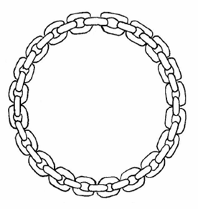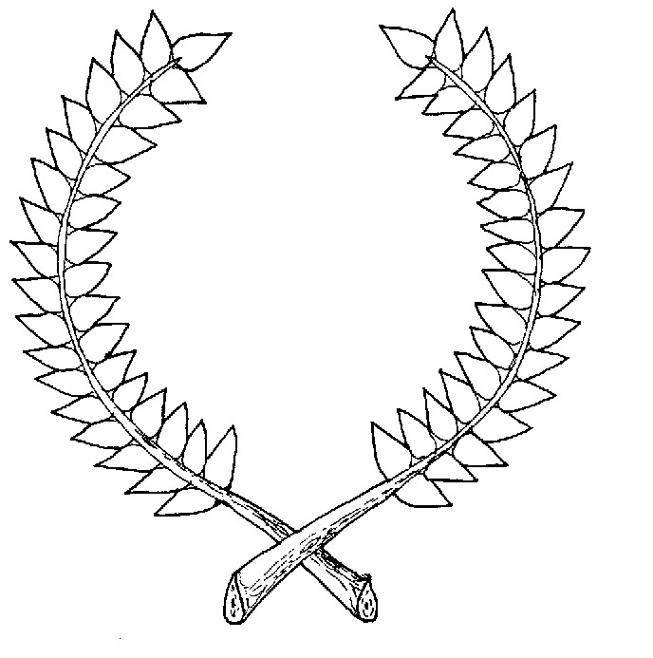
Other Awards

Court Baronage – The accolade of Court Baron or Court Baroness is given for exceptional service to the Crown and/or the kingdom and is a highly-prized award. Those who have served as Territorial Baronage receive this award upon completion of their tenure. The recipient of this award is addressed as “Your Excellency”.

Besides being a recognition of the work one has done within the SCA, being the recipient of one of the aforementioned awards gives you precedence. Precedence is the order of rank for ceremonial occasions. The higher the award you possess the higher the placement you have in ceremonies. In cases of equal rank, the recipient with the earliest date of receiving is placed first. In cases of equal rank received on the same day, alphabetical placement is used.
Non-armigerous Awards
There are some awards that convey no position in the Order of Precedence. The reason they hold no precedence is that they are special recognitions and fall outside the normal award structure. The following honors are this type of award:
Order of the Queen's Chalice: given to those young people who have provided service to the kingdom and its people above that normally expected of them.
Order of the Keeper of the Flame: given to those who through their appearance, actions and deeds demonstrate an exceptional amount of honor and courtesy, and exemplify themselves in efforts to create a medieval aura. This award may be bestowed only once per reign. Companions of the order may place "Keeper of the Flame" after their name and may bear the order's badge.
Order of the Sword of Calontir: given to those individuals or groups who have performed dramatic deeds concerning the art and science of combat, strategy, tactics and/or Society warfare.




Queen's Endorsement of Distinction (QED): the Queen of Calontir bestows this recognition upon three individuals who have come to her notice during her reign; once in each of these categories:
1. Unto the individual combatant or archer who has shown the highest of chivalric behavior.
2. Unto the individual who has best exemplified gentle and courteous behavior.
3. Unto the individual who best exemplified the ideals and goals of the Society.
King's Favor: given at the discretion of the King for personal service to himself or to the Crown. The traditional token is a ring from the King's hand.
Order of the Rose: automatically bestowed upon all consorts who have successfully completed their reign, after their investiture in the County rank. Members may style themselves as Companions of the Rose.

This Page Intentionally Left Blank
Award Recs: What They Are, Why They Are Done and How To Do Them
by Modar Neznanich
What is an Award Recommendation?
A simple definition of a kingdom award rec would be: A letter to the Crown of your kingdom recommending that someone be recognized for their efforts with an award.
Why Do an Award Recommendation?
Because it is a responsibility. And because it is an opportunity. As a participating member of the SCA, you have both the right and responsibility to let the Crown know of individuals who are doing exemplary work in a craft, skill or service. The reason we have this responsibility is because the Crown cannot be everywhere at once, cannot see everything that everyone is doing. We as members of the Populace have the opportunity to inform the Crown of the activities of our fellow gentles and the reasons they deserve recognition.
You can recommend anyone for ANY award, including a Peerage. You do not have to possess that award or have any award at all to recommend others for awards.
Why Deserving People Sometimes Get Skipped
If the Crown doesn’t see the activities a person is doing and doesn’t get award recs for the person, that person will not be recognized for their efforts. And this has happened to a lot of gentles over the years. Why?
1. They work quietly in the background, doing everything from kitchen scut-work to event clean-ups for a long time. This amount of selfless effort and work deserves acknowledgement, but because they were always in the background, the Crown did not see them to know they needed recognition.
2. Everyone thinks they already have the award. Sometimes people “slip through the cracks”. They are known for doing stuff for so long that everyone assumes they have already received an award. This is the reason we should always check to make sure that folks we see doing things do indeed have awards worthy of their efforts.
3. Folks think that someone else will put the person in for an award, so they don’t need to send an award rec in for them. The result is that no award rec is ever sent in because everyone is sure that someone else is already doing it. Don’t make this assumption…go ahead and write an award rec. It never hurts a person to have another award rec sent in about them.
How Does One Do an Award Recommendation?
There are basically three steps to this. First, you must determine who you want to recommend for an award. Second, you must determine what type of award they should be recommended for and if they have the award already or not. Third, you need to write the award rec.
Step one is fairly easy. Any gentle you see involved in constructive activities within the SCA is either deserving of an award or working toward deserving an award. When you note someone you feel deserves recognition for their skills or service, find out what their name is and where they are from. If they are from your local group this is easily done, as you most likely already know them. If they are from another group you may have to make inquiries either of them or of others who know them.
Step two is also easy. The best way to determine what awards a person has is to check the Kingdom Order of Precedence (OP). Most kingdoms now have their OP on-line, usually connected to the Kingdom Heralds webpage. The Calontir OP currently is located on-line at: http://calontir.sca.org/herald/op/index.html The quickest means of using this is to do a name search. Clicking on the Name Search link takes you to a search engine page. To use the search engine, simply type in the person’s SCA name (no titles) and click on the Search button. It will then present a list of people with that name and what awards they have. Other means of determining what awards a person has include speaking with the person’s local herald, the person’s friends or significant other. Usually they will know what awards a person has.
Now comes the task of determining what award to recommend the person for. Knowing what award the person should be recommended for will come easier over time as you advance in rank yourself and gain awards. However, anyone can check the on-line article Etcetera - the Kingdom of Calontir by Jessa d'Avondale at http://www.pbm.com/~lindahl/jessa/calontir.html for information on AoA level awards, Grant level awards and other Calontir specific awards. For information on the Peerage awards, as well as additional information on what is usually expected in order to receive Calontir awards, go to the on-line article
Living in the SCA by Thoman Shadan Secarius at: http://calontir.sca.org/herald/award-intro.html
A quick breakdown of the Calontir awards you might recommend someone for:
Award of Arms |  | - |  | recognition of service and/or promise in any of the Arts, Sciences, Fighting or Archery
Torse |  | - |  | continued service to the local group, Kingdom and/or Society
Golden Calon Swan |  | - |  | accomplishment in the arts
Leather Mallet |  | - |  | accomplishment in the sciences
Iren-Fyrd |  | - |  | accomplishment as a fighter
Boga-Fyrd |  | - |  | accomplishment as an archer
 |  | -
Grant of Arms, Simple |  | - |  | non-specific and/or wide-variety of service to the Kingdom
Cross of Calontir |  | - |  | continued and extensive service to the Kingdom and/or Society
Calon Lily |  | - |  | high accomplishment in the arts
Silver Hammer |  | - |  | high accomplishment in the sciences
Iren-Hirth |  | - |  | high accomplishment as a fighter
Boga-Hirth |  | - |  | high accomplishment as an archer
 |  | -
Pelican |  | - |  | mastery in the field of service to the Kingdom and/or Society
Laurel |  | - |  | mastery of an art or science
Chivalry |  | - |  | mastery at armed combat
 |  | -
Queen’s Chalice |  | - |  | for younger SCA members in recognition of service above that normally expected of them
Keeper of the Flame |  | - |  | demonstrates exceptional honor, courtesy and exemplary efforts in creating a medieval aura
Sword of Calontir |  | - |  | dramatic deed of combat or military science
Court Baron (ess) |  | - |  | exceptional service to the Kingdom; only given about once per reign
 | - | - | -
Step three is the actual writing of the award rec. Perhaps not the easiest part, but still relatively simple to do. Most kingdoms now have an on-line award rec webpage where you can fill out the recommendation and send it electronically. The on-line Calontir Award Rec webpage is at: http://www.calontir.info/award/index.html You can also send an award rec to the Crown via e-mail or by regular mail. (Check your kingdom newsletter for blank award rec forms to photocopy and the address to send the award recs to.) But no matter what means you use to send the recommendation to the Crown, there is key information that needs to be supplied on the award rec. This includes these 12 things:
1. | Name of the award being recommended
2. | Area of Endeavor/Reason for award being recommended (i.e. service, leatherwork, fighting, research, heraldry, etc.)
3. | SCA name of person being recommended
4. | Gender of person being recommended
5. | Local group of person being recommended (if at all possible)
6. | Modern name of person being recommended (if at all possible)
7. | Modern address of person being recommended (if at all possible)
8. | Events the person being recommended will be attending in the future (if at all possible)
9. | Your SCA name (as the recommender)
10. | Your SCA group
11. | Your contact info (phone and/or mailing address and/or e-mail address)
12. | Explanation of why the person deserves the award.
.
If you are not using one of the on-line forms that prompt you where to insert what information, write your recommendation in a structured manner so it is easy for the Crown to understand who you are recommending and what you are recommending them for. A sample award rec letter follows:
............................................................
Unto Their Royal Majesties of Calontir, <King's name> and <Queen's name>
From <your name>
Greetings.
I am writing this letter to bring to your attention someone I believe is deserving of a(n) <name of award>.
This person’s SCA name is <person’s SCA name> and his/her modern name is <person’s modern name>.
He/She lives in <name of person’s SCA group>.
I believe they deserve this award because <give information on why this person deserves the award you are recommending them for. Be specific/detailed and give as many examples of their skills, service, etc. as possible. If you are recommending the person for an Arts or Sciences award, try to include information on the degree of the person’s skill, what classes they teach or one-on-one teaching they do of their art, note if they have published articles in any SCA newsletters or on any webpages>.
He/She has been in the SCA for <length of person’s time in the SCA> and demonstrates the type of activity deserving of recognition.
I think they will be attending the following events <list upcoming events the recommended person may be attending>.
<Signature>
<Your SCA Name>
<Your modern name>
<Your address>
<Your phone number & e-mail address (if applicable)>
<Your SCA group’s name>
.............................................................
Notes on Writing Award Recs
Write one letter per person per award rec. Don’t send a letter for multiple people to get an Award of Arms. Send a separate award rec for each person. Don’t recommend the same person for multiple awards on the same award rec. If you feel they are deserving of more than one award, then send a separate award rec for each award, even though it’s for the same person. (The Crown will need to separate award recs out into individual recommendations.)
Each person who wants to recommend someone should send in a separate award rec. Separate award recs show the Crown that there is support for this person because people have taken the time to write individual award recs. Several people signing one award rec gives the impression that people are willing to sign off on it, but it’s not important enough to the people to write one of their own.
Type or neatly write. Do not use calligraphy. Communicate in clear plain English. Don’t speak foresoothly or with flowery speech.
Find out what name the recipient uses and how to spell it. If they go by a nickname or shortened version of their registered name, be sure to give both names in the award rec. The Crown may know the person by their nickname but not their full name. If the person is from another group but you don’t have their full name, be sure to include what group they are from.
The higher the award you are recommending the person for, the more examples you should cite of the person’s work. Talk with others about the person to find out details and information.
Indicate how long the individual being recommended has been in the SCA.
Detail the accomplishments, offices and other factors that cause you to believe this person should be recognized. What have they done and for how long? How many people have been affected by this person’s deeds?
Realize that people can be deserving of awards because they have contributed to the SCA in many small ways over time. Don't overlook ways in which they have been helpful. Also remember that if the person has come into your area from an outside branch or another kingdom, you may need to research what they have done prior to you having met them.
Keep a copy of the award rec for yourself, in case you need to re-send it, or to use as an example for other award recs.
Some Award Rec Etiquette
While it is important that we make sure all deserving individuals receive recognition for their efforts, there are some things to be aware of. Now, while these things may see pretty obvious, it is surprising what has occurred over the years.
1. Do not put an award rec in for yourself.
2. Do not put an award rec in for your significant other.
3. Do not put an award rec in for the Crown (wait until after they step down).

I Sent in an Award Rec, But the Person Didn’t Get the Award. Why?
Many times someone says they sent the Crown an award rec for a person but that the recommended person didn’t get the award. And the person who sent the award rec in wants to know why or how this happened. There are several reasons that may contribute to this.
1. The Crown usually likes to receive more than one letter so They can get confirmation on the recommended person’s achievements. Did the recommending person see an isolated occurrence or is there a “history” of the recommended person’s skill and/or activity level? The more letters the Crown receives about a deserving person, the better…so this is why it’s important that each of us do our part to send in award recs.
2. Some awards come from Polling Orders. This means the members of the Order for that particular award are polled by the Crown to get the members’ opinion of the recommended person’s skill and activity level. If there is some concern about the recommend person (such as needing to teach classes, travel more, etc.) then the Order may suggest to the Crown that They wait to bestow the award. In such cases, members of the Order tend to seek out the recommended individual and encourage them to do what is needed to overcome any concerns brought up.
3. The Polling Order did not have enough members at the meeting to form a consensus for the Crown concerning the recommended person. If this is the case, then the recommended person will be discussed at the next meeting of the Order…but this could be some months later.
4. The recommended person did not show up at any courts where the award could be presented. The Crown always prefers to present an award to the recommended person Themselves. When the recommended person never shows at a court, then things can get problematic. If the award is a first-level award (Award of Arms, Leather Mallet, Golden Calon Swan, Torse, etc.) the Crown *may* decide to allow someone else to accept the scroll on behalf of the recommended person. It would be extremely rare that the Crown would present a Grant Level award “in abstentia”, and doubtful that a Patent Level award would ever be given without the recommended person being present.
5. Not enough time has passed since the recommended person’s last award. Many times the Crown likes to “space out” awards for individuals. This is done so the individual has time to enjoy and appreciate the award they have received before another award is bestowed. This also helps prevent someone from getting multiple awards in a very short period of time, then going for a LONG time without any more awards and thus becoming disheartened. It also helps prevent someone from “topping out”; that is getting all the awards possible early in their SCA career and never getting any other recognition in court.
6. The award rec did not have all of the information the Crown needed to make a determination on the award. If there is no complete name information for the person being recommended or only one example of their work is mentioned or you forget to identify yourself as the recommender, then most likely the award rec will be considered invalid and not acted upon.
If you feel someone deserves an award, you sent an award rec in and they did not get the award, resend the award rec during the reign of the next Crown.

What *is* an Award?
An award is NOT a merit badge. It is a symbol of the level of skill one has achieved in an activity or the level of service one has given. But it is not meant to be a reward for an activity that one has finished. It’s a recognition of the level one has achieved and there is the expectation that the level will be maintained with the hope that the recipient will advance farther. With the top level awards, it is expected that the recipient will not only maintain the level of service, skill and activity that earned them the award, but that they will pass on to others their knowledge and be an example for others to emulate.
How to Create an Order of Precedence
by Modar Neznanich
What is an Order of Precedence?
An Order of Precedence (O.P.) is a listing of individuals and the awards they have received.
What is the purpose of an Order of Precedence?
An O.P. is a tool that can be used to establish the correct March of Precedence for ceremonies (such as calling forth the entrants in Crown Tourney and other pageantries), to help folks determine who to write an award recommendation for (by being able to find what awards someone does and does not have) and help the kingdom keep their recordkeeping in order (by having the award data available for individuals to validate).
How does someone create an Order of Precedence?
There is no one “true way” to create an O.P. When starting to create an O.P. for a group, household, etc. there are several factors to consider:
I. Method of display
II. Information to include
III. Date format to use
IV. Use of abbreviations
I. Method of Display
This is how you want the information in the precedence to look. There are different means of doing this, but there are three basic styles: A) Alphabetical Order, B) Rank Order and C) Award Listing Order.
A. Alphabetical Order
This format lists individuals in alphabetical order of their SCA name. The advantage of this style of listing is that it is easy to determine where a person should be placed in the listing. It also provides a resource for quickly determining whether a gentle in your group has received and award lately. A couple of examples for doing an alphabetical listing follow. NOTE: All names used are fictitious.
Example 1:
Anne of Green Gables (Anne Smith)
Torse (04/11/2002); Award of Arms (07/01/1999)
Beatrice Delbimbo (Sharon Williams)
Torse (08/12/1998); Award of Arms (12/12/1996)
Colyne MacLean (Ralph Johnson)
Leather Mallet (08/14/1997); Award of Arms (02/16/1995)
David the Scout (Donald Drake)
Golden Calon Swan (10/13/2003); Award of Arms (11/26/1997)
Edward Longridge (James Jackson)
Chivalry (05/22/2001); Iren-Hirth (10/14/1997); Torse (05/18/1997); Iren-Fyrd (10/12/1996);
Boga-Fyrd (04/11/1994); Award of Arms (05/12/1992)
Giles of Blackwater (Thomas Knight)
Golden Calon Swan (01/01/2002); Cross of Calontir (03/03/2001); Iren-Hirth (02/10/01); Iren-Fyrd
(05/21/2000); Silver Hammer (07/17/1997); Leather Mallet (08/11/1997); Torse (10/10/1995); Award
of Arms (03/28/1988)
Stephen Whitebridge (Stan Jones)
Chivalry (04/20/2001); Iren-Hirth (1/12/1998); Iren-Fyrd (10/19/1996); Award of Arms (09/01/1992)

Example 2:
Anne of Green Gables (Anne Smith)
Torse (04/11/2002)
Award of Arms (07/01/1999)
Beatrice Delbimbo (Sharon Williams)
Torse (08/12/1998)
Award of Arms (12/12/1996)
Colyne MacLean (Ralph Johnson)
Leather Mallet (08/14/1997)
Award of Arms (02/16/1995)
David the Scout (Donald Drake)
Golden Calon Swan (10/13/2003)
Award of Arms (11/26/1997)
Edward Longridge (James Jackson)
Chivalry (05/22/2001)
Iren-Hirth (10/14/1997)
Torse (05/18/1997)
Iren-Fyrd (10/12/1996)
Boga-Fyrd (04/11/1994)
Award of Arms (05/12/1992)
Giles of Blackwater (Thomas Knight)
Golden Calon Swan (01/01/2002)
Cross of Calontir (03/03/2001)
Iren-Hirth (02/10/2001)
Iren-Fyrd (05/21/2000)
Silver Hammer (07/17/1997)
Leather Mallet (08/11/1997)
Torse (10/10/1995)
Award of Arms (03/28/1988)
Stephen Whitebridge (Stan Jones)
Chivalry (04/20/2001)
Iren-Hirth (01/12/1998)
Iren-Fyrd (10/19/1996)
Award of Arms (09/01/1992)

B. Rank Order
This format is what most people think of when the term Order of Precedence is discussed. It lists individuals according to their highest award and the date upon which it was given. Considered by many to be the most historical form of precedence listing, its advantage is that you can quickly identify those members of your group who have received the highest recognition.
The basic formula for rank order lists are:
1. Each person is listed according to the highest award they have received.
2. If multiple people have received the same award, list the gentle who received it at the earliest date, first.
3. If several people received the same award on the same day, list them alphabetically within the same
ranking. (Not by who was called into court first.)
4. Two (or more) of the same level award do NOT rank someone above anyone else of that same level with
only one award. They are listed where the date of the first award of that level places them.
A couple of examples for doing a rank listing follow. In these examples, awards in the entries are listed in chronological order from most recent to oldest. Awards could also be listed from highest award to lowest award, if desired. NOTE: All names used are fictitious.
Example 1:
Stephen Whitebridge (Stan Jones)
Chivalry (04/20/2001); Iren-Hirth (1/12/1998); Iren-Fyrd (10/19/1996); Award of Arms (09/01/1992)
Edward Longridge (James Jackson)
Chivalry (05/22/2001); Iren-Hirth (10/14/1997); Torse (05/18/1997); Iren-Fyrd (10/12/1996);
Boga-Fyrd (04/11/1994); Award of Arms (05/12/1992)
Giles of Blackwater (Thomas Knight)
Golden Calon Swan (01/01/2002); Cross of Calontir (03/03/2001); Iren-Hirth (02/10/01); Iren-Fyrd
(05/21/2000); Silver Hammer (07/17/1997); Leather Mallet (08/11/1997); Torse (10/10/1995); Award
of Arms (03/28/1988)
Colyne MacLean (Ralph Johnson)
Leather Mallet (08/14/1997); Award of Arms (02/16/1995)
Beatrice Delbimbo (Sharon Williams)
Torse (08/12/1998); Award of Arms (12/12/1996)
Anne of Green Gables (Anne Smith)
Torse (04/11/2002); Award of Arms (07/01/1999)
David the Scout (Donald Drake)
Golden Calon Swan (10/13/2003); Award of Arms (11/26/1997)
Example 2:
Stephen Whitebridge (Stan Jones)
Chivalry (04/20/2001)
Iren-Hirth (01/12/1998)
Iren-Fyrd (10/19/1996)
Award of Arms (09/01/1992)
Edward Longridge (James Jackson)
Chivalry (05/22/2001)
Iren-Hirth (10/14/1997)
Torse (05/18/1997)
Iren-Fyrd (10/12/1996)
Boga-Fyrd (04/11/1994)
Award of Arms (05/12/1992)
Giles of Blackwater (Thomas Knight)
Golden Calon Swan (01/01/2002)
Cross of Calontir (03/03/2001)
Iren-Hirth (02/10/2001)
Iren-Fyrd (05/21/2000)
Silver Hammer (07/17/1997)
Leather Mallet (08/11/1997)
Torse (10/10/1995)
Award of Arms (03/28/1988)
Colyne MacLean (Ralph Johnson)
Leather Mallet (08/14/1997)
Award of Arms (02/16/1995)
Beatrice Delbimbo (Sharon Williams)
Torse (08/12/1998)
Award of Arms (12/12/1996)
Anne of Green Gables (Anne Smith)
Torse (04/11/2002)
Award of Arms (07/01/1999)
David the Scout (Donald Drake)
Golden Calon Swan (10/13/2003)
Award of Arms (11/26/1997)
In the examples above, Sir Stephen was knighted before Sir Edward, so Sir Stephen has higher precedence than Sir Edward, even though Sir Edward has more awards than Sir Stephan. Award level takes precedence over number of awards.
C. Award Listing Order
This format lists the awards by name in order of the awards rank/level. Underneath each award name, the recipients are listed. The advantages of this method are that you can put in a brief explanation of what each award is given for and it is easy to determine who the members of a particular award order are.
Under each award, the recipients may be listed either alphabetically or in order of the date they received the award. A couple of examples for doing an award order listing follow. NOTE: All names used are fictitious.
Example 1: Alphabetical
Order of the Torse [Given for service to group, office or kingdom]
Anne of Green Gables (Anne Smith) 04/11/2002
Beatrice Delbimbo (Sharon Williams) 08/12/1998
Edward Longridge (James Jackson) 05/18/1997
Giles of Blackwater (Thomas Knight) 10/10/1995
Example 2: By date of award
Order of the Torse [Given for service to group, office or kingdom]
Giles of Blackwater (Thomas Knight) 10/10/1995
Edward Longridge (James Jackson) 05/18/1997
Beatrice Delbimbo (Sharon Williams) 08/12/1998
Anne of Green Gables (Anne Smith) 04/11/2002
When a listing is put together in a format that first notes the names of award recipients then the award titles (such as the Alphabetical Order does), this is generally called a "Who's Who". Some places also refer to this as "Awards by Recipient Name". Some places consider this a type of O.P. and some places do not, viewing it only as a "Grand List of the Populace".
When a listing is put together in a format that lists the individuals in order of highest awards to lowest awards (such as the Rank Order does), it is considered a "pure O.P." because at a glance you know who has the greatest precedence, then who follows whom. This is the only format that all places consider to be a true O.P.
When a listing is put together in a format that first notes the awards then places the recipient names under that award (such as the Award Listing Order does), it is generally referred to as a "Book of Lists". Some places also refer to this as "Recipients by Award Name". Technically this is not a "true O.P." because it is not providing the complete award and rank rating of the individuals but merely the lineage of a particular award.

II. Information to include
What info you wish to include in your Order of Precedence will depend on what you wish to use the O.P. for, how compact space-wise you need to have the O.P. and local custom. The most basic precedence information consists of the person's SCA name, awards they have received and the date of the award. After that, it’s up to you. However, the more info that is provided, the more uses the O.P. can have. Some additional information to consider including:
A. Modern name. This creates a cross-reference that can help keep any confusion between gentles clear, particularly if the Kingdom Office receives information on different gentles who might accidentally be using the same name.
i.e. Giles of Blackwater (Thomas Knight)
B. Titles such as Lord, Lady, His Lordship, Baron, etc. However, if you do include titles, do NOT list titles in front of names when making an O.P. This makes it more difficult to quickly scan a listing. If you want to include titles, put them on a separate line or following the name.
i.e. Giles of Blackwater, His Lordship (Thomas Knight)
C. Reason the person received the award (service, leatherwork, archery, etc). This helps to locate folks with similar interests.
i.e. Giles of Blackwater (Thomas Knight) Golden Calon Swan (01/01/2002) <for Calligraphy>
D. Former SCA names. This can keep confusion from happening over whether a gentle has an award or not.
i.e. Giles of Blackwater (Thomas Knight) <formerly Ed the Unruly>
E. Blazon of registered heraldic device. This is helpful for folk who want to “do something heraldic” for a friend and need a source for what their heraldry is. It can possibly also help determine who may need heraldic assistance.
i.e. Giles of Blackwater (Thomas Knight)
Golden Calon Swan (01/01/2002)
Award of Arms (03/28/1988)
Heraldic Device: Argent, in pale three swords bendwise gules.
If you added everything, an entry in the listing might look something like:
Giles of Blackwater, His Lordship (Thomas Knight) <formerly Ed the Unruly>
Golden Calon Swan (01/01/2002) <for calligraphy>
Cross of Calontir (03/03/2001) <for extended service>
Iren-Hirth (02/10/2001) <for leadership at wars>
Iren-Fyrd (05/21/2000) <for fighting skill>
Silver Hammer (07/17/1997) <for skill in cooking>
Leather Mallet (08/11/1997) <for promise in cooking>
Torse (10/10/1995) <for continued service>
Award of Arms (03/28/1988) <for service to group>
Heraldic Device: Argent, in pale three swords bendwise gules.
III. Date format to use
There are different manners in which the dates used in an O.P. may be displayed. Dates may be numeric in various formats including: month/day/2-digit year, month/day/4-digit year, 4-digit year/month/day, etc. or alphanumeric with the month spelled out. Some prefer to list the date first then the award (to make easier sorting by date), others like to list the award first, then the date. It really doesn’t matter which style is used, so long as it is used consistently throughout the O.P.

IV. Use of abbreviations
Some prefer to spell out the award names in an O.P. Others prefer to abbreviate the names to save space. (But if you do use abbreviations, put a record of what the abbreviations stand for at the beginning of your listing.) Either way is fine; simply stay consistent throughout the O.P. The abbreviations for Calontir awards are:

Armigerous Awards Abbreviation
Counts/Countess County
Court Baron/Court Baroness No abbreviation
Duke/Duchess Duchy
Order of the Boga-Fyrd Boga-Fyrd
Order of the Boga-Hirth Boga-Hirth
Order of the Calon Lily OCL
Order of the Chivalry – Knight KSCA
Order of the Chivalry – Master of Arms MSCA
Order of the Cross of Calontir OCC or Cross
Order of the Golden Calon Swan OGCS or Swan
Order of the Iren-Fyrd Iren-Fyrd
Order of the Iren-Hirth Iren-Hirth
Order of the Laurel Laurel
Order of the Leather Mallet OLM or Leather Mallet
Order of the Pelican Pelican
Order of the Rose Rose
Order of the Silver Hammer OSH or Silver Hammer
Order of the Torse OT or Torse
Simple Awards of Arms AoA
Simple Grants of Arms GoA
Territorial Baron/Territorial Baroness No abbreviation
Viscount/Viscountess Viscounty
Non-Armigerous Awards Abbreviation
Augmentation of Arms Augmentation
Order of the Keeper of the Flame Keeper of the Flame
Order of the Queen's Chalice OQC
Order of the Sword of Calontir OSC
The following recognitions convey no position in the Order of Precedence, but should be recorded:
King’s Favor No abbreviation
Queen's Endorsement of Distinction Q.E.D.
Thegns of Calontir (former) Thegn (King or Queen's name)
Listing Order
Who goes where? While you should list all the awards an individual has (even the non-armigerous ones), you still need to determine where those awards put the people in the listing. Following is the ranking of the armigerous awards that determine where an individual is placed, based on the date of receiving the award. The awards listed in each line are equal to the others on that line.
1. Duke / Duchess
2. Counts / Countess / Order of the Rose
3. Viscount / Viscountess
4. Knight / Master of Arms / Laurel / Pelican
5. Territorial Baron / Territorial Baroness
6. Boga-Hirth / Calon Lily / Cross of Calontir / Iren-Hirth / Silver Hammer / Foreign GoA-bearing Awards
7. Simple Grants of Arms
8. Court Baron / Court Baroness
9. Boga-Fyrd / Golden Calon Swan / Iren-Fyrd / Leather Mallet / Torse / Foreign AoA-bearing Awards
10. Simple Awards of Arms
Foreign Awards
This refers to awards individuals have received from kingdoms other than your own. How such awards are handled can vary from kingdom to kingdom. In Calontir, the method for inclusion of foreign awards is to place them in the award listing by date received, just as if they were Calontir awards.
Who to List
A precedence list is used to keep track of members and to recognize the accomplishments of those who have contributed to your group. It is normally recommended that you list everyone currently active in your group, even if they haven't received an SCA award yet. Some people suggest that you also include everyone who has ever resided in the group, even if they no longer live there. However, more common convention is to keep two Order of Precedence lists; one that is the group's Current Order of Precedence and one that is the group's Historical Order of Precedence. The Current O.P. lists just the individuals currently active in your group. This one will get the most use, as you will use it for helping to determine who needs to have award recs written for them, to plan any March of Precedence your group wants to do, etc. The Historical O.P. should have a listing for everyone who has been an active part of your group at some point. If you want, you can use symbols or notes in this historical listing to signify if a person has moved out of your group, stopped playing in the SCA or is deceased. An example of how these entries might be done is:
Cecily MacFarlane (Sally Johnson) [now plays in Barony of Seven Wonders]
Leather Mallet (08/14/1997)
Award of Arms (02/16/1995)
John de Loch (John Williams) [moved, status unknown]
Torse (08/12/1998)
Award of Arms (12/12/1996)
Anne of Westmoreland (Anne Jones) [deceased]
Torse (04/11/2002)
Award of Arms (07/01/1999)
Raymond the Tall (Ronald Smith) [moved, now in Kingdom of Ansteorra]
Award of Arms (06/01/2003)
Getting Award Information
When you are ready to start creating your group’s Order of Precedence, first check to see if your kingdom has an on-line version of an O.P. If so, start by copying from there the information on your members. If there is not an on-line O.P. or if you do not have access to it, start instead by creating a list of all the members of your group, then put in what information you know. This is your working copy of the O.P. Take it to your members, asking them to update their entries. Once this is done, you should have an up-to-date Order of Precedence. Currently the Calontir Order of Precedence is on-line at: http://calontir.sca.org/herald/op/index.html
Updating
One thing you have to be aware of, almost as soon as you complete your O.P. it will be out of date. Things are constantly changing. Gentles change their SCA name or get an award. Folks are joining or leaving the SCA. All sorts of changes occur, so you will need to constantly update the O.P. to keep the information accurate. If you are the “Keeper of the O.P.” for your group but you are not the local herald, please be sure they get a copy of the O.P. when it is updated.
As the kingdom has an on-line version of the Kingdom Order of Precedence, be sure to regularly check your own group O.P. against the kingdom O.P. to see if there are any discrepancies. If some are found, please report the information to the Kingdom Clerk of the Precedence.
Section XIV

Silent Heraldry

This Page Intentionally Left Blank

Silent Heraldry: Introduction
by Suzanne de la Ferté

Lesson 1: Introducing Silent Heraldry
Silent Heraldry is sign language used in the SCA environment. While we are signers, very few of us are certified interpreters, but all of us share the desire to open up the wonderful world of the SCA to the hearing impaired.

History of Sign Language
In the 15th century, Rudolphus Agricola (1443 – 1485), wrote “De Inventione Dialectica” as a result in his interest in the deaf. He wrote that a person who is born deaf can express himself by putting down his thoughts in writing. The book was not published until the 16th century.

In the 16th century, Girolamo Cardano (1501 – 1576), was an Italian physician concerned about his deaf child. Cardano read and agreed with Agricola’s book and also believed that the deaf need to learn to read and write. Cardano invented some kind of code for teaching, but did not pursue it.

Also in the 16th century, Pedro Ponce De Leon (1520 – 1584), a Catholic monk, established the world’s first school for the deaf at the Monastery of San Salvador near Madrid, Spain. He taught his deaf students first to write, while showing them with his finger the object named by the written characters, then drilling them to repeat with the vocal organs, the words which correspond to the characters.

In the 17th century, Juan Pablo Bonet (1579 – 1620), published his famous book “Simplification of Sounds and the Act of Teaching the Deaf to Speak”. He believed that deaf-mute should be forced to learn the one-handed manual alphabet using pictures illustrating the position of the hand for each letter before learning to speak and lipreading.

Also in the 17th century, John Bulwer (1614 – 1684), an English physician who published two books, “The Natural Language of the Hand” and “The Art of Making Manual Rhetoric”. He was convinced that the “language of the hand” was the “one language that was natural in all men, especially for the deafened in the use of the manual alphabet. He also published “The Deaf and Dumb Man’s Friend”, the first English book to explain the subject of deafness and its accompanying language problems.

In the 17th century, George Dalgarno, (? – 1687), published a book entitled “The Deaf and Dumb Man’s Tutor”. In this book, he had many theories about methods for teaching to the deaf. He knew that the deaf could be taught to speak and lipread, but thought that using the manual alphabet was more adviseable.

In the late 17th century, Johamn Konrad Ammon (1698 – 1774), was a doctor of medicine, but was interested in trying to educate deaf mutes. He only worked on youths between 8 and 15 years of age. He published two books, one in 1692 (written in Latin) and the other in 1700 called “A Dissertation Speech”.

In 1755, Abbe Charles Michel de l’Epee of Paris founded the first free school for the deaf. He taught that deaf people could develop communication with themselves and the hearing world through a system of conventional gestures, hand signs, and finger spelling. The abbe took signs that were already being used by a group of deaf people in Paris and standardized them which resulted in a signed version of spoken French.

In 1778, Samuel Heinicke of Leipzig, Germany, an educator who used speech and speech-reading instead of the manual method of communication, established the first public school for the deaf that achieved government recognition.

Abbe de l’Epee’s manual communication methods, along with Samuel Heinicke’s oral methods were the basis for today’s concept of total communication. Total communication encourages the use of all available means of communication – sign language, gesturing, finger-spelling, lip-reading, speech, hearing aids, reading, writing, and pictures.

About American Sign Language
The term “sign language” means different things to different people. Here in the United States, it can refer to Manually Coded English (MCE), Signed Exact English (SEE), or American Sign Language (ASL). MCE and SEE are structured similarly to spoken English. SEE is the sign language often used in an educational / teaching environment.

ASL is the sign language most deaf people use when they communicate with one another. ASL has its own rules, word order, and grammar. It also has its own slang expressions and dialects. The different ASL dialects correspond to the accents heard in spoken English. When a word does not have its own sign, ASL signers resort to the manual alphabet if they cannot find a sign for a word with a similar meaning to initialize (like the B handshape used with the “car” sign to create a new sign for the word “bus”).

Getting Attention and Basic Communication
Hearing people can call out to other hearing people to get their attention. Deaf people, on the other hand, normally wave rather than call. The size and intensity of the wave depend on how far away a person is. When a deaf person is facing away from you, you should gently tap his/her shoulder to get his/her attention.

When you want to communicate with a deaf person, but do not know how to sign, be sure to look into the other person’s eyes. Eye contact is extremely important. Sometimes, facial expression and body language alone are enough to convey a message.

Language
Because ASL is so visual, facial expression is of the utmost importance – it is the equivalent of your tone of voice. Facial expressions should be practiced. You can express many different sentiments, without even moving a hand, once you are able to express your thoughts through facial expression.

Movement
The simplest movement can alter a sign’s meaning. The direction of the sign can mean the difference between such opposite words as GIVER and RECEIVER. Repeating a sign can indicate the frequency of an action, or the number of items – whether the sign represents a noun or a verb. The size of a sign will generally relate to the size of the item.

Palm Orientation
It is important to notice in which direction a hand is turned. The words UP, DOWN, LEFT, and RIGHT are all signs in which the orientation is very important.

Use of Space
Draw an imaginary rectangle from the top of your head down to your waist, from one shoulder to the other. This is your signing space.

Person Indicator
The person indicator is made by putting both arms by your sides, palms facing inward, and then moving them downwards. When added to a root sign, the person indicator shows that you are referring to a person. It also makes the distinction between a noun and a verb. For example, the meaning of the LIBRARY sign, followed by the PERSON indicator, is LIBRARIAN.

Manual Alphabet
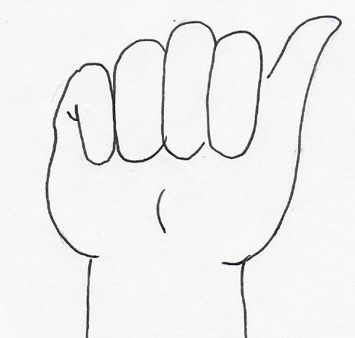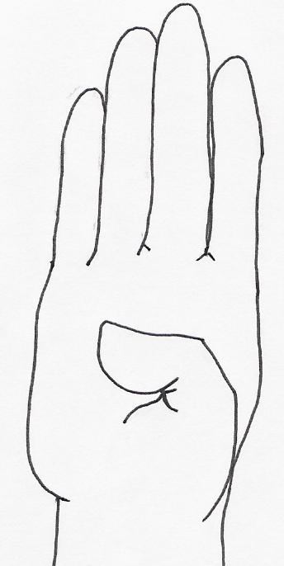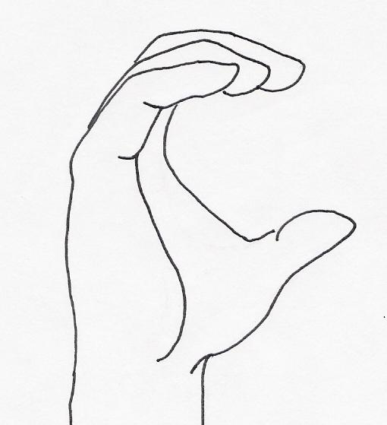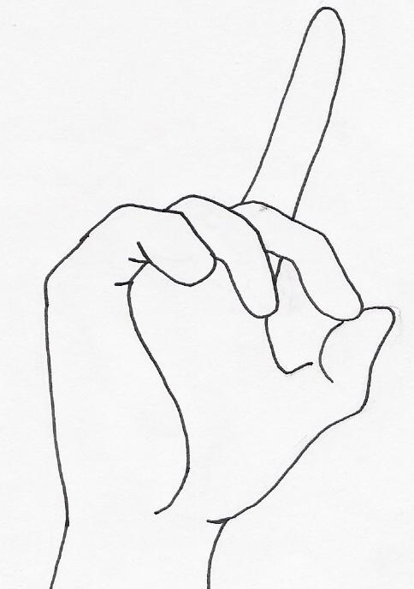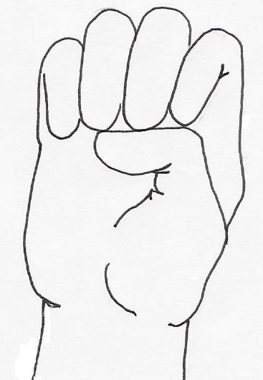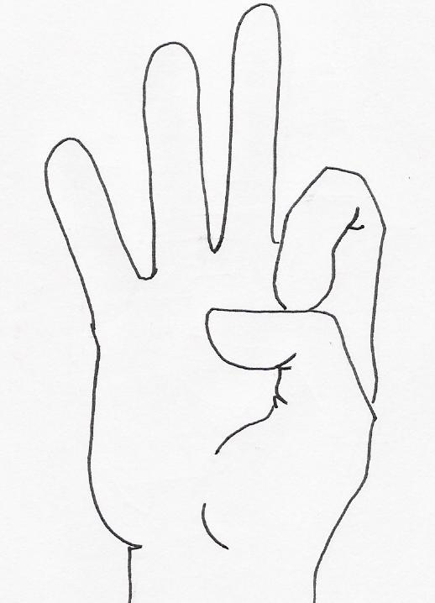
A B C D E F

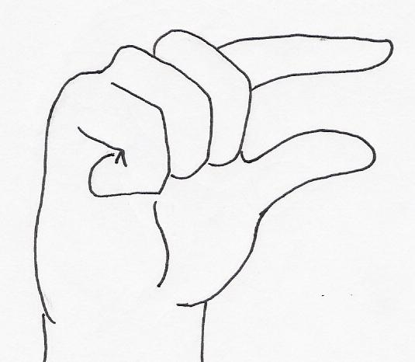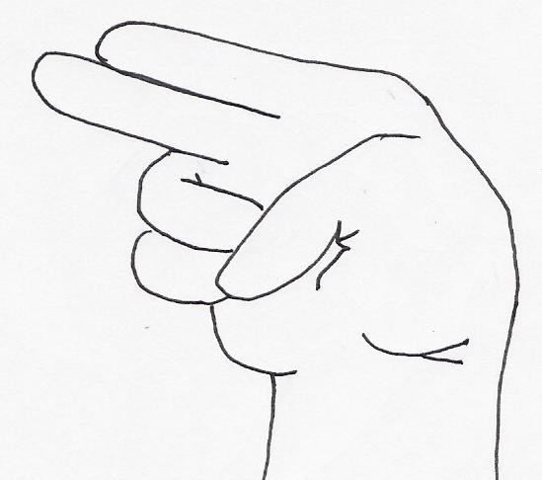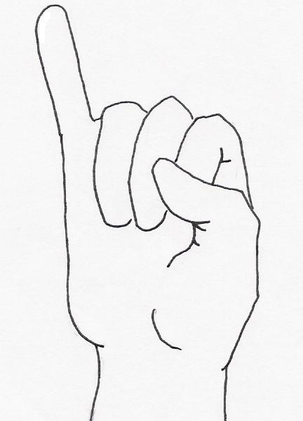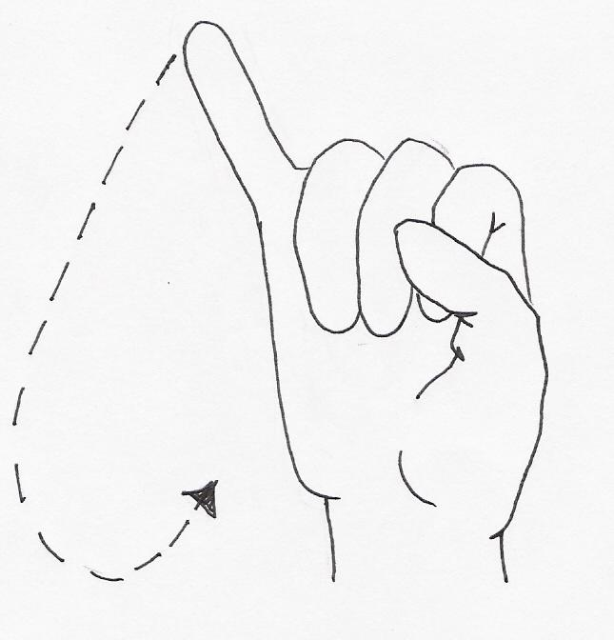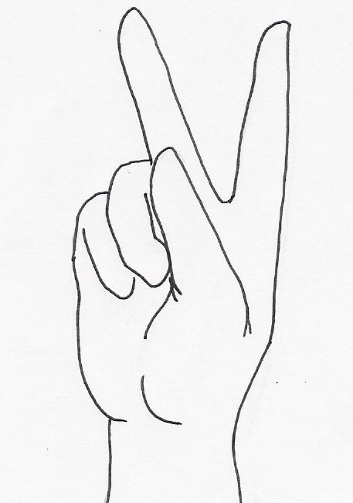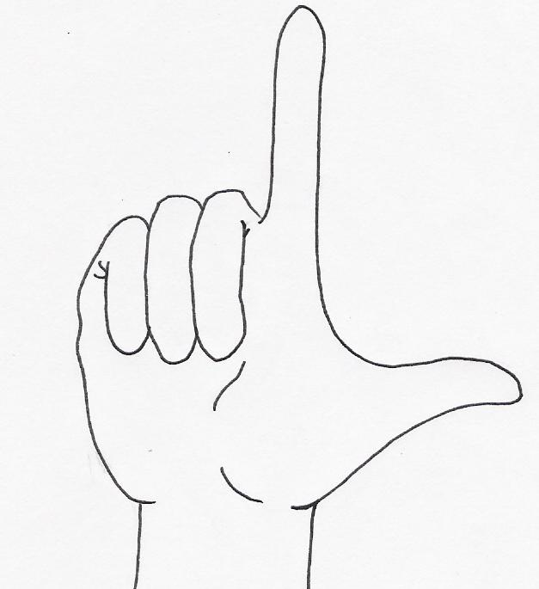
G H I J K L

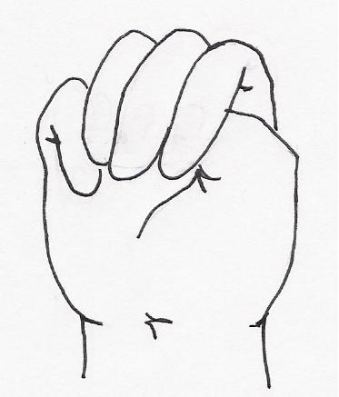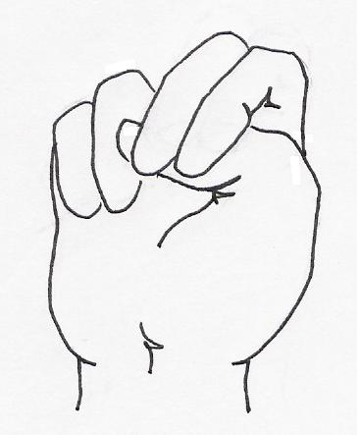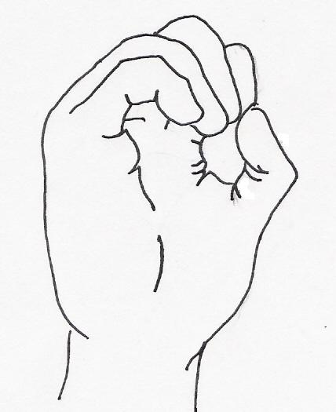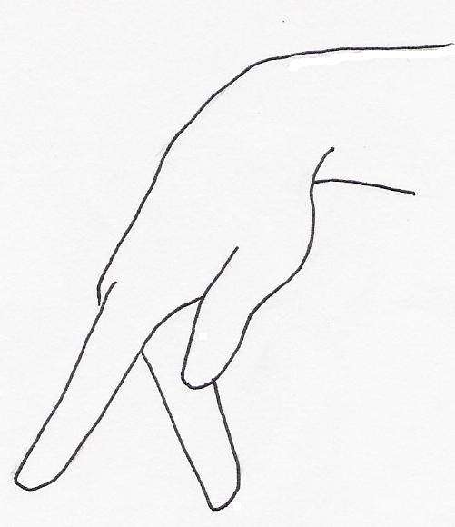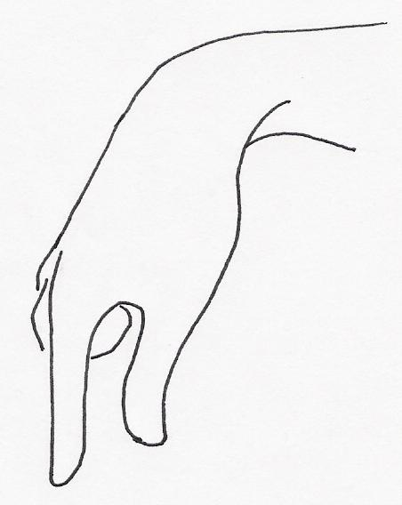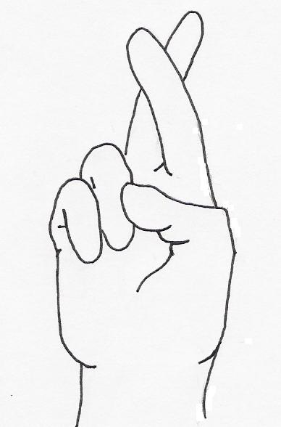
M N O P Q R

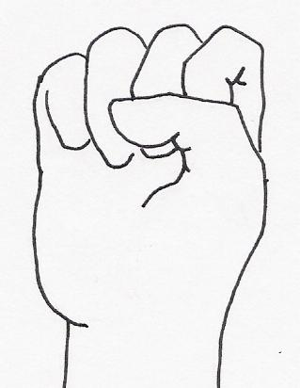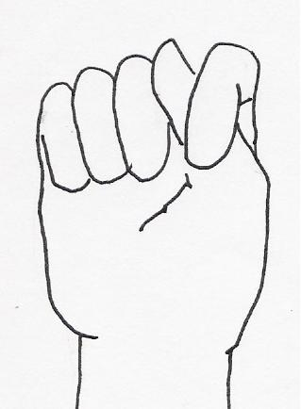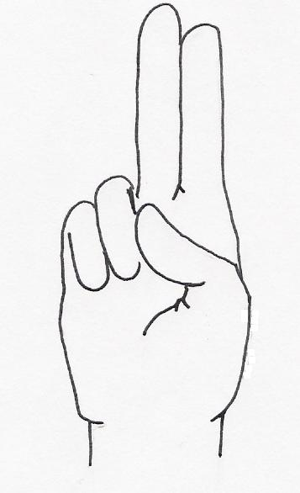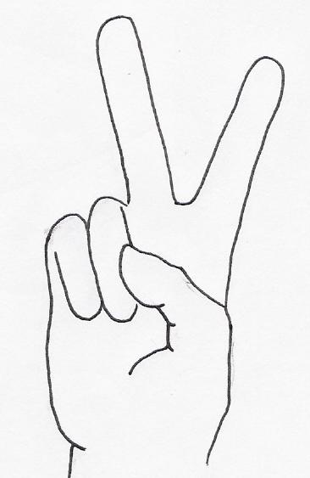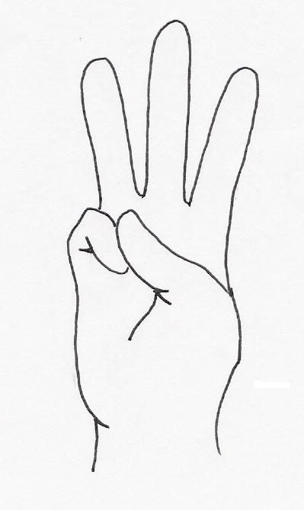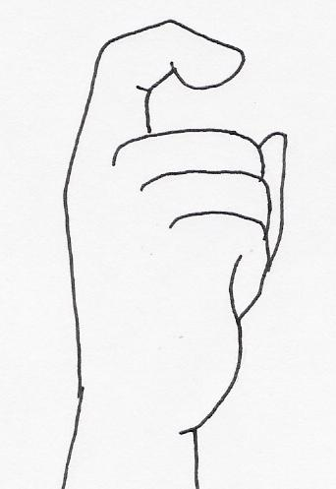
S T U V W X
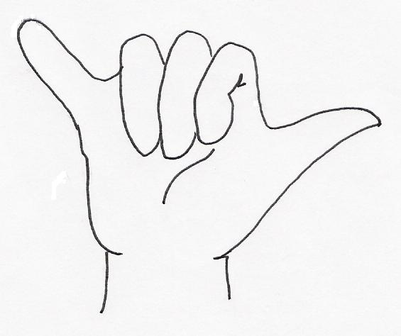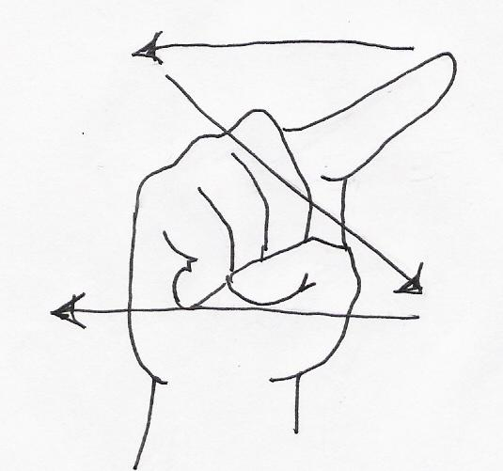
Y Z

Number Signs
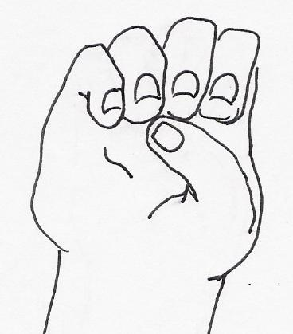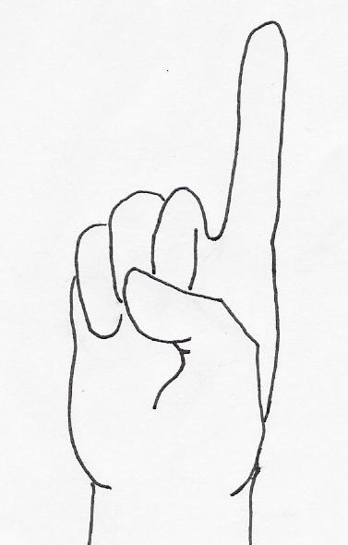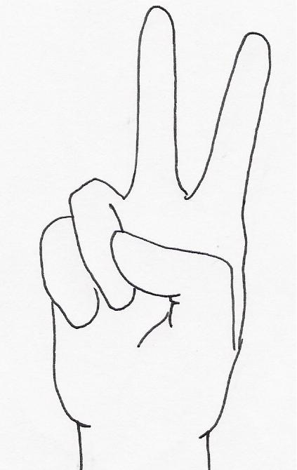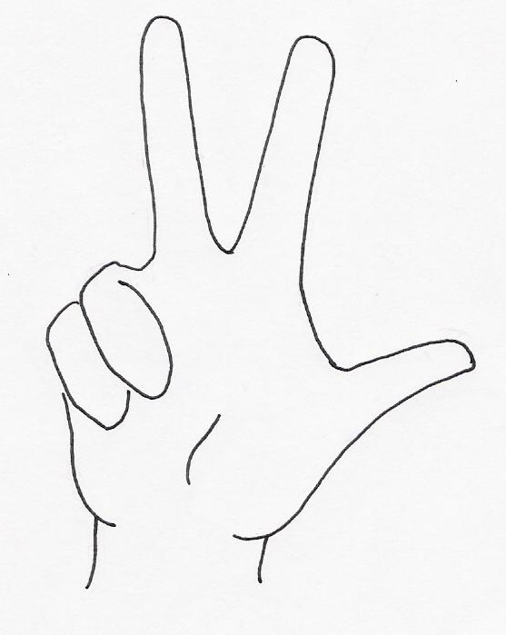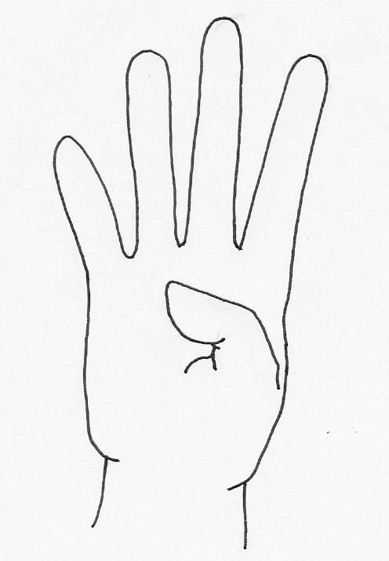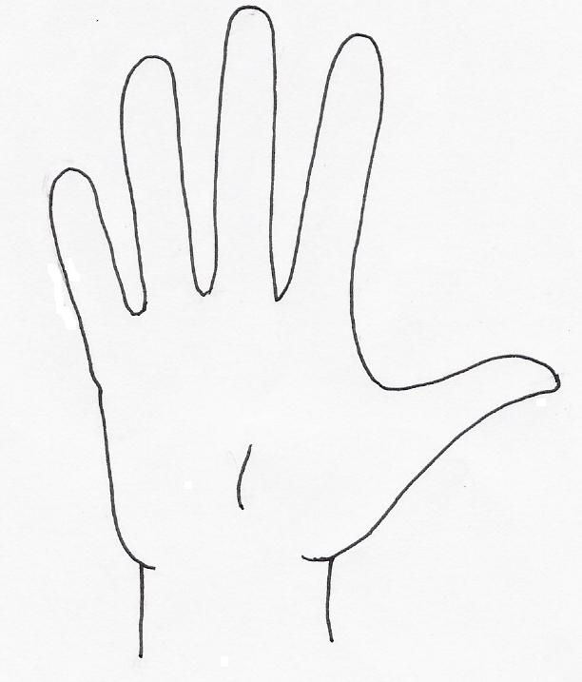
0 1 2 3 4 5

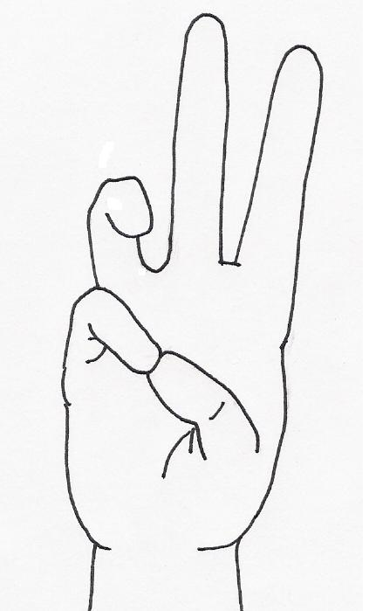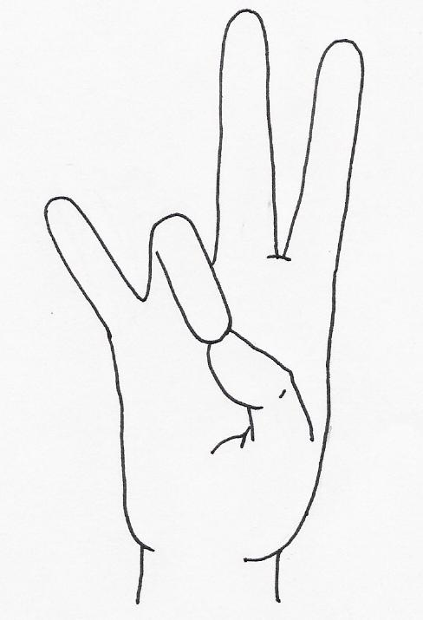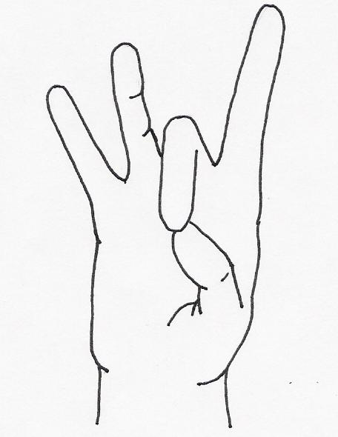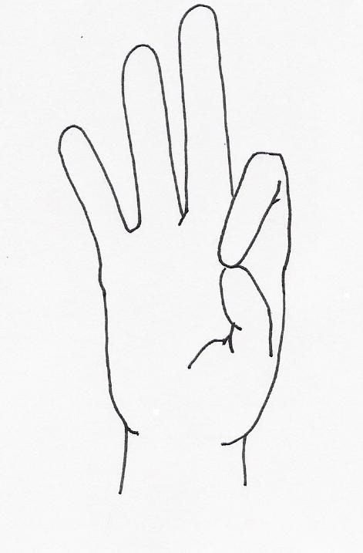
6 7 8 9 10

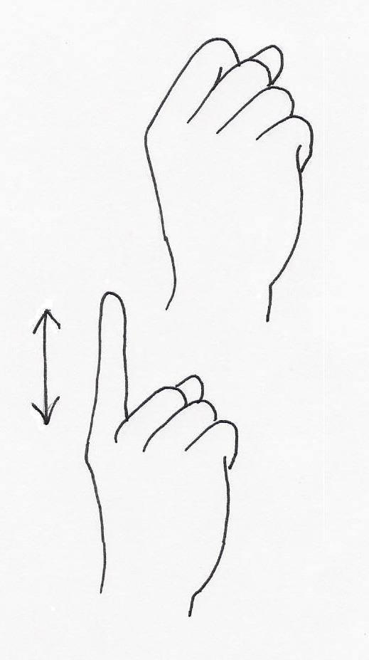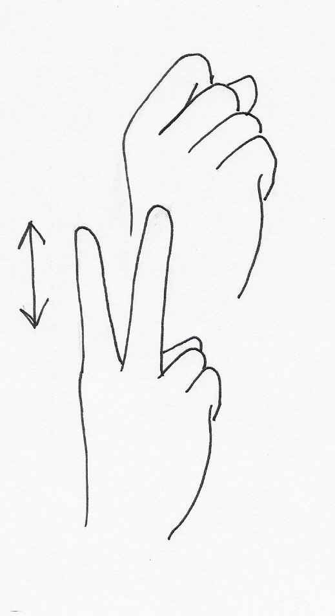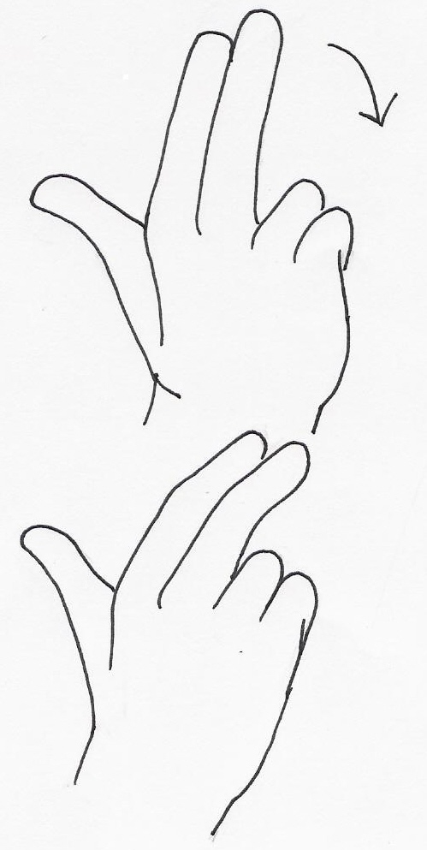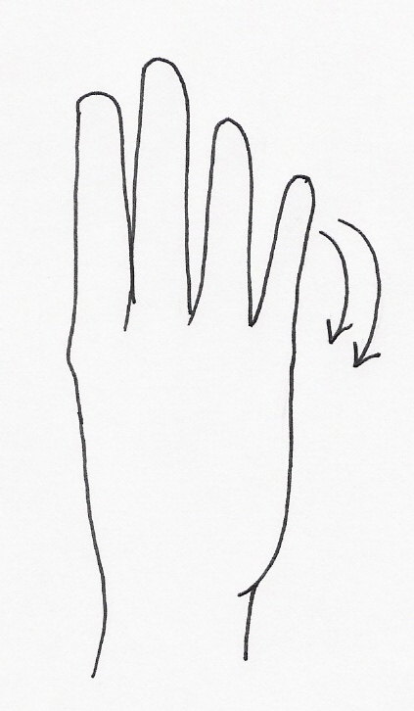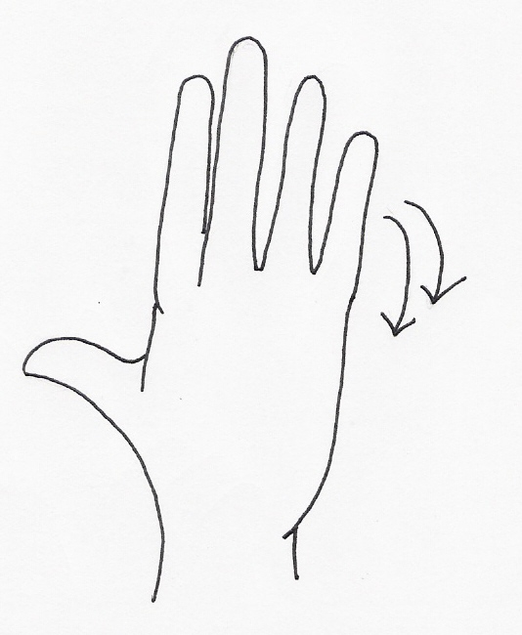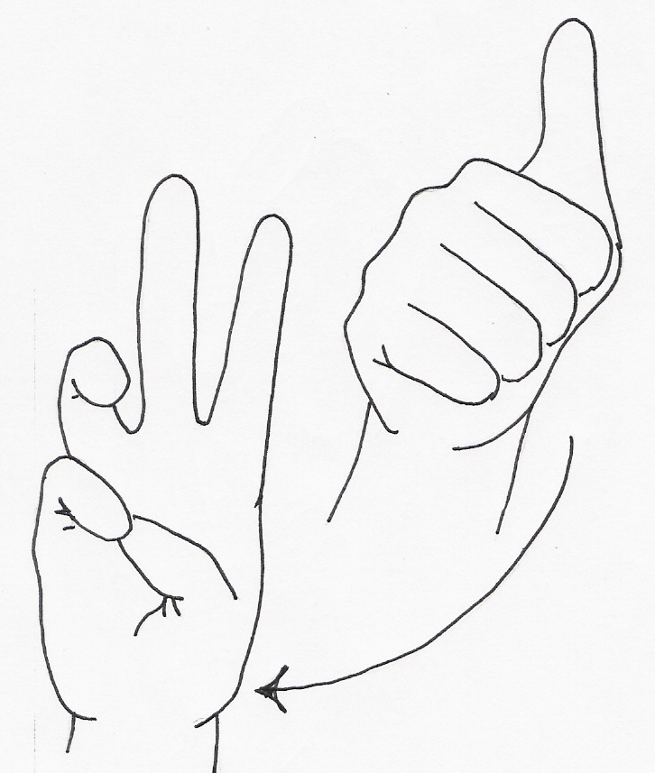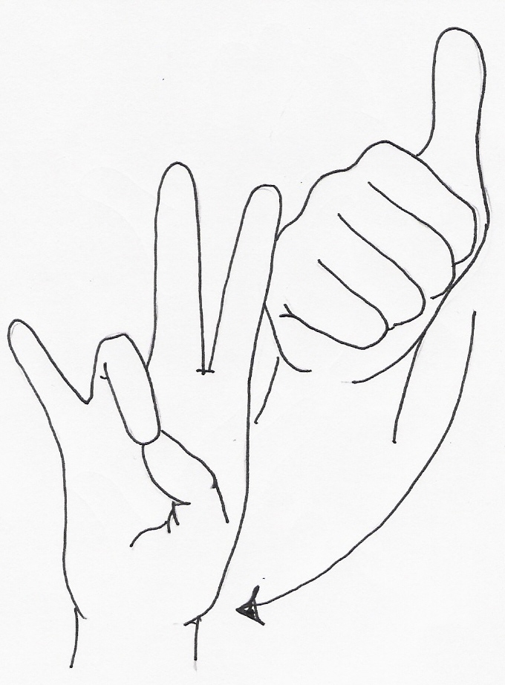
11 12 13 14 15 16 17

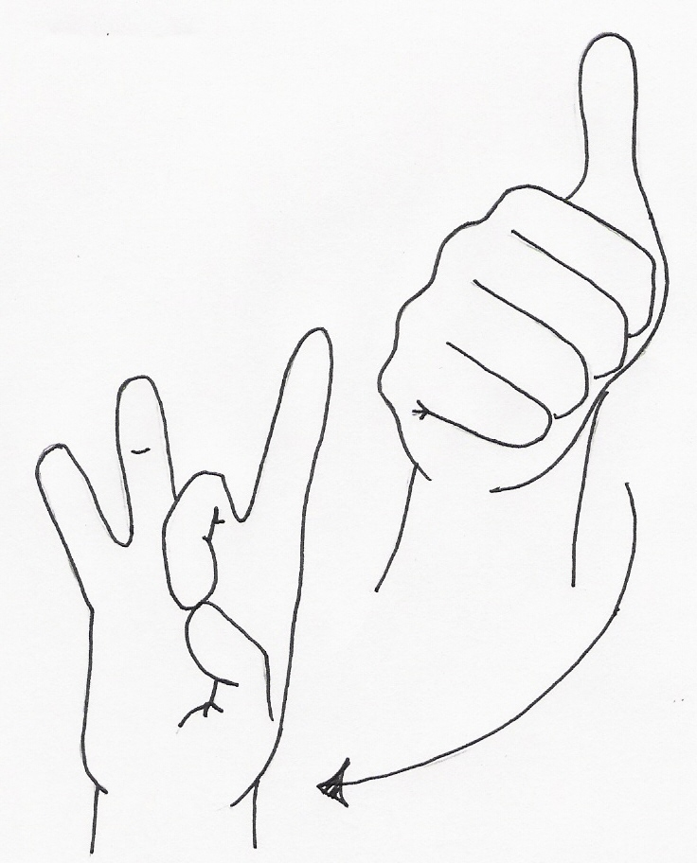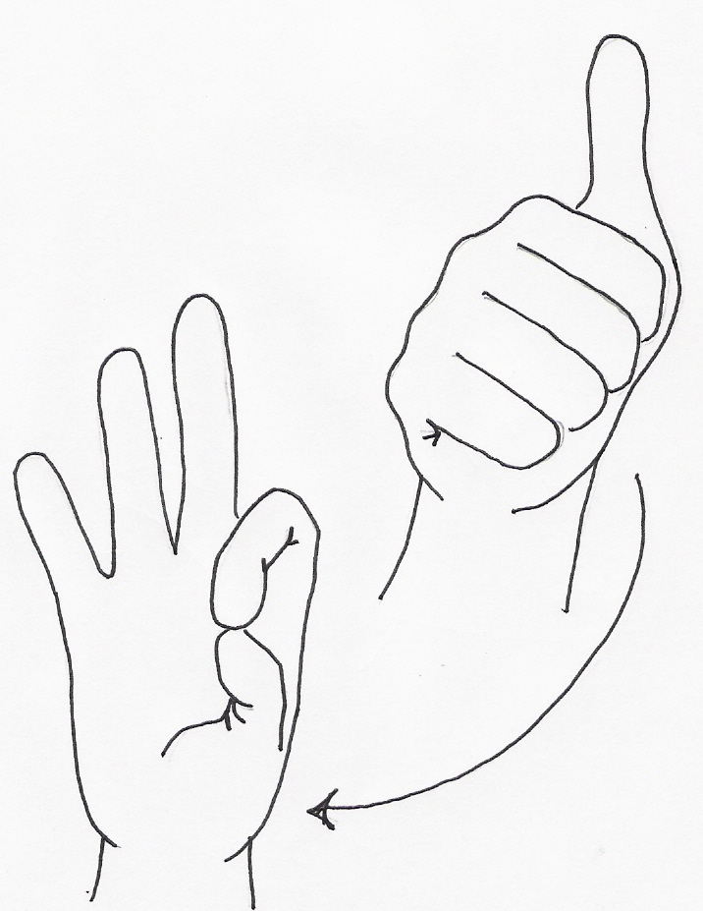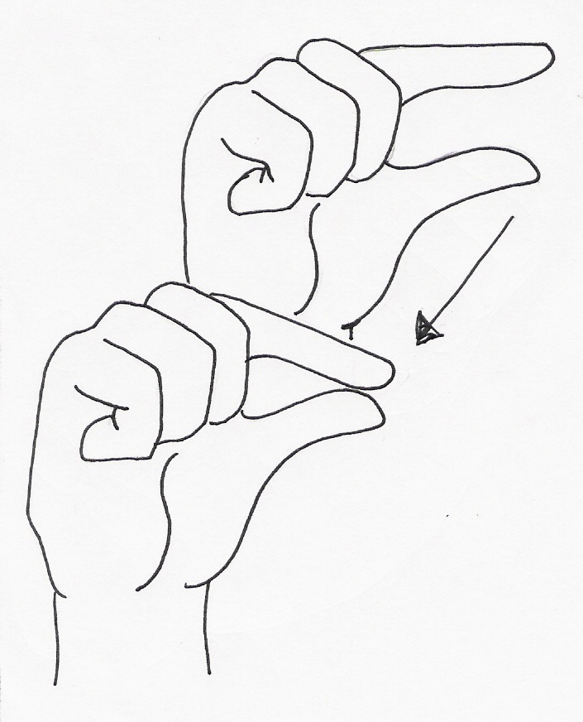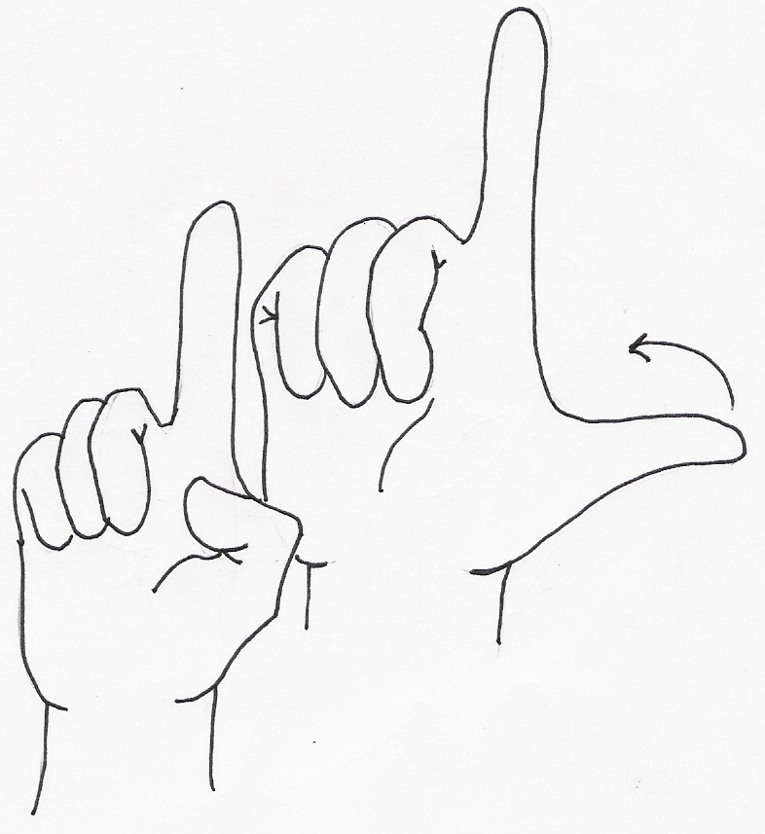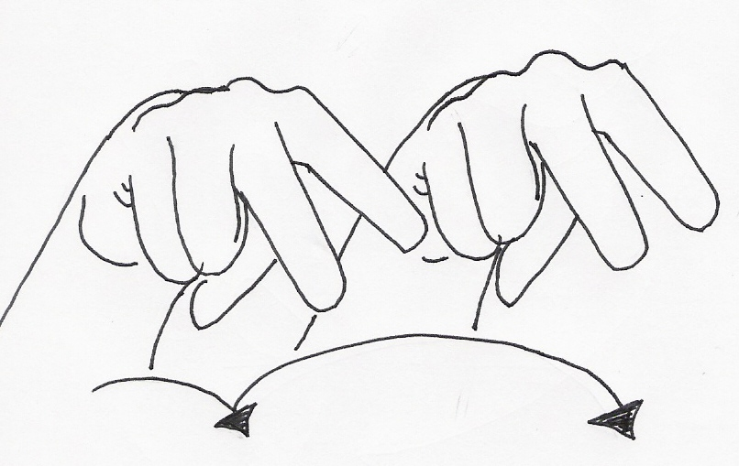
18 19 20 21 22

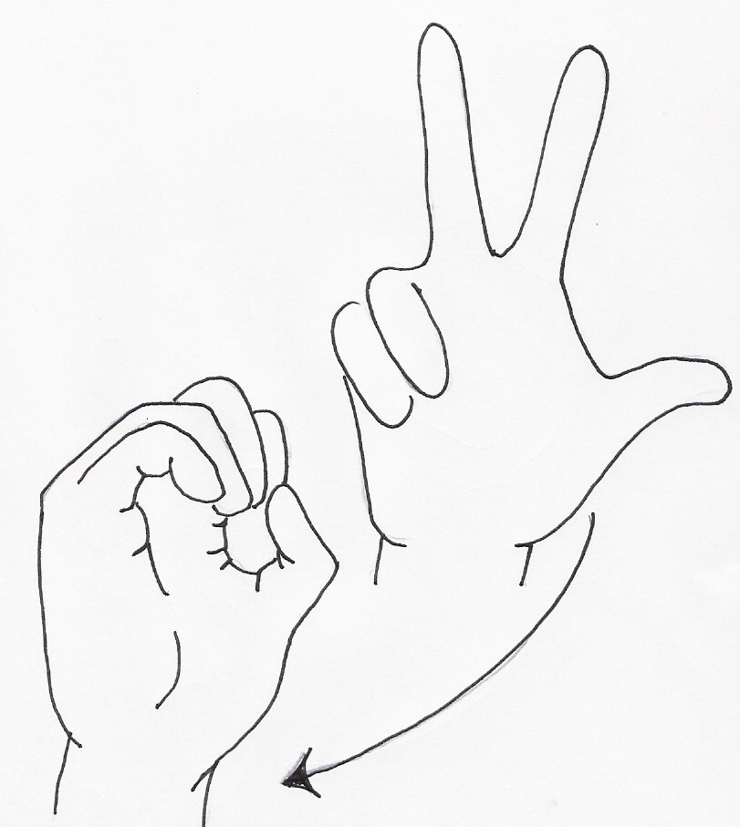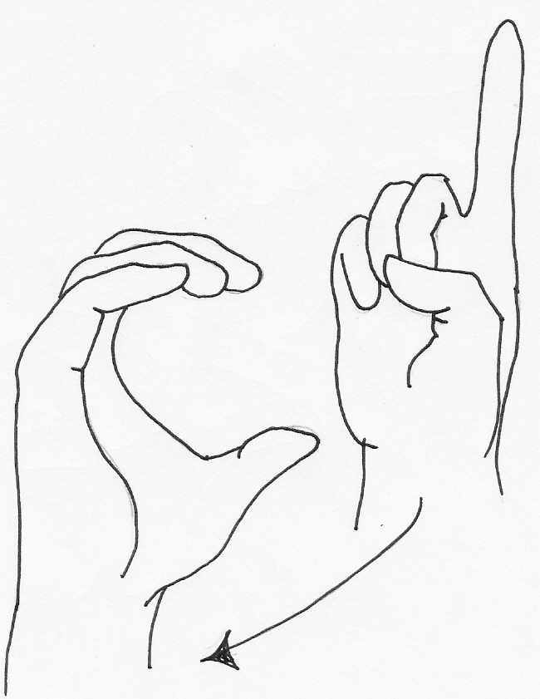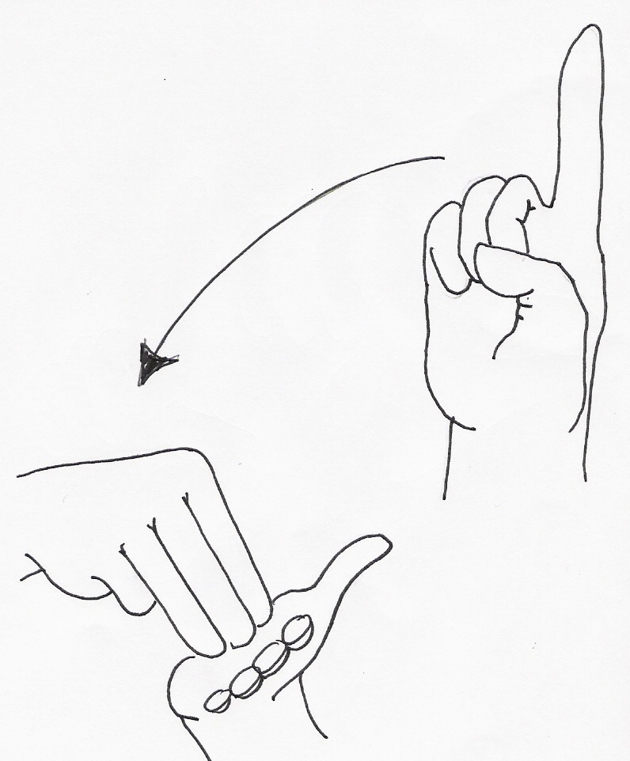
30 100 1000

Basic Greeting Signs
Signed English | ASL
Hi! My name is | Hi! Me
Pleased to meet you. | Happy meet you.
What's your name? | You name what?
Are you deaf or hearing? | You deaf hearing what?
Where did you learn to sign? | You learn sign where?
I am learning to sign. | Me learn sign.
Slowly, please. | Slow please.
Thank you. | Thank you.

Signs | Word Descriptions of Actions
am | Touch an A handshape to the lips and arc forward and upward
are | Place right R handshape to bottom lip. Move sign outward, arcing slightly upward
fine | Touch the thumb of the right hand (fingers spread) to the center of the chest area
happy | Touch chest with flat fingers of both hands in a forward circular motion, as if “stirring” emotions of joy
hello | Place hand on forehead as if to salute (but not as rigid). Move hand outward, ending up with palm facing forward in the air just a few inches from the forehead
how | Place hands back to back in front of the chest area, hands slightly bent, palms downward. Knuckles will slightly touch. Revolve hands in and then upward until hands end in a position where palms are flat and turned upward
I, me (asl) | Point to self, touching the center of the chest
I (se) | Touch the I handshape to the center of the chest
meet | Bring the D handshapes together, palm to palm
to | Move the right index finger to touch the left index finger
welcome | Using a W handshape with the right hand, touch the forehead and then the middle of the chest, arcing the movement to indicate you are welcoming someone to you (This mimes a man taking off his hat/cap and bowing)
who | Place the right hand in an L handshape on the chin, touching with the thumb. Slightly move the index finger twice
you | Point in the direction where someone is located. If no one is there, point to an imaginary person.
slow | One flattened hand moves slowly up the back of the other flattened hand.
please | The open, flattened, hand circles over the heart to indicate pleasure
thank you | The hand moves out and down. This sign is similar to the gesture of kissing one’s hand and extending the hand towards someone else in order to show your gratitude

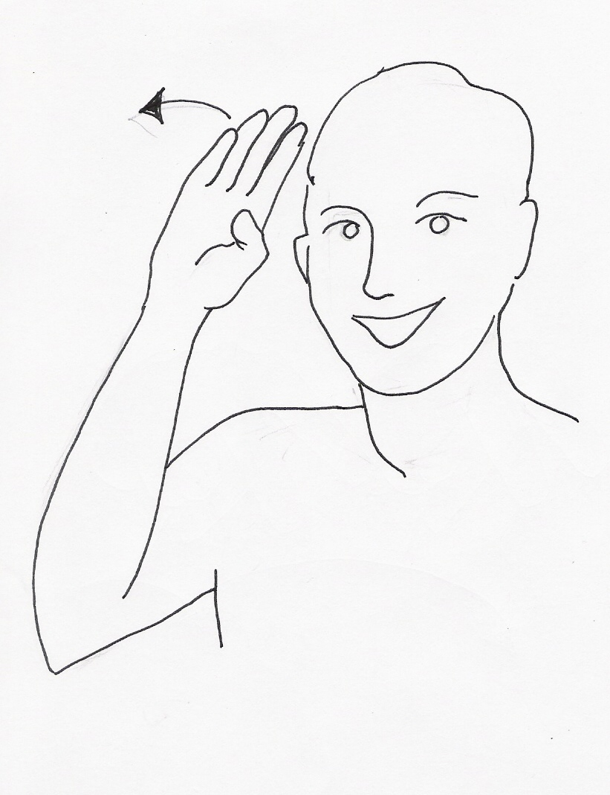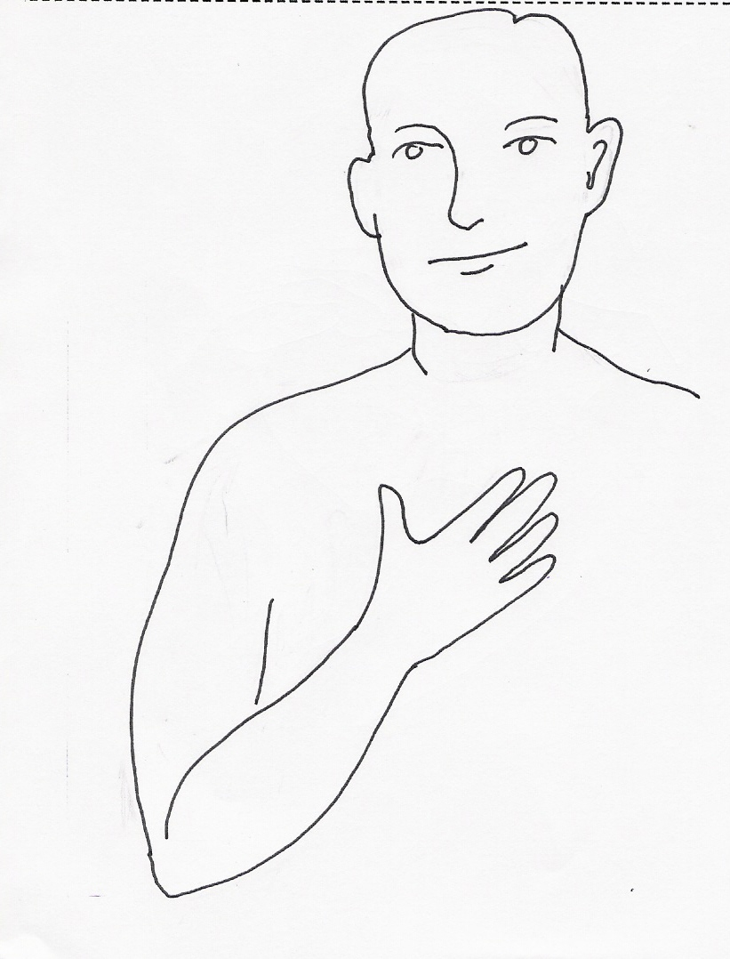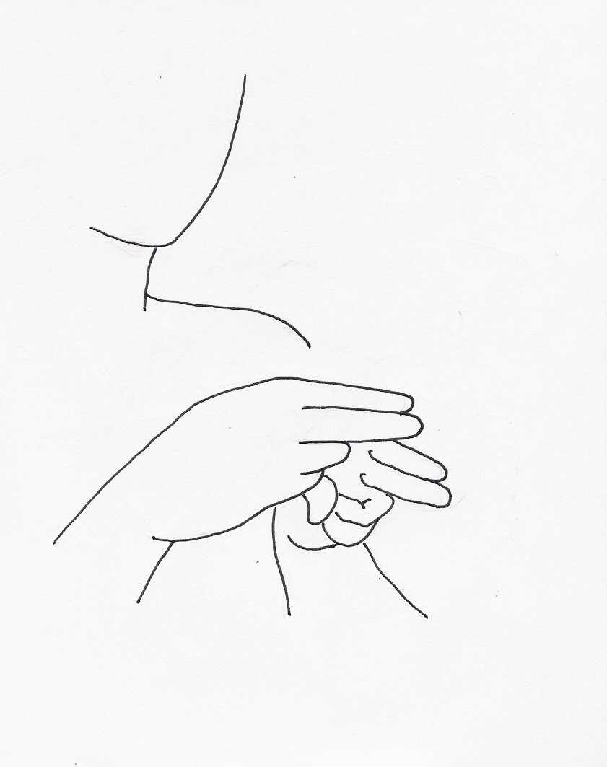
HI MY NAME

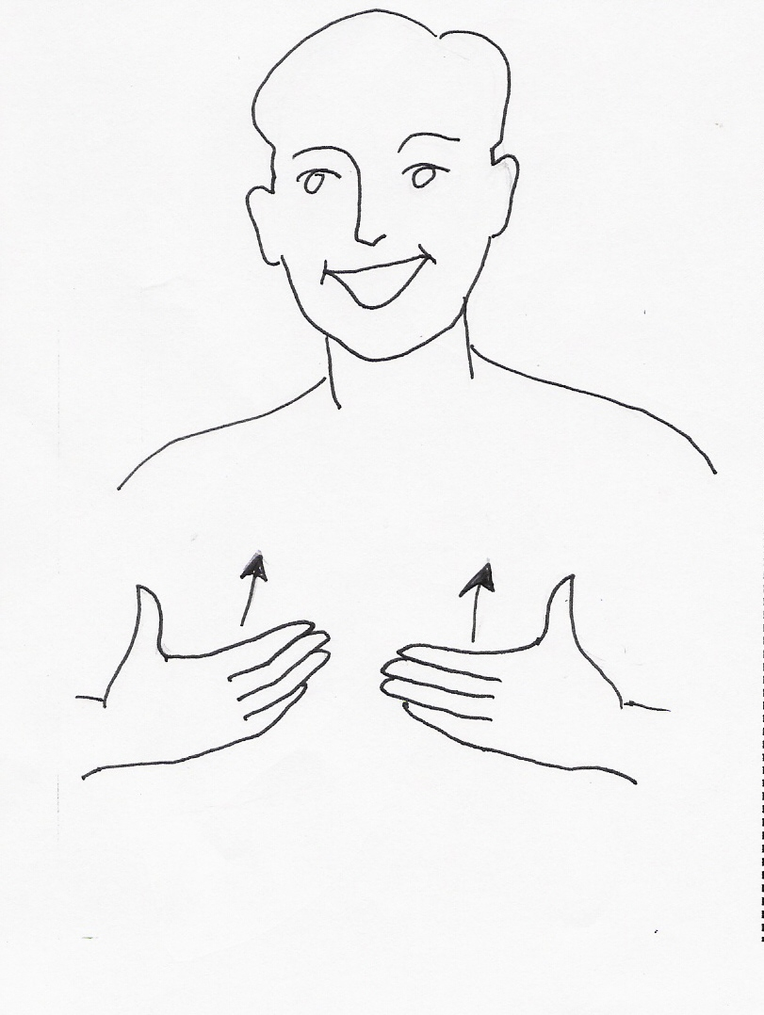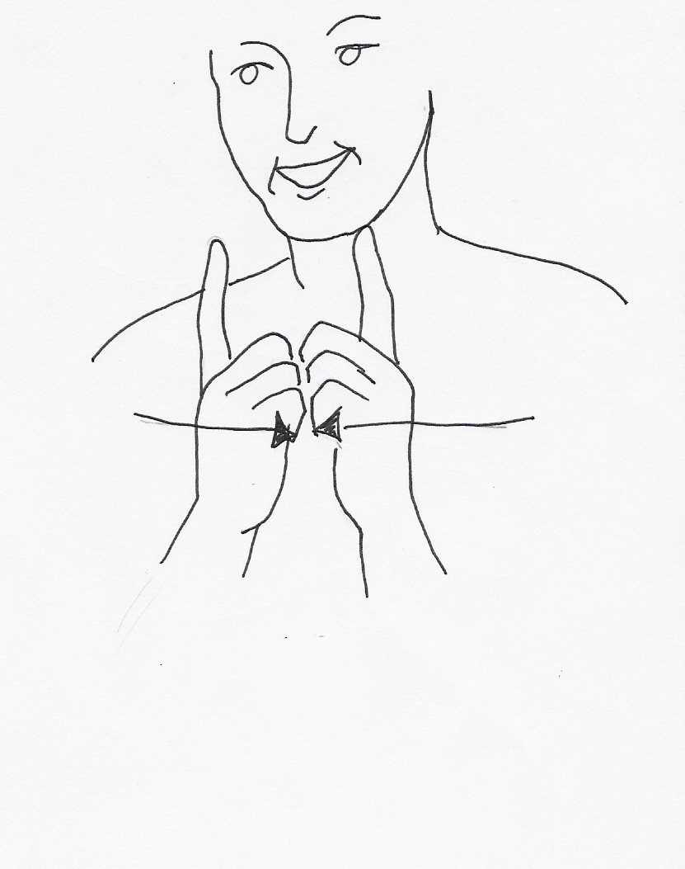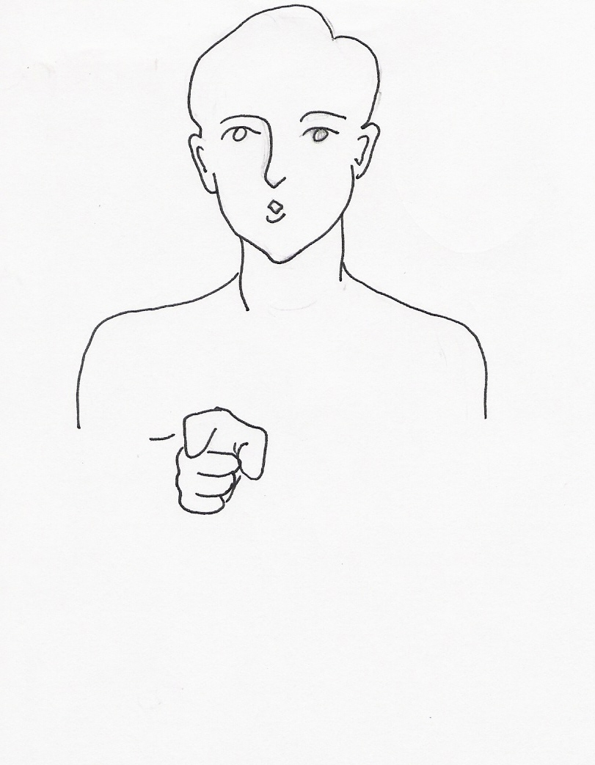
HAPPY MEET YOU

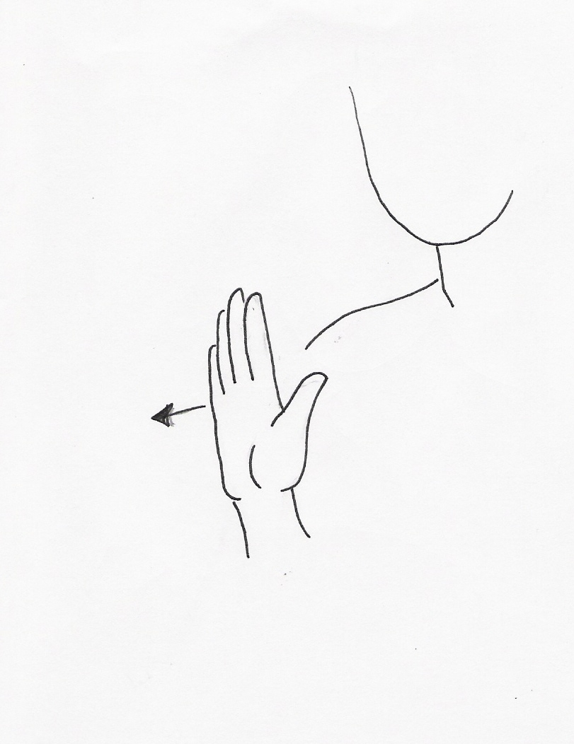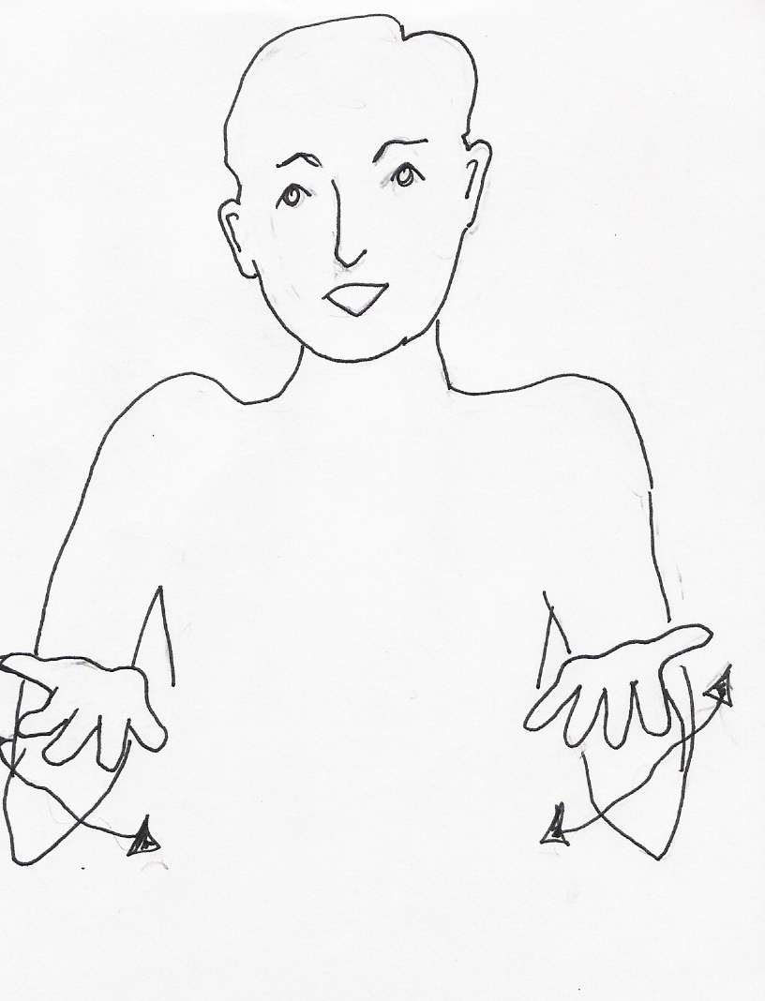
YOUR NAME ??

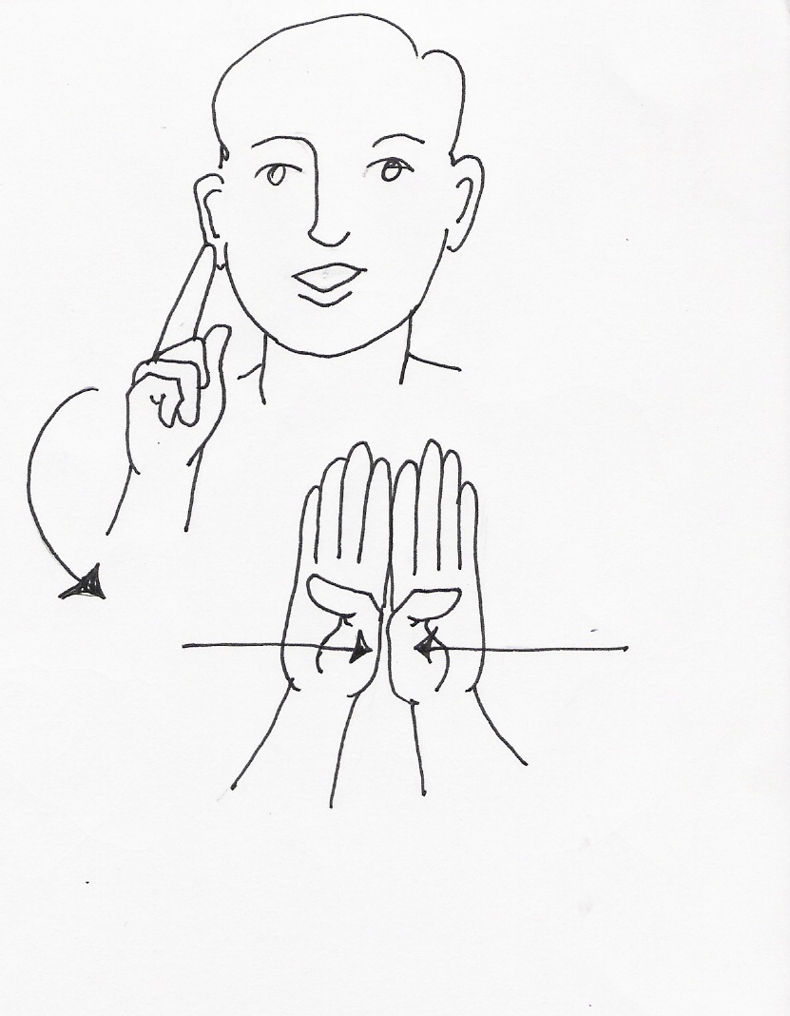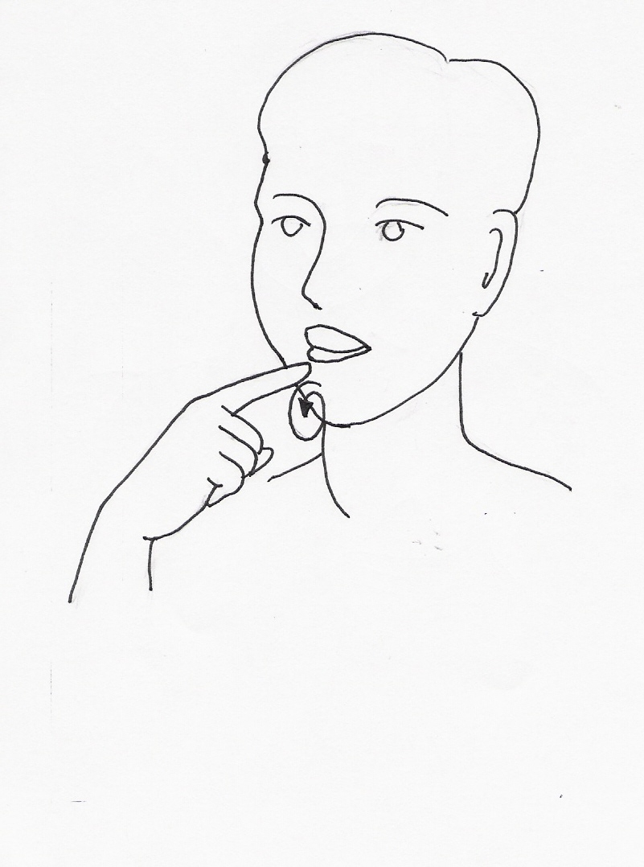
YOU DEAF HEARING ??

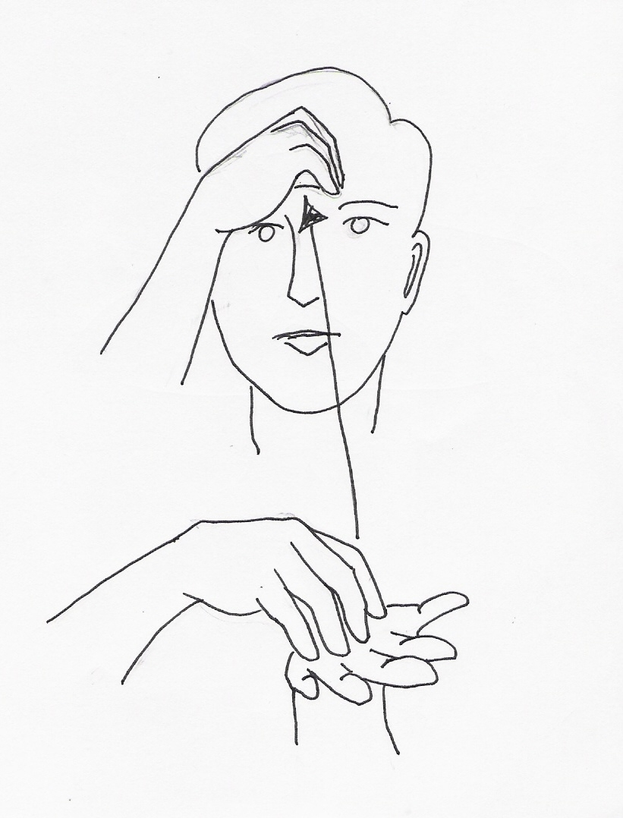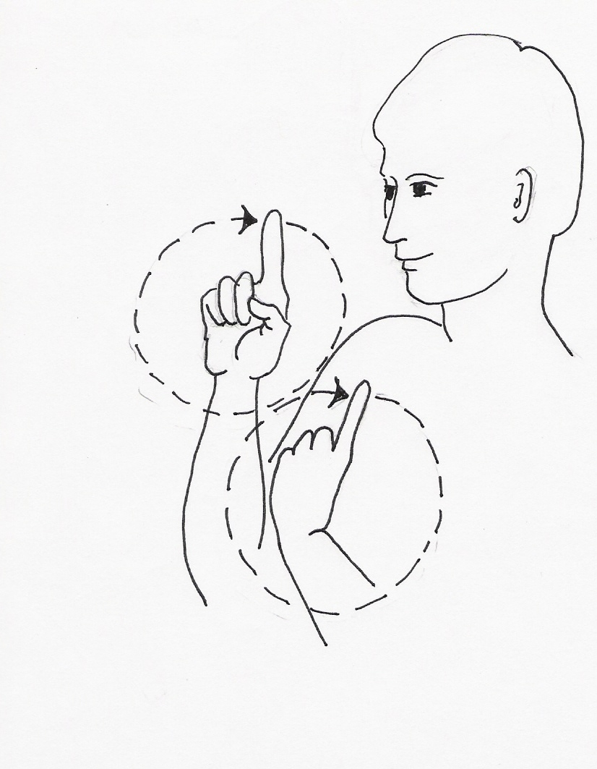
YOU LEARN SIGN WHERE ??

ME (I) LEARN SIGN

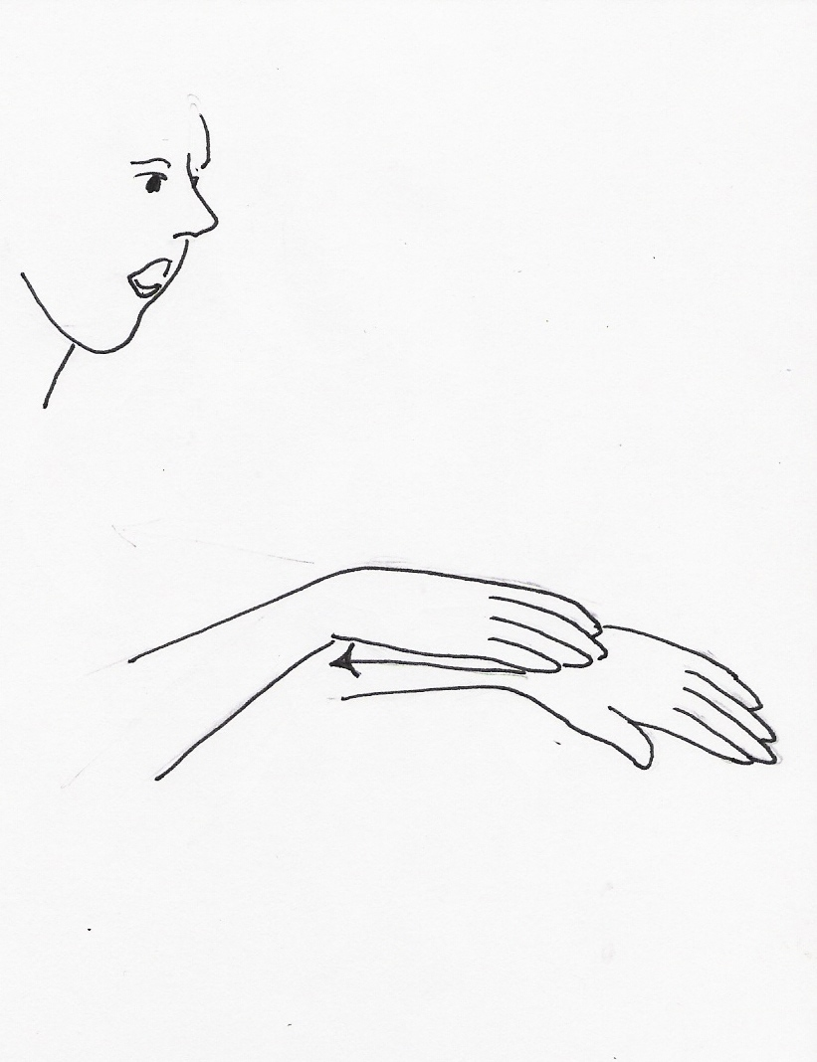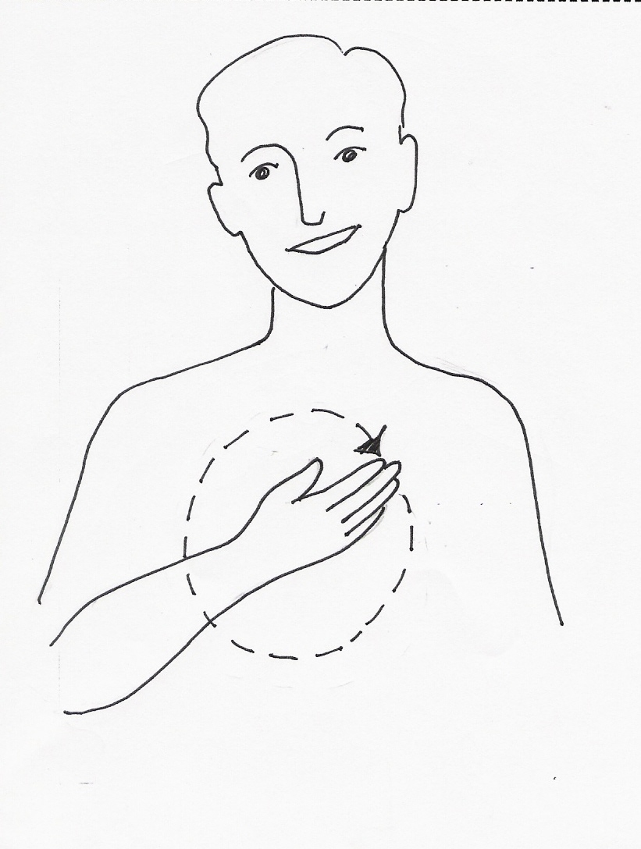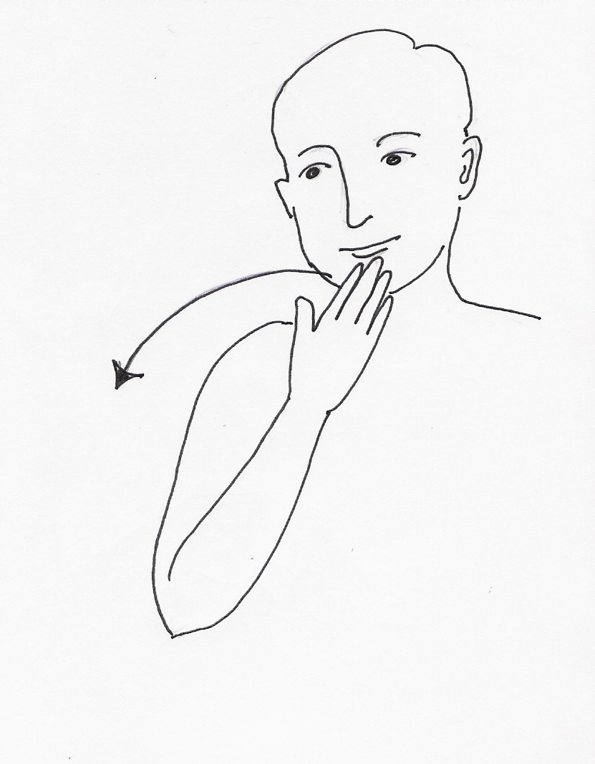
SLOW PLEASE THANK YOU

This Page Intentionally Left Blank

Silent Heraldry: Basics
by Suzanne de la Ferté

Lesson2: Basic Silent Heraldry

Describing the SCA
Signed English | ASL
SCA means Society for Creative Anachronism | SCA mean Society Creative Anachronism
An anachronism is something out of its natural time | Anachronism mean different time from today
We study and recreate the history of the Middle Ages | We study act history Middle Ages (spell out)
and the Renaissance | Renaissance (spell out)
The years 600 through 1600. | Year 600 through 1600
The SCA has groups all around the world. | SCA group around world.
Calontir | Calontir
Kansas | Kansas
Missouri | Missouri
Iowa | Iowa
Nebraska | Nebraska
Northern Arkansas | North Arkansas

Signs | Word Descriptions of Actions
class | Using both hands, the C handshape, palms facing outwards, are held a few inches apart at chest height. They are swung around in unison, so that the palms are now facing the body.
society | The sign CLASS is made with the S handshapes
creative (inventive) | The 4 handshape moves forth from the forehead to represent thoughts pouring forth
anachronism (different time) | The sign DIFFERENT plus the sign TIME
different | The forefingers are crossed (one in front of the other), then pull away from each other
time | The sign HOUR is made with the T handshape
hour | The forefinger circles the other hand to represent the hour hand going around the clock face once an hour
means | The V handshape presses down on the palm, moves up and twists, then presses down again
from | One finger pulls back from the other
today | The sign NOW plus the sign DAY
now | The hands move straight down to indicate the present (now). In ASL, the body represents the present tense, the front of the body represents the future and the back of the body represents the past
day | The horizontal arm (representing the surface of the earth) with the D handshape (representing the sun), moves to a vertical position pivoting on the elbow
we (asl) | The index finger moves from one shoulder to the other shoulder
we (se) | The hand, in a W handshape, moves from one shoulder back to the other
study | The fingers of one hand wiggle as the hand moves back and forth towards the palm of the other hand. (The wiggling fingers represent the eyes as the person reads a book)
act | The hands swing back and forth to show they are doing something
history | The H handshape moves down on an angle
year | The S handshapes revolve around each other representing the movement of the earth around the sun.
600 | The 6 handshape plus the C handshape (the roman numeral C represents a hundred)
through | One hand goes through the fingers of the other hand
1600 | The 16 handshape plus the C handshape (the roman numeral C represents a hundred)
group | Using both hands, the G handshape, palms facing outward are held a few inches apart at chest height. They are swung around in unison, so the palms now face the body
around | The index finger of one hand circles(goes around) the fingertips that are closed together and held upright
world | The W handshapes circle each other
Calontir | The sign HEART plus the sign LAND
heart | The middle finger taps the chest over the area of the heart. (Alternate sign is to draw a heart shape over the heart)
land | The sign DIRT plus the sign AREA
dirt | Using both hands, the thumb rubs against the fingers (feeling the texture of the soil)
area | The S handshapes, parallel to the floor, move in a semi-circular motion starting near the body and ending further away.
kansas | The K handshape plus the S handshape (KS, the abbreviation for Kansas)
missouri | The M handshape plus the O handshape (MO, the abbreviation for Missouri)
iowa | The I handshape plus the A handshape (IA, the abbreviation for Iowa)
nebraska | The N handshape plus the E handshape (NE, the abbreviation for Nebraska)
north | The N handshape is moved up to show the position of north when a map is held directly in front of the body.
arkansas | The A handshape plus the R handshape (AR, the abbreviation for Arkansas)

Explaining the SCA
Signed English | ASL
People in the SCA like to do many things | People SCA like do many things
Often, they start out by finding how people in the past did the things they like to do today. | Often, start find out how people past do same like do today.
As a part of being involved in the SCA, it is possible to get different types of awards | Part involve SCA, possible get different awards
We have 3 basic areas of study - fighting, service, and the arts and sciences | 3 basic study - fight, service, art science
Each of these areas of study have 3 main levels of awards. | Each 3 levels awards
Beginner - Award of Arms | Award Arms - beginner
Intermediate - Grant of Arms | Award Grant - intermediate
Advanced - Patents of Arms | Award Patent - advanced / top

Signs | Word Descriptions of Actions
People | The 'P' hands, side by side, are moved alternately toward the body in continuous counterclockwise circles
Like (Enjoy) | The open right hand is circled on the chest, over the heart.
Do | The bent 5 handshapes move back and forth to the sides of the body
Many | The fingers are thrown out to indicate that there is a lot of something
Things | The palm is facing upward and the hand bounces to the side to indicate different items (things).
Often | The sign AGAIN is repeated twice.
Again | The fingertips of the right curved hand touches the left palm
Start | The index finger twists between the fingers of the other hand to indicate the turning of a key in an ignition switch
Find out | The thumb and forefinger of the dominant hand pick up something out of the other hand
How | One Y handshape twists back and forth against the other Y handshape to represent the concept of asking how to take something apart
Past | The hand moves over the shoulder. In signing, the body represents the present time and motion forward of the body represents the future while movement to the back of the body represents the past
Like (Same) | The extended forefingers come together to show that both of them are identical (the same).
Today | The sign NOW and DAY are combined
Now | The hands (in a Y handshape) move straight down to indicate the present (now). In ASL, the body represents the present tense, the front of the body represents the future and the back of the body represents the past
Day | The horizontal arm represents the surface of the earth. The moving hand represents the movement of the sun across the sky during the day
Basic | One hand circles below the other hand to show the lowest level of something
Study | The fingers of one hand wiggle as the hand moves back and forth towards the palm of the other hand. The wiggling fingers represent the eyes looking something over and the palm represents a book
Fight | The two fisted hands move up and down to represent two people in a fist-fight
Service | Both hands are held in front of the body with the palms facing up; they are then alternatingly moved back and forth
Art | The little finger, which represents a pencil or paintbrush, draws something on the palm of the other hand
Science | The A handshapes move in alternate circles in front of the body. Each hand represents a test tube and the sign shows a scientist pouring the contents of a test tube
Each | One A handshape moves down the other A handshape
Level | The fingertips of each hand touch one another on a leveled horizontal plane to indicate the first level, then the motion is repeated to indicate a 2nd and 3rd level
Award | The hands move forth to offer something
Beginner | BEGIN plus PERSON
Begin | The index finger twists between the fingers of the other hand to indicate the turning of a key in an ignition switch
Person | The P handshapes move down the sides of the body
Intermediate | The fingers of one hand are divided to show the concept of something being in the middle
Advanced (Top) | The hands move upward in two movements that form a slight arc toward the body

Kingdoms in the SCA
19 Kingdoms in the SCA:
Aethelmearc
Central/Western Pennsylvania, Western New York, and West Virginia
Ansteorra
Oklahoma and most of Texas

An Tir

Oregon, Washington, and the northern tip of Idaho
Artemisia
Montana, southern Idaho, most of Utah, western Colorado, and Wyoming
Atenveldt
Arizona
Atlantia
Maryland, most of Virgina, North and South Carolina, and a bit of Georgia
Caid

Southern California, greater Las Vegas area, Hawaii
Calontir
Kansas, Missouri, Iowa, Nebraska, and northern Arkansas
Drachenwald
Europe, Africa, Middle East
Ealdomere
Ontario (except for Essex county and northwestern Ontario around Thunder Bay)

East

Eastern Pennsylvania, eastern New York, Delaware, New Jersey, Connecticut, Rhode Island, Massachusetts, Vermont, New Hampshire, Maine
Gleann Abhann
Mississippi, Louisiana, most of Arkansas, and small portions of Tennessee and Kentucky
Lochac
Australia and New Zealand
Meridies
Alabama, almost all of Georgia, a bit of the panhandle of Florida, parts of Tennessee,
Kentucky, and Virginia

Middle

Ohio, Kentucky, Indiana, parts of Michigan, Illinois, a nip of Iowa
Northshield
North Dakota, South Dakota, Minnesota, Wisconsin, the upper peninsula of Michigan
Outlands
New Mexico, most of Colorado, parts of Wyoming and Nebraska, and EI Paso and
Hudspeth counties of Texas
Trimaris
Majority of Florida, Panama, and Antarctica

West

Northern California, Nevada, Alaska, Japan, Korea, and Pacific Rim

Signs | Word Descriptions of Actions
AETHELMEARC | Interlaced fingers (for the escarbuncle) + “*ROLLING”
ANSTEORRA | “*SUN” starting from waist upwards + “*STAR”
AN-TIR | “*LION” + mime the claw outwards
ARTEMISIA
ATENVELDT | “*SUN” + “*FACE”
ATLANTIA | Handshape for “A” + “*SEA, OCEAN”
CAID | Simultaneously with both hands outline the shape of crescents in the air at eye height
CALONTIR | “*HEART”: + “*LAND”
DRACHENWALD | Mime sign for “firebreath” + “*WOODS”
EALDOMERE | “*FLOWER” + “*WOLF”
EAST | Handshape for “E” moved towards the right
GLENN ABHANN
LOCHAC
MIDDLE | Non-dominant hand, palm upwards. Dominant hand above this, palm facing body, “B” handshape. Dominant hand moves in small circle and lowers to “strike” center of non-dominant palm with fingertips.
MERIDIES | Handshape for “M” + 3 “*STARS”
NORTHSHIELD
OUTLANDS | “*DEER” + sign for animal jumping outward
TRIMARIS | “*THREE” + “*SEA, OCEAN”
WEST | Handshape for “W” moved towards the left

Groups in Calontir

Kansas
Shire of Bois d'Arc (Parsons, Pittsburgh, Independence, and surrounding areas)
Shire of Dun Ard (Leavenworth)
Barony of Forgotten Sea (Kansas City)
Canton of Aston Tor
Shire of Cum an lolair (Johnson and Miami counties) Shire of Fyren-Ar (Emporia)
Shire of Spinning Winds (Riley county and area) Barony of Vatavia (Wichita)

Missouri
College of Bellewode (Kirksville) Shire of Calanais Nuadh (Rolla) Barony of Forgotten Sea (Kansas City) Canton of Riverhold (Jefferson county) Shire of Standing Stones (Columbia) Barony of Three Rivers (St. Louis)

Iowa
Barony of Couer d'Ennui (Des Moines) Canton of Axed Root (Ames)
Shire of Deodar (Cedar Rapids) Shire of Heralds Hill (Mason City) Shire of No Mountain (Grinnell)
Shire of Shadowdale (Iowa City)

Nebraska
Barony of the Lonely Tower (Omaha)
Barony of Mag Mar (Lincoln)

Arkansas
Shire March of the Grimfells
Shire of Stronghold of Lost Forest Shire of Oakheart
Shire of Wyvern Cliffe

Royalty
Signs | Word Descriptions of Actions
king | The K handshape moves from the chest to the waist while crossing the body. The movement indicates the location of the royal sash worn by kings.
queen | The sign KING is made with the Q handshape
prince | The sign KING is made with the P handshape
princess | The P handshape outlines the bodice and sash worn by a princess. (Start at the side of the chest opposite your dominant hand. “Pull” towards your dominant hand, then move down the dominant-hand side of your body.)
baron | The sign KING is made with the B handshape
baroness | The sign PRINCESS is made with the B handshape
count | The sign KING is made with the C handshape, ending in a T handshape (to differentiate it from the sign for Christ)
countess | The sign PRINCESS is made with the C handshape
duke | The sign KING is made with a D handshape
duchess | The sign PRINCESS is made with the D handshape
earl | The sign KING is made with an E handshape
marchioness (?) | The sign PRINCESS is made with the E handshape
viscount | The sign KING is made with a V handshape
viscountess | The sign PRINCESS is made with the P handshape

Calontir Awards

Patents of Arms
Chivalry / Knight
Laurel
Pelican

Signs | Word Descriptions of Actions
KNIGHT | [The K handshape at waist, moving from center to dominant side "(Indicating a belt)
LAUREL | [The sign CROWN is made with an L handshape (indicating a laurel wreath).
CROWN | [The C handshapes (held with palms slightly out), held over head and lowered as if placing crown on head.
PELICAN | [The sign BIRD is made with a P handshape, then the P handshape is brought down to the dominant side (indicating a Pelican vulning itself).
BIRD | [The thumb and forefinger mimic the action of a bird's beak.

Grants of Arms
Thegn of Calontir (personal service and counsel to the Crown)
Hirth of Calontir (Huscarls)
Iren-Hirth (fighters)
Boga-Hirth (archers)
Order of the Calon Lily (arts)
Order of the Silver Hammer (sciences)
Order of the Cross of Calontir (service)

Signs | Word Descriptions of Actions
thegn | The sign CROWN plus the sign SERVICE plus the sign ADVICE
crown | The C handshapes (held with the palms slightly out), held over head and lowered as if placing crown on head.
service | Both hands are held in front of the body with the palms facing up; they are then alternately moved back and forth
advice | The movement of the hand represents the concept of information being sent forth
huscarl | The sign KING plus the sign PROTECTOR
king | The K handshape moves from the chest to the waist while crossing the body. The movement indicates the location of the royal sash worn by kings.
protector | The hands lock in a defensive position. The hands are blocking against an attacker followed by the sign indicating a person.
iren-hirth | The sign WARRIOR plus the sign HUSCARL
warrior | The W handshapes move back and forth as if in a struggle are followed by the sign indicating a person.
boga-hirth | The sign ARCHER plus the sign HUSCARL
archer | A movement of the hands mimics the motion of shooting a bow is followed by the sign indicating a person.
calon lily | The sign ART plus the sign CALONTIR plus the sign LILY
art | The little finger, which represents a pencil or paintbrush, draws something on the palm of the other hand.
lily | The sign FLOWER is made with an L handshape.
flower | A flattened O handshape moves from one side of the nose to the other to represent smelling flowers
silver hammer | The sign SCIENCE plus the sign SILVER plus the sign HAMMER
science | The A handshapes move in alternate circles in front of the body. Each hand represents a test tube and the sign shows a scientist pouring the contents of a test tube.
silver | The forefinger points to the ear and then pulls away while changing to an S handshape. This sign is similar to the sign GOLD which is made with a Y handshape instead of an S handshape.
hammer | The motion of the hand is similar to that of swinging a hammer
cross of calontir | The sign SERVICE plus the sign CROSS plus the sign CALONTIR
cross | The H handshape outlines the shape of a cross.
service | Both hands are held in front of the body with palms facing up; they are then alternately moved back and forth

Awards of Arms

Fyrd of Calontir (Fyrdmen)
Iren-Fyrd (fighters)
Boga-Fyrd (archers)
Order of the Calon Swan (arts)
Order of the Leather Mallet (sciences)
Order of the Torse (service)

Signs | Word Descriptions of Actions
fyrdman | The sign for QUEEN plus the sign for PROTECTOR
queen | The sign KING is made with the Q handshape
protector | The hands lock in a defensive position. The hands are blocking against an attacker followed by the sign indicating a person.
iren-fyrd | The sign WARRIOR plus the sign FYRDMAN
warror | The W handshapes move back and forth as if in a struggle are followed by the sign indicating a person.
boga-fyrd | The sign ARCHER plus the sign FYRDMAN
archer | A movement of the hands mimics the motion of shooting a bow is followed by the sign indicating a person.
calon swan | The sign ART plus the sign CALONTIR plus the sign SWAN
art | The little finger, which represents a pencil or paintbrush, draws something on the palm of the other hand.
swan | The sign BIRD is made with an S handshape.
bird | A flattened O handshape moves from one side of the nose to the other to represent smelling flowers
leather mallet | The sign SCIENCE plus the sign LEATHER plus the sign HAMMER
science | The A handshapes move in alternate circles in front of the body. Each hand represents a test tube and the sign shows a scientist pouring the contents of a test tube.
leather | The fingertips of a modified H handshape brushes against the upper chest.
hammer | The motion of the hand is similar to that of swinging a hammer
torse | The sign SERVICE plus ???
service | Both hands are held in front of the body with palms facing up; they are then alternately moved back and forth

Non-armigerous Awards and Honors

Order of the Rose
(consorts who have successfully completed their reign)
Order of the Sword of Calontir
(individual/group - dramatic deeds concerning the art and science of combat, strategy, tactics, and/or Society warfare)
Order of the Keeper of the Flame
(individual - who, through appearance, actions, and deeds demonstrate an exceptional amount of honor and courtesy, and exemplify themselves in efforts to create a medieval aura)
Order of the Queen's Chalice
(young people who have provided service to the kingdom above that normally expected of them)
Queen's Endorsement of Distinction
King's Favor
Iren Feran
Falcon's Heart

Signs | Word Descriptions of Actions
order of the rose | The sign for ORDER plus the sign for ROSE
order | The sign CLASS is done with O handshapes
class | Using both hands, the C handshape, palms facing outward, are held a few inches apart at chest height. They are swung around in unison, so that the palms now face the body.
rose | The sign FLOWER is made with an R handshape
flower | A flattened O handshape moves from one side of the nose to the other to represent smelling flowers
sword of calontir | The sign SWORD plus the sign CALONTIR
sword | The sign KNIFE is followed by the removal of a “sword” from its holder and using it in a “duel”
knife | The moving index finger represents the slicing motion of a knife
keeper of the flame | The sign KEEPER plus the sign FLAME
keeper | One of the signs for hold is made with the K handshapes followed by the person sign
hold | The hands hold (grip) something
flame | The wiggling fingers represent flames
queen’s chalice | The sign QUEEN plus the sign CUP
queen | The sign KING is made with a Q handshape
cup | One hand in a C shape rests on the palm of the other hand indicating the shape of a cup.

Students
Squire
Apprentice
Protege

Signs | Word Descriptions of Actions
squire | The sign for KNIGHT made with the S handshape
apprentice | The sign for LAUREL plus the sign STUDENT
student | The sign LEARN is followed by the sign indicating a person
learn | The movement of the hand shows knowledge being taken from a book and placed in the brain
protege | The sign for PELICAN plus the sign STUDENT

Pennsic Silent Heraldry

SCA-SPECIFIC SIGN LANGUAGE

REVISED FOR PENNSIC XXIII, A.S. XXIX

This handout is a meager attempt to explain sign language in words. While someone who knows sign language will probably understand some of the handout, it is *unbelievably difficult* to explain sign language in words. Therefore this handout is meant as a reminder for those who have taken the class *and is not intended to stand as a teaching document on its own*.

The basic philosophy behind the invention of SCA-specific signs to date is this: if it exists in the language, _don't mess with it_! I!! [1] If it does not exist in the language, the first place to look for an idea to invent a sign is the heraldry. If it does not immediately lend itself to either of these techniques, try to brainstorm what the term means and work from there. [2]

I will NEVER be able to cover every possible sign invention -- I'll never be in that many places at once!! But if my students have the techniques to cope with new and unusual sign situations on their own, that's all I can ask for.

This handout compiled by Lady Ariane Desiree des Cedres, called Cedar

Michelle R. Owings-Christian
21 Englishtown Road
Parsippany, NJ 07054
(201) 887-1779 (home)
(201) 660-6828 (office)

If you have any questions, thoughts, ideas, concerns about sign language use in the SCA, please feel free to contact me at the address/phone above or drop by the MAGICANDLE merchant booth wherever you may find it. (Most East Kingdom events and, always, PENNSIC.)

[1] For example, the heraldry of the Middle Kingdom is wonderfully iconic and would make a great heraldry-based sign. But there is already a sign for the word 'middle' and when someone says "middle", as an interpreter I automatically do the sign that exists.

[2] There is an ASL sign for 'court' but it means a court of
law in the modern sense. When I tried to decide on a sign for Court
in the SCA sense, I finally created a "portmanteau sign": a combination
of the signs for 'meeting' and 'celebration', which is how I see SCA Courts.

NOTE: All ASL signs are preceded by an asterisk (*)
[Ed. note: The phrase "Manual Alphabet Letter" is shortened “MAL” to preserve my wrists and space. I have also removed the sections on Kingdom Awards, as my wrists are griping. :) [ If you really want them, you can contact Cedar

Signs | Word Descriptions of Actions
*king | MAL "K" from non-dominant shoulder to dominant hip. (Be sure that the palm orientation is correct -- if not, this can easily be confused with the sign for "*PRINCE")
*queen | MAL "Q" moving from non-dominant shoulder to dominant hip.
*prince | MAL "P" moving from non-dominant shoulder to dominant the hip. (Be sure that the palm orientation is correct – if not, this can easily be confused with the sign for “*KING”
*princess | MAL “P” moving from non-dominant shoulder to dominant shoulder to dominant hip  Note: I have also seen the signs for “*PRINCE” and “*PRINCESS” reversed. I believe it is a regional difference.
duke | MAL “W” at dominant temple (the closest we could come to the STRAWBERRY LEAVES of a ducal coronet of rank)
duchess | MAL “W” at dominant temple + “*GIRL” + “*FORMAL, POLITE, FANCY”
count | MAL “C” moving from center of forehead to dominant temple
countess | MAL “C” at dominant temple + “*GIRL” + “*FORMAL, POLITE, FANCY”
viscount | MAL “V” moving from center of forehead to dominant temple
viscountess | MAL “V” at dominant temple + “*GIRL” + “*FORMAL, POLITE, FANCY”  (Be VERY CAREFUL with the palm orientation on the “v” so as not to sign “*STUPID” – palm should be facing to the NON-DOMINANT side)
laurel | MAL “L” on each hand placed on chest where the peerage medallion would rest, showing the shape of the laurel wreath
pelican | Duck-bill (handshape like the sign for “*NO”) then same handshape moving to pierce the chest (the symbol of the order, the pelican vulning itself)
*peer | Sign for “*EQUAL”
master/mistress | Sign for equal made into an initialized sign using the MAL “M” on each hand (all masters/mistresses of whatever flavor are peers)
knight | MAL “K” at the waist moving from center to dominant side, drawing the belt which is the symbol of the order
squire | MAL “S” in the same movement as the sign for “KNIGHT”
master/mistress of arms | MAL “M” at non-dominant shoulder, moving to dominant hip where it becomes MAL “A”, for the baldric that is the symbol of the order
baron | Closed “X” handshape moving from center of the forehead to dominant side, denoting three of the pearls in the Baronial coronet
baroness | Closed “X” handshape moving from center of the forehead to dominant side, denoting three of the pearls in the Baronial coronet + “*GIRL” + “*FORMAL, POLITE, FANCY”  Note: If it becomes important to differentiate between a “LANDED” and a “COURT” baron/baroness, you can do so. When I lived in the Midrealm, it was easy to do because all LANDED barons had gold coronets and all COURT barons had silver coronets. But that does not seem to hold true in the Eastrealm (and these are the only two kingdoms of which I have any experience).
seneschal | “*KEY” + “*PERSON” indicator
exchequeur | “*COUNT” + “*PERSON” indicator
marshall | Mime pulling a sword then with “one” handshapes, cross fingers in saltire (the heraldry denoting marshals)
autocrat | “*CONTROL” + “*PERSON” indicator (Closed “X” handshape on both hands, palms facing each other. Move alternately forward and backward – as in pulling strings) I’ve also seen the ASL sign for “BOSS” made with an “A”, but I find that a very awkward maneuver.
archery marshall | Left hand in “one” handshape, right hand MAL “M”, miming pulling back a bow from the left handshape
herald | Sign for “*LECTURE” done with an “H” handshape
chirurgeon | Using a “C” handshape, make the sign for “*HOSPITAL”
majesty | “M” handshape moving up – the sign for “*HIGH”
excellency | “E” handshape moving up – the sign for “*HIGH”
highness | “H” handshape moving up – the sign for “*HIGH”
royal | MAL “R” moving from non-dominant shoulder to dominant hip
court | Sign for “*CELEBRATE” + sign for “*MEETING”
oyez | “*ATTENTION”
*kingdom | “*KING” + “*AREA”
barony | Baron + “*AREA”
minister of arts | “*TEACHER” initialized with the MAL “M” + “*ART”
minister of sciences | “*TEACHER” initialized with the MAL “M” + “*SCIENCE”
minister of arts/sciences | “*TEACHER” initialized with the MAL “M” + “*ART” + “*SCIENCE”
award of arms | “*GIFT” + display with “A” handshape

Section XV

Courtesy and Graces

This Page Intentionally Left Blank

General Protocol and Etiquette
by Modar Neznanich
When first starting in the SCA, things can seem a bit confusing, particularly when there are some folk about who are wearing crowns, coronets and other fancy pieces of paraphernalia. What do those items mean and who gets to wear them?

What the “fancy hats or brass hats” and “doo-dads” mean will vary, depending on the type they are. But in general, it means the folk wearing them are either currently in charge of overseeing various functions of the SCA or have previously done so or have displayed an advanced degree of skill in an area of service, art, science or martial endeavor.

Following are listings of items associated with special ranks or achievements. Hopefully, it will help you to identify the rank and/or position the bearer of such objects. Realize that some specifics (such as award medallions) will vary from kingdom to kingdom, but the basics will still apply. The lists below are based on Calontir law and tradition.

Crowns, Coronets and Circlets

A. With Embellishments
1. Royalty
a. King/Queen - Crowns of Gold (With a Cross of Calatrava)
b. Prince/Princess - Crowns of Silver (With a Cross of Calatrava)
2. Nobles
a. Duke/Duchess - Coronets of gold with strawberry leaves
b. Count/Countess (Earl, Graf, etc.) - Coronets of gold with embattlements
c. Viscount/Viscountess - Coronets of silver with embattlements
d. Baron/Baroness - Coronets with six pearls or six spheroids (either above band or on band)

B. Without Embellishments
1. Peers - Circlet of gold or silver; no protrusions above/below the band; simple
decoration; not to exceed 1” height
2. Champions
a. King’s Champion - Circlet of blackened steel; unembellished and unornamented; 1” in height
b. Queen’s Champion - Circlet of brushed steel; unembellished and unornamented; 1” in height
3. Populace - Circlet of any metal; no protrusions above/below the band; no decoration;
not to exceed ½” height

Medallions & Other Award Items

The following descriptions of the medallions that award-bearers may wear are very general. Depictions of the awards may be seen in the article entitled “Awards of Calontir”.

A. Patent Holders (Peers)
1. Master / Mistress of the Pelican - Medallion with a Pelican; a red hat with ermine trim; red cloak with ermine trim
(may have person’s device surrounded by blood drops)
2. Master / Mistress of the Laurel - Medallion with a Laurel Wreath; gold cloak with ermine trim (may have person’s
device surrounded by a laurel wreath)
3. Chivalry - No medallion, but a plain unadorned gold chain, spurs and a white belt or
baldric; black cloak with ermine trim (may have person’s device surrounded
by a gold chain)

B. Grant Holders
1. Cross of Calontir - Medallion with gold background, a purple Cross of Calatrava and a purple
border.
2. Silver Hammer - Medallion with black background, a silver hammer and a silver border.
3. Calon Lily - Medallion with split background of purple and gold with a fleur-de-lys and a
border that is counterchanged (colors flipped from the background).
4. Boga-Hirth (Huscarl) - Medallion with the background split in an upside-down embattled “v”, the top
black with two crossed white archery bows and the bottom white with a purple
Cross of Calatrava.
5. Iren-Hirth (Huscarl) - Medallion with the background split in an upside-down embattled “v”, the top
black with two crossed white axes and the bottom white with a purple Cross of
Calatrava.

C. AoA Holders
1. Torse - Medallion with a heraldic wreath/torse of gold and purple; with no set
background color.
2. Leather Mallet - Medallion with three brown mallets atop an “up and down” embattled white
band on a purple background.
3. Golden Calon Swan - Medallion with a purple background and gold swan.
4. Boga-Fyrd (Fyrdman) - Medallion with a purple Cross of Calatrava on an embattled white “v” section
between two white archery bows on a black background.
5. Iren-Fyrd (Fyrdman) - Medallion with a purple Cross of Calatrava on an embattled white “v” section
between two white spears on a black background.
6. Award of Arms - No medallion; although recipient is presented with a scroll.

NOTE: Any member of the populace regardless of their rank or awards may have a cloak with their heraldic device on it. One merely cannot use symbols or other display around it that one is not entitled to.

Belts

A.Knight - white belt of any sort

B. Squire - red belt
(sometimes has the heraldic device of the Knight they are squired to upon it)

C. Apprentice - green belt
(sometimes has the heraldic device of the Laurel they are apprenticed to upon it)

D. Protégé - yellow belt
(sometimes has the heraldic device of the Pelican they are protégéd to upon it)

Forms of Address

There are formal means of addressing gentles, based upon their titles and rank within the SCA. Following is a list to help you know how, by custom, to address such individuals in a formal setting or when you are not personally acquainted with them.

A. Royalty
1. King/Queen - Your/His/Her Majesty
2. Prince/Princess - Your/His/Her Highness

B. Nobles
1. Duke/Duchess - Your/His/Her Grace
2. Count/Countess (Earl, Graf, etc) - Your/His/Her Excellency
3. Viscount/Viscountess - Your/His/Her Excellency
4. Baron/Baroness - Your/His/Her Excellency

C. Patent Holders (Peers)
1. Master/Mistress of the Pelican - Master/Mistress
2. Master/Mistress of the Laurel - Master/Mistress
3. Knight - Sir/Dame
4. Master/Mistress of Arms - Master/Mistress

D. Grant Holders
1. Cross of Calontir - Your/His Lordship - Your/Her Ladyship
(Honorable Lord/Honorable Lady in some kingdoms)
2. Silver Hammer - Your/His Lordship - Your/Her Ladyship
(Honorable Lord/Honorable Lady in some kingdoms)
3. Calon Lily - Your/His Lordship - Your/Her Ladyship
(Honorable Lord/Honorable Lady in some kingdoms)
4. Boga-Hirth (Huscarl) - Your/His Lordship - Your/Her Ladyship
(Honorable Lord/Honorable Lady in some kingdoms)
5. Iren-Hirth (Huscarl) - Your/His Lordship - Your/Her Ladyship
(Honorable Lord/Honorable Lady in some kingdoms)
E. AoA Holders
1. Torse - Lord/Lady
2. Leather Mallet - Lord/Lady
3. Golden Calon Swan - Lord/Lady
4. Boga-Fyrd (Fyrdman) - Lord/Lady
5. Iren-Fyrd (Fyrdman) - Lord/Lady
6. Award of Arms - Lord/Lady

F. Non-Award Holders
1. SCA name - no title
2. Generic reference - milord/milady (not a title/rank)

This Page Intentionally Left Blank
Interacting with the Royalty
by Modar Neznanich

If you become active within the SCA, it will only be a matter of time before you and the Royalty “cross paths”. This may be in a court setting or while walking around at an event. For many folks this can be a nervous time for them, as they want to do what is proper and present the appropriate actions to acknowledge the Crown’s presence. Following are some guidelines to assist you.

In Court

1. The most likely interaction that a member of the populace will have with the Royalty in court
is one of these:
a. You are receiving an award
b. You are an officer and have an official function to perform
c. You have an announcement to make
d. You have a presentation to make
e. You are swearing fealty
f. You are involved in some form of shtick.
2. If you are called into court and you don’t know why…don’t panic. Most likely the Crown has an award to present to you; if not that, they most likely will ask you to provide them with some information, or ask you to inform the populace of something. There is nothing to fear. What you do is:

Approach the thrones until you are approximately 20 feet away and bow/curtsy to the Royalty.
Once you have done this first bow/curtsy, walk briskly into Court.
When you are in front of the Royalty, bow/curtsey once again, then kneel on the cushions
(that’s what they’re there for).

Suppose there are several sets of Royalty and/or Baronages at the head of court. How do you do bows then? To whom do you bow first?

This is not a simple answer because it can vary based on custom rather than law. Most gentles
in Calontir do the bows in this manner:

If you’re in Calontir, bow to the King & Queen (one bow), then the Prince & Princess (one bow unless they are seated separately <rare>, then one bow to each), then bow to any visiting Royalty, then bow to any Calontir Baronages, then any visiting Baronages. Once you’re through bowing, kneel on the cushions.

If you’re in a foreign kingdom, bow first to the King & Queen (one bow) whose kingdom you’re in, then to your own kingdom’s Royalty (if present). Again, once you’re through bowing, kneel on the cushions.

Side Notes on Bowing:
a. The physical limitations of a site may require shortening the distances where one stops to bow…that’s okay
b. Some kingdoms have the custom that one bow is sufficient even if the dais has several sets of Royalty, that it is not necessary to bow to all of them. The reasoning is that the Royalty presiding over the court in question are the “important ones”, and by honoring them, you are honoring all other Royalty on the dais, as They are the guests of the presiding Royalty.

Once you have knelt in front of the Crown, They will conduct their business with you
(presentation of an award, etc.).

When their business with you is done, rise from your knees, back out of the Royal Presence
(10 foot Sanctum Rule), bow, then turn and walk briskly out of court.

Side Note on Backing Out of the Royal Presence:
a. IF THERE ARE STAIRS…do not attempt to back down the stairs. This will only
tempt fate to cause you to fall. Turn all the way around (or at least sideways) to go
down the steps. Once at the bottom of the steps, turn back to the Crown, bow to
Them, then turn and walk briskly out of court.
b. Should you have been seated to a far side of the populace assembled, please exit down
the center aisle, then return to your seat, rather than exit to a side.

3. If you are called into court and you know that you are there to do an officer function or
make an announcement (autocrat thank you, announce winner of contests, present prizes,
do some shtick, etc.), what you do is:

Approach the thrones until you are approximately 20 feet away and bow/curtsy to the Royalty.
Once you have done this first bow, walk briskly into Court. When you are in front of the
Royalty, bow once again and then ask permission to address the populace.

Once the Crown has granted you leave to address the populace, move so that you are standing to one side of the Crown, angle yourself toward those gathered and announce what you are there for (loudly enough, so the populace can hear), and then do what is necessary. When done, turn back to the Crown, thank Them for allowing you to take time in court, bow, then turn and walk briskly out of court.

4. If you (or a group) are called into court to make a presentation to the Crown, what you do is:

If there is a large group of people involved in your presentation, gather your people in advance of court and try to sit together, preferably near the center aisle. When called into court, allow those with the item(s) to present and anyone who will be speaking to go in the front. The rest should follow quickly.

Approach the thrones until those in front are at the edge of the Royal Presence. Those in front should stand still for a moment to give those following a chance to come to a halt also. Everyone in the group should then bow. Once the bow is done, the person speaking should ask permission of the Crown to present them with an item or items).

When the Crown has granted permission, those with the items and the speaker should move into the Royal Presence; everyone else should kneel. Those who have moved into the Royal Presence should now kneel and give the items to the Crown. (If the nature/size of the item prevents kneeling, this is okay.)

The Crown will most likely have a few words of thanks for the presenters. Following the thanks, those in the Royal Presence should stand and back out of the Royal Presence, everyone else should stand. Once those in the Royal Presence have backed out, everyone should bow. Then everyone should turn and walk briskly out of court.

Side Note for people making announcements and presentations:
a. Keep it as short as possible.
b. Make sure that the person speaking has a loud voice and, preferably, is a good speaker - otherwise those attending court cannot hear or understand what is going on. This makes
court tedious and boring.
c. If you know you’ll need to speak in court and you do not have a loud voice (or are
uncomfortable with public speaking) BEFORE court, talk to the court herald. The
court herald, if asked, will speak with the Crown for you about allowing someone else to
come with you into court to speak for you or having the court herald state your business.
d. Never do shtick unless the Crown has been made aware of it in advance. They may not
need all the details, but They will want to know what’s going to happen in Their court.

5. If you are going into court to swear fealty, what you do is:

Approach the Royal Presence, along with everyone else who is coming to swear fealty at that
time. When you arrive as close as you can get (this will vary depending on the number of
participants), bow, then kneel with everyone else swearing fealty.
If you have gotten there first and can use the cushions, do so. However, be courteous - if
someone with bad knees needs them, let them have use of the cushions. The court herald will
come forward and give you the words to state, giving your oath of fealty.

Once the oath has been given and the Crown has responded, along with everyone else, rise and
give a short bow. Then walk briskly back to your seat.

6. Weapons and Court

Unless you are a member of the chivalry in fealty or your function in court is marshal in nature
(General of the Army, etc), it is usually best not to wear weaponry to court. If you know in
advance that you will be going before the Crown in court (for announcements, etc) then remove
the weapon prior to court beginning. If you are wearing a weapon and get called into court
unexpectedly, when you first stand, simply remove the weapon and either place it in your seat,
on the floor by your seat or ask someone sitting next to you to hold the weapon. Then proceed
into court normally.

In Public

1. Free Roaming Royalty
It’s possible that you and/or the Royalty will be walking around an event and you’ll come across each other. What do you do?
a. First, don’t panic.
b. Second, if you see Them in time, and there is adequate room, remember the Sanctum rule. Sanctum is defined as an area 10 feet in radius surrounding the Crown’s presence, which may be used exclusively by the Crown, and into which other persons may enter solely upon the invitation of the Crown. This applies to all the Royalty (King, Queen, Prince and Princess). When the Royalty is “free roaming” and there is adequate space and time to do so, allow 10 feet of clear space between yourself and them. This “circle of privacy” allows them to discuss things and handle various business without having to retreat to the Privy Chamber.

Side Notes on the Sanctum rule:
i) The distance to allow varies from kingdom to kingdoms. Some kingdoms give as
much as 20 feet of space.
ii) In Calontir, it is also considered courteous to apply the Sanctum rule to Territorial
Baronages when they are conducting official business. They are acting as
representatives of the Crown at that point.
iii) In some kingdoms it is the custom to apply the Sanctum rule to Territorial Baronages at all times, the same as the Royalty.
c. Third, simply bow or curtsy to acknowledge Them. If there’s not space to apply the Sanctum rule, don’t worry. They should be aware of the physical limitations of the surroundings and take that into consideration.
d. What happens if you fail to notice the Royalty as They pass by? Well, don’t be upset, no one is going to be angry if you didn’t notice the Royalty passing by. Some members of the Royalty like to (or have need to) pass through the populace at an event without making “a show”. This is usually referred to as going in “stealth mode”. Most likely if the Royalty wants to do this, They will not be wearing Their crowns. If the Royalty passes you in such mode, it is still courteous to acknowledge Them by bowing.
e. If the Royalty stops to talk to you, don’t panic! Remember that the members of the Royalty are people too. Simply be polite and respectful.
2. Sitting in State
Sitting in State refers to when the Crown is sitting on the Thrones, but is not holding court. If the Crown is not involved in a meeting, it is permissible for populace members to stop and talk to the Royalty, if they so desire. You should follow the Sanctum Rule previously noted and stop outside the Royal Presence and await notice. Once you are noticed, simply ask if They would be willing to talk to you (be polite, use proper forms of address as mentioned earlier). If They are already talking with someone else (or some unexpected business arrives), They may ask you to stick around until things are finished. Or you may be asked to come back later. If so, do not feel put-off…the Royalty usually has a lot to do at an event and many things vying for Their attention. Most likely They will be willing to see you later, when They are not busy.

Besides talking to the Royalty when They are Sitting in State, it is also a great time to make
personal presentations to Them. Due to the hectic nature of courts, the Royalty rarely has an
opportunity to examine items presented to Them in court. If such a presentation is done
while They are Sitting in State, They have more time to thank you and discuss the gift.

When passing by the Crown, when They are Sitting in State, it is proper to acknowledge
Them with a small bow or curtsey.

3. In Proxy (Passing the Royal Pavilion or the Royal Thrones when Empty)
In several kingdoms, it is tradition to show respect for the Royalty/Baronages by acknowledging Them even if no one is sitting on the Thrones when you pass, by bowing. In Calontir there is a mix. Some gentles will do such acknowledgement; others prefer to save their reverence for the people themselves who hold those positions. The choice is yours.

4. Feast
When the Crown is present at the Head Table of a feast and you are passing by, you should treat this as if They were Sitting in State and give them a small bow or curtsey. If you wish to speak with Them, approach to the edge of the Royal Presence (remember the Sanctum Rule) and wait to be acknowledged. Then bow, step forward and speak with Them. If you are a server, you are given implied permission to approach the Head Table to serve Them. However, always address Them politely and respectfully. Also, give a small bow if you can do so without jeopardizing what is being served or removed from the table.

In Private (Inside the Privy Chamber)

This is an area that will vary from Crown to Crown. It will also be affected by the relationship you have with the Crown. Just remember that if others are present, it is usually best to refer to the Royalty with more formal address, even if you’re old friends from all the way back in grade school.

This Page Intentionally Left Blank
Section XVI

Heraldic Education

This Page Intentionally Left Blank

Frequently Given Answers (That Are Wrong)
by Master Gawain of Miskbridge, Green Anchor Herald
(with assistance from Lady Alanna of Volchevo Lesa, Master Dmitrii Volkovich and Master Da’ud ibn Auda)

Heraldry

1. Only queens can use roses on their arms.
What is reserved to queens (and Companions of the Rose) are rose wreaths. Chaplets of roses are reserved to princesses. By extension, orles and bordures of roses are also reserved. Single and multiple roses of any tincture* are not reserved, and are registered all the time, so long as they don’t look too much like a wreath.
(* A rose tinctured gules and argent is an English royal badge, the “Tudor rose”, and is not registerable in the Society.)

2. Charges that have been previously registered in the Society are always OK to use.
The College of Arms’ level of understanding of period heraldic practices has increased greatly over the years. A number of charges that have been registered in the past are now seen to be at odds with the heraldry of our period of study and are no longer accepted for registration.

3. You have to have an Award of Arms before you can register your heraldry. (Alternate version: You have to have an AoA before you can display your heraldry.)
Anyone may register heraldry. Until they receive an Award of Arms from the Crown, it is called a “heraldic device” instead of a “coat of arms”. The two are registered and displayed identically; only the terminology changes when you become armigerous. N.B.: This is not a practice firmly based on historical precedent.

4. Sable is a fur.
Yes, sable is a dark-brown luxury fur. No - in heraldry, sable means black; which is classified as a color, not a fur.

5. Furs are considered neutral with respect to the Rule of Tincture, so they may be placed upon, or be charged with, either metals or colors.
This is mostly true in heraldry outside the SCA, but we consider each fur individually: in the ermine family we categorize furs by their field tincture, since that has the greater area: ermine = argent, so is considered a metal, while counter-ermine = sable, so is considered a color. On the other hand, furs of the vair family have more or less equal areas of both tinctures, so are indeed considered neutral. A charge of either of the constituent tinctures is still not allowed go over or under a vair fur, though.

6. A bar sinister on a coat of arms shows that the bearer is a bastard.
This is wrong in at least two ways. First, there is no such thing as a “bar sinister” in heraldry. A bar is a narrow horizontal stripe, so there is no way for it to be sinister. Second, one of a number of marks of illegitimacy, well-known because it was used by some acknowledged bastards of the French crown, was the “bendlet sinister couped overall”, also called a “baton sinister”. This is definitely not the only mark of illegitimacy used in period heraldry.

7. They stopped checking against mundane armory, so now you can use anything you want.
“It is true that the SCA College of Arms no longer checks for conflict against any but famous non-SCA arms. But to deliberately search out a real coat of arms and to adopt it is, in short, theft. Your arms should represent you, not someone else. Independent invention or creation of a coat of arms which may be similar to non-SCA arms, however, is permissible.” - Da’ud ibn Auda

Names

1. Citing the use of a name in a book about the Middle Ages or Renaissance is sufficient documentation.
Sorry, many fiction authors use names that were never used in the setting of the story, or even (gasp!) make them up! Even fiction writers of our period often used names not found outside their works. Unfortunately, many writers of non-fiction about our period translate or modernize name spellings, so you can’t even rely on a history text for the correct spelling of a name.

2. If you can find a name in a “what to name the baby” book, you have documented it sufficiently.
Baby books are fine for helping you choose a name for your baby. Alas, they almost never give information about when a particular name was used historically, nor do they normally give you anything but the modern form. Frequently the “meaning” listed is also inaccurate, not to mention that the “meaning” of a given name is irrelevant to its acceptability by the CoA.

3. Spelling was quite variable before the modern era, so you can spell a name any way you like.
In our period, the spoken version of a word was primary, while the written form was simply a way of recording it. Any spelling that would reproduce the sound was “correct”, but the way sounds were represented varied widely from language to language and even from one period of time to another within the same language. It takes at least a little familiarity with a particular language to understand what the rules are. What you can depend on is that they are distinctly different from those for 20th C. American English.

4. If you find a masculine name that you like, you can make its feminine cognate by adding “-a” to the end.
This is not even true for modern English. “Williama” is not the feminine cognate of “William”. In many of the Latin-derived languages, it is sometimes true; but, for example, in the Celtic languages such as Irish or Scots Gaelic or Welsh, it is almost never the case.

College of Arms Procedures

1. If you submit stuff at the Pennsic consultation table, you’ll hear about it a lot sooner, because they rule on it right there.
Unfortunately, no; items submitted at Pennsic go through the same procedure as items submitted through your local pursuivant. Because they were submitted along with a lot of others, they may take a month or so longer than otherwise. They will probably stand a better chance of passing though, because they have probably been looked over by more experienced heralds than your local officer.

2. I don’t need to register my name again with the College of Arms because I have it on my membership card so it’s already registered with the office of the Registry.
What’s on your card is whatever you put on your membership application. It has nothing to do with registering your name. If you put “King Richard Lionheart” on the form, that’s what they’ll type on that card.

[Permission is granted to reprint this article in SCA publications.]

Heraldic Myths
(Clearing Up Misconceptions Involving SCA Heraldry)
compiled by Modar Neznanich
There are many misconceptions involving SCA heraldry that have developed over the years. This article attempts to address some of the most common concerns and provide current and correct information about them.
Armory (Device/Badge) Related Myths
1. I can register my family's coat-of-arms because it already belongs to me.
This is false. If you are in fact entitled to arms in the real world, you can't register those exact arms. This is per the Administrative Handbook of the College of Arms (III.B.6.). However, any blazonable difference, even if it isn't worth a CD, clears it of this problem. (As per the 8/97 LoAR concerning the device of David of Moffat, from An Tir.)
A side note concerning family coat-of-arms:
Arms are property. The first person to carry a coat of arms passes that coat to his descendants, who pass it
on to theirs, and so on. Different countries have used different rules for the transmission of heraldry. Traditionally the right to bear arms has been transmitted through the male line only. In some places, all sons of an armiger (someone who bears arms) inherit the arms; in others only the oldest male inherits the arms and all other sons must change the arms in some way to show that they are a junior member of the family. (British law was recently changed to allow women to inherit arms, but this is such a recent change that it will not affect genealogical research for several years).
Thus, finding arms attributed to your surname does not mean that you have the right to carry those arms; it means that someone with your last name once had the right to carry them. The same surname is often borne by unrelated people, and you have to show a direct male line of descent to a person who is known to have arms. Demonstrating this relationship can be a major task.
[Quoted from the article, "Genealogical and Heraldic Research Sources" produced by the Academy of St. Gabriel and webpage maintained by Jim Trigg (Blaise de Cormeilles).]
2. Sable is considered a fur in SCA heraldry.
This is false. Sable means black, which is classified as a color, not a fur in SCA heraldry.
(Confusion arises because there is an actual animal fur known as sable.)
3. Furs are considered neutral with respect to the Rule of Tincture. Hence they may be placed upon either metals or colors, or be charged with either metals or colors.
This is mostly true in heraldry outside the SCA, but the SCA considers each fur individually. In the case of the ermine style furs, their background tincture categorizes them since that has the greater area. Therefore ermine, being mostly comprised of argent, is treated like a metal. Counter-ermine, being mostly comprised of sable, is treated like a color. In the case of vair style furs and potent style furs which have more or less equal areas of both tinctures, they are indeed considered neutral. However, a charge of either of the constituent tinctures is not allowed go over or under a vair fur.
(i.e. If using the standard blue and white vair, neither an azure or argent may be placed on the vair sections, nor the vair placed on blue or white sections.)
4. The Heralds have stopped checking against mundane armory, so now you can use any device you want, even if it existed in period.
Perhaps it was best stated by the former SCA Laurel King of Arms Da'ud ibn Auda, "It is true that the SCA College of Arms no longer checks for conflict against any but famous non-SCA arms. But to deliberately search out a real coat of arms and to adopt it is, in short, theft. Your arms should represent you, not someone else. Independent invention or creation of a coat of arms which may be similar to non-SCA arms, however, is permissible."
5. My spouse and I must use identical colors and/or charges to show that we are married.
In period practice, the use of identical colors and/or charges by a man and a woman identified them as brother and sister, not husband and wife.
6. All the "simple" devices are taken, so you will need to have a bordure or chief or some such thing on your device.
While many "simple" devices have already been registered, thanks to the implementation of the Modest Proposal several years ago, a large amount of heraldic space has been made available, allowing greater ease in registering simple devices.
7. The more complex a device is the more likely it is to pass.
This is not necessarily true. The SCA Heraldry Rules for Submission (VIII.1.a.) states, "Armory must use a limited number of tinctures and types of charges." It additionally says, "As a rule of thumb, the total of the number of tinctures plus the number of types of charges in a design should not exceed eight."
8. You can't use the quartered field division because that means marshalling which isn't allowed.
This is false. You can use a quartered field, just not in a manner that implies marshalling. The SCA Heraldry Rules for Submission (XI.3.) states, "Divisions commonly used for marshalling, such as quarterly or per pale, may only be used in contexts that ensure marshalling is not suggested.”
a. Such fields may be used with identical charges over the entire field or with complex lines of partition or charges overall that were not used for marshalling in period heraldry.
b. Such fields may only be used when no single portion of the field may appear to be an independent piece of armory. No section of the field may contain an ordinary that terminates at the edge of that section, or more than one charge unless those charges are part of a group over the whole field. Charged sections must all contain charges of the same type to avoid the appearance of being different from each other.
9. If the blazon (word description) of the device is too long, they won't register it.
This is false. As long as a device meets the SCA heraldry rules and does not conflict, it can be registered, no matter how long the word description is.

10. The shape of the form you submit your device on is the shape you must display it on (always).
This is false. In period, coats-of-arms were displayed in various shapes including lozenges, heart-shapes, roundels, heater-shield, square, rectangle, etc. The escutcheon (shield) shape is a convenient armorial shape for most designs and perhaps the most commonly recognized. Hence that is the standard shape placed on forms. The square (formerly roundel) shape is also common and used to quickly identify badge forms from device forms. However, the shape on the form of your submission does not limit you on what shape you display your device on. If you wish to designate a piece of armory as your device, submit it on an escutcheon (shield) shape form. If you wish to designate a piece of armory as a badge, submit it on a square badge form. But then you may display either device or badge on any of the shapes previously noted.
11. The *exact* shade of color/metal used on the submission sheet is the *exact* shade you must always display your device in (always).
This is false. You are not required to display your device in the same shade of tincture that was used on your submission forms. Period practice shows us that various shades were used for the same tincture. This was sometimes a result of local dyes, sometimes a matter of taste. And the metals can be displayed in a metallic or non-metallic tincture (Or as gold or yellow, Argent as silver or white).
12. Badges have to be fieldless.
This is false. Badges may have fields.
13. Heralds consider the cutoff for period as 1485.
This is currently false. The current cutoff is 1600, although there is a "gray area" for names: if it's documented up thru 1650, it's allowed, on the premise that the reference was to someone born before 1600.
The origins of the 1485 cutoff belief for most people derives from a 1992 TI article "Heraldry in the SCA" by Mistress Elis O'Boirne and Duke Frederick of Holland. On the second page of the article is a glossary where some terms and concepts are defined, among them is the following: "Period: For heraldic purposes, charges must have been knowable before 1600 or invented within the SCA since AS I, and style should be taken from pre-1485 heraldic usages." (Lee Forgue, 1992)
14. I can't have a cloak with my device on it unless I'm a Peer.
This is false. You may display your device on a cloak, tunic or other garb. You merely may not use a symbol on your cloak display that is reserved for peers unless you are a peer. (By law or custom, this may vary from Kingdom to Kingdom, but could include displayed around the device: a chain, a laurel wreath, a pelican in its piety <or vulning itself>, a chapeau, a white belt or an orle of blood-drops around the outside of the device.)
15. Charges that have been previously registered in the Society are always okay to use.
This is false. The College of Arms' level of understanding of period heraldic practices has increased greatly over the years. A number of charges that have been registered in the past are now seen to be at odds with the heraldry of our period of study and are no longer accepted for registration.

16. You can't have people/body parts (particularly a hand) as a charge.
This is false. Such charges are allowed. However, a gules hand on argent in something that could appear as an augmentation is deemed the Red Hand of Ulster and is prohibited in the SCA. Additionally, a "Hand of Glory" (hands flaming, enflamed or on flames) is a prohibited charge. Any other hands, even red hands on white, are OK barring conflict.
17. Unicorns can't be registered because they're mythical beasts (or because they’ve all been used up).
This is false. There are many creatures/monsters used in period heraldry that are mythical. And while there have been a large number of unicorns registered in SCA heraldry, it is still possible to register a device with a unicorn on it.
18. I can't use an annulet unless I'm a knight, because an annulet is a link of chain, and chains are reserved for knights.
This is false. While unadorned chains have been reserved for knights in the SCA, an annulet is considered to be a ring, not a chain link and may be used by non-knights.
19. I can't use a lion on my device unless my persona is English, because lions are on the arms of England.
This is false. Lions are not restricted to English coats-of-arms or those with English personas.
20. Only queens can use roses on their arms.
This is false. What is reserved to queens (and Companions of the Rose) are rose wreaths. Chaplets of roses are reserved to princesses. Single and multiple roses may be registered as long as they don't look like a wreath.
Note however that a rose tinctured both gules and argent is an English royal badge, called the "Tudor rose", and is not registerable in the Society.
21. I can't use black roses because that is considered a symbol of evil.
This is false. As stated in the previous answer, single and multiple roses may be registered as long as they don't look like a wreath.
22. I can only use a sword on my device if I'm a fighter.
This is false. Anyone, fighter or non-fighter, may use a sword as a heraldic charge.
23. You can't register pawprints.
This is false. Anyone may use a pawprint as a heraldic charge. The only concern about pawprints is that a pawprint is a pawprint is a pawprint. No difference is given between the pawprints of different animals. NOTE: Pawprints are deemed to be a step from period practice (registerable but a "weirdness").

24. You can't register knots.
This is false. Some knots are allowed, but certain knots, particularly SCA-invented knots, are disallowed.
(For example, the LoAR dated 9/96 states that the Donnelly knot was disallowed after 2/97.)
25. You can't register knotted serpents.
This is false. Serpents, even nowed ones, are registerable. They simply must be in the form of one of the allowed type of knots.
26. You can't register compass roses.
This is false. While unattested in period armory, they are registerable.
27. You can't use red gouttes (drops) on your device unless you're a Pelican.
This is false. The use of red drops on a device is allowed for anyone.
28. The use of dragons is restricted. (A – You can't use a dragon unless you're from the Middle Kingdom because that's their symbol. B – You can't use a dragon if you're from the Middle Kingdom. C – You can’t register a dragon because they’ve all been used up.)
All of these are false. Neither the Middle Kingdom nor anywhere else restricts the use of dragons as a heraldic charge. And while a large number of devices have been registered that have dragons on them, it is still possible to register a device that has a dragon. There are only two restrictions on dragons. 1) You may not use an Imperial Dragon (five-toed Chinese Dragon) as that is the symbol of the Emperor of China. 2) You may not use a Royal Dragon (four-toed Chinese Dragon) as that is the symbol of the Ruler of Korea.
29. The use of tigers is restricted. (A – You can't use a tiger unless you're from the East Kingdom because that's their symbol. B – You can't use a tiger if you're from the East Kingdom.)
Both of these are false. Neither the East Kingdom nor anywhere else restricts the use of tigers as a heraldic charge.
30. You can't register mullets of five greater and five lesser points sable via Ansteorra.
This is false. At one time Ansteorra considered a policy, backed by the Crown, that nobody in Ansteorra would be allowed to register such a charge unless it was for an augmentation granted by the Crown. However, as anyone can appeal a kingdom heraldic decision, and the College of Arms would register such, because there is no general restriction on such a charge, this policy would be ineffective. Thus, they do not have such a policy.
31. Apes and monkeys can't be used on devices because they were once used to represent slavery (several pro-slavery handbills during the Civil War represented slaves as primates in chains).
This is false. There is no restriction on the use of primates as heraldic charges.

32. You have to have an Award of Arms before you can register your heraldry.
This is false. Anyone may register heraldry. Until they receive an Award of Arms (or higher award), it is called a "heraldic device" instead of a "coat of arms". Only the terminology changes when you become armigerous.
33. You have to have an Award of Arms before you can display your heraldry.
This is false. Anyone is permitted by law and custom to display their registered armory whether they have awards or not. There is occasional controversy about the theory regarding UNregistered armory, but in practice you can display just about any armory you like, even if it's not period style.
34. A Grant of Arms gives the person the right to bear the Kingdom arms as a part of their device.
This is false. Nobody can bear, as part of their personal arms, the complete arms of an SCA branch. (Although some kingdoms give augmentations of arms and the Crown may ask that it include something very close to the kingdom arms.)
35. Only the Seneschal can display the Shire's arms.
Noted in the July 1980 LoAR cover letter from SCA Laurel Sovereign-of-Arms Office is this information:
"The arms of a branch are reserved to the head of the branch. In the case of a kingdom, principality or barony this is the King, Prince or Baron. In all other cases it is the seneschal. Kings, Princes and Barons may bear the arms of their branch upon a shield in battle as if they were their own personal arms, so long as they hold their office and no longer. Seneschals may not do so. All heads of branches may display the banner of the branch to indicate their presence. At any event held in a branch the arms of the branch may be displayed whether or not the head of the branch is present, to indicate that the branch is hosting the event. In grand marches the arms of branches may be carried by groups marching as those branches. Otherwise nobody can display the arms of a branch as if they were personal arms."
This translates to a hosting group of an event may display the group arms, even if the head of the branch is not present. All other times, the display of branch arms is reserved for when the head of the branch is participating at the event. (Please note that this does not require the head of a branch to be sitting in their camp at all times for the group arms to be flown there…merely that the head of the branch must be attending the event.).
It is suggested that a group register a badge that may be displayed by any shire member to denote affiliation.
36. The jessant-de-lys charge is either symbolic of the English 'leopard' devouring the French 'lily' or it is a representation of a panther's face issuing that sweet breath that can spellbind even a dragon.
Like many stories of heraldic symbology, there seems to be no real support for these claims. Several of these sort of "pat explanations" evolved during the revival of romance of the Victorian era, with no basis in medieval history.

37. There is a set manner in which ermine spots/semy charges have to be drawn. (A - can't be chopped by the edge of the shield. B - must be chopped by the edge of the shield. C – can’t lie under a charge. D – must lie under a charge.)
This is false. There is no single set manner. Such charges may be complete or chopped, as the bearer wishes. They may lie under a charge or not, as the bearer wishes. They may be drawn in a regular patter or placed in where they fit. The only recommendation is not to place such under charges of the same tinctures as it can blur the identifiability of the charge.
38. You can fimbriate anything. (Conversely, you cannot fimbriate anything.)
Both are false. The SCA Heraldry Rules for Submission (VIII. 3) states, "Voiding and fimbriation may only be used with simple geometric charges placed in the center of the design."
39. Semys are field treatments, not charges. In terms of layering, semys count as a treatment; in terms of difference, they count as a charge group.
This is false. They are CHARGES for all purposes of the rules, for layering, for contrast, for difference, for style, whatever. Exception: semy of ermine spots are part of an ermined tincture, not charges. Quasi-exception to the exception: one or a few ermine spots are not semy and so they count as separate charges, not as part of a tincture.
40. You can't get more than one CD for a group of secondaries.
This is false. Different changes to the same group of *secondaries* gets one CD per change.
41. You can get more than one CD for a group of tertiaries.
This is false. You cannot get more than one CD for all the changes to a single group of *tertiaries*.
42. There are restrictions against using letters. (A - You can't register anything with letters. B – You can register words but not letters. C – You can register letters but only on a badge not a device.)
Letters (and words) may be registered on either badges or devices. The only current restriction is that armory with just a single letter, and nothing else on it, will not be registered. As per the 8/94 LoAR under the Laurel King of Arms, Da'ud ibn Auda, "Precedent still disallows armory consisting of a single letter or abstract symbol which, as the astrological symbol for Earth, this is. Otherwise, letters, words, and abstract symbols are fair game.
NOTE: As of the March 2006 LoAR, there has been an extension on the restriction. In the return of the armory of Yamahara Yorimasa (via AEthelmearc), it states: "We therefore extend the ban on single abstract charges to cover any armory consisting solely of abstract charges, in any language (e.g., Japanese kanji, Norse runes, Arabic script, etc.). This applies whether the armory consists of a single word or a phrase." The LoAR also states, "The use of kanji is one step from period practice. By which, yes, we mean period European heraldic practice."

43. You must have registered armory in the SCA, even if your persona wouldn't have.
The only requirements some Kingdoms have is, to receive the scroll for an Award of Arms, you must have a registered device. (This is to get the scroll, not the award.) Also some Kingdoms require you to have a device (or one in process) if you want to fight in their Crown Tourney.
44. A badge only needs one CD from other armory.
Badges are subject to the same rules of conflict as devices.
45. You can't have an argent bend, because that's reserved to Masters of Arms.
This is false. Argent bends are not reserved heraldic charges. This myth may have arisen from a misunderstanding of the entry in the College of Arms’ Glossary of Terms which states that only a Master of Arms can have a white baldric on their arms. A bend is not considered a baldric. In fact, it is hard to see how a baldric could be put on arms in a recognizable manner except by vesting a human with one.
46. A bar sinister, a bend enarched, a bend sinister or a bendlet sinister on a coat of arms shows that the bearer is a bastard.
First, there is no such thing as a "bar sinister" in heraldry. A bar is a narrow horizontal stripe, so there is no way for it to be sinister. Second, there was no set general pattern in any armorial system to designate bastardry. Neither a bend enarched, a bend sinister nor a bendlet sinister denotes bastardry. Although some acknowledged bastards of the French crown, did use a "bendlet sinister couped overall" (also called a baton sinister) on their devices.
47. You can't have charges on flaunches.
This is false. There are examples of charged flaunches in period, although they were not very common. Such are perfectly registerable. NOTE: While flaunches can be charged, tierces cannot be charged.
48. You can't have a metal charge on a fieldless badge.
This is false. Charges composing a fieldless badge may be either a metal or a color.
49. Laurel wreaths have one leaf for every kingdom in existence at the time of submission.
This is false. If this were true the laurel wreath on the device of the Middle Kingdom would have two leaves, the laurel wreath of the East would have one leaf, and the laurel wreath of the West would be a stick with no leaves.
50. A reasonable way to draw up a coat of arms is to put everything you do on it.
This is false. In period heraldry the only devices that had charges dealing with what activities you did was that of merchants' arms, and that was done in a limited way.

51. If you have "a charge and another charge tincture semy of charges", the semy applies to the first charge as well as the second.
For example, you have a device with a blue field, a white roundel and a bordure that is white with green drops. Is the correct blazon "Azure, a roundel and a bordure argent goutty vert." or "Azure, a roundel argent and a bordure argent goutty vert." ? While this one was debated at one time, it has been determined that "Azure, a roundel and a bordure argent goutty vert." puts gouttes on both the roundel and the bordure. "Azure, a roundel argent and a bordure argent goutty vert" gets the gouttes on the bordure only.
52. You can display armory that isn't registered, but you have to put a red bendlet on it.
This is false. At one time, there was a custom in the Kingdom of An Tir of putting a red duct-tape "bend" across unregistered armory, on the field of combat. This is no longer the case.
53. You only have to check badges for conflict versus other badges.
This is false. You have to check all armory against all other registered armory
54. All charges whose tinctures are "proper" are considered neutral with respect to the Rule of Tincture. Hence they may be placed upon either metals or colors, or be charged with either metals or colors.
This is false. Not ALL "proper" charges are considered neutral. Some "proper" charges are considered to have a metal tincture class and some are considered to have a color tincture class. This depends upon the charge. In the College of Arms Glossary of Terms, there is a table entitled Conventional "Proper" Colorings that lists which tincture class various charges are.
55. You have to check your device against every known coat-of-arms for conflict.
In January 1995, the "Modest Proposal" took effect. As a result, the only heraldic devices that must be checked against are those listed in the SCA Ordinary and Armorial (O&A). All protected mundane heraldry that devices must be conflict checked against is listed in the O&A.
56. Changing a group's heraldry affects its status.
This is false. Once a group is established, changing it's device does not affect its status. Note, however that a petition is needed to make a change in a group's heraldry. The Administrative Handbook of the College of Arms (IV.C.5.) does state, "Submissions involving the name or arms of an active branch must include evidence of support for the action on the part of a majority of the active members of the branch. In the case of branches with no ruling noble, this support may be demonstrated by a petition of a majority of the populace and officers or by a petition of the seneschal and at least three-quarters of the other local officers. In the case of branches with ruling nobles, such petitions must also include a statement of support from the ruling noble."
57. If your SCA group is a College, the group's heraldry has to have a book on it.
This is false. While many modern-world colleges utilize a book in their arms, there is no such requirement for SCA groups. HOWEVER, the Administrative Handbook of the SCA College of Arms, in section II.D.2., does state: "By Society convention, all branch arms must include one or more laurel wreaths as an important element in the design."
58. You can't have charges on a tierce.
This is correct. From examples in period, tierces were not charged. However, the SCA has registered a few tierces where the line-edge of the tierce utilized a complex/fancy line of division, rather than a plain line.
59. You can't have charges on a gore or a gusset.
This is correct. From examples in period, these were not charged. At one time the SCA did allow them to be charged, but no longer.
Name and Title Related Myths
1. I don't need to register my name again with the College of Arms because I have it on my membership card so it's already registered with the office of the Registry.
This is false. The name on your membership card is whatever name you put on your membership application. It has nothing to do with registering your name with the SCA College of Arms.
2. Any name that sounds medieval can be registered.
This is false. All names must conform to the following rules: (RfS 1.a. Compatible Content) “All submissions shall be period in content. Each element of a submission shall be compatible with period usage.” (RfS 2.) “Every word in a Society name must be compatible with period naming practices, as is required by General Principle 1a of these rules.”
3. You can make new names based on known patterns, so you can make any letter substitutions you want.
This is misleading. You *can* form names using documented elements or interpolating between existing names or using known patterns. Random substitutions of letters does not count as "following the language constructs".
4. Spelling was quite variable before the modern era, so you can spell a name any way you like.
Not exactly. In our period, the spoken version of a word was primary, while the written form was simply a way of recording it. Any spelling that would reproduce the sound was "correct", but the way sounds were represented varied widely from language to language and even from one period of time to another within the same language. It takes at least a little familiarity with a particular language to understand what the rules are for the language. What you can depend on is that the rules for languages in period are distinctly different from those for 20th C. American English.
5. If you find a masculine name that you like, you can make its feminine cognate by adding "-a" to the end.
This is false, even for modern English. In many of the Latin-derived languages, it is sometimes true, but in the Celtic languages such as Irish or Scots Gaelic or Welsh, it is almost never the case.

6. If a name has been registered before, it will be registered again (even if it's not documentable) because of the Grandfather Clause.
This can be false. The College of Arms' level of understanding of period naming practices has increased greatly over the years. A number of names that have been registered in the past are now no longer accepted for registration. (Actual real-world related individuals may petition to utilize a name element their relation used, if that element is no longer considered acceptable for registration purposes.)
7. _No_ household names are being registered anymore, as they are "Out of Period".
This is false. Household names may be registered, however they must following period naming practices. The SCA Heraldry Rules for Submission (III.2.b.iv.) states, "Household names must follow the patterns of period names of organized groups of people. Possible models include Scottish clans (Clan Stewart), ruling dynasties (House of Anjou), professional guilds (Baker's Guild of Augsburg, Worshipful Company of Coopers), military units (The White Company) and inns (House of the White Hart)."
8. Names need only one or two citations.
There is no fixed limit, just whatever makes a plausible argument. In practice, usually one example suffices if it's clearly of the same culture and general time period, in the spelling and usage desired, used by a human, and if there's no reason to believe it was unique (as for a legendary hero/ine). Otherwise, you may need more to demonstrate plausibility.
9. Citing the use of a name in a book about the Middle Ages or Renaissance is sufficient documentation.
Unfortunately, many writers of non-fiction about our period translate or modernize name spellings, so you can't even rely on a history text for the correct spelling of a name. And in the case of fiction, many authors either make names up or use name out of context for the period they are writing about.
10. If you can find a name in a "what to name the baby" book, you have documented it sufficiently.
This is false. While such books are fine for choosing a name for your baby, they almost never give information needed to make them a good resource. (When a particular name was used historically.) Nor do they normally give you anything but the modern form. Frequently the "meaning" listed is also inaccurate.
11. You always address someone using their highest title.
Custom varies as to which title to use when a person has multiple titles. In some places, when a person is in the course of performing duties for an office, the use of their office title takes precedence over their award titles. The best policy is to ask. (In some Kingdoms, fighters are announced on the fighting field by their highest fighting title, not using titles earned from non-fighting awards.)
12. "Title stacking", like "Duke Sir Master Baron", is fine.
Title-stacking is a far from period practice and most SCA authorities recommend not doing it. Although this could vary with local custom.

13. "Alphabet soup", like "John of York, OP, OSM, ASC", is period and fine.
Initialisms are post-period and are generally discouraged, although this does vary with local custom.
14. All the elements of a name have to date to within 300 years of each other.
This is false. The 6/95 Laurel of Arms Cover Letter states: "There have been some commenters of late who have been calling for the return of name submissions where the various elements of the name are not dated to within 300 years of each other. Other commenters are apparently under the impression that some names have already been returned because their various elements are not dated to within 300 years of each other. Laurel is at a loss to understand how a precedent set by Baron Bruce which said specifically that a temporal discontinuity of 300 years or more was not, in and of itself, sufficient reason to return a name, has become in recent times the "300 year rule" requiring the return of a submission."
15. "Fitz" denoted bastardry.
This is false. Fitz is simply the Anglo-Norman word for "son", derived ultimately from the Latin <filius>.
Personnel Related Myths
1. If you don't have a loud booming voice, you can't be a herald.
There are many aspects to heraldry and not all of them require a loud voice. Book heraldry does not require such and for vocal work, almost anyone can be taught projection that can make them heard in court. If you have an interest, don’t hesitate to get involved in heraldry.
2. All Heralds know all about Heraldry.
This is not true. Some heralds have specialties (book heraldry, field heraldry, court heraldry or a mixture). And like anything else, there is a learning curve. Some heralds pick up in one area faster than in others. If what someone tells you doesn't make sense, ask someone else. If you can document it, you stand a chance, even if everyone says "No Way, we don't do that"...precedents have been overturned before.
3. Shires have pursuivants, Baronies and Kingdoms have heralds.
This is a matter of local custom and will vary widely from Kingdom to Kingdom. In some Kingdoms the title depends on the office, in other Kingdoms the title depends on the rank of the individual. In Calontir, custom has been for Baronies to register a title for their herald and use the designator Pursuivant with it (i.e. Fountain Pursuivant for the Forgotten Sea herald; Hippogriff Pursuivant for the Three Rivers herald, etc.). Shires in Calontir are allowed to register a titled name for their group herald if they so desire (i.e. Talon Herald for the Cum an Iolair herald, Sea-Sheep Herald for the Aston Tor herald, etc.) or they may simply use their group’s name with the Herald designator (i.e. Houndsford Herald, Crescent Moon Herald, etc.) without registering a title.

Procedure Related Myths
1. Heraldic customs and sumptuary laws are universal throughout all SCA Kingdoms.
This is false. While some Kingdoms have similar customs and laws, many are greatly different from each other.
2. The heralds only look for ways and reasons to return a submission, they don't try to help it pass.
Nothing could be further from the truth. A large part of the work done by heralds (at every level) is to work toward determining how to help someone with their submission.
3. You _have_ to be a paid/registered SCA member to register a name/device.
This is false. Anyone may register a name/device. The only heraldic benefit a paid SCA, Inc. membership gets you is, if you have an item in conflict with another item in the same months' Laurel meeting, and you're a member and they're not, you win.
4. You can send a name and device registration through any group in any kingdom.
This is false. Administrative Handbook (IV.b): "Kingdom of Residence – Submissions normally must be made through the appropriate heraldic officers as defined by the kingdom of which the submitter is a subject according to Corpora and Board policy." Each kingdom has its own rules about whether you even submit through groups versus sending it direct to kingdom.
5. If you register arms, you cannot change them _ever_.
This is false. You have to pay the submission fee again, but you may change arms as often as you want.
6. War (Pennsic, Estrella, Lilies, etc) submissions are different because:
a. They stand a better chance of passing and will be processed sooner.
b. Submissions taken at Pennsic go straight to Laurel.
c. All Kingdoms take submissions at Pennsic.
d. If the heralds at Pennsic don't find conflict with my submission it will pass because that's
all the heralds who check, together in one place and so Laurel will know it's okay.
Not all Kingdoms accept submissions at Pennsic. And which do can vary from year to year. The same is true of other wars. Also, items submitted at wars go through the same procedure as items submitted through your local pursuivant/kingdom. The downside to submitting at wars is that because they were submitted along with a lot of others, they may take a month or so longer to process than is otherwise normal. The upside to submitting at wars is that the submission will probably stand a better chance of passing, because they have probably been looked over by a larger number of more experienced heralds.
8. If you resubmit, you don't have to pay.
This varies from Kingdom to Kingdom. While the Laurel office does not require any payment for resubmissions, Kingdoms are allowed to, so as to cover the costs of handling the paperwork. However, no Kingdom can charge for resubmissions made within a year of a submission’s return. Some Kingdoms charge after the 1 year grace period, others give a longer period. In Calontir submitters have one year following a return to resubmit without having to repay.
9. To hold court, you must have a warranted herald.
This will vary by local custom and Kingdom by Kingdom. Some places require such, some do not.
Calontir does not require someone to be a warranted herald to handle court.
10. According to Corpora, the herald is the deputy seneschal and has to step in should the seneschal be unable to perform their duties.
This is false. This is not in Corpora. While a Kingdom could put such into Kingdom law, no known Kingdom has to my knowledge.
11. The main reason the SCA College of Arms requires the standardized, color-fast medium of Crayola Classic Markers to be used when emblazoning (coloring in) heraldry forms is based on the system used by Laurel and some Kingdoms for conflict checking. The new submitted item is often simply held up along side the item it potentially conflicts with and people look at it from a distance and see if they can be told apart.
This is incorrect. First, the College of Arms does not require that Crayola Classic Markers be used on forms...but does recommend the use of some sort of watercolor markers as they are stable color-wise. Crayola Classic Markers are very accessible and inexpensive and meet the needs of being color-fast, which is why many folks recommend them. But that specific brand is not required to be used. The reason a color-fast medium is desired is that usually some ten or more people will handle every single submission before it's registered. It'll be mailed three times, minimum, across several climate zones and often into amazingly different weather patterns. Then it'll be filed forever. The colors used have to stay identifiable so the heralds can verify that the blazon (written description) matches the emblazon (colored picture) and is correct. If you mail purple and the receiver gets blue because your ink faded in less than a week, that's a major problem. (And yes, the College of Arms has seen many examples like this.) All but the most expensive markers will alter some, but as long as change is minute and the colors are still identifiable as a hue of their original color, that's perfectly fine. Watercolor markers are pretty darned stable and why they are highly recommended.
Regular wax crayons and metallic markers can cause problems with forms sticking together, colors changing, color flaking or rubbing off and so on. Thus crayons and metallics are NOT recommended and the use of such could cause a return of a submission for a re-draw.
To help your submission have the best chance: when selecting the shade to use on the forms, make sure the red does not have an orange tinge to it. Use a bright (but not pale) yellow for gold (even if you plan to use a metallic shade when you make banners, etc). Make sure the purple is not too blue or too red in appearance. Never use a pastel shade on the form...utilize a rich shade of the colors.
Second, the College of Arms rarely utilizes conflict-checking by visual means. The primary means of conflict checking is via comparison of the designs utilizing the blazons (written descriptions) and applying the Rules for Submission (RfS) to determine if there is a conflict. Usually the only time a visual test is applied is when you've got identical or very, VERY nearly identical tinctures AND very nearly identical outline in the designs. It's extremely rare. Laurel visually checks everything the CoA asks for, but most of the time it is not an issue and the check proves that. Additionally, when a visual check is done, it is usually done from a relatively short distance (ranging from 1' to 6').

12. You cannot use washable markers on submission forms.
Untrue. The requirements for colored submission forms are clarity of color and durability. The Administrative Handbook section IV.C.1. states that, "The preferred medium for colored armory sets is watercolor markers such as Crayola Classic Markers." These are given as an example, and are a good one, but many brands of markers are acceptable, and 'classic' is the color set (primaries), not a designator of washability.
So long as your purple is truly purple, your red is red and neither pink nor orange, your yellow not orange, and your blue true blue and not teal or any other shade that blurs the line between the heraldic tincture intended and another color, the colors are fine. Durability is important; forms are not archived immediately, they are handled quite a bit during the submission process. Markers, intended for the use of active children, survive well the sort of handling the forms will get.
Washable ink does not come off paper; it's supposed to come off skin and out of some clothing. If your markers provide color which is strong and true, they should be fine.
Do not use paint, pastels or wax crayons. Paint flakes off, pastels and crayons melt and stick the pages together, possibly ruining the forms in the process. Do not use highlighters as forms are scanned and highlighter color will not scan, leaving all such colored areas white on the scan. Do not use metallics, they do not scan and might flake off the paper and do not show true on the form with gold turning bronze or brown and silver going gray, pink, blue or black depending on what the particles were suspended in.
SCA General Information Myths
1. You have to have a name and armory before attending your first event.
This is false. There is no such requirement.
2. You need a persona name to authorize to fight.
This can vary from Kingdom to Kingdom. While there may be a need to record a name, so that Kingdom records show who is authorized, a person should be able to use their real name as opposed to a persona name.
3. You can't have purple clothing because they're reserved to royalty.
This is false. The SCA has no such restriction. This might possibly be a confusion from some of the Renaissance Faires that state that *only* the Queen may wear purple -- no one else among the official performers is allowed even a scrap of purple ribbon unless the Queen gave it to them. (Of course, this, like other "costume rules", doesn't apply *AT ALL* to paying customers.)
4. Plain, unadorned red, green and yellow belts are reserved for squires, apprentices and proteges respectively.
This is a matter of local custom. This "reservation" has been customary but not written in any Kingdom Law. It is possible for a Kingdom to add it to their Kingdom Law, if desired.

5. Anyone in the SCA can wear a simple unadorned circlet.
This varies by Kingdom Law and local custom. [Recently the Laurel Office tried to rule that such regalia was not restricted. However a BoD ruling overturned this, stating that the Laurel Office couldn't legislate regalia that wasn't for SCA-wide orders. Thus, it has returned to the status of being up to Kingdom law and custom.]
6. The Academy of St. Gabriel charges money.
This is false. They do NOT charge for their services. The Academy of St. Gabriel is a group of volunteers who research medieval names and armory. Their primary purpose is to assist members of the Society for Creative Anachronism to find historically accurate medieval names and coats of arms for use in SCA activities. Their contact info is located at: http://www.s-gabriel.org/index.html
REFERENCES
Article, Frequently Given Answers (That Are Wrong) by Master Gawain of Miskbridge
Article, Genealogical and Heraldic Research Sources by the Academy of St. Gabriel
Article, Heraldic Mythology (or The Good, the Bad and the Cool-but-not-Period) by Jodi McMaster
Article, The Heraldry Cliché Checklist by Alan Fairfax
Archived SCAHRLDS List e-mail collected by Daniel de Lincolia
SCAHRLDS List discussions, Academy of St. Gabriel discussions and SCA event discussions including (but not limited to) these people: AElfwyn aet Gywrum, Alan Fairfax, Alanna of Volchevo Lesa, Alasdair MacEogan, Alison Macdermot, Alisoun MacCoul of Elphane, Amanda of Coldcastle, Anguss Scrymgeour, Antonio Miguel Santos de Borja, Arval D'Espas Nord, Aryanhwy Prytydes merch Catmael Caermyrdin, Astrid Thorkelsdottir, Athenais Bryennissa, Banba MacDermott, Barak Raz, Beautrice Hammeltoune, Betony ferch Meilyr ap Emrys, Blaise de Cormeilles, Briana Etain MacKorkhill, Bronwen o Gydweli, Bruce Draconarius of Mistholme, Caelin of Andred, Calum Ra’arsach mac Leoid, Cat of Castlemere, Caterina, Cathal, Ceatt o Gulcleth, Charles Stewart O'Connor, Christian de Holacombe, Christopher Thomas, Clarissa Wykeham, Damien of Baden, Daniel de Lincolia, Da'ud ibn Auda, Devnet macShiehie, Dierdre, Dmitrii Volkovich, Donal Galbraith, Dorcas Whitecap, Drogo the Forgetful, Duncan MacConacher, Eadric Flecher The Wild, Effric neyn Kenyeoch vc Ralte, Eilidh Swann, Eloine ni Mhaoileoin, Elisabeth de Rossignol, Elizabeth Braidwood, Elsbeth Anne Roth, Elspeth inghean Dougall, Eogan mac Ailpein, Ermenrich von Duisburg, Etienne de St. Amaranth, Evan da Collaureo, Fergus Stout, Fi MacKenzie, Frithiof Silversparre, Gawain of Miskbridge, Genevieve la flechiere, Ghislaine d’Auxerre, Giles of Redheugh, Giulietta da Venezia, Gorm of Berra, Gotfrid von Schwaben, Gwalchmai Saethydd, Hartmann Rogge, Herveus d’Ormonde, Hywel ap Ieuan, Iona Lynch, Isabella Benalcazar, Ivanor M’Quhairr of Sighty Crag, Jacqueline de Meux, Jaelle of Armida, Jadwiga Marina Majewska, Jadwiga Zajaczkowa, James of the Lake, James the Mercer, Johan Magnusson Kivisuo, Julien de Monfort, Kwellend-Njal Kolskeggson, Lindorm Eriksson, Livia Montgomery, Llygoden Llwyd, Lothar von Katzenellenbogen, Lyle FitzWilliam, Madoc Arundel, Madawc Caradawg, Marcello Caprioli, Margaret Makafee, Maridonna Benvenuti, Marten Bröker, Martinus Draco Byzantios, Maryn Grey, Mongke Gal, Morgana yr Oerfa, Naitan de Yerdeburc, Nastasiia (Tasha) Ivanova Medvedeva, Owen ap Morgan, Pedro de Alcazar, Pendar the Bard, Perronnelle Charette de La Tour du Pin, Predslava Vydrina, Quintonus Alexander, Rafaella d'Allemtejo, Ramon de la Luna, Raonull Modar, Raphael Karl der Heidelberger, Raphael van Antwerpen, Rayah Blackstar, Robert the Bald, Roberto Carlos Dominguez, Rodrigo, Rory, Rouland Carr, Rys, Sandor Dosa, Seraphina MacDonald, Seumas Fraser, Shauna of Carrick Point, Solveig Throndarsdottir, Sorcha MacLeod, Sven Noren, Talan Gwynek, Tangwystyl, verch Morgant Glasvryn, Teceangl Bach, Thomas Blackmoor, Thomas the Black, Þorfinn Hrolfsson, Tibor of Rock Valley, Tibor the Indecisive, Tristan ap Syrddin of Ellesmere, Twilleliah nic Taillier, Vasili iz Naitemneshoi Dollina, Walraven van Nijmege and Zenobia Naphtali
Examples of Furs
by Gotfrid von Schwaben

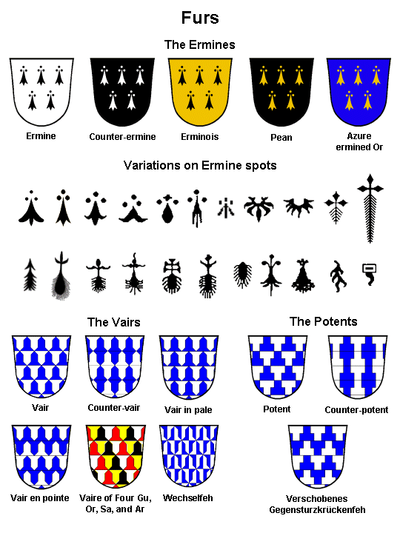

This Page Intentionally Left Blank

Engrailed vs Invected
(Some Picture Examples)
.

March 2007 LoAR Cover Letter:
"We therefore confirm and expand our current definition: A field division engrailed
has the points to the "honorable" part of the shield: Per fess, per chevron, per bend
and per bend sinister engrailed have the points to chief, while Per pale engrailed now
has the points to dexter. A field division invected has the points to the less honorable
part of the shield: Per fess, per chevron, per bend and per bend sinister invected have
the points to base, and Per pale invected has the points to sinister."

Engrailed Examples |  |  |  | Invected Examples
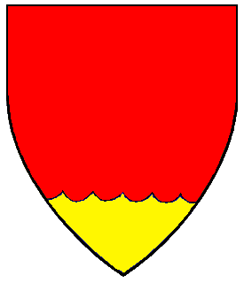 |  |  |  | 
Base Engrailed |  |  |  | Base Invected
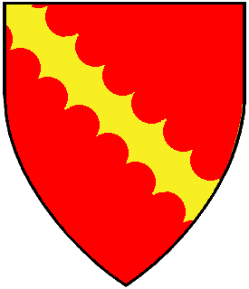 |  |  |  | 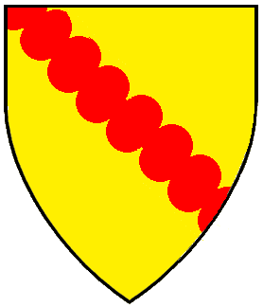
Bend Engrailed |  |  |  | Bend Invected
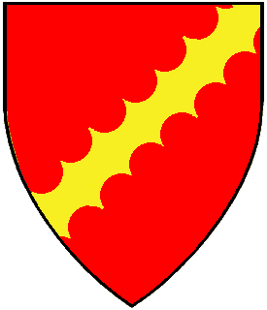 |  |  |  | 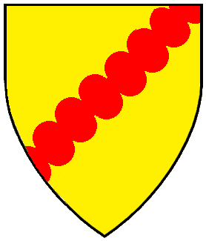
Bend Sinister Engrailed |  |  |  | Bend Sinister Invected
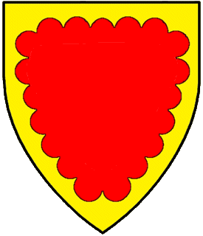 |  |  |  | 
Bordure Engrailed |  |  |  | Bordure Invected
 |  |  |  | 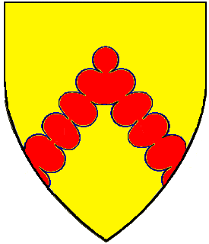
Chevron Engrailed |  |  |  | Chevron Invected
 |  |  |  | 
Chief Engrailed |  |  |  | Chief Invected
 |  |  |  | 
Fess Engrailed |  |  |  | Fess Invected
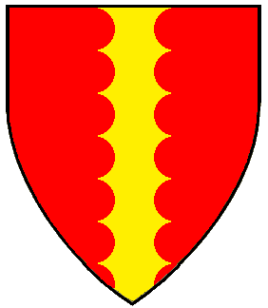 |  |  |  | 
Pale Engrailed |  |  |  | Pale Invected
 |  |  |  | 
Per Bend Engrailed |  |  |  | Per Bend Invected
 |  |  |  | 
Per Bend Sinister Engrailed |  |  |  | Per Bend Sinister Invected
 |  |  |  | 
Per Chevron Engrailed |  |  |  | Per Chevron Invected
 |  |  |  | 
Per Fess Engrailed |  |  |  | Per Fess Invected
 |  |  |  | 
Per Pale Engrailed |  |  |  | Per Pale Invected

This Page Intentionally Left Blank

Difference Between
Embattled, Bretessed & Embattled Counter-Embattled

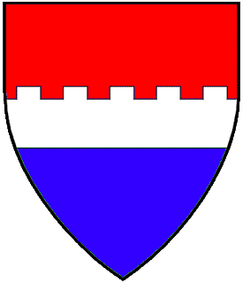 |  | 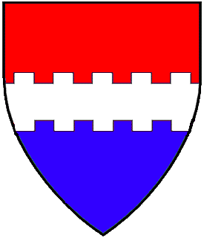 |  | 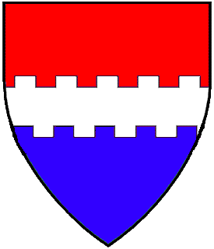
fess  embattled |  | fess  bretessed |  | fess  embattled counter-embattled
no bottom embattlement |  | embattlements are  opposite other side |  | embattlements are  off-set from other side

This Page Intentionally Left Blank

Examples of Some Triangular Divisions & Charges:
(Per Chevron Inverted, Pile, Chaussé and Chief Triangular)

Device Examples |  |  |  | Badge Examples
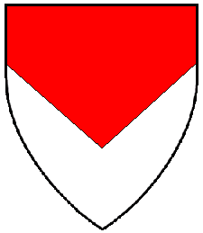 |  |  |  | 
Per chevron inverted: This field division starts on the sides of the shield,
down a little bit from the corners.

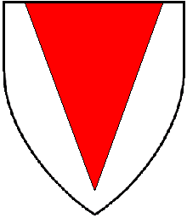 |  |  |  | 
Pile: This charge (object) starts in from the corners at the top and extends
down toward the base, but not [usually] touching the bottom. There should NOT be
room for any other object to be placed under the point of the pile.

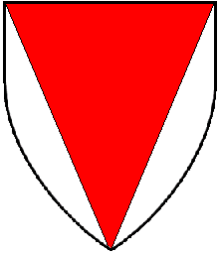 |  |  |  | 
Chaussé: This field division runs from the top corners to the bottom center.
The example shown would be blazoned, "Gules, chaussé argent." The field
is the red center section and the white edge sections are the chaussé portion.
No difference is given between a pile and chaussé (as per April 2000 LoAR),
thus "Argent, a pile gules." is directly in conflict with "Gules, chaussé argent."

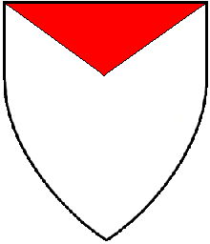 |  |  |  | 
Chief Triangular: This ordinary (object) begins in the corners and extends
to a point that is one-quarter to one-third the way down the shield.

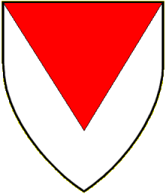 |  |  |  | 
INCORRECT: This depiction is often drawn for "per chevron inverted",
but it is incorrect and will be sent back by the College of Arms for a re-draw.
The division line does not issue from the sides and thus cannot be
"per chevron inverted". It does not extend far enough down (to the bottom)
to be chaussé. The top section does not start in from the corners, nor is it
deep enough to be a pile and it is too deep to be a chief triangular.
Do not do this!!!

There is a field division that is similar to the triangular divisions and charges that have already been discussed. But where the previous elements utilize two different tinctures in the design, this motif divides the field into three sections.
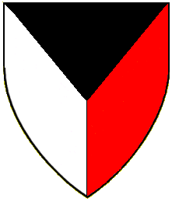 |  |  |  | 
Per pall: This field division starts in the corners and extends to a point about the middle of the shield then splits the design down the middle, making three sections.

This Page Intentionally Left Blank

Marshalling in Heraldry
Marshalling is a style of heraldic design to show familial relationships or alliances. While such was done in the middle ages, it is not registerable in the SCA. To assist folks in understanding what is and what is not considered marshalling, presented here are some guidelines and some pictorial examples:
Guidelines:
1. | A field divided per pale with different charges in each half of the field is not allowed,  if there is a plain (straight) line of division. If the per pale line is a complex (fancy)  line, then it is allowed.
2. | A field divided per pale with the same charge in each half of the field is allowed,  even if the line of division is a plain (straight) line.
3. | A field divided quarterly with one type of charge in the top left and bottom right quarters and a different type of charge in the top right and the bottom left quarters is not allowed if the lines dividing the field into quarters is a plain (straight) line of division.  If either the per pale line or the per fess line is a complex (fancy) line, or both the per pale and per fess line is a complex (fancy) line, then it is not considered marshalling... but doing this may create poor style <which could cause a return for non-period style>, so consider such a design carefully.
4. | A field divided quarterly with a different charge in each of the four sections is considered both marshalled arms and to be "slot machine heraldry".
5. | A field divided quarterly with one (same) type of charge in the top left and bottom right quarters and just a tincture (no charges) in the top right and the bottom left quarters is allowed, even if the lines of division are plain (straight) lines.  A field divided quarterly with one (same) type of charge in the top right and bottom left quarters and just a tincture (no charges) in the top left and the bottom right quarters is allowed, even if the lines of division are plain (straight) lines.
6. | A field divided quarterly with different types of charge in the top left and bottom right quarters and just a tincture (no charges) in the top right and the bottom left quarters is considered marshalled arms.  A field divided quarterly with different types of charge in the top right and bottom left quarters and just a tincture (no charges) in the top left and the bottom right quarters is  considered marshalled arms.
Visual Examples:
 |  | 
Marshalling | Not Marshalling | Not Marshalling
 | 
Marshalling | Not Marshalling
 |  | 
Marshalling | Not Marshalling | Not Marshalling
 |  | 
Marshalling  [Per last line of  RfS XI.3] | Marshalling  [Per last line of  RfS XI.3] | Not Marshalling
RfS XI.3. Marshalling: Armory that appears to marshall independent arms is considered presumptuous. Period marshalling combined two or more separate designs to indicate descent from noble parents and claim to inheritance. Since members of the Society are all required to earn their status on their own merits, apparent claims to inherited status are presumptuous. Divisions commonly used for marshalling, such as quarterly or per pale, may only be used in contexts that ensure marshalling is not suggested. a. Such fields may be used with identical charges over the entire field, or with complex lines of partition or charges overall that were not used for marshalling in period heraldry. b. Such fields may only be used when no single portion of the field may appear to be an independent piece of armory. No section of the field may contain an ordinary that terminates at the edge of that section, or more than one charge unless those charges are part of a group over the whole field. Charged sections must all contain charges of the same type to avoid the appearance of being different from each other.

Marshalling for Display Purposes

NOTE: Armory designs that appear to marshall independent arms are considered presumptuous and cannot be registered…HOWEVER...display of such heraldry showing allegiance or marriage is allowed (and encouraged) in the SCA.

Visual Examples:
 |  | 
Original Device #1 |  | Original Device #2
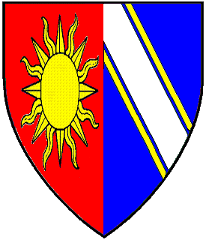 |  |  |  | 
Per Pale  Marshalling |  | Quarterly  Marshalling |  | Dimidiation  Marshalling

This Page Intentionally Left Blank

HERALDIC TERMS
compiled by Modar Neznanich

The following terms, and their definitions, are used in heraldry. Some terms and practices were used in period real-world heraldry only. Some terms and practices are used in modern real-world heraldry only. Other terms and practices are used in SCA heraldry only. Most are used in both real-world and SCA heraldry. All are presented here as an aid to heraldic research and education.

A LA CUISSE - at the thigh

A LA QUISE - at the thigh

ABAISED - a charge or element depicted lower than its normal position

ABAISSÉ - a charge or element depicted lower than its normal position

ABASED - a charge or element depicted lower than its normal position

ABATEMENTS - marks of disgrace placed on the shield of an offender of the law. There are extreme few records of such being employed, and then only noted in rolls. (As who would display their device if it had an abatement on it?)

ABISME - a minor charge in the center of the shield drawn smaller than usual

ABOUTÉ - end to end

ABOVE - an ambiguous term which should be avoided in blazon. Generally, two charges one of which is above the other on the field can be blazoned as in pale or an X and in chief a Y.

ABYSS - a minor charge in the center of the shield drawn smaller than usual

ACCOLLÉ - (1) two shields side-by-side, sometimes united by their bottom tips overlapping or being connected to each other by their sides; (2) an animal with a crown, collar or other item around its neck; (3) keys, weapons or other implements placed saltirewise behind the shield in a heraldic display.

ACCOMPANIED - between

ACCORNE - having horns or attires

ACCOSTED - side by side

ACHIEVEMENT - the full display of armorial honors including the escutcheon (shield), crest, wreath, mantling helm, supporters, compartments and mottoes.

ACORNÉ - being horned or attired

ACORNED - bearing acorns

ADDORSED - back to back

ADOSSÉ - back to back

ADUMBRATED - term applied to a charge depicted with a shadow of a darker/lighter hue of the shield's tincture

AFFRONTÉ - head and body facing observer

AFFRONTY - head and body facing observer

AIGUISÉ - pointed

AILETTES - (also called Emerasses) small escutcheons affixed to the shoulders of an armored knight.

AISLÉ - having wings

ALAND - (also Alant) a mastiff dog with short ears

ALERION - (also Allerion) without legs/feet or beak

ALISÉ - rounded or globular

ALLERION - without wings or beak

ALLOCAMELUS - also called an Ass-camel, this creature is part camel, part ass.

ALLUMÉ - refers to a beast's eyes being flecked with color

ALPHYN - (1) a creature like a stocky heraldic tyger with tufts of hair on its body and eagle claws for forefeet; also has a thick mane, knotted tail and long ears; (2) this creature has a body much like that of a wolf with the front legs and belly of a dragon. It also has long pointed ears, a long thin tongue, and a knotted tail.

ALTERNATE NAME - any name a participant in the SCA registers with the College of Arms other than their primary persona name.

AMBULANT - walking

AMPHISBÆNA <dragon-style> - (also called: Amfivena, Anphine, Anphivena and Fenmine) a dragon-like beastie with a head at each end. In SCA heraldry it is usually depicted as dragon with bird's wings and a head at either end.

AMPHISBÆNA <serpent-style> - (also called: Amfivena, Anphine, Anphivena and Fenmine) a serpent with two heads, one at each end of its body.

ANCHORED - ending in the flukes of an anchor <e.g. a cross anchored>

ANCIENT - a small flag ending in a point, similar to a pennon.

ANIME - having flames issuing from mouth and ears

ANNELLED - ringed (usually through the nose) <e.g. a bull annelled>

ANNODATED - bent in the form of the letter "S"

ANNULET - a ring

ANNULETTY - terminating in rings

ANTELOPE, HERALDIC - (1) a creature with an antelope body, heraldic tyger face, tusks, serrated horns, a lion tail and tufts down its spine; (2) Like a Tyger but with serrated horns and a deer’s legs. Probably the same as an Ibex though the horns may curve more. The antelope’s horns point backwards, the ibex’s forwards according to some references; (3) creature with a a body like a deer's, but with tusks, a lion's tail, and serrated horns

APAUME - hand, glove or gauntlet open showing palm

APPAUME - hand, glove or gauntlet open showing palm

APRES - a creature with the body of a bull and the tail of a bear

AQUILATED - semy of eagle heads

ARCHED - bent in the form of an arch

ARGASILL - a heraldic antelope

ARGENT - the heraldic tincture (metal) silver (usually represented by white)

ARMED - having teeth or talons or horns or claws or wearing armour

ARMIGER - a person who has been awarded the right to arms. Arms in the Society can only be given by the Crown of a kingdom, and come in three levels: Awards of Arms, Grants of Arms, and Patents of Arms (aka Letters Patent). A person with registered personal armory who is not an armiger has a device, but armigers have arms.

ARMORIAL - (1) Adjective. Of or related to armory. (2) Noun. A list of armory organized by the bearers' names.

ARMORIAL ELEMENT - a component of heraldic design. An armorial element may be a charge, a line of division, a line of partition, a field treatment, a tincture, or other component that maybe used in designing armory.

ARMORY - any design that the College of Arms registers or protects, including devices/arms and badges. This includes various important non-SCA armory from the real world and may also include trademarks, logos, and other graphic symbols that resemble heraldic bearings.

ARMS - a heraldic design that uniquely represents the person or group that owns it. In the SCA, people who have been awarded arms by the Crown of a kingdom may call their heraldic device "arms." The distinction between arms and a device is not tracked by the SCA College of Arms.

ARONDI - rounded or curved

ARRACHE - torn off

ARRANGEMENT - the placement of charges in a group relative to the other charges in the group. For example, three roundels two and one is a different arrangement than three roundels in fess. Arrangement is sometimes confused with Location, and sometimes with Orientation.

ARRAYED - richly appareled

ARRIERE - the back. "Volant en arriere" refers to the term for a bird or insect in flight and seen from above. The term tergiant is more commonly used.

ARRONDI - rounded or curved

ARROUNDIE - rounded or curved

ASCENDANT - rising upwards

ASCENDING - of a bird or wing creature taking flight

ASSIS - sitting. The more common tern is sejant.

ASSURGANT - {also assurgent} rising from or out of <e.g. a hand assurgant from a ford>

AT GAZE - a peaceful animal (usually referring to deer) standing with head facing the observer <e.g. a stag at gaze>

AT SPEED - a deer, fox or horse in running position

ATOP - said of a charge which is conjoined to another charge to base <e.g., a falcon perched atop a gauntleted cubit fesswise = in pale a falcon conjoined at the feet to a gauntleted cubit fesswise.>

ATTIRED - having antlers

ATTIRES - antlers

AUGMENTATION OF ARMS - (Also, Augmentation.) An honor added to a registered device. In the SCA, first the Crown of a kingdom must give the recipient of the augmentation the right to add a charge or charges to a registered device as an honor, then the honor must be registered with the College of Arms. An augmentation is not registered as a change of armory; instead, both the underlying arms and the arms with augmentation are protected. Therefore, the underlying armory can be changed while keeping the augmentation the same (assuming no style problems result). Augmentations are usually registered by the College of Arms in the form "[Blazon of device], and as an augmentation, [blazon of augmentation]".

AULNED - of a plant having a beard <e.g. a stalk of barley aulned>

AVERSANT - means "turned away"; refers to seeing the back of a charge (especially when talking about a hand, glove or gauntlet); has also been used to refer to a critter walking away from the viewer (aka called "south end of a north bound animal").

AZURE - the heraldic tincture (color) blue

BADGE - a piece of armory used by an individual or group to identify possessions, retainers, members, or other items. A badge is distinguished from a device, which is used solely by its owner (or the owner's herald). A badge also differs from a device in that it may be fieldless.

BADGER - a hard-working burrowing creature, known for its fierce fighting skill particularly when protecting home and family. In heraldry it is many times referred to as a brock.

BAGWYN - (1) a creature similar to heraldic antelope but with the tail of a horse and long curved horns; (2) in SCA heraldry it is described as similar to an antelope, but with a bushy tail, fringes of fur on the legs, and long swept-back attires.

BALANCE - the state of having charges distributed evenly or in accordance with period heraldic rules. Balance is not the same as symmetry. As a general rule, if all the charges are on one side of the shield, the design is considered unbalanced. However, period sensibilities for balance are not always obvious to the modern eye, and period heraldic designs should be consulted before making any categorical statements about balance. By looking at period designs, we find that "Azure, in chief three escallops Or" is balanced, but "Azure, to dexter three escallops in pale Or" is less balanced. Likewise, we find that "Quarterly gules and argent, in dexter chief a mullet argent" is balanced, but "Quarterly gules and argent, in dexter base a mullet argent" is not balanced.

BANDED - encircled with a band or ribbon

BANNER - a square or oblong flag emblazoned with arms; the principal personal flag used throughout the Middle Ages by the nobility.

BANNER, ENSIGN - a square or rectangular flag on which is displayed the full achievement of arms

BANNEROLE - a small banner, often stiffened or supported along its upper edge

BANNEROLL - a small banner, often stiffened or supported along its upper edge

BARS - medium sized bands that runs horizontally across the shield; usually two or more

BARBED - describing either rose sepals or the head of an arrow (pheon)

BARNACLE GOOSE - legends say that barnacle geese grow on trees whose branches hang over water. The young birds hang from the branches via their beaks. When the birds are mature, they fall from the trees; if they fall into the water they float and are safe, but those that fall on the land die.

BARRY - the field of the shield divided into many bars (of an even number of alternating tinctures).

BASE - the lower portion of the shield

BASILISK - a cockatrice with a dragon’s head stuck on the end of his tail

BAT - (also called Reremouse) seventh century sources state that the bat is a bird. But unlike other birds, it is a four-legged and resembles a mouse and makes a squeaking sound. The Latin name for the creature is "vespertilio" which refers to the time it flies (after twilight).

BATON - a couped bendlet

BAUCÉANT - see Beauseant

BAUDRICK - the sword belt

BEAKED - describing the beak of a bird or monster

BEAUSEANT - (also called the Piebald Banner) the banner of the Knight's Templar. It is: Per fess Sable and Argent.

BELLED - having a bell or bells attached

BEND - a broad band running diagonally across the shield from top left to bottom right (when viewed by observer)

BEND SINISTER - a broad band running diagonally across the shield from top right to bottom left (when viewed by observer)

BENDLETS - medium sized bands running diagonally across the shield from top left to bottom right (when viewed by observer), usually two or more

BENDLETS SINISTER - medium sized bands running diagonally across the shield from top right to bottom left (when viewed by observer), usually two or more

BENDWISE SINISTER - lying diagonally across the field from sinister chief to dexter base. Frequently misblazoned as bend sinisterwise, bendwise indicates the angular orientation, and sinister modifies that orientation.

BENDY - the field of the shield divided into many bendlets

BENDY SINISTER - the field of the shield divided into many bendlets sinister

BENEDICTION, IN - a hand apaume with first and second fingers erect and the others closed

BESANT - an Or colored roundel (represents a coin)

BESAUNT - an Or colored roundel (represents a coin)

BEZANT - an Or colored roundel (represents a coin)

BEZANTE - semy of bezants

BEZANTY - semy of bezants

BICAPITATED - having two heads

BICORPORATE - two creatures combatant sharing one head

BILLET - a rectangle shaped charge that represents a brick face

BILLETTY - semy of billets

BILLETY - semy of billets

BLASTED - of a tree without leaves

BLAZING STAR - a comet

BLAZON - to describe a heraldic device with words; the verbal description of a piece of armory.

BLEMISHED - broken <e.g. a sword blemished>

BOLTING - said of a rabbit or hare in a salient position

BONACON - (Also known as a Bonasus) a bull-like (or bison-like) creature with horns which curl inwards, a horse's tail and a short mane. Its horns were consider useless, but the creature was reported to be very dangerous as it defends itself by shooting burning excrements at its enemies. First noted in heraldry as a crest granted to Richard Chandelor in 1560. In SCA heraldry, the SCA College of Arms has a precedent again the registration of such a monster: "The bonacon was considered too offensive by a significant fraction of the College and is therefore not allowed for use in the SCA."

BORDURE - a border running along the edge of the escutcheon

BOREYNE - a creature with a barbed tongue, dorsal fin, the forelegs of a lion and the hind legs of an eagle

BOTEROLL - (also called a Cramplet) the metal termination piece of a scabbard

BOUND - describing the cover of a book

BRACED - interlaced

BRANCH - an official chapter of the Society for Creative Anachronism.

BREATHING - equivalent and more commonly blazoned as "At Gaze"

BRIDLED - having/wearing a bridle <e.g. a horse bridled>

BRISTLED - having bristles <e.g. a boar bristled>

BURGEE - banner used at sea, usually swallowtailed but square or rectangular in hoist

BURGEONEE - of fleur-de-lys with petals about to open like buds

BYNAME - the part of a personal name other than the given name. Byname is a broad term that includes hereditary surnames, patronymics, locatives, occupational descriptions and epithets.

CABLED - having a rope or chain attached <e.g. a lantern cabled>

CABOSHED - an animal head affronty but cut off clean behind the ears so that no part of the neck is visible

CABOSSED - an animal head affronty but cut off clean behind the ears so that no part of the neck is visible

CADENCY - the method of modifying armory to indicate a relationship with the owner of the original armory. Changes that were made to distinguish one device from another can be considered the smallest changes that were considered significant enough to be noticed at the time they were used. These changes are called cadency steps. Some changes to heraldry may not indicate cadency but may still be blazonable. Such changes include artistic variants of charges such as the tincture of a horse's mane, or the choice between a cross bottony and a cross crosslet. Systems of cadency vary depending on the time and place.

CALOPUS - (also called Chatloup) a creature with a wolf body, a cat head and goat horns.

CALYGREYHOUND - (1) a creature with the head of a wildcat with bulbous horns, tufted body & tail and claws on the forefeet; (2) creature that has the body of an antelope, the claws of an eagle of its forelegs and the hooves of an ox on its hind legs (3) in SCA heraldry it is described as a creature with a cat's face, tufted body and tail, eagle's forelegs and frond-like horns.

CAMELEOPARD - a giraffe

CAMELOPARD - like a cameleopard but with 2 long, winging horns

CANT - a heraldic pictorial pun [Most are done on surnames, but there are period examples of cants on first names as well as cants on occupations, positions and offices held by a person]

CANTON - a small square, usually in the upper left corner of the escutcheon. Reserved in SCA heraldry. It is used most often for an augmentation of arms.

CAP-A-PIE - fully armed

CAPARISONED - of an animal (usually a horse) barded and covered by ornamental cloth

CAREERING - term applied to horses that is equivalent to and more commonly referred to as salient.

CARETYNE - a creature with the body and horns of a bull, the head has a snout and tusks like a boar, cloven feet (and just one ear by some reports), which breathes fire and has gold spots (some reports say it is white with gold spots). May have originated from the Cretan Bull of Hercules mythos or the Marathonian Bull of Theseus mythos. Creature is noted as being on the badge of a Tudor-period courtier.

CARTOUCHE - an oval. Many times referring to the oval escutcheon used by popes and other Italian ecclesiastics.

CASQUE - a helm

CAT-A-MOUNT - (also called a cat-a-mountain) - a wild cat

CATOBLEPAS - a four-legged bull-like creature with a head that is large for its body, and blood-shot eyes that always look down.

CENTAUR - a creature that is half-man and half-horse. A centaur wielding a bow is called a sagittary.

CERASTES - a serpent with no spine and two ram's horns on it's head.

CD - (Also called Clear Difference) In armory, a difference of type, number, tincture, arrangement, or posture that has been deemed equivalent in importance to the addition or removal of a mark of cadency.

CHAINED - being possessed of a chain <e.g. a lion rampant chained>

CHANGE, MAJOR - used in the name registration process to describe a degree of change which the submitter may allow, or refuse to allow, to be made to the name in order to allow it to be registered. Major changes include dropping an element or phrase, changing the order of the name elements, and changing the language of an element.

CHANGE, MINOR - used in the name registration process to describe a degree of change which the submitter may allow, or refuse to allow, to be made to the name in order to allow it to be registered. Minor changes include accents, punctuation, hyphenation, addition or deletion of a letter, upper-lower case changes, etc.

CHAPÉ - field divided per chevron enhanced

CHARGE - a pictorial representation used for heraldic purposes; an item depicted on a piece of armory. A charge may be a simple geometric figure, such as a fess or a roundel, or a representation of an animate or inanimate item, such as a sword or a lion. A charge may be directly on the field, overall, or entirely on another charge.

CHARGE GROUP - a set of charges used together in a design as a single unit. The charges in groups in heraldry usually fall into standard arrangements depending on their number and what other items are involved in the design. A collection of charges that are arranged in such a standard arrangement are considered a single group, even if they are of different types and/or tinctures. For example, Per fess argent and gules, two towers sable and a roundel argent contains a single group of primary charges in the standard charge arrangement of two and one.

CHARGE GROUP 1: PRIMARY - the most important group of charges in a piece of armory. In blazons, the primary charge group is usually mentioned immediately after the field (though a strewn charge group is not primary when it is blazoned before a central charge group). If there is a central ordinary lying entirely on the field, it is the primary charge. If there is no such central ordinary, then the primary charge group is the set of charges of the same size that lie in the center of the design and directly on the field. An overall charge can never be the primary charge. In any piece of armory with charges there will always be a primary charge group, unless the only charges are peripheral. There cannot be more than one primary charge group in any given design. In "Gules, a pale between two mullets argent", the pale is the primary charge. In "Or, a maunche between three roundels azure" the maunche is the primary charge. In "Per chevron argent and sable, two roses and a fleur-de-lys counterchanged and on a chief purpure three hearts argent", the roses and fleur-de-lys are the primary charge group, because they are all of about the same size and in a standard arrangement. In "Azure semy of mullets and a chief argent" the strewn mullets are the primary charge group; in "Azure semy of mullets, an eagle and a chief argent" the eagle is the primary charge. In "Sable, a lion Or, overall a bend argent", the lion is the primary charge. In "Azure, a chief Or" there is no primary charge group.

CHARGE GROUP 2: SECONDARY- a group of charges on the field around the primary charge group. A design may have more than one secondary charge group. Each group may confer difference independently. In "Gules, a pale between two mullets argent", the mullets are the secondary charge group. The secondary charges in "Or, a maunche between three roundels azure" are the roundels. In "Sable, a chevron cotised argent between three millrinds Or" there are two secondary charge groups, the cotises and the millrinds. In "Per chevron argent and sable, two roses and a fleur-de-lys counterchanged and on a chief purpure three hearts argent", the chief is the secondary charge group. A peripheral charge group is a type of secondary charge group.

CHARGE GROUP 3: TERTIARY - any group of charges placed entirely on other charges. Tertiary charges in a group may be together, such as three charges on a chief, or may each be on members of the same charge group. "Per chevron argent and sable, two roses and a fleur-de-lys counterchanged and on a chief purpure three hearts argent" has one group of tertiary charges on the chief. "Gules, a chevron between three roses Or, each charged with a cross fitchy sable" has one group of tertiary charges, the crosses. "Or, on a fess gules an escallop between two millrinds Or, all within a bordure vert charged with eight roundels argent" has two groups of tertiary charges, one group with the escallop and millrinds and the other with the roundels. Each tertiary group contributes to difference independently.

CHARGE GROUP 4: PERIPHERAL - a charge or group of charges that are placed on the field near the edge of a piece of armory without affecting the rest of the design. Peripheral charges include (but are not limited to): the chief, the bordure, the base (including the point pointed), the quarter, the canton, the gyron, the orle, the double tressure, and flaunches. Gores and gussets are not peripheral charges (because they extend so far into the center of the field). Peripheral charges are never primary charges, even if they are the only charges on the field. Peripheral Charge Groups are a type of secondary charge group.

CHARGE TYPE - The kind of a charge in a piece of armory. "Gules, a chevron between two candles and a lantern Or" has three types of charges: chevrons, candles, and lanterns. "Argent, on a pale purpure between two lions combatant gules three lions passant Or" has two types of charges: pales, and lions in two different postures.

CHASE, IN FULL - of a hound in pursuit (courant position)

CHASED - (also called Umbration, Adumbration and Chasing) This term means voided but with the interior details and lines still showing as well as the outline. In SCA heraldry, the practice was disallowed in April 1982, as part of the general ban on "thin-line heraldry" that also restricts voiding and fimbriation.

CHATLOUP - (also called Calopus) a creature with a wolf body, a cat face and goat horns.

CHECKY - being divided into small squares of alternating tinctures (1 color and 1 metal)

CHEQUY - being divided into small squares of alternating tinctures (1 color and 1 metal)

CHEVRON - a broad band in the shape of an inverted "V" that stretched horizontally across the shield

CHEVRONELS - medium size bands in the shape of an inverted "V"

CHEVRONNY - the field of the shield divided into many chevrons or chevronels

CHIEF - top third of the shield

CHIMERA - a fire breathing creature that has the body of a goat, the head of a lion and the tail of a serpent. Sometimes depicted as a lion body with three heads (one lion, one goat, one serpent/dragon-like).

CHORDILIERE - (also called Cordon) a silver cord which sometimes encircles a widow's coat-of-arms

CINQUEFOIL - a conventional flower of 5 equal parts. In early heraldry it was synonymous with a rose.

CLASPED - describing the clasp of a book

CLEAR DIFFERENCE - (Also called a CD.) In armory, a difference of type, number, tincture, arrangement, or posture that has been deemed equivalent in importance to the addition or removal of a mark of cadency.

CLENCHED - hand, glove or gauntlet with all fingers closed

CLIMANT (also Clymant) - term for a goat in rampant position

CLOSE - a bird, or other winged creature, with wings down and close to the body

CLOSED - a bird, or other winged creature, with wings down and close to the body

CLOUE - nailed

CLYMANT (also Climant) - term for a goat in rampant position

COAT-OF-ARMS - originally the linen coat worn over armor on which the armorial device of the wearer was depicted. Currently it refers to a heraldic device which is a heraldic design that uniquely represents the person or group that owns it. A person who has not been awarded arms may register personal armory as a device. This device will become arms when the person receives an award, grant, or patent of arms.

COCKATRICE - similar to a wyvern but with a cock’s head, comb and wattles, and a barbed tongue

CODED - having a scrotum of a different tincture

COHERENT - refers to armory when all the elements of a design work together to produce a single effect. Usually, a field division or the primary charge establishes a pattern of arranging items on the field. Coherence is diminished by placing elements with no relation to each other, or ignoring the pattern set in the design. Coherence is also be diminished by using unlike charges in a group.

COILED - of a snake, wrapped around itself with head erect

COJOINED - joined together

COLLARED - having a plain collar

COLLEGE OF ARMS - in the SCA this consists of the Sovereign(s) of Arms, the warranted heralds on Laurel staff, the Principal Herald of each kingdom, and such other persons as Laurel may deem to be of assistance.

COLLEGE OF HERALDS - in the SCA this consists of the Principal Herald of a kingdom, the warranted heralds and pursuivants of a kingdom, and such other persons as the Principal Herald may deem to be of assistance.

COLOR - in SCA heraldry, the colors are azure, gules, sable, purpure and vert. The furs that use colors as underlying tinctures, such as counter-ermine and pean, are treated like colors for contrast purposes.

COMBATANT - (also combattant) refers to two creatures facing each other in the rampant position. [A few sources applied this only to wild or warlike beasts, but many other sources applied this to any animal, monster or beast.]

COMBED - describing the crest of a rooster (cock)

COMET - an estoile of six points with a tail extending from it

COMPARTMENT - the surface (often drawn as a grassy mound) on which the supporters stand

COMPATIBLE - in keeping with the normal usage for period heraldry. In the SCA this is extended to also include the domain of the Society.

COMPLEMENT, IN HER - a full moon with a face

COMPLEXITY COUNT - a measure of armorial simplicity. The Complexity Count is the sum of the number of types of charges and the number of tinctures in an armorial design. In the SCA this is discussed in the their Rules for Submission. Armory with an excessively high complexity count may be returned. However, armorial designs which are period in style may be registered even if they have a high Complexity Count.

COMPONE - being composed of a single row of rectangles consisting of an alternating color and metal. If there are two rows of rectangles it is called "counter-compony". If there are three or more rows of rectangles, it is called "checky".

COMPONY - being composed of a single row of rectangles consisting of an alternating color and metal. If there are two rows of rectangles it is called "counter-compony". If there are three or more rows of rectangles, it is called "checky".

CONFLICT - a submission which is too similar to a protected item is said to be in conflict. For armory, this occurs if the submission is only a cadency step or less different from the protected item. For names, this occurs if the submission is not readily distinguishable from the registered item.

CONJOINED - joined together

CONTOURNE - {also contourny} {sometimes misspelled contourney} refers to an animate charge reversed to face to sinister

CONTOURNY - {also contourne} {sometimes misspelled contourney} refers to an animate charge reversed to face to sinister

CONTRAST - a level of visual distinction between different tinctures.

CORDED - tied with a cord

CORDON - (also called Chordiliere) a silver cord which sometimes encircles a widow's coat-of-arms

COTISE - a very small diminutive of a bend, fess, pale or chevron. They are always in pairs and one lies on either side of the ordinary it is a diminutive of.

COTISED - of an ordinary having a cotise on either side of it.

COUCHANT - laying down with head up

COUE - the tail between the legs. More commonly called "cowed".

COUNTER - prefix meaning opposite

COUNTERCHANGED - whereby a shield is divided by a line of partition and any charge placed thereon has its tinctures reversed on either side of the line.

COUPED - cut short by a straight horizontal line

COUPED CLOSE - cut short by a straight vertical line

COURANT - running at speed

COURSE, IN FULL - of a hound in pursuit (courant position)

COWARD - the tail between the legs

COWED - the tail between the legs

CREMELLE - having crenellations. More commonly called "embattled".

CRAMPLET - (also called a Boteroll) the metal termination piece of a scabbard

CRESCENT - a curved partial moon with the "horns" pointing upwards

CRESCENT REVERSED - a curved partial moon with the "horns" pointing downwards

CREST - the charge/symbol that is set upon the helm in a full achievement.

CRESTED - describing the crest of a rooster (cock)

CRI DE GUERRE - literally means "cry of war"; a war-cry/motto put on a scroll beneath a displayed coat-of-arms

CRINED - describing hair or mane

CROSS, IN - charges placed in the form of a cross

CROSS-WISE - charges placed in the form of a cross

CROWNED - having a crown

CRUSILLY - semy of crosses (one of the most common is a semy of crosses crosslet)

CRUSILY - semy of crosses (one of the most common is a semy of crosses crosslet)

CUFFED - having cuffs

CUISSE, A LA - at the thigh

CURIOSITY, IN ITS - of a cat standing upright against and peering into a cauldron

CYCLAS - a surcoat cut short at the front and long at the back

DANCETTY - applies only to a two-sided ordinary (such as a pale or fess) which zigzags or dances across the field. Indeed, a fess dancetty may be blazoned simply as a dance. Modern non-SCA heraldic treatises define dancetty as a larger version of indented, but period blazons do not make this distinction.

DEBRUISED - overlaid

DECHAUSSE - dismembered

DECOLLATED - decapitated

DECOLLE - decapitated

DECRESCENT - a curved partial moon with the "horns" pointing to sinister

DEFAMED - having no tail (of a creature that normally has a tail)

DEFAULT - often used as an adjective meaning "standard, not needing to be blazoned"; it may be applied to arrangement, orientation, or posture.

DEGRADED - placed upon/atop steps

DELF - charge that is represented by a square

DEMI - having only the upper half depicted

DEMOBISON - (also spelled demo-bison) a bat-winged bison; a demon-bison

DENTED - having teeth of a different tincture

DESIGNATOR - the word used in a non-personal name (such as for a group or an office) to define the type non-personal name. Designators may be the types of official branches (such as Barony, Shire, Kingdom, etc.), or they may be other kinds of designations (such as Order, Guild, House, Office, Pursuivant and so forth). Designators do not contribute to difference between non-personal names.

DEVICE - a heraldic design that uniquely represents the person or group that owns it. A person who has not been awarded arms may register personal armory as a device. This device will become arms when the person receives an award, grant, or patent of arms. The distinction between arms and a device is not tracked by the College of Arms.

DEXTER - left side of the shield when observed from the front; right side of person wearing the shield

DIAPERING - refers to the field of a shield being decorated with damask or arabesque or knotwork in a lighter or darker shade of the tincture it is on. Thus it gives ornamentation without being a part of device.

DIFFERENCE, CLEAR - (Also called a CD.) In armory, a difference of type, number, tincture, arrangement, or posture that has been deemed equivalent in importance to the addition or removal of a mark of cadency.

DIFFERENCE, SIGNIFICANT - in armory, a level of difference which would have been considered by heralds in period to be a cadency step; in most cases, a sufficient amount of difference to grant a Clear Difference. A Significant Difference is a lesser level of difference of charge type from Substantial Difference. For example, a pine tree is significantly different from an oak tree (because they have widely differing shapes), but they are not substantially different from each other (because they are both trees). In names, two name phrases are significantly different if they are readily distinguishable both in sound and appearance.

DIFFERENCE, SUBSTANTIAL - in armory, a level of difference would have been considered by heralds in period to be more than a cadency step. A greater level of difference of charge type than significant difference. In most cases the use of a charge as a main charge that has a substantial difference from the main charge of another device will automatically clear any conflict with the other device. For example, a sword is substantially different from a sun. Thus "Gules, a sword Or" is clear of conflict from "Gules, a sun Or."

DIMIDIATION - having two halves of different shields joined together in a "per pale" merging.

DIMINUTIVE - in names, a name that is derived from another name as a shortened or pet form. Belet, Bibby, Ibbe, Ibbet, Libbe, and Tibota were all period diminutives of Isabel. Some diminutives are actually longer than the original name. For example Jobin is a period diminutive of Job and Josekyn is a period diminutive of Joss. In armory, it refers to multiple and (usually) narrower variants of an ordinary. For example, two bars are diminutives of a fess, and two bendlets are diminutives of a bend. SCA armory does not use most single diminutives of charges, as they were considered artistic variants of the single ordinary in period.

DISARMED - without claws or beak or horns or teeth or talons (of a creature normally having them)

DISCLOSED - having wings displayed but pointing down. More commonly referred to as "displayed inverted".

DISMEMBERED - of a beast with head, legs and tail separate from body

DISPLAYED - with wings expanded (spread-eagle)

DISTILLING - shedding drops

DOCUMENTED - found in a source that was created before 1600 A.D. More recent sources that quote sources created before 1600 are acceptable as documentation unless they are shown to be erroneous.

DOLPHIN - (also called Delphine) sea creature whose name derives from them joining together to sing. They are noted as being the fastest beasts in the sea and for the fact that they can jump over most ships.

DOMAIN OF THE SOCIETY - for the SCA, this refers to Europe and areas that were in contact with Europe before 1600 A.D.

DORMANT - sleeping; laying down with head down

DOUBLE-HEADED - having two heads

DOUBLE-QUEUED - having two tails

DOUBLED - having the lining turned up (usually clothes)

DRAGON - one of the most well-known heraldic monsters. The heraldic dragon is a 4-legged beast with a horny head, barbed tongue, scaly back, armoured rolls on the chest and belly, 2 bat-like wings, 4 legs with talons like an eagle’s, and a pointed tail often with an arrow-like end.
It is usually shown rampant, statant or passant, and rarely displayed like an eagle. A sea dragon has no wings

DYNAMIC - a design arrangement which gives an impression of motion or activity. This can happen by posing charges so that their apparent weight is not over their bases, such as in a depiction of a running man who is leaning forward so that his weight does not appear to be firmly supported by his feet. It can also happen if charges are unevenly spaced to give an impression of motion from one to the next. Dynamic is the opposite of static. In general, dynamic designs are not typical of period heraldry.

EDGED - describing the surface formed by the closed pages of a book

ELEMENT, ARMORIAL - a component of heraldic design. An armorial element may be a charge, a line of division, a line of partition, a field treatment, a tincture, or other component that maybe used in designing armory.

ELEMENT, NAME - a part of a name. A name element is usually a single word, such as a given name or an adjective in a description byname. A name phrase is made up of name elements; while these terms are sometimes used interchangeably, they help to distinguish issues involving the construction of words from issues of the construction of appropriate grammatical phrases. For example, in the name Richard of Sheepford, “Sheepford” is a name element, while the byname “of Sheepford” is a name phrase.

ELEVATED - pointing upwards <e.g. wings elevated>

EMBATTLED - having crenellations (like the battlements of a castle)

EMBLAZON - the drawing or depiction of a piece of armory.

EMBOWED - curved or bent

EMBRUED - spattered or dripping with blood

EMBRUSED - spattered or dripping with blood

EMERASSES - (also called Ailettes) small escutcheons affixed to the shoulders of an armored knight.

EN SOLEIL - surrounded by rays of the sun <e.g. a rose en soleil>

ENCIRCLED - of a serpent when coiled

ENDORSED - back to back

ENFIELD - creature with head and ears of a fox, chest of a greyhound, forelegs are those of an eagle, and hindquarters, back legs and tail of a wolf.

ENFILED - pierced with

ENFLAMED - flaming; having flames all about or having flames issuant from a charge

ENGOULED - (also called Engoulee and Engoulé) term meaning partly swallowed describes an object disappearing into the jaws of anything and is used to refer to (1) when the ends of a ordinary [usually bends & crosses] terminate in heads swallowing the ordinary; (2) when one heraldic charge is being swallowed by another charge, for example an infant engouled by a serpent.

ENGRAILED - a line with semi-circular indents with the points outward

ENHANCED - raised above the normal position

ENLASSÉ - a term meaning "enlaced"; interlaced

ENRAGED - having tongue and claws of a specific tincture

ENSIGN - In SCA heraldry it refers to the heraldic design that is reserved for use by a kingdom's populace to denote their alliance to the kingdom.

ENSIGN BANNER - in modern world heraldry, it refers to a square or rectangular flag on which is displayed the full achievement of arms. In SCA heraldry it refers to a banner flown by a member of a kingdom's populace (upon which is the kingdom ensign) to denote their alliance to the kingdom.

ENSIGNED - having a charge placed above <e.g. a lion ensigned of a crown>

ENTOURED - surrounded by

ENVIRONED - encircled by

EPITHET - a byname that describes physical or mental characteristics, personality traits, or characteristic behavior. The term nickname and descriptive byname is also sometimes used. Little John, Ethelred the Unready, and Richard Gotobedde are all examples of names with epithets. T

EQUIPPED - fully armed

ERADICATED - uprooted

ERASED - torn off in a horizontal plane leaving a ragged edge

ERASED CLOSE - torn off in a vertical plane leaving a ragged edge

ERECT - upright

ERMINED TINCTURES - these are heraldic furs. There are many possible varieties of these, all based on the design of strewn ermine spots (abstract designs representing ermine tails). The most common are ermine (argent with sable ermine spots), counter-ermine (sable with argent ermine spots; also known as ermines, but that term is discouraged in the SCA due to the possibility of typographic errors), erminois (Or with sable ermine spots) and pean (sable with Or ermine spots). Other combinations do not have unique names and must be explicitly blazoned as <tincture> ermined <tincture>, e.g., gules ermined argent (gules strewn with argent ermine spots). Unlike other designs featuring strewn charges, the ermine variants are furs and are classed as separate tinctures in their own right, rather than as charged fields. However the ermine spots must have good contrast with the tincture on which they are placed (for example "Azure ermined gules" does not have acceptable contrast.). For contrast purposes, these furs are classed either as colors or metals according to their underlying tincture (so ermine is classed as a metal, and pean is classed as a color). Ermine spots can also be used as normal charges; if not in a strewn arrangement they are treated no differently from any other charges.

ESCUTCHEON - shield or shield shape

ESTOILE - a star of six wavy rays

ESTOILY - semé of estoiles

EXTENDED - of a tail when held in a horizontal position (tip may curl)

EYED - having eyes of a specific tincture

FACE - the head of a lion, leopard, panther or fox when caboshed

FEATHER - the feather of a bird.

FEATHERED - describing the fletching of an arrow

FERRATED - semy of horseshoes

FESS - a broad horizontal band across the center of the shield

FESS POINT - the center point of an escutcheon, the middle point on the shield

FESSWISE - lying in the direction of a fess

FIELD - the surface of a shield upon which charges are placed

FIELD PRIMARY ARMORY - armory that has no charges, or an uncharged peripheral ordinary.

FIELD TREATMENT - a repeating pattern drawn in a tincture with good contrast over the field or a charge. Field treatments leave more of the underlying tincture showing than they cover. They are considered a part of the field or charge tincture. The term field treatment is not a standard real-world heraldic description for a class of armorial designs, but is the SCA catch-all term for the few period heraldic designs meeting this description. Field treatments include masoned and the forms of papellony and scaly which are drawn as voided scales. Field treatments do not include the ermined furs, fretty or strewn charges.

FIELDLESS ARMORY - a badge with no specified field tincture; such badges may be displayed on any appropriate background. Badges without fields should be designed as a single unit, with the charges all connected in some way as if they were cast out of metal in a mold. Devices may not be fieldless.

FIGURED - having a human face

FILLET - a narrow horizontal band placed in the lowest quarter are of the chief. (The bottom fourth part of the top third part of the escutcheon.)

FIMBRIATED - having fimbriation

FIMBRIATION - outlining a charge in a contrasting tincture. In general, a simple convex charge such as a pale, roundel, or a heart may be fimbriated, while a charge with a more complex outline such as a lion cannot. In SCA heraldry, fimbriation is only allowed for charges in the center of the field.

FINNED - having fins of a different tincture

FIRED - ignited; in flames

FITCHED - of an object whose base (or foot) is pointed

FITCHY - (also spelled fitchée) of an object whose base (or foot) is pointed (e.g. a cross fitchy)

FLAMANT - in flames

FLEXED - bent or bowed

FLIGHTED - describing the fletching of an arrow

FLORY - ending in fleur-de-lis; a line with fleur-de-lys (all their points and base going in the same direction)

FLORY-COUNTERFLORY - of a line with fleur-de-lis alternating the direction of their points and bases

FLOTANT - floating (usually ships or flags)

FLUTED - having grooves (usually pillars)

FOLIATED - having leaves (e.g. a staff foliated)

FORCENE - a rearing horse with both hind hooves on the ground instead of one hoof as in the rampant position

FORD - a base that is barry wavy azure and argent

FOUNTAIN - a roundel that is barry wavy azure and argent

FOURCHE - forked <e.g. a tail fourche>

FRACTED - broken

FRINGED - having a fringe of a specific tincture

FRUCTED - bearing fruit

FULL CHASE, IN - of a hound in pursuit (courant position)

FULL COURSE, IN - of a hound in pursuit (courant position)

FUMANT - emitting smoke <e.g. a fireball fumant>

FURNISHED - a horse wearing a caparison

FURS - in SCA heraldry, the furs include ermine, counter-ermine, erminois, pean, vair, potent, and their variants (ermined tinctures). The furs also include the variants of scaly and papellony which consist of solid-tinctured scales of two alternating tinctures. Furs composed equally of a metal and a color (e.g. vair) are considered neutral for contrast purposes. Furs that use a metal as the underlying tincture (e.g. ermine) are treated as metals for contrast. Furs that use a color as the underlying tincture (e.g. pean) are treated as colors for contrast purposes.

FUSIL - a lozenge with the top and bottom elongated

FUSILLY - when the field is composed of fusils, each touching at their points

GABONE - a term equivalent to and more commonly called Compone

GAMBE - (usually spelled jambe) the lower part of a creature's leg cut off at the second joint

GANSAS - a swan-like creature that has only one leg with (one) webbed foot on which is one talon. Yearly they migrate to the moon.

GARB - a wheat sheaf

GARNISHED - adorned, decorated

GEMMED - having or describing a precious stone <e.g. a crown gemmed>

GERATTY - an old term that is equivalent to and more commonly called "semy"

GIVEN NAME - the name given to a person at birth or in a naming ceremony such as baptism. In the English naming tradition, the given name is usually a person's first name, so Francis Drake's given name is Francis.

GLISSANT - of a snake when gliding

GLORY - a halo

GLORY, IN HIS - a full sun with a face

GOBONY - a term equivalent to and more commonly referred to as "compony"

GOLPE - a purpure colored roundel (represents a wound)

GONFALON - (also spelled Gonfallon) a personal flag emblazoned with the arms, and supported by means of a horizontal pole suspended by cords at the top of a staff.

GONFANNON - a personal flag emblazoned with the arms, and supported by means of a horizontal pole suspended by cords at the top of a staff.

GORGED - encircled about the throat

GOUTE - a drop

GOUTTE - a drop

GOUTTE D'EAU - an Argent drop that represents a water drop {plural: goutty d'eau}

GOUTTE D'HUILE - a Vert drop that represents an oil drop {plural: goutty d'huile}

GOUTTE D'OLIVE - a Vert drop that represents an oil drop {plural: goutty d'olive}

GOUTTE D'OR - an Or drop that represents a molten gold drop {plural: goutty d'Or}

GOUTTE DE POIX - a Sable drop that represents a drop of pitch/tar {plural: goutty de poix}

GOUTTE DE POURPRE - a Purpure drop that represents a drop of wine {plural: goutty de pourpre}

GOUTTE DE SANG - a Gules drop that represents a drop of blood {plural: goutty de sang}

GOUTTE DES LARMES - an Azure drop that represents a tear drop {plural: goutty des larmes}

GRANDFATHER CLAUSE - in regards to SCA heraldry, it is the popular name given to the guarantee in Corpora that, once registered, a name or piece of armory remains registered unless the owner requests its release, regardless of changes in the Rules for Submissions and standards applied to submissions after that time. The term Grandfather Clause is also sometimes applied to the provisions that allow a submitter to use elements that they have previously registered in new name or armory submissions, even if those elements are no longer acceptable under the current Rules for Submissions. On a case by case basis, this allowance has been extended to the submitter's immediate legal family.

GRAY AREA - for the purposes of documenting names and armory, anything that can be documented as late as 1650 may be considered acceptable, even though the official cut-off date of the SCA's domain as defined in Corpora is 1600. 1601-1650 is known as the gray area, and exists because it is logical to assume that something current in the period 1601-1650 may also have been current in the last years of the 16th Century, so long as there is no specific evidence to the contrary. Gray area documentation should only be used as a last resort.

GRIFFIN - (also spelled Gryphon and Griffon) a creature with the head, breast, wings and claws of an eagle, with the hindquarters and tail of a lion. It has swept-back pointed ears. If rampant it is termed segreant. A male griffin (called a Keythong) has no wings but often has horns and a spiky tail.

GRINGOLY - ending with serpent heads

GROUP - in regards to SCA heraldry, a collection of people, not necessarily an official branch. Households, orders, and branches are all referred to as groups in the Rules for Submissions.

GROUP, CHARGE - a set of charges used together in a design as a single unit. The charges in groups in heraldry usually fall into standard arrangements depending on their number and what other items are involved in the design. A collection of charges that are arranged in such a standard arrangement are considered a single group, even if they are of different types and/or tinctures. For example, Per fess argent and gules, two towers sable and a roundel argent contains a single group of primary charges in the standard charge arrangement of two and one.

GUARDANT - head turned to face the observer

GUARDED - having the lining turned up (usually clothes)

GULES - the heraldic tincture (color) red

GULON - a creature known to be like a dog in shape and size with a cat face, which has very sharp nails, long brown hair, and a tail like a fox.

GURGES - a whirlpool depicted as a spiral

GYRON - a triangular sector of the field formed by half of a bend line and half of a fess line meeting at the middle of the shield.

GYRONNY - the field being composed of gyrons (usually eight). This is done by dividing the field with a "per fess" line, a "per pale" line, a "per bend" line and a "per bend sinister" line.

HABITED - clothed

HAFTED - describing the handles of tools and weapons

HALF - for the purposes of counting armorial difference, half is usually defined in the mathematical sense. However, in certain circumstances, half may be defined differently. These circumstances are:

(i) The bottommost of three charges arranged two and one, either alone on the field or surrounding a
central ordinary such as a fess or chevron, is defined as one-half of that charge group. However, no
more than one difference may be obtained by making changes to that bottommost charge.

(ii) The two portions of a field divided per chevron or per chevron inverted are each considered half for
determining difference of the field.

HAMADE - a bar couped

HARDSHIP CLAUSE - in regards to SCA heraldry, it sometimes happens that a submission is delayed so long by circumstances outside the submitter's control that changes in the Rules for Submissions or their interpretation make it unregisterable. Depending on the exact circumstances, and on a case-by-case basis, the submission may be judged according to the older Rules for Submissions and interpretations; this policy is popularly known as the Hardship Clause.

HARPY - a vulture-like bird with the head and breasts of a woman

HAURIANT - erect with head upwards

HEDGEHOG - (also called Herison and Urchin) a creature known for its quills used in defense and for spearing fruit to take home to its young.

HELMED - wearing a helmet

HER COMPLEMENT, IN - a full moon with a face

HER PLENTITUDE, IN - a full moon with a face

HERALD - in regard to SCA heraldry, when the term is used with a capital H, Herald is a title referring to a person at a particular level in the College of Arms. Used with a small h, a herald is a person who works regularly on some aspect of heraldry.

HERALDIC - of or pertaining to heralds or heraldry

HERALDIC DEVICE - a heraldic design that uniquely represents the person or group that owns it. A person who has not been awarded arms may register personal armory as a device. This device will become arms when the person receives an award, grant, or patent of arms.

HERALDRY - the study of the art & science of armorial bearings

HEREDITARY SURNAME - a byname passed to all the offspring in a family, and therefore also called family names. Modern English surnames usually come last, so Francis Drake's surname is Drake. Other cultures may place their hereditary surnames in other positions in the name. The alternate term "Inherited Surname" is also used to refer to this type of byname. Hereditary surnames are often called simply surnames, but this usage is ambiguous and should be avoided.

HERISSONY (also herissoneé) - of a cat with its back in an enarched position (commonly called a "Halloween cat")

HILTED - describing the handle and guard of a weapon

HIND - a female deer

HIPPOCAMPUS - (also called a heraldic Sea-Horse) a beast with the top half of a horse and bottom half being a fish's tail. It usually has forelegs with webbed paws.

HIPPOGRIFF - (also called a hippogryph) this creature is a cross between a horse and a griffin, with the front of a female griffin and the back of a horse.

HIS GLORY, IN - a full sun with a face

HIS SPLENDOR, IN - a full sun with a face

HOODED - having a hood on <e.g. a hawk hooded>

HORNED - having horns

HUMETTY - couped at the ends <e.g. a saltire humetty>

HURT - an azure roundel (represents a bruise)

HURTY - semy of hurts

HYDRA - a 7-headed dragon

HYDRUS - (also called an Enhydros) this is an animal known for killing crocodiles from the inside after being swallowed by them.

HYENA - a canine-like creature that eats human corpses and has the ability to change its sex.

IBEX - a heraldic antelope with straighter horns.

IGNITED - in flames

IMBRUED - spattered or dripping with blood

IMPALED - said of two coats-of-arms shown side by side on the same escutcheon. (The escutcheon is divided "per pale" and there is a separate coat-of-arms in each of the two sections.)

IMPORTANT NON-SCA NAMES & ARMORY - in regards to SCA heraldry, real-world names and armory that Laurel has designated important enough to protect.

IN ANNULO - multiple charges in a circular arrangement

IN BENEDICTION - a hand apaume with first and second fingers erect and the others closed

IN CROSS - charges placed in the form of a cross

IN FULL CHASE - of a hound in pursuit (courant position)

IN FULL COURSE - of a hound in pursuit (courant position)

IN HER COMPLEMENT - a full moon with a face

IN HER PLENTITUDE - a full moon with a face

IN HIS GLORY - a full sun with a face

IN HIS SPLENDOR - a full sun with a face

IN ITS CURIOSITY - of a cat standing upright against and peering into a cauldron

IN ITS PIETY - of a pelican wounding its breast with its beak and nourishing its young with its own blood

IN ITS PRIDE - of a peacock (or turkey) affronty with its tail fanned out in display

IN ITS VIGILANCE - of a crane when standing on one leg and holding a stone in the other

IN LURE - two wings joined at the base with their tips pointing downward

IN SALTIRE - charges placed in the form of a saltire

IN TRIAN ASPECT - position of a charge that gives three dimensional appearance (few period charges done as such)

IN VENERATION - kneeling as if in prayer

INCENSED - having flames issuing from mouth and ears

INCRESCENT - a curved partial moon with the "horns" pointing to dexter

INDENTED - applies to a line of division which zig-zags across the field, e.g., per fess indented, a chief indented. Victorian and modern non-SCA heraldic treatises define indented as a smaller version of dancetty, but period blazons do not make this distinction.

INDORSED - back to back

INFLAMED - in flames

INVECTED - a line with semi-circular indents with the points inward

INVERTED - downward or upside-down

INVOLVED - encircled

IRRADIATED - surrounded by rays of light

ISSUANT - emerging from behind; proceeding from; coming out of

ITS CURIOSITY, IN - of a cat standing upright against and peering into a cauldron

ITS PIETY, IN - of a pelican wounding its breast with its beak and nourishing its young with its own blood

ITS PRIDE, IN - of a peacock (or turkey) affronty with its tail fanned out in display

ITS VIGILANCE, IN - of a crane when standing on one leg and holding a stone in the other

JACENT - lying on its side

JACULUS - this is a winged, leaping snake. Usually the wings are bat-wings. In the SCA such a creature is referred to as a pithon or if the wings are bird-type wings, a winged serpent.

JAMBE - the lower part of a creature's leg cut off at the second joint

JELLOPED - having wattles

JESSANT - emerging

JESSANT-DE-LYS - having a fleur-de-lys emerging from a charge

JESSED - having thongs attached <e.g. a hawk jessed>

KEYTHONG - a male griffin, it has no wings but often has horns and a spiky tail.

KRAKEN - in SCA heraldry it is depicted as a squid, with tentacles and a pointed head; the number of tentacles are left to the artist, but is most commonly shown with ten.

LAMIA - (also spelled Lammia) a creature with the upper half of a woman and the lower half of a snake

LANGUED - having a tongue of a specific tincture

LAUREL - in regards to SCA heraldry, the Laurel Sovereign of Arms, who is the principal heraldic officer of the Society and the head of the College of Arms. Laurel is ultimately responsible for seeing that the duties of the heralds, as defined in Corpora, are fulfilled.

LEATHERED - describing the cover of a book

LEAVED - having leaves

LEGAL NAME - this term is used to distinguish the formal name a person has outside the SCA from his or her Society name.

LEGAL NAME ALLOWANCE - the popular name given to the rule that allows submitters to use elements of their legal names in appropriate locations in a Society name (providing it meets the guidelines in the Rules for Submission)..

LEGGED - describing legs (usually of a bird)

LETTER OF ACCEPTANCES AND RETURNS - in regards to SCA heraldry, a monthly letter in which the Laurel Sovereign of Arms publicizes decisions on recent submissions. This is usually abbreviated LoAR.

LETTER OF COMMENT - in regards to SCA heraldry, a letter written by a member of the College of Arms to discuss current submissions and advise the Sovereign(s) of Arms on the acceptability of the names and armory that are being considered. This is usually abbreviated LoC. In kingdoms which have an internal submissions process using internal Letters of Intent, the Letter of Comment written at the Society level for the College of Arms is often termed an External Letter of Comment (abbreviated ELoC or XLoC) and the Letter of Comment written for use within the Kingdom is termed an Internal Letter of Comment (abbreviated ILoC).

LETTER OF INTENT - in regards to SCA heraldry, a letter written by a Principal Herald or a deputy to describe the submissions from their kingdom. This is usually abbreviated LoI. In kingdoms that have an internal submissions process using Letters of Intent, the Letter of Intent written at the Society level for the College of Arms is often termed an External Letter of Intent (abbreviated ELoI or XLoI) and the Letter of Intent written for use within the Kingdom is termed an Internal Letter of Intent (abbreviated ILoI).

LETTER OF PENDS & DISCUSSION - in regards to SCA heraldry, a letter written by the Sovereign(s) of Arms to identify submissions which have been pended and issues which require discussion by the College of Arms. This is usually abbreviated LoPaD.

LETTER OF RESPONSE - in regards to SCA heraldry, a letter written by a member of the College of Arms for purposes of responding to commentary written in Letters of Comment. This is usually abbreviated LoR.

LEUCROCOTTA - a creature that has the haunches of a stag, and the head of a badger, the neck, breast and tail of a lion.

LINED - having an inside lining

LION-DRAGON - creature have the foreparts of a lion and hind parts of a dragon

LIONCED - when the ends of a charge end in a lion face (e.g. a cross lionced)

LIONCELS - refers to lions when there are more than one lion on a shield. Comes from the fanciful story that a lion, being the King of the Beasts, cannot share a shield with other lions. The only way there could be more than one lion would be if they were young lions (lioncels) that had not become the King of Beasts yet.

LOCATION - the placement of a charge or group of charges relative to the field. For example, three roundels in fess are in a different location than three roundels in chief, although their arrangement remains the same.

LOCATIVE BYNAME - (Also, Locative.) A byname referring to a geographical location. The reference may be by name, as in of York and Shropshire, or by description, as in atte Ford and Hill.

LODGED - a stag, hind or deer in a couchant position

LUBOLF - a hippopotamus-like creature with fangs.

LURE, IN - two wings joined at the base with their tips pointing downward

MAINTAINED CHARGES - small objects that are held by an animate charge are said to be maintained, such as a lion rampant maintaining a sword. Maintained charges are usually too small to count towards difference.

MAINTAINING - holding (usually away from the body)

MAJOR CHANGE - used in the name registration process to describe a degree of change which the submitter may allow, or refuse to allow, to be made to the name in order to allow it to be registered. Major changes include dropping an element or phrase, changing the order of the name elements, and changing the language of an element.

MAN-ANTELOPE - a heraldic antelope with the face of a man

MAN-LION - a lion with the face of a man

MANED - having a mane of a different tincture

MANTICORE - (also spelled manticora) a creature with a lion body, scorpion stinger at end of its tail and a man's face

MANTLING - in a full achievement, the stylized drapery hanging down the back of the helm, and many times carried down on either side of the escutcheon.

MANTYGRE - a creature with the body of a tiger, and the head of an old man with horns.

MASK - the head of a fox when caboshed

MASONED - describing the cement of brickwork or other masonry

MASONY - divided into masoned or brickwork shapes

MATRONYMIC - a name given to offspring to indicate the name of the mother. The daughter of a Yorkshirewoman named Rose might take the metronymic Rosedoghter. Sometimes spelled metronymic.

MAUNCH - (also maunche) a heraldic charge that represents a sleeve, cut off along side of body and with a long lappet pendant from the cuff; looks somewhat like the letter "M"

MELUSINE - a two-tailed mermaid

MEMBERED - describing the legs of a bird or griffon

MERMAID - a sea creature with the upper body of a woman, and the lower body of a fish. When depicted as holding a comb and mirror, they are blazoned as " a mermaid in her vanity".

MERMAN - a sea creature with the upper body of a man, and the lower body of a fish.

METAL - in SCA heraldry, the metals are argent and Or. Furs that use metals as underlying tinctures, such as ermine and erminois, are treated as metals for contrast.

METRONYMIC - a name given to offspring to indicate the name of the mother. The daughter of a Yorkshirewoman named Rose might take the metronymic Rosedoghter. Sometimes spelled matronymic.

MINOR CHANGE - used in the name registration process to describe a degree of change which the submitter may allow, or refuse to allow, to be made to the name in order to allow it to be registered. Minor changes include accents, punctuation, hyphenation, addition or deletion of a letter, upper-lower case changes, etc.

MINOTAUR - a creature with the body of a man and the head of a bull

MODERN - for SCA purposes, modern is anything after 1600 A.D.

MODEST PROPOSAL - in regards to SCA healdry, the name given to the proposal, implemented in 1996, that the College of Arms restrict calling conflict of submitted armory to national arms, national flags, and a limited subset of other non-SCA armory. Such non-SCA armory which is still protected is added to and listed in the Armorial and Ordinary of the SCA College of Arms.

MOLET - a mullet (a five pointed star)

MON - (More correctly Monshu) Japanese armorial insignia. The SCA allows mon-like designs only if they can be blazoned in European heraldic terms.

MONKFISH - a sea creature with the upper body of a robed monk and the lower body being a fish-tail.

MONOCEROS - a creature that has the head of a stag, the body of a horse, the feet of an elephant and the tail of a boar.

MONSTER - a heraldic monster is any creature used in heraldry that does not exist outside the imagination. Monsters may either be clearly invented, such as the sea-lion, or a confused interpretation of a genuine animal, such as the heraldic tyger.

MULLET - a five pointed star

MULLETY - semy of mullets

MUSIMON - a goat with four horns

MUTILE - dismembered

MUZZLED - having a muzzle

NAIANT - swimming

NAISSANT - emerging from the midst of

NAME, ALTERNATE - any name a participant in the SCA registers with the College of Arms other than their primary persona name.

NAME ELEMENT - a part of a name. A name element is usually a single word, such as a given name or an adjective in a description byname. A name phrase is made up of name elements; while these terms are sometimes used interchangeably, they help to distinguish issues involving the construction of words from issues of the construction of appropriate grammatical phrases. For example, in the name Richard of Sheepford, “Sheepford” is a name element, while the byname “of Sheepford” is a name phrase.

NAME, LEGAL - this term is used to distinguish the formal name a person has outside the Society from his or her Society name.

NAME PHRASE - a name phrase is a component of a name, such as a given name or a byname. It can be a single word, such as a given name or byname, or a collection of words that are grammatically linked and together serve as a byname, like an article and its noun such as the Smith, a preposition and its object such as of York, or an adjective and the noun it modifies such as White Horse. A name phrase is made up of name elements; while these terms are sometimes used interchangeably, they help to distinguish issues involving the construction of words from issues of the construction of appropriate grammatical phrases. For example, in the name Richard of Sheepford, “Sheepford” is a name element, while the byname “of Sheepford” is a name phrase. The required designator in household and Society order names is a name phrase.

NAME, PRIMARY - in the SCA, the name under which the College of Arms records, including armory registrations, are kept.

NAME, SOCIETY - in the SCA, the name under which the College of Arms records, including armory registrations, are kept.

NEUTRAL TINCTURE - a term used to refer to armorial elements (fields or charges) equally divided of a color and a metal. Elements that are neutral are generally considered to have good contrast with colors and metals so long as they do not share any tincture. For example, a field "per pale sable and argent" has good contrast with "a bordure gules", but not with "a bordure sable".

NEBEK - a heraldic tyger, depicted more hairy than usual

NEBULY - a line that makes undulations like the ends of puzzle pieces

NIMBED - encircled with a nimbus

NIMBUS - circle of radiant light; a halo

NOMBRIL - the point of an escutcheon that is halfway between the fess point and the bottom center of the escutcheon

NOWED - knotted

OCCUPATIONAL BYNAME - a byname indicating the bearer's occupation, such as Smith and Fleshewer (for a butcher).

OGRE - a sable colored roundel (represents an ancient cannon-ball)

OGRESS - a sable colored roundel (represents an ancient cannon-ball)

ON - said of a charge or group of charges which is placed entirely on other charges (tertiary charge(s)); e.g., on a pale argent a sword gules; on a chief sable three escallops argent.

ON A FLAME - a charge completely surrounded by a flame is said to be on a flame.

ONOMASTIC - of or related to the study of names.

ONE-HALF - for the purposes of counting armorial difference, half is usually defined in the mathematical sense. However, in certain circumstances, half may be defined differently. These circumstances are:

(i) The bottommost of three charges arranged two and one, either alone on the field or surrounding a
central ordinary such as a fess or chevron, is defined as one-half of that charge group. However, no
more than one difference may be obtained by making changes to that bottommost charge.

(ii) The two portions of a field divided per chevron or per chevron inverted are each considered half for
determining difference of the field.

OPEN - referring to a book

OPINICUS - (1) a creature with a griffin’s head, neck and wings, a lion’s body and a bear’s (or camel’s according to some references) tail. (2) a creature similar to the griffin, but all four legs are lion's legs, and the tail is that of a bear.

OPPRESSED - overlaid

OR - the heraldic tincture (metal) gold; by convention, the tincture Or is capitalized in SCA blazons.

ORDINARY - (1) A simple geometric charge. Although different lists of ordinaries may be found in heraldic texts, in SCA heraldry the term denotes those simple geometric figures that pass through the center of the field and terminate at the edge of the field (the pale, fess, bend, bend sinister, chevron, cross, saltire, pall, and pile), their diminutives, and the simple geometric additions to the edges of the field (the chief and bordure). (2) A list of pieces of armory, organized by charge types.

ORIENTATION - the direction a charge faces and the direction its axis runs. Swords, by default, have a palewise orientation, with point to chief and the length of the sword vertical on the shield. Other orientations include bendwise, fesswise, inverted, reversed, or contourny. Orientation is sometimes confused with arrangement. Orientation is an aspect of posture and in SCA heraldry is controlled by the same rule for difference: RfS X.4.h.

ORLE - a narrow band that runs parallel to the edges of the shield

OVERALL - a term applied to charges that cross over both edges of another charge to lie on the field on either side. For instance, "Or, a lion rampant purpure and overall a fess sable" has the fess starting on the field on one side, crossing over the center of the lion, and lying on the field on the other side. An overall charge is considered to lie directly on the field, and must have good contrast with it. An overall charge can never be the primary charge; in addition, there can only be a single group of overall charges.

OVERT - open (referring to wings)

PALE - a broad vertical band across the center of the shield

PALEWISE - lying in the direction of the pale

PALL - a broad band "Y" shaped charge that stretched across the shield

PALLET - a diminutive of a pale; medium size bands running vertically across the shield, usually two or more

PALY - the field of the shield divided into many pallets

PANTHEON - (also called a Pard) a creature that has the body of a hind with a fox tail, covered all over with mullets (sometimes depicted with a mule-like head)

PANTHER, HERALDIC <English> - a stylized natural panther with its body covered with roundels of various tinctures and had flames issuing from its mouth and ears

PANTHER, HERALDIC <Continental> - a stylized panther with the head and forelimbs of an eagle; sometimes the head has horns as well.

PAPELLONY - divided in scale shapes

PARD - (also called a Pantheon) a creature that has the body of a hind with a fox tail, covered all over with mullets (sometimes depicted with a mule-like head)

PARTITION - a division of the field into pieces that have different tinctures. Some partitions follow and are named after ordinaries, like per pale, per fess, per bend, and per saltire; others have their own names, like checky, lozengy, and quarterly.

PASCANT (also Pascuant) - feeding (used only for cattle or sheep)

PASSANT - walking, with the dexter fore-paw raised

PATRONYMIC - a name given to offspring to indicate the name of the father. The son of an Irishman named Brian might use the patronymic “mac Briain”. This term is used generally in the SCA Rules for Submissions to mean both patronymic and metronymic.

PATTÉE - spreading

PEGASUS - a winged horse

PELICAN - (1) a bird that legend says pierces its own breast to feed it's young; (2) in regards to SCA heraldry, the Pelican Sovereign of Arms, who is a principal heraldic officer of the Society after Laurel.

PELLET - a sable colored roundel (represents an ancient cannon-ball)

PELLETY - semy of pellets

PENDANT - hanging from

PENDED - in regards to SCA heraldry, a submission is pended when the College of Arms has not been provided with sufficient information to provide adequate commentary. This can be either because the Letter of Intent has an error, or because an issue was raised in commentary which must be resolved before the pended submission may be considered. When a Letter of Intent is in error, submissions will only be pended if the error can be described succinctly in text; an omitted or misleading emblazon is grounds for return.

PENNANT - generic term applied to any tapering nautical flag

PENNON - a medium sized personal flag, about three feet in length, swallowtailed or triangular, charged with arms

PENNONCELLE - a small pennon (usually 18 inches in length), usually carried on head of a lance or staff

PERCHED - of a bird when standing on an object

PERIOD - a term used to refer to the culture the SCA attempts to recreate. Period is pre-Seventeenth Century Western European.

PERIOD OF THE SOCIETY - the time before 1600 A.D.

PERIPHERAL CHARGE GROUP - a charge or group of charges that are placed on the field near the edge of a piece of armory without affecting the rest of the design. Peripheral charges include (but are not limited to): the chief, the bordure, the base (including the point pointed), the quarter, the canton, the gyron, the orle, the double tressure, and flaunches. Gores and gussets are not peripheral charges (because they extend so far into the center of the field). Peripheral charges are never primary charges, even if they are the only charges on the field. Peripheral Charge Groups are a type of secondary charge group.

PERMISSION TO CONFLICT - in regards to SCA heraldry, the owner of any registered item may allow the registration of a specific submission that would otherwise conflict by writing a letter of permission to conflict, or may direct Laurel to reduce the level of protection of that item with a blanket letter of permission to conflict. Permission to conflict can be granted for either name or armory submissions. Provisions for permission to conflict are detailed in the SCA College of Arms Administrative Handbook

PERMISSION TO PRESUME - in regards to SCA heraldry, the owner of any registered item may allow the registration of a specific submission that would otherwise presume a relationship by writing a letter of permission to presume. This allows a person to claim a close relationship to someone whose name is already registered. Provisions for permission to presume for names are discussed in the SCA College of Arms Rules for Submission.

PERSONA STORY - as used in the College of Arms, the term refers to an attempt to justify a name combining elements from disparate cultures by reference to the persona's fictional biography. It is College policy to ignore persona stories.

PETITION OF SUPPORT - in regards to SCA heraldry, a document signed by a majority of the populace and officers, or the seneschal and three-quarters of the officers of a Society branch, stating their support of the name and/or arms submitted to Laurel for registration. A branch with ruling nobles must include a statement of support from the ruling nobles in the petition. A valid petition must include a clear description of the item submitted; either the blazon or emblazon is sufficient for a petition regarding branch arms, though both are preferable. Special rules may apply to submissions by Kingdoms and Principalities. These rules are described in the SCA College of Arms Administrative Handbook.

PHEON - an arrowhead (usually depicted with barbs engrailed on inner edge)

PHOENIX - (also spelled Fenix) a demi-eagle rising from the flames

PHRASE - short for Name Phrase. A name phrase is a component of a name, such as a given name or a byname. It can be a single word, such as a given name or byname, or a collection of words that are grammatically linked and together serve as a byname, like an article and its noun such as the Smith, a preposition and its object such as of York, or an adjective and the noun it modifies such as White Horse. A name phrase is made up of name elements; while these terms are sometimes used interchangeably, they help to distinguish issues involving the construction of words from issues of the construction of appropriate grammatical phrases. For example, in the name Richard of Sheepford, Sheepford is a name element, while the byname of Sheepford is a name phrase. The required designator in household and Society order names is a name phrase.

PIERCED - perforated; having a hole in a charge

PIETY, IN ITS - of a pelican when wounding its breast with its beak and nourishing its young with its own blood

PILE - a triangular wedge

PITHON - this is a bat-winged snake (not to be confused with a python which is a type of non-winged snake)

PIZZLED - having a penis of a different color from the body

PLACE NAME - the name for a geographic area, such as the name of a town or region. In the Society, place names are the names of shires, baronies, principalities, kingdoms, and other official branches.

PLACEMENT - the location of a charge or group of charges relative to the field. For example, three roundels in fess are in a different location than three roundels in chief, although their arrangement remains the same.

PLATE - an argent colored roundel (represents a silver coin)

PLATY - semy of plates

PLENTITUDE, IN HER - a full moon with a face

PLUMED - having a plume of feathers

PLUMMETY - divided into stylized feather shapes

PLURALS - the plural of [a charge name plus modifier] is always [charges plus modifier] (e.g., lion rampant/lions rampant; cross fleury/crosses fleury).

POLLED - having the horns removed (of a creature normally with horns)

POMETTY - referring to a cross or escarbuncle having a circular projection in the middle of each arm

POMME - a vert colored roundel (represents an apple)

POMMELLED - describing the pommel of a weapon

POSED - placed

POSITION - the placement of a charge or group of charges relative to the field. For example, three roundels in fess are in a different location than three roundels in chief, although their arrangement remains the same.

POSTURE - the pose in which a beast or other animate charge is placed, such as rampant, passant, etc. Orientation is an aspect of posture and in SCA heraldry is controlled by the same rule for difference:
RfS X.4.h.

POTENT - crutch or "T" shaped

POTENTY - field or charge divided into potent sections

POUNCING - said of a bird (usually a falcon) seizing it's prey

PRECEDENT - in regards to SCA heraldry, a decision by Laurel regarding a submission that may be applied to other similar submissions. Only expressly stated Laurel decisions should be considered precedents; registrations without comment do not necessarily set precedent.

PRESUMPTUOUS - claiming more importance for oneself than one is due. A person who pretends to be entitled to special treatment or recognition because of status, rank, or abilities that the person does not hold or has not earned is presumptuous.

PRETENTIOUS - claiming more importance for oneself than one is due. A person who pretends to be entitled to special treatment or recognition because of status, rank, or abilities that the person does not hold or has not earned is presumptuous.

PREYING - devouring prey

PREYING UPON - devouring prey

PRIDE, IN ITS - of a peacock (or turkey) affronty with its tail fanned out in display

PRIMARY CHARGE GROUP - the The most important group of charges in a piece of armory. In blazons, the primary charge group is usually mentioned immediately after the field (though a strewn charge group is not primary when it is blazoned before a central charge group). If there is a central ordinary lying entirely on the field, it is the primary charge. If there is no such central ordinary, then the primary charge group is the set of charges of the same size that lie in the center of the design and directly on the field. An overall charge can never be the primary charge. In any piece of armory with charges there will always be a primary charge group, unless the only charges are peripheral. There cannot be more than one primary charge group in any given design. In "Gules, a pale between two mullets argent", the pale is the primary charge. In "Or, a maunche between three roundels azure" the maunche is the primary charge. In "Per chevron argent and sable, two roses and a fleur-de-lys counterchanged and on a chief purpure three hearts argent", the roses and fleur-de-lys are the primary charge group, because they are all of about the same size and in a standard arrangement. In "Azure semy of mullets and a chief argent" the strewn mullets are the primary charge group; in "Azure semy of mullets, an eagle and a chief argent" the eagle is the primary charge. In "Sable, a lion Or, overall a bend argent", the lion is the primary charge. In "Azure, a chief Or" there is no primary charge group.

PRIMARY NAME - in the SCA, the name under which the College of Arms records, including armory registrations, are kept.

PRINCIPAL HERALD - the chief heraldic officer of a kingdom, and a Great Officer of State in that kingdom. The Principal Herald is in charge of all heraldic activities within the kingdom.

PROPER - (1) Specifying that a charge appears in its natural hues. A zebra proper has the zebra's characteristic pattern of black and white stripes; a tree proper has a brown trunk and green leaves. Proper should not be used to indicate colorings that can be described in terms of the usual heraldic tinctures: a raven proper is better blazoned as a raven sable. It should also be used only if a competent artist will be able to draw the animal correctly without extensive research. (2) Indicates a standard set of tinctures for a standard heraldic charge, such as a sword proper, which has an argent blade and Or hilt and quillons, or a rose proper, which is a rose gules, barbed vert and seeded Or.

PROTECTED ARMORY - in regards to SCA heraldry, Armory with which new Society armory may not conflict. This includes armory that has been registered in the Society, as well as armory from outside the Society which is deemed important enough to protect. All protected armory is published in the Society Armorial and Ordinary, but is protected as soon it is so identified, and does not wait until the next publication of the Society Armorial and Ordinary to be protected. The list of protected armory from outside the Society may be modified to add or remove entries as further research directs.

PURFLED - decorated (usually describing material)

PURPURE - the heraldic tincture (color) purple

PURSUIVANT - in medieval times, one studying to be a herald

QUARTERLY - dividing the field of the shield into four (equal) sections per cross

QUATREFOIL - a stylized four-petaled flower.

QUESTING BEAST - creature with a serpent head, a leopard body, the hindquarters of a lion and the feet of a hart (from Arthurian legend)

QUEUE FOURCHE - the tail of a beast divided at mid point and having two tip ends

QUEUED - tailed

QUILL - a heraldic term for a spool about which yarn or thread is wound. Also called Embroiderer's quill or Quill of yarn.

QUILL PEN - a feather, the lower end of which has been cut into a nib.

QUILLED - describing the quill of an ostrich feather

QUISE, A LA - at the thigh

RAGULY - a line similar to embattled (having castle crenellation), but the crenellation all slant to one side

RAISED - of a portcullis, having only the lower portion of the crossbars showing at the top of the gateway

RAMPANT - standing on one hindfoot with one foreleg raised above the other

RAYED - having rays

RAYONNE - ending in rays or tongues of flame

RAYONNY - ending in rays or tongues of flame

REBATED - cut short

REFLEXED - curved backwards

REGENCY COURT - A court held on behalf of the king and/or queen when they cannot be present, and on their specific instructions, at which awards are given in their name. A regency court is normally held only by someone otherwise able to preside in court, e.g. a prince or princess, or a landed baron or baroness. Although, it is not unknown for royal peers to be delegated in this way as well.

REGIONAL STYLE - in regards to SCA heraldry, regional style refers to heraldry or naming practices of a particular time and place. A submission must be entirely consistent with a single regional style in order to be considered under the regional style sections of the armory rules on documented exceptions.

REGISTRATION - acceptance by the Sovereign(s) of Arms of a piece of armory or name for future protection. The College of Arms will only register items it believes are compatible with period names and armory, are not offensive or presumptuous, and do not conflict with items already protected. Registered items are protected from conflict with other proposed names and armory to the best ability of the College of Arms.

REGUARDANT - a beast looking back over its shoulder

REPLENISHED - filled <e.g. a tankard replenished>

REQUIRED CHARGES - in a few cases, pieces of armory are required to incorporate a particular charge in the design. The SCA requires at least one laurel wreath on the arms of every official branch, and a crown on the arms of every kingdom. These required charges are for branch arms only, not badges.

REREMOUSE - (also known as a Bat) seventh century sources state that the bat is a bird. But unlike other birds, it is a four-legged and resembles a mouse and makes a squeaking sound. The Latin name for the creature is "vespertilio" which refers to the time it flies (after twilight).

RESERVED CHARGES - some charges are specifically reserved in the SCA for use by particular groups or individuals, for instance the coronet with strawberry leaves reserved to Dukes and Duchesses, the circle of chain reserved to Knights, or the Laurel wreath reserved to Society branches.

RESPECTANT - refers to two creatures facing each other in the rampant position. [A few sources applied this only to domestic or peaceful beasts, but many other sources applied this to any animal, monster or beast.]

RESTRICTED CHARGES - some charges are so closely associated with royal families or specific honors outside the SCA that they may not be used in Society armory at all. Examples of these include "Azure semy-de-lys Or" used by France, a Chinese Dragon with five toes used only by Chinese Emperors, or a Tudor Rose. A few others have acquired such negative connotations that their registration may cause offense to a significant portion of the population. An example of such is the swastika, because of its association with the Nazis.

REVERSED - inverted or turned upside down; most often used to describe an inanimate charge oriented the opposite of its default orientation along a horizontal axis; e.g., a sword fesswise reversed = a sword fesswise point to sinister; an arrow fesswise reversed = an arrow fesswise, point to dexter. (Non-SCA blazon uses reversed to describe what SCA blazon terms inverted; i.e., a charge turned upside down along the vertical axis of the shield.)

RINGED - having a ring

RISING - a bird (or winged creature) about to take flight

ROMPU - broken, interrupted or displaced (with broken piece usually above rest)

ROUNDEL - a flat tinctured disc

ROUSANT - of a bird about to take wing

SAGITTARY - a centaur wielding a bow

S'ELONGEANT (also s'elongant) - elongated or stretched out; when of a domestic feline many times its head is depicted lower than hind-quarters

SABLE - heraldic tincture (color) black

SALAMANDER - an elemental fire-spirit shown as a lizard enflamed.

SALIENT - leaping

SALTIRE - a charge composed of two broad bands forming an "X" shape that stretches across the shield both horizontally and vertically

SALTIRE, IN - charges placed in the form of a saltire

SANGLANT - blood-stained

SANGLIANT - blood-stained

SANS - without

SANS WINGS - without wings (of creatures normally having them)

SATYR - a creature whose lower half is that of a goat and whose upper half is that of a man, but with goat horns

SATYRAI - (also called a mantyre) a creature with the face of an old man, a tyger body and antelope horns and tail

SAWFISH - (also called a Flying Fish) winged sea monster named for the saw-toothed crest on its back with which it cuts a ship when swimming under it so that as the water rushes in and drowns the crew.

SCA-COMPATIBLE - applied term is applied to elements of submissions (whether name or armorial) that, to the best of our knowledge, were not used in period but which have been declared registerable on the basis of their great popularity, such as Rhiannon and compass stars. The use of an SCA-compatible element is a weirdness.

SEA MONSTER - other than a sea-dog, sea-unicorn or sea-wolf, any creature created by combining the normal upper half of an animal to a fish tail

SEA-DOG - a dog (usually a talbot) with webbed feet, scales, dorsal fin and an otter tail

SEA-DRAGON - a beast with the top half of a dragon and bottom half being a fish's tail.

SEA-GOAT - a beast with the top half of a goat and bottom half being a fish's tail.

SEA-HORSE - (also called a Hippocampus) a beast with the top half of a horse and bottom half being a fish's tail. It usually has forelegs with webbed paws.

SEA-LION - a beast with the top half of a heraldic lion and the bottom half being a fish’s tail.

SEA-SERPENT - there are a variety of sea monsters. Many are snake-like sea creatures, others are monstrous whale-like or squid/octopus-like in appearance. In SCA heraldry the sea-serpent is depicted as a finned snake-like creature.

SEA-SHEEP - a beast with the top half of a sheep and bottom half being a fish's tail.

SEA-STAG - a beast with the top half of a stag and bottom half being a fish's tail.

SEA-UNICORN - the upper half of a unicorn attached to a fish tail, but whose front feet are webbed feet

SEA-WOLF - (1) a beast with the top half of a wolf and the bottom half being a fish's tail; (2) a wolf with webbed feet, dorsal fin and scales

SECONDARY CHARGE GROUP - a group of charges on the field around the primary charge group. A design may have more than one secondary charge group. Each group may confer difference independently. In "Gules, a pale between two mullets argent", the mullets are the secondary charge group. The secondary charges in "Or, a maunche between three roundels azure" are the roundels. In "Sable, a chevron cotised argent between three millrinds Or" there are two secondary charge groups, the cotises and the millrinds. In "Per chevron argent and sable, two roses and a fleur-de-lys counterchanged and on a chief purpure three hearts argent", the chief is the secondary charge group. A peripheral charge group is a type of secondary charge group.

SEEDED - having seed vessels

SEGREANT - of a griffon in rampant position (wings raised/displayed)

SEJANT - sitting

SEJANT ERECT - sitting upright

SEME - alternate spelling of Semy. An adjective meaning that something is strewn with identical charges. (It is from the French semé, the past participle of the verb semer 'to strew'.) A field Azure semy-de-lys Or is blue with a pattern of gold fleurs-de-lys on it. A bordure vert semy of rowels argent is green and is charged with several (at least five and usually eight) white rowels evenly spaced around it. The charges so used are called strewn charges. When placed directly on the field, strewn charges are considered a separate charge group from any other charges. Strewn charges may be considered the primary charge group if there are no other charge groups present or if the only other charge groups present are peripheral charge groups. When placed on another charge, strewn charges are considered a tertiary charge group. Strewn charges are not considered a field treatment. Ermine spots in an ermined tincture are not considered strewn charges; they are considered part of a separate tincture.

SEMY - an adjective meaning that something is strewn with identical charges. (It is from the French semé, the past participle of the verb semer 'to strew'.) A field Azure semy-de-lys Or is blue with a pattern of gold fleurs-de-lys on it. A bordure vert semy of rowels argent is green and is charged with several (at least five and usually eight) white rowels evenly spaced around it. The charges so used are called strewn charges. When placed directly on the field, strewn charges are considered a separate charge group from any other charges. Strewn charges may be considered the primary charge group if there are no other charge groups present or if the only other charge groups present are peripheral charge groups. When placed on another charge, strewn charges are considered a tertiary charge group. Strewn charges are not considered a field treatment. Ermine spots in an ermined tincture are not considered strewn charges; they are considered part of a separate tincture.

SENMURV - The front half of a dog and the wings and rear body of a bird (usually drawn in Persian style).

SEPS - a serpent with pointed ears, whose poison is so strong that what it eats is instantly liquefied.

SFPP – abbreviation for the phrase “step from period practice”; means the submitted item has one break from the usual period style for that type of item (name construction or armorial arrangement. It typically refers to the idea that the SCA College of Arms can usually accept a name or armorial design that has one break with the usual period style provided that it is not overly obtrusive. Informally this is also called “a weirdness”.

SIMURGH - (also called a Persian Peacock) a peacock with separated, long twisting tail feathers (usually drawn in Persian style).

SEXED - having genitals of a different color than rest of body

SHAFTED - referring to the shaft of a tool or weapon

SHUT - of a book when closed

SIGNIFICANT DIFFERENCE - in armory, a level of difference which would have been considered by heralds in period to be a cadency step; in most cases, a sufficient amount of difference to grant a Clear Difference. A Significant Difference is a lesser level of difference of charge type from Substantial Difference. For example, a pine tree is significantly different from an oak tree (because they have widely differing shapes), but they are not substantially different from each other (because they are both trees). In names, two name phrases are significantly different if they are readily distinguishable both in sound and appearance.

SINISTER - right side of the shield when observed from the front; left side of person wearing the shield

SINOPLE - equivalent to and more commonly referred to as "vert" (green).

SIREN - creature that has the upper body of a woman but the lower half of a web-footed sea bird and large wings

SIRRUSH - a creature that is serpent-like, with the head a scaly head and skin of a snake, with the forefeet of a cat, and birds claws for hind feet.

SLIPPED - having a stalk (refers to plants)

SLOT MACHINE HERALDRY - the popular name given to the part of Rule for Submissions which states that three or more types of charges should not be used in the same [charge] group. In "Argent, in fess a cherry gules, a bell sable, and a lime vert", there are three types of charges (cherry, bell, and lime) in the primary charge group; in "Argent, two lions combattant and a sword and axe crossed in saltire purpure", there are also three types of charges (lion, sword, and axe) in the primary charge group.

SOARING - flying upward

SOCIETY - the Society for Creative Anachronism, Inc.

SOCIETY NAME - in the SCA, the name under which the College of Arms records, including armory registrations, are kept.

SOLEIL, EN - surrounded by rays of the sun <e.g. a rose en soleil>

SPANCELLED - fettered (usually a horse)

SPHINX - a creature with the body of a lion, wings and a human face. A version called the Gyno-Sphinx is depicted with a woman's head and breasts. The Egyptian Sphinx (also called an Ando-Sphinx), has a man's head, wearing a pharaonic head-dress and has no wings. .

SPLENDOR, IN HIS - a full sun with a face

SPRINGING - of a deer when salient; deer leaping with forelegs raised and bent and both hindlegs on ground

SPURRED - having spurs <e.g. a rooster spurred>

STATANT - standing, with all feet on the ground

STATIC - in a design context, this means all the elements appear fixed and unmoving. Heraldic postures usually appear to place the weight of any beast firmly on its feet and the body posed unnaturally in a stiff position. Designs are balanced around the center of the shield so that the design looks rigid. Static designs are typical of period heraldry. The opposite of static is dynamic.

STEELED - being composed of steel; greyish in tincture

STEP FROM PERIOD PRACTICE – (abbreviated SFPP); means the submitted item has one break from the usual period style for that type of item (name construction or armorial arrangement. It typically refers to the idea that the SCA College of Arms can usually accept a name or armorial design that has one break with the usual period style provided that it is not overly obtrusive. Informally this is also called “a weirdness”.

STRIKING - flying downward in an attack

STRINGED - having a string or strings <e.g. a harp stringed, a bow stringed>

STUDDED - having studs

STYLE - the way elements are combined to form a complete name or armory submission.

SUBMISSION - a name or piece of armory that is presented to the SCA College of Arms for registration.

SUBMITTER - the person who presents a submission to the SCA College of Arms for registration.

SUBSTANTIAL DIFFERENCE - in armory, a level of difference would have been considered by heralds in period to be more than a cadency step. A greater level of difference of charge type than significant difference. In most cases the use of a charge as a main charge that has a substantial difference from the main charge of another device will automatically clear any conflict with the other device. For example, a sword is substantially different from a sun. Thus "Gules, a sword Or" is clear of conflict from "Gules, a sun Or."

SUFFLEXED - it means "bent under"; usually applied to a creature's tail being bent under the body or a creature's head greatly bowed down.

SUPPORTERS - in a full achievement, the human, natural or fabulous/mythical creatures which stand on either side of an escutcheon and support/protect it.

SUPPRESSED - overlaid

SUR LE TOUT - overall

SURGIANT - bird or wing creature rising from the ground

SURJEANT - bird or wing creature rising from the ground

SURNAME - a byname passed to all the offspring in a family, and therefore also called family names. Modern English surnames usually come last, so Francis Drake's surname is Drake. Other cultures may place their hereditary surnames in other positions in the name. The alternate term "Inherited Surname" is also used to refer to this type of byname. Hereditary surnames are often called simply surnames, but this usage is ambiguous and should be avoided.

SURTOUT - (more commonly called "overall") a term applied to charges that cross over both edges of another charge to lie on the field on either side. For instance, Or, a lion rampant purpure and overall a fess sable has the fess starting on the field on one side, crossing over the center of the lion, and lying on the field on the other side.

SUSTAINED CHARGES - large objects that are held by an animate charge are often said to be sustained, such as a lion rampant sustaining a polearm. A charge is said to be sustained if it is large enough to count towards difference. The rule of thumb is whether, if the charge and the charge sustained were separated, the two charges would be so nearly equivalent in size that they could reasonably be blazoned as a single group of two equally important charges. Another term for sustained charges is supported charges, such as a lion rampant supporting a polearm. An object that is being held that is not large enough to count for towards a difference is considered to be maintained, rather than sustained.

SWORD AND DAGGER RULE - in regards to SCA heraldry, the popular name given to rulings which disallow the use of similar but non-identical charges together on the field or in the same charge group. In "Gules, a dragon and a wyvern combattant argent" the dragon and the wyvern are both on the field, and are similar but not identical; therefore this design violates the rule. Closely related are the rulings which disallow the use of the same charge in a primary and secondary group. In "Gules, a mullet and in chief three mullets Or", both groups of mullets are on the field; therefore this design violates the rule. Conversely, in "Gules, a mullet and on a chief Or three mullets gules" the rule is not violated, as the two groups of mullets are not both on the field.

SYMMETRY - a pattern of repeating design. Mirror symmetry reflects a design across an imaginary line to form a like design that is the mirror image of it. Two lions combatant are mirror symmetric. Radial symmetry repeats a design at regular intervals around an imaginary center. Two fish in annulo are radially symmetric. None of these forms of symmetry is common in heraldic design, as they change the orientation and facing of objects. Period heraldry usually keeps them oriented the same way.

TALENT - an Or colored roundel (represents a coin)

TASSELLED - having tassels

TERGIANT - turned so that the back faced the observer <e.g. a turtle tergiant>

TERTIARY CHARGE GROUP - any group of charges placed entirely on other charges. Tertiary charges in a group may be together, such as three charges on a chief, or may each be on members of the same charge group. "Per chevron argent and sable, two roses and a fleur-de-lys counterchanged and on a chief purpure three hearts argent" has one group of tertiary charges on the chief. "Gules, a chevron between three roses Or, each charged with a cross fitchy sable" has one group of tertiary charges, the crosses. "Or, on a fess gules an escallop between two millrinds Or, all within a bordure vert charged with eight roundels argent" has two groups of tertiary charges, one group with the escallop and millrinds and the other with the roundels. Each tertiary group contributes to difference independently.

THEA - alternate name for Theow, a creature that is a wolf with cloven feet and a mane of many colors

THEOW - a creature that is a wolf with cloven feet and a mane of many colors

THOS - alternate name for Theow, a creature that is a wolf with cloven feet and a mane of many colors

THROUGHOUT - extending to the edge(s) of the escutcheon

TIERCE - one-third of the shield palewise,(usually the dexter or sinister side)

TIERCED PER PALL - divided into three sections in a "Y" shape

TINCTURE - in regards to SCA heraldry, one of the seven standard hues used in SCA armory, or a fur. The tinctures are the colors azure (blue), gules (red), purpure (purple), sable (black), and vert (green) and the metals argent (white/silver) and Or (yellow/gold). Furs include the ermined furs and vair, potent, scaly, papelonny, and their variations.

TITLE - a word that indicates the rank of the person using it. In regards to the SCA, (1) A form of address that indicates the rank of the person using it. These titles may only be used as authorized in Corpora. (2) A heraldic title is the name of a heraldic office (such as Pelican and Wreath) and is unrelated to rank.

TITLE, ALTERNATE - the SCA has formally reserved the titles used in the SCA and their translations into languages other than English. These titles may only be used as authorized in Corpora. .

TORQUED - wreathed

TORSE - a band of twisted strands (of material) of the primary metal and primary metal used in the device

TORTEAU - a gules colored roundel (represents a round loaf of bread or tart)

TORTEAUX - plural of torteau

TOWERED - having towers

TOYOTA, RULE OF - an informal term referring to the idea that the submitter may register armory that is not the best style or taste so long as it does not violate the Rules for Submissions. This is based on the advertising slogan "You Asked for It, You Got It!"

TRAGOPAN - an eagle with curved horns

TRANSFIXED - pierced

TRANSFLUENT - water flowing through or beneath

TRAVERSED - facing to sinister

TREFLEE - semy of trefoils

TREFOIL - a stylized three-leaf plant with a short stalk

TRIAN ASPECT, IN - position of a charge that gives three dimensional appearance (few period charges done as such)

TRICORPORATE - three creatures pallwise sharing the same head

TRIPPANT - a deer in the passant position

TROGODICE - a reindeer with forward-curving horns

TROTTING - of a horse

TRUSSED - of birds when devouring prey

TRUSSING - of birds when devouring prey

TUFTED - having tufts of hair on tail, limbs, etc.

TYGER - the heraldic tyger has a body like a wolf with a thick mane and a lion tail, and has massive jaws and a pointed snout

TYPE, CHARGE - The kind of a charge in a piece of armory. "Gules, a chevron between two candles and a lantern Or" has three types of charges: chevrons, candles, and lanterns. "Argent, on a pale purpure between two lions combatant gules three lions passant Or" has two types of charges: pales, and lions in two different postures.

ULULANT - howling, wailing. Applied to a creature (usually a wolf) with its head upraised, as if howling at the moon.

UNGULED - describes the hoofs of animals

UNICORN - the heraldic unicorn has a horse’s body, a single long horn, a lion’s tail, tufted hocks and cloven hoofs like a goat, and a beard

UPON - an ambiguous term which should be avoided in blazon.

URDÉ - pointed

URDY - pointed

URIANT - of a fish when diving head downward, belly to sinister

URINANT - of a fish when diving head downward, belly to sinister

VAIR - a fur (originally squirrel). It is depicted in heraldry in several stylized forms, alternating the tinctures argent and azure.

VAIRY - a heraldic fur, depicted in the style of vair, but using tinctures other than the argent and azure combination.

VAMBRACED - of an arm wearing armour

VARIANTS, LINGUISTIC - different spellings or pronunciations of the same word. Spelling was not fixed during the period studied by the Society, and often changed over time, so a single word may have several variant forms. To be registered, variants must be documented as plausible following the guidelines in the SCA College of Arms Rules for Submission.

VEILED - having a veil

VEINED - when the veins of a leaf are a different tincture than the rest of the leaf

VENERATION, IN - kneeling as if in prayer

VERT - the heraldic tincture (color) green

VERVELLED - having thongs with rings attached to them

VESTED - clothed (usually of vestments)

VIGILANCE, IN ITS - of a crane when standing on one leg and holding a stone in the other

VIROLED - having decorative bands

VOIDABLE CHARGE - a charge which can be voided, that is, have the middle cut out, allowing the field or other tincture to show through. The cutout portion should both be of the same shape as the charge and follow along the outline of the charge. In general, a simple geometric charge such as a pale, roundel, or a heart is voidable, while a charge with a more complex outline such as a lion is not. Charges in the center of the field are considered voidable and charges elsewhere on the field are not. This does not, of course, affect charges that are voided as part of their nature, such as mascles and annulets.

VOIDED - of a charge, the center removed

VOL - two wings joined, the tips upward

VOLANT - flying horizontally

VOLUTED - encircled

VORANT - devouring

VULNED - wounded

VULNING - wounding to produce blood

WATTLED - referring to the wattles

WEIRDNESS - an informal term referring to the idea that the College can usually accept a name or armorial design that has one break with the usual period style provided that it is not overly obtrusive. More commonly this concept is referred to as a “Step from Period Practice” or its abbreviation SFPP.

WEIRDNESSES, RULE OF TWO - A name or device that has two violations of period style, or two weirdnesses, is less likely to be registered.

WINGED - having wings

WODEHOUSE - a wild man of the woods, depicted as covered in green hair except where the flesh is visible; in the face, elbows, knees, hands and feet

WREATH - in regards to SCA heraldry, the Wreath Sovereign of Arms, who is a principal heraldic officer of the Society after the Laurel Principal Sovereign of Arms.

WREATH, LAUREL - a laurel wreath is a circular charge, with its chief-most ends nearly touching. Two sprigs (straight branches) crossed to form a V is not a wreath. Imagine a Laurel Wreath, kind of like a horse shoe, but with greenery."

WREATHED - encircled by

WREATHED ABOUT - encircled by

WYVERN - scaly, dragon-like creature with wings and two legs

YALE - an antelope-like or horse-like creature with the tusks of a boar and two horns, one going each direction, and covered with roundels (usually depicted as white with red spots)

YPOTRYLL - a creature with a boar face and tusks, a camel body with two hairy humps, and the legs, hooves and mane of an ox.

ZULE - another term for a chess rook. It is found in the arms of Zuleistein: "Gules, three zules argent; a label of three points of the last."

This Page Intentionally Left Blank

Section XVII

Ceremony Text

This Page Intentionally Left Blank

SWORD OATH

“I, (combatant’s name), do hereby declare my intent to compete in the Crown Lists of the Kingdom of Calontir. I swear by the Sword that I shall conduct myself upon the field in a chivalrous and noble manner. I swear by the Sword a gentle person has given me their favor and agreed to rule with me should I emerge victorious. I swear by the Sword I shall count the blows dealt me fairly and honestly. I swear by the sword I shall accept all fights which may fall my lot in the Crown Lists, save my right to refuse a fight with a weapon I deem unchivalrous. I swear by the Sword, should I achieve the throne, I will rule justly and to the utmost of my abilities, sparing no effort to fulfill my duties as Sovereign. All these things I swear by this Sword, and upon my honor. Thus swear I, (combatant’s name).”

This Page Intentionally Left Blank

Example of a Field Court Investiture of the Crown Prince and Princess

King: No reign may last forever. It is the duty of each Sovereign to provide for a successor to ensure the lineage of the realm. Today, as our law and tradition demand, Calontir held its Crown Tournament to determine lawful Heirs to the Falcon Thrones.

Queen: <COMBATANT> and <CONSORT> please kneel before Us.

King: <COMBATANT> by your valor and skill you have advanced the honor of your Consort and have shown yourself to be worthy of the title of Prince of Calontir. Will you undertake this burden knowing that when Our time is done a greater duty awaits you?

<COMBATANT>: yes

Queen: By your gentle grace and beauty you have inspired your champion to victory and a crown this day. Will you undertake this burden knowing that when Our time is done a greater duty awaits you?

<CONSORT>: yes

King: Then receive from Us the Coronets of the Prince and Princess of Calontir, and swear your oath of Fealty.

Swear on coronets (herald prompting)

<C&C>: I, ___________, do here swear fealty and do homage unto the Crown of Calontir. I promise to prepare myself as Heir so that when I ascend to the Throne, I may wear the Crown with the utmost dignity, honor, justice and compassion. I swear it to the Great Officers of State and I swear it to the people of Calontir.

Place coronets on Prince and Princess

Queen: (to the P&P) Arise then and see the populace before you.
(to the populace) Calontir, behold your new Prince and Princess.

This Page Intentionally Left Blank

Section XVIII

Appendices

This Page Intentionally Left Blank

APPENDIX I: Heraldry Websites

Society Heraldry Page
http://heraldry.sca.org/

Calontir Kingdom Heraldry Page
http://www.calontir.sca.org/herald/index.html

Calontir College of Heralds Information & Resource Page
http://www.modaruniversity.org/Calontir-Heralds.htm

Calontir Heraldry Forms
http://www.modaruniversity.org/Heraldry4.htm

How to Fill Out Heraldic Submissions Forms
http://www.modaruniversity.org/Instruct.htm

Calontir On-Line Picture Armorial
http://www.calontir.sca.org/herald/armorial/

Calontir Order of Precedence
http://www.calontir.sca.org/herald/op/index.html
Laurel-of-Arms Letters of Acceptance & Returns (LoARs)
http://heraldry.sca.org/loar/
Rules for Submission (RfS)
http://heraldry.sca.org/heraldry/laurel/rfs.html

College of Arms Administrative Handbook
http://heraldry.sca.org/heraldry/laurel/admin.html

SCA College of Arms Glossary of Heraldic Terms
http://heraldry.sca.org/heraldry/coagloss.html

Reserved Charges
http://heraldry.sca.org/heraldry/coagloss.html#reserved

Restricted Charges
http://heraldry.sca.org/heraldry/coagloss.html#restricted
Conventional “Proper” Colorings
http://heraldry.sca.org/heraldry/coagloss.html#proper
Conventional SCA Default Postures
http://heraldry.sca.org/heraldry/coagloss.html#default

Terms Commonly Misused in the SCA College of Arms
http://heraldry.sca.org/heraldry/coagloss.html#appendix

Precedents of the SCA College of Arms
http://heraldry.sca.org/laurel/precedents.html
SCA Ordinary & Armorial
http://oanda.sca.org/ordinary/index.html
Heraldic Myths (Information to clear up misconceptions involving SCA heraldry)
http://www.modaruniversity.org/Myths.htm
Vocal Heraldry
http://www.modaruniversity.org/vocal.htm

Conflict Checking
http://www.modaruniversity.org/Heraldry2.htm#Conflict
Protocol Information
http://www.modaruniversity.org/Protocol.htm

SCA Award Information
http://www.modaruniversity.org/Protocol.htm#Awards

Name Resources
http://www.s-gabriel.org/names/
http://heraldry.sca.org/heraldry/laurel/names.html
http://www.modaruniversity.org/Heraldry2.htm#Names

Rolls of Arms (SCA & Historical)
http://www.modaruniversity.org/Heraldry2.htm#Rolls

SCA Heraldry Informational & Educational Articles
http://heraldry.sca.org/heraldry/laurel/education.html
http://www.modaruniversity.org/Heraldry2.html

Parker's Glossary
http://www.heraldsnet.org/saitou/parker/

APPENDIX II: Heraldry Mailing Lists

There are several electronic mailing lists that can help you learn more about submissions or figure out specific problems. The heralds on the lists are there to discuss heraldry, so jump right in and ask questions - it's one of the fastest ways to learn. Here are three that might interest you:

Scahrlds@listserv.aol.com
To join, send mail to listserv@listserv.aol.com with "subscribe scahrlds yourfirstname yourlastname" in the body of the message. (Do not put quotes in message.) List is high traffic, but has many Very Experienced Heralds to help.

calontir-heralds@yahoogroups.com
Join this group from the yahoogroups website, http://groups.yahoo.com/ and you will need a yahoo ID.
Low tomedium traffic; a good way to get to know your fellow heralds.

sca_heralds@yahoogroups.com
Join this group from the yahoogroups website, http://groups.yahoo.com/ and you will need a yahoo ID.
Low traffic and mostly new heralds at the time of this writing, which makes some very new heralds more comfortable. There is a small sprinkling of more experienced heralds to help you learn.

This Page Intentionally Left Blank
Section XIX

Forms

This Page Intentionally Left Blank

Agreement to Serve as Calontir Branch/Group Herald

I agree to serve as group Herald within the Kingdom of Calontir.
I understand that the office of Herald is very important to my group, the Kingdom and the SCA. The duties and responsibilities of this office assist my group to enhance the participation and experience of members in the SCA.

I understand that the duties of the office of Herald are outlined in the Herald Handbook, which is located on-line at the kingdom website. Additionally, I understand that it is recommended that a physical copy of the handbook be printed from the on-line source and kept in the permanent files of the local office.

I understand that my warrant as herald may be lost due to failure to administer the duties of the office, or repeated failure to send in on-time reports, or failure to maintain my SCA membership.
I agree to carry out the duties and responsibilities of my office to the best of my ability.
I wish to become the Herald for the group ___________________________________.
I have discussed this with my group’s Seneschal and the group desires me to be their heraldic officer.
Personal Information [Please Type or Print Neatly]:

SCA Name: ___________________________________________________________

Legal Name: __________________________________________________________

Street Address: ________________________________________________________

City, State, Zip Code: ___________________________________________________

Email address: ________________________________________________________

Phone: ______________________________________________________________

SCA Membership #______________________________Exp. Date:_______________

SCA Name of local Seneschal: ____________________________________________

Signature: __________________________________________ Date:_____________
Please mail a copy or e-mail a scan of the completed form to the Kingdom Herald.

This Page Intentionally Left Blank

Calontir Court Report Form

Event: Modern Date:
SCA Name of Hosting Group: Group’s Mundane Location:
Local Group Herald: Court Herald:

Royalty Present
King’s Name: Queen’s Name:
Prince’s Name: Princess’ Name
Baron’s Name: Baroness’ Name:
Other Royalty: (specify name, rank & group/location)

Name: SCA Group:
Phonetic Pronunciation:
□ Award. Award Name: Reason for award:
□ Presentation. Description of item(s):
Made as: □ Personal gift □ Donation to Kingdom Fund, specify:
□ Regalia □ Largesse □ Other, specify:

Name: SCA Group:
Phonetic Pronunciation:
□ Award. Award Name: Reason for award:
□ Presentation. Description of item(s):
Made as: □ Personal gift □ Donation to Kingdom Fund, specify:
□ Regalia □ Largesse □ Other, specify:

Name: SCA Group:
Phonetic Pronunciation:
□ Award. Award Name: Reason for award:
□ Presentation. Description of item(s):
Made as: □ Personal gift □ Donation to Kingdom Fund, specify:
□ Regalia □ Largesse □ Other, specify:

Calontir Court Report Form, continued

Name: SCA Group:
Phonetic Pronunciation:
□ Award. Award Name: Reason for award:
□ Presentation. Description of item(s):
Made as: □ Personal gift □ Donation to Kingdom Fund, specify:
□ Regalia □ Largesse □ Other, specify:

Name: SCA Group:
Phonetic Pronunciation:
□ Award. Award Name: Reason for award:
□ Presentation. Description of item(s):
Made as: □ Personal gift □ Donation to Kingdom Fund, specify:
□ Regalia □ Largesse □ Other, specify:

Name: SCA Group:
Phonetic Pronunciation:
□ Award. Award Name: Reason for award:
□ Presentation. Description of item(s):
Made as: □ Personal gift □ Donation to Kingdom Fund, specify:
□ Regalia □ Largesse □ Other, specify:

Name: SCA Group:
Phonetic Pronunciation:
□ Award. Award Name: Reason for award:
□ Presentation. Description of item(s):
Made as: □ Personal gift □ Donation to Kingdom Fund, specify:
□ Regalia □ Largesse □ Other, specify:

Heraldic Consultation Sheet
(PLEASE PRINT)
Submitter Information
Legal name: ________________________________________________________________________
Address: ________________________________________________________________________
City/State/Zip: ________________________________________________________________________
Phone: __________________________ _ E-mail: ____________________________________
Gender: M F Date of birth: _____/_____/_____
Local Group Name: ________________________ Local herald: ________________________________
Consulting herald: ________________________ Consultant’s E-mail: __________________________
SCA Name: __________________________________________________________________________
New
Already Registered - When and in what kingdom: _____________________________________
Resubmission - Previous name attempted: _____________________________________
Name Change - Previously registered name: _____________________________________
Alternate Name - Previously registered name: _____________________________________
Other - Please explain: _____________________________________
Culture(s) desired: _________________________ Time Period: ________________________________
Persona Gender: M F Don’t care Desired Meanings: ___________________________
Citations & Notes: List each element with Source Name & Author, Page #, Date of Element, Language of Element and URL .


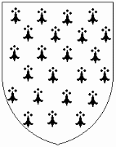
Heraldic Device: New Resubmission Change Other: ________________________
METALS (Pick 1) COLORS (Pick 1 or 2) FURS (Pick 0 to 2)
Argent (silver/white) Azure (blue) Ermine Vair
Or (gold/yellow) Gules (red) Erminois Vair variant
Purpure (purple) Counter-ermine
Sable (black) Pean
Vert (green) Ermine variant
CHARGES (Objects client is interested in):

Proposed Blazon:

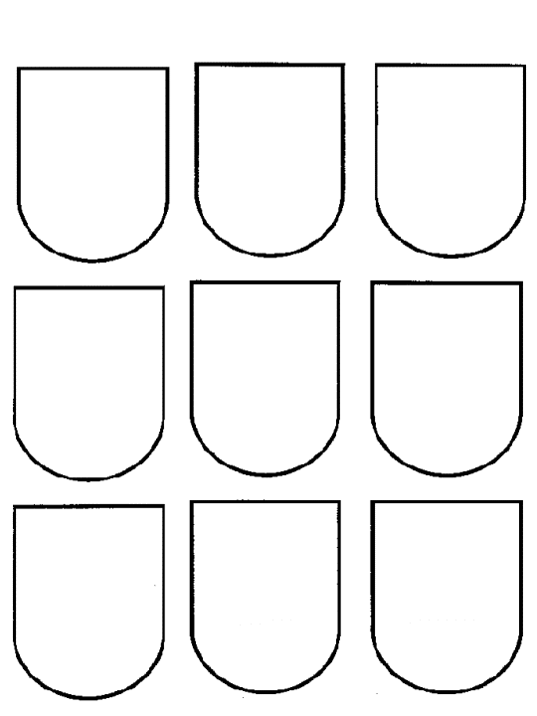
Date: __________ Group: ____________________________
Quarterly Report for Group Herald

This is the quarterly report on the heraldic activities of your office. Please return it to your
Regional Herald. You are required to return the form by the 15th of April, July and October.

Personal Information SCA Name: ______________________________________________________________
Modern Name: ___________________________________________________________
Street Address: ___________________________________________________________
City, State, Zip: ___________________________________________________________
Phone Number: (______) ______ - __________
Email address: ____________________________________________________________

Heraldic Activities
What heraldic activities have you or your group participated in or hosted this quarter?
[For example: Kingdom Courts, Baronial Courts, consulting on submissions, vocal work at tournaments & events, workshops held, heraldic competitions held.] This list should include a summary (at a minimum) of these activities, but please feel to go into as much detail as you like.

Are other members of your group taking part in heraldic activities? (circle one) YES / NO
[Please list their SCA name and activity, if possible.]

Date: __________ Group: ____________________________

Heraldic Classes
What heraldic classes have you attended or taught this quarter?
What heraldic classes has your group hosted this quarter?
[Please note if these were at local meeting, kingdom events, etc. If you taught, please state that.]

Are other members of your group taking part in heraldic classes? (circle one) YES / NO
[Please list their SCA name and activity, if possible.]

Date: _____________ Name of SCA Group: _________________________________

Heraldic Submissions
What heraldic submissions have been made by members of your group this quarter?
If known, include information about submissions made last quarter but resolved (i.e. registered or returned) this quarter:

SCA Same of Submitter Submission Type When Submitted Current Status
(name, device, etc.) (if known) (passed, returned, etc)

Does your office have files on group members that have made submissions? (circle one) YES / NO

Are you aware that if you’re missing heraldic records that you can request copies of submission files for gentles in your group from the Kingdom Saker Office? (circle one) YES / NO
[Note: You must request files by submitter name.]
Date: _____________ Name of SCA Group: _________________________________

Awards Listing
Please provide an alphabetical listing of members of your group who have received awards in
the past quarter.

SCA Name Award When Received
(date & name of event)

If there are corrections needed to the Kingdom Order of Precedence (missing awards, someone who has moved in from another Kingdom who needs to be added, etc) please list those below.

SCA Name Award When Received
(date & name of event)

Do you have any questions, comments or suggestions for your Regional Herald or the Gold
Falcon Herald? If so, please feel free to list them here.

Do you have any suggestions on how to improve this form?
Date: _____________ Name of SCA Group: _________________________________
Domesday Report for Group Herald
This is the annual report on the heraldic activities of your office as group herald.
Please return it to your Regional Herald. You are required to return the form by January 15.

Personal Information

SCA Name: ______________________________________________________________
Modern Name: ___________________________________________________________
Street Address: ___________________________________________________________
City, State, Zip: ___________________________________________________________
Phone Number: (______) ______ - __________
Email address: ____________________________________________________________

Heraldic Activities
What heraldic activities have you or your group participated in or hosted this year?
[For example: Kingdom Courts, Baronial Courts, consulting on submissions, vocal work at tournaments & events, workshops held, heraldic competitions held.] This list should include a summary (at a minimum) of these activities, but please feel to go into as much detail as you like.

Are other members of your group taking part in heraldic activities? (circle one) YES / NO
[Please list their SCA name and activity, if possible.]

Date: _____________ Name of SCA Group: _________________________________

Heraldic Classes
What heraldic classes have you attended or taught this year?
What heraldic classes has your group hosted this year?
[Please note if these were at local meeting, kingdom events, etc. If you taught, please state that.]

Did you attend a Calontir Kingdom Heraldic Symposium this year? (circle one) YES / NO

Did you attend a foreign kingdom’s Heraldic Symposium this year? (circle one) YES / NO

Did you attend the Known World Heraldic Symposium this year? (circle one) YES / NO

Are other members of your group taking part in heraldic classes? (circle one) YES / NO
[Please list their SCA name and activity, if possible.]

Date: _____________ Name of SCA Group: _________________________________

Heraldic Submissions
What heraldic submissions have been made by members of your group this year?
If known, include information about submissions made last year but resolved (i.e. registered or returned) this year:

SCA Same of Submitter Submission Type When Submitted Current Status
(name, device, etc.) (if known) (passed, returned, etc)

Does your office have files on group members that have made submissions? (circle one) YES / NO

Are you aware that if you’re missing heraldic records that you can request copies of submission files for gentles in your group from the Kingdom Saker Office? (circle one) YES / NO
[Note: You must request files by submitter name.]
Date: _____________ Name of SCA Group: _________________________________

Awards Listing
Please provide an alphabetical listing of members of your group who have received awards in
the past year.

SCA Name Award When Received
(date & name of event)

If there are corrections needed to the Kingdom Order of Precedence (missing awards, someone who has moved in from another Kingdom who needs to be added, etc.) please list those below.

SCA Name Award When Received
(date & name of event)

Date: _____________ Name of SCA Group: _________________________________

Resource Listing
Please provide a listing of the books owned by your local office and note any other resources available to the office. [For example: Three-ring notebooks with copies of Academy of Saint Gabriel articles, Web access to Laurel website, etc.]

Do you have any questions, comments or suggestions for your Regional Herald or the Gold
Falcon Herald? If so, please feel free to list them here.

Do you have any suggestions on how to improve this form?

This Page Intentionally Left Blank

Examples of Permission to Conflict Letters
[As per Appendix D of the Administrative Handbook of the CoA]

This grants permission to one specific individual to conflict with your name or armory.

General Permission to Conflict

For Name

I, [Name], known in the SCA as ([Society name]) give [Name of submitter], known in the SCA as ([Society name of submitter]) permission for [his/her] name "[Submitted Name]" to be similar to, but not identical to, my name, "[Registered Name]". I understand that this permission cannot be withdrawn once [name of submitter]'s name is registered.

[Date] [Signature of [Name]]

For Armory

I, [Name], known in the SCA as ([Society name]) give [Name of submitter], known in the SCA as ([Society name of submitter]) permission for [his/her] armory "[Blazon of submission]" to look similar to, but not identical to, my armory, "[Blazon of registered armory]". I understand that this permission cannot be withdrawn once [name of submitter]'s armory is registered.

[Date] [Signature of [Name]]

This Page Intentionally Left Blank
Examples of Blanket Permission to Conflict Letters
[As per Appendix D of the Administrative Handbook of the CoA]

This grants permission to all individuals to conflict with your name or armory.
Blanket Permission to Conflict
For Name
I, [Name], known in the SCA as [Society name] waive the full protection of my registered name "[Registered name]". I grant permission to any future submitter to register a name that is (not identical to/at least a syllable different from) my registered name. I understand that this permission can be withdrawn by written notice to the Laurel Sovereign of Arms, but that conflicting items registered while it is in force will remain registered.
[Date] [Signature of [Name]]
For Fielded Armory
I, [Name], known in the SCA as [Society name] waive the full protection of my registered armory "[Blazon of registered armory]". I grant permission to any future submitter to register armory that is (not identical to|at least one countable step different from) my registered armory. I understand that this permission can be withdrawn by written notice to the Laurel Sovereign of Arms, but that conflicting items registered while it is in force will remain registered.
[Date] [Signature of [Name]]
For Fieldless Armory:
I, [Name], known in the SCA as [Society name] waive the full protection of my registered armory "[Blazon of registered armory]". I grant permission to any future submitter to register armory that is not identical to my registered armory. I understand that this permission can be withdrawn by written notice to the Laurel Sovereign of Arms, but that conflicting items registered while it is in force will remain registered.
[Date] [Signature of [Name]]
Note that a blanket permission to conflict will under no circumstances allow the registration of identical names or armory.

This Page Intentionally Left Blank

Examples of Standard Forms of Heraldic Will
[As per Appendix D of the Administrative Handbook of the CoA]

Note that portions (such as the general release of an item) may be taken out if it does not apply.
Heraldic Will Sample #1
I [Legal name of owner], known in the Society for Creative Anachronism, Incorporated (SCA) as [SCA name of owner] leave to [legal name of heraldic heir], known in the SCA as [SCA name of heraldic heir, if any] my (name/armory) registered in the SCA, ([name to be transferred]/blazoned as [blazon of armory to be transferred].
I [Legal name of owner], known in the Society for Creative Anachronism, Incorporated (SCA) as [SCA name of owner] release the following names and armory registered to me in the SCA [insert list of all names or armories to be released]
[Date] [Signature of [Name]]
Heraldic Will Sample #2
I [Legal name of owner], known in the Society for Creative Anachronism, Incorporated (SCA) as [SCA name of owner] wish to make the following determinations to my name(s) and/or armory upon my death as below:
[select options as desired; items may be split amongst multiple people or released entirely]
- transfer to [legal name of heraldic heir], known in the SCA as [SCA name of heraldic heir, if any] my [name/armory] registered in the SCA, [insert name or "blazoned as [insert blazon of armory]].
- release the following [name/armory] registered to me in the SCA [insert list of all names or armories to be released]
[Date] [Signature of [Name]]

This Page Intentionally Left Blank
Petition for Registration of Group Name

We the undersigned members and officers of the <insert group type (Barony, Shire, etc) and name> in the Kingdom of Calontir, affirm that we approve of the submission of the name, <insert name being submitted>.

Date Signatures of Officers or Populace Office held (if applicable)

_________ ___________________________________________________ _____________________

_________ ___________________________________________________ _____________________

_________ ___________________________________________________ _____________________

_________ ___________________________________________________ _____________________

_________ ___________________________________________________ _____________________

_________ ___________________________________________________ _____________________

_________ ___________________________________________________ _____________________

_________ ___________________________________________________ _____________________

_________ ___________________________________________________ _____________________

_________ ___________________________________________________ _____________________

_________ ___________________________________________________ _____________________

_________ ___________________________________________________ _____________________

_________ ___________________________________________________ _____________________

_________ ___________________________________________________ _____________________

_________ ___________________________________________________ _____________________

_________ ___________________________________________________ _____________________

_________ ___________________________________________________ _____________________

_________ ___________________________________________________ _____________________

_________ ___________________________________________________ _____________________

_________ ___________________________________________________ _____________________

_________ ___________________________________________________ _____________________

_________ ___________________________________________________ _____________________

This Page Intentionally Left Blank

Petition for Registration of Group Device

We the undersigned members and officers of the <insert group type (Barony, Shire, etc) and name> in the Kingdom of Calontir, affirm that we approve of the submission of the branch device, <insert blazon>. (Pictured below.)

<insert colored picture of badge>

Date Signatures of Officers or Populace Office held (if applicable)

_________ ___________________________________________________ _____________________

_________ ___________________________________________________ _____________________

_________ ___________________________________________________ _____________________

_________ ___________________________________________________ _____________________

_________ ___________________________________________________ _____________________

_________ ___________________________________________________ _____________________

_________ ___________________________________________________ _____________________

_________ ___________________________________________________ _____________________

_________ ___________________________________________________ _____________________

_________ ___________________________________________________ _____________________

_________ ___________________________________________________ _____________________

_________ ___________________________________________________ _____________________

_________ ___________________________________________________ _____________________

_________ ___________________________________________________ _____________________

_________ ___________________________________________________ _____________________

_________ ___________________________________________________ _____________________

_________ ___________________________________________________ _____________________

_________ ___________________________________________________ _____________________

This Page Intentionally Left Blank

Petition for Registration of Group Badge

We the undersigned members and officers of the <insert group type (Barony, Shire, etc) and name> in the Kingdom of Calontir, affirm that we approve of the submission of the branch badge, <insert blazon>. (Pictured below.)

<insert colored picture of badge>

Date Signatures of Officers or Populace Office held (if applicable)

_________ ___________________________________________________ _____________________

_________ ___________________________________________________ _____________________

_________ ___________________________________________________ _____________________

_________ ___________________________________________________ _____________________

_________ ___________________________________________________ _____________________

_________ ___________________________________________________ _____________________

_________ ___________________________________________________ _____________________

_________ ___________________________________________________ _____________________

_________ ___________________________________________________ _____________________

_________ ___________________________________________________ _____________________

_________ ___________________________________________________ _____________________

_________ ___________________________________________________ _____________________

_________ ___________________________________________________ _____________________

_________ ___________________________________________________ _____________________

_________ ___________________________________________________ _____________________

_________ ___________________________________________________ _____________________

This Page Intentionally Left Blank

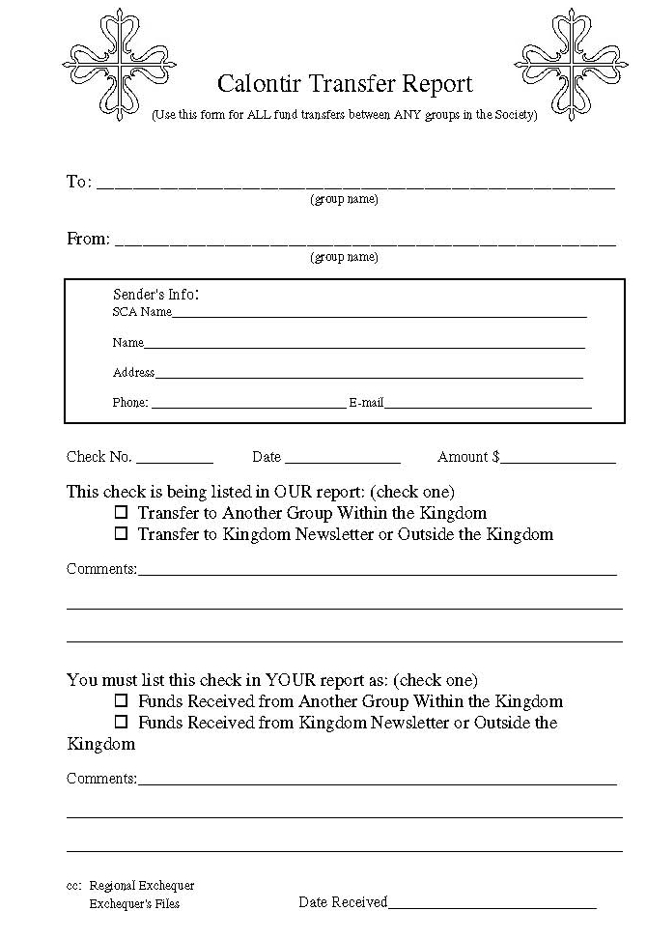

This Page Intentionally Left Blank
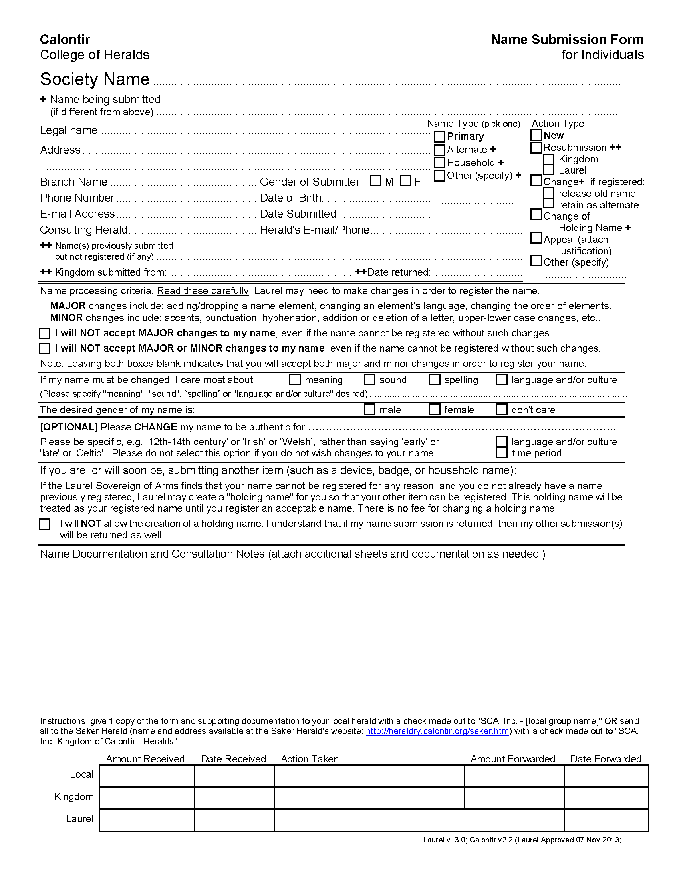

This Page Intentionally Left Blank

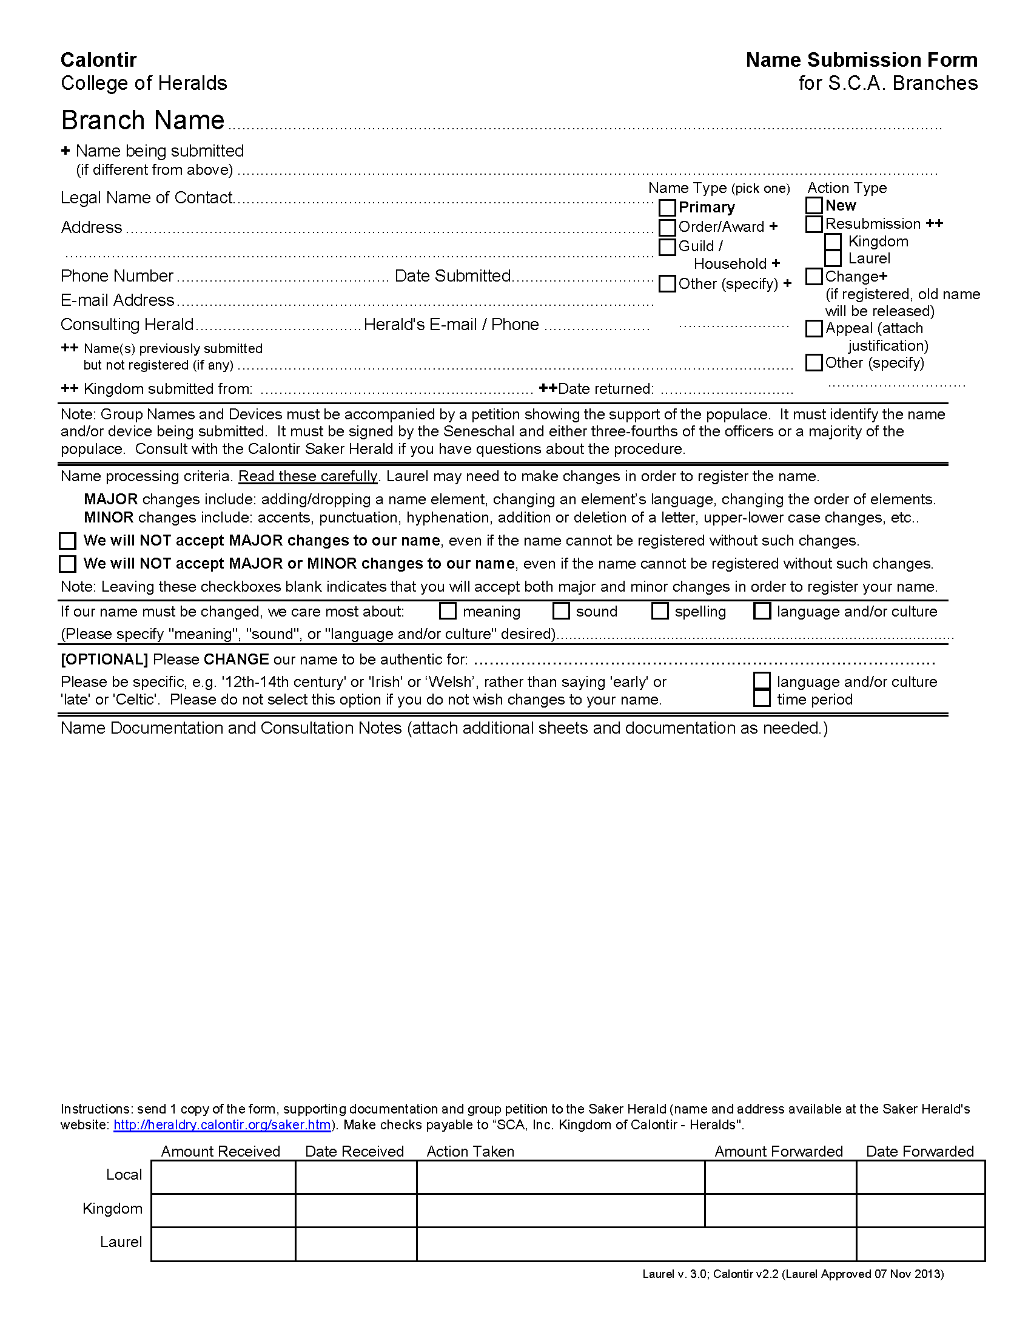

This Page Intentionally Left Blank

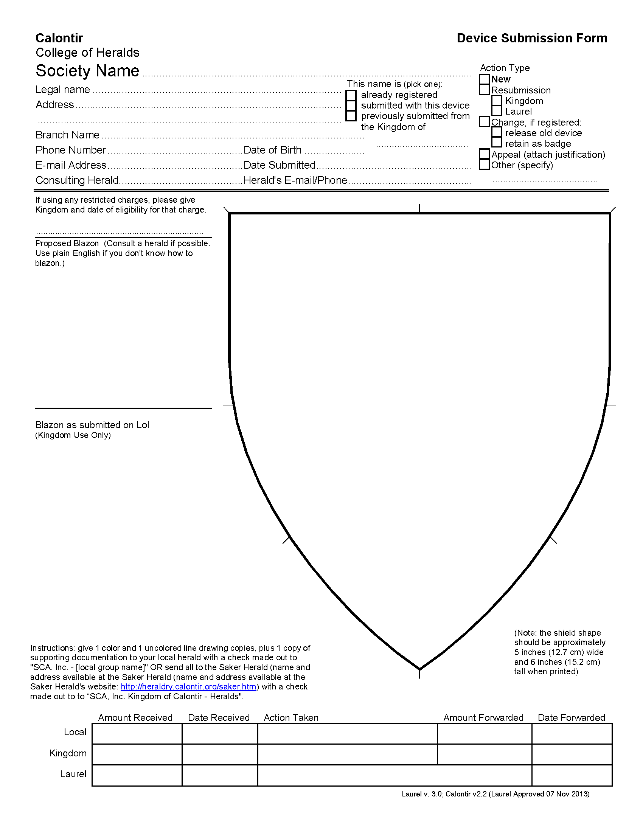

This Page Intentionally Left Blank

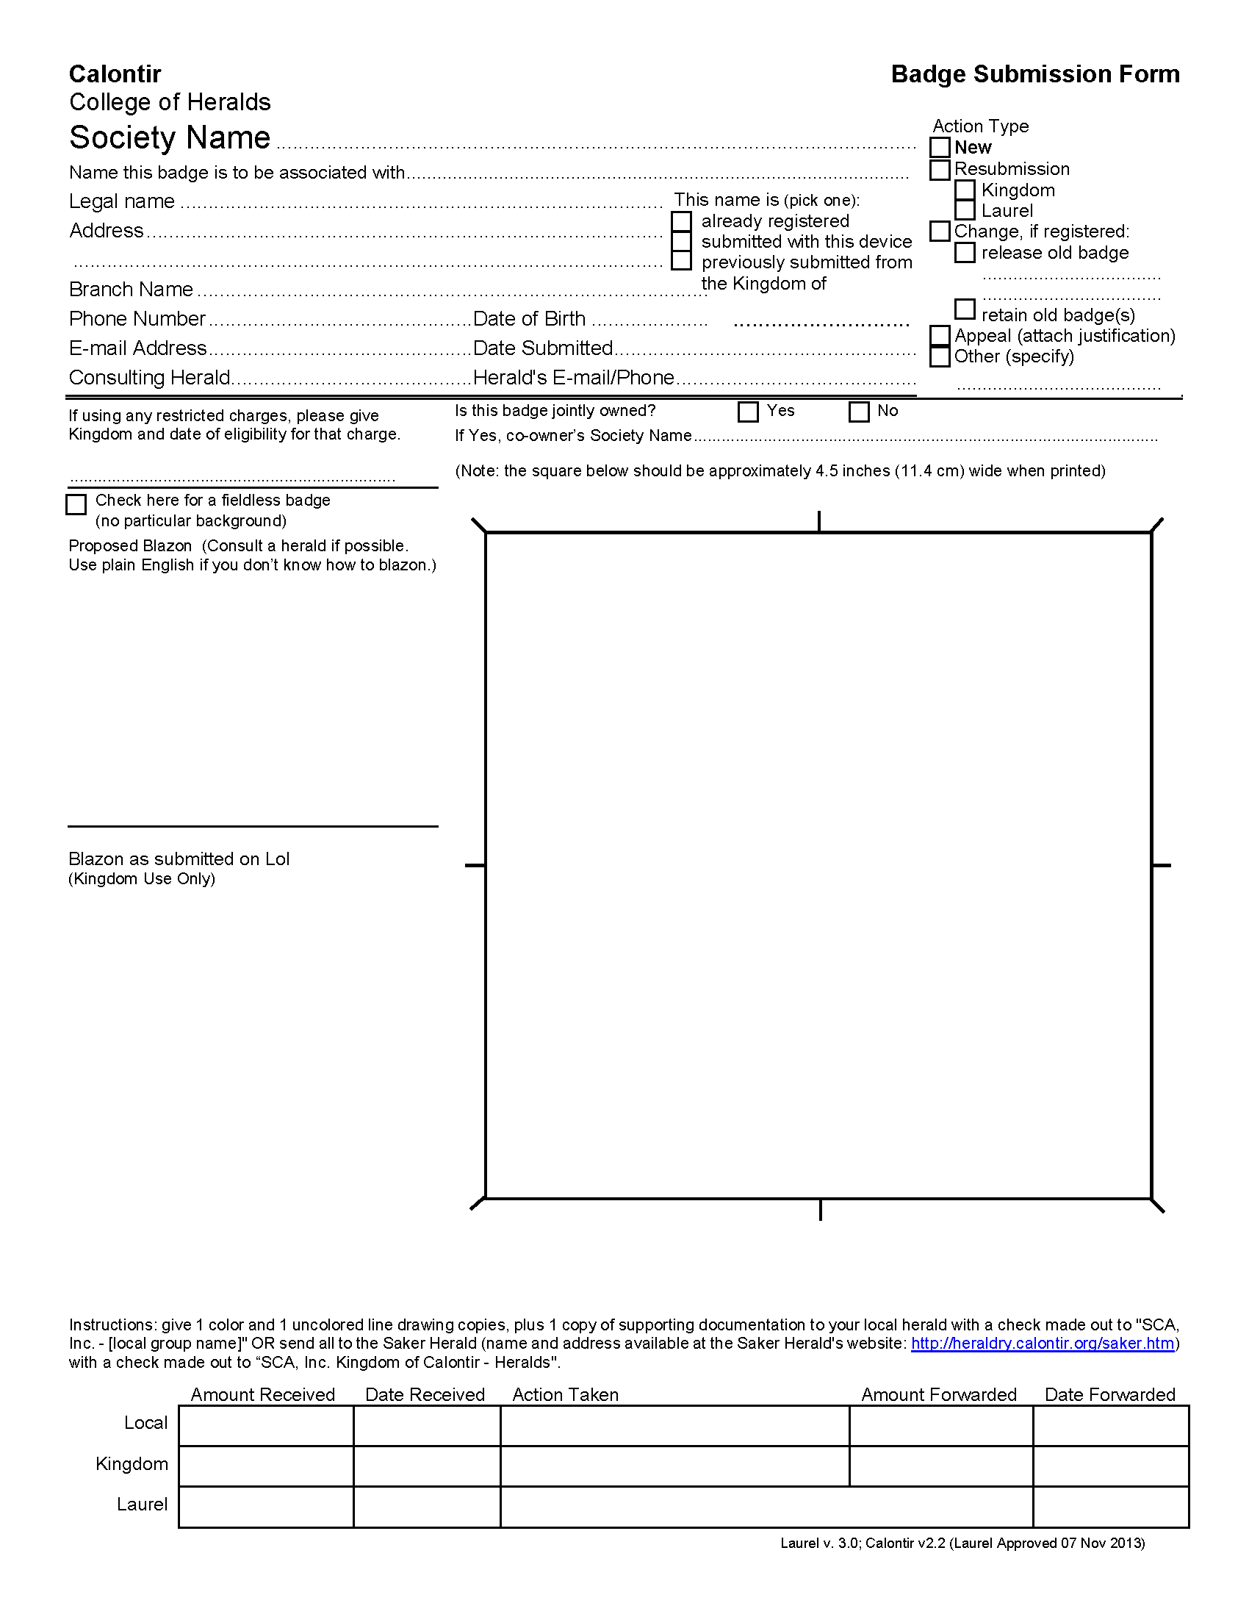

This Page Intentionally Left Blank

