Lesson 1: Introducing Silent Heraldry
Silent Heraldry is sign language used in the SCA environment. While we are signers, very few of us are certified interpreters, but all of us share the desire to open up the wonderful world of the SCA to the hearing impaired.

History of Sign Language
In the 15th century, Rudolphus Agricola (1443 – 1485), wrote “De Inventione Dialectica” as a result in his interest in the deaf. He wrote that a person who is born deaf can express himself by putting down his thoughts in writing. The book was not published until the 16th century.

In the 16th century, Girolamo Cardano (1501 – 1576), was an Italian physician concerned about his deaf child. Cardano read and agreed with Agricola’s book and also believed that the deaf need to learn to read and write. Cardano invented some kind of code for teaching, but did not pursue it.

Also in the 16th century, Pedro Ponce De Leon (1520 – 1584), a Catholic monk, established the world’s first school for the deaf at the Monastery of San Salvador near Madrid, Spain. He taught his deaf students first to write, while showing them with his finger the object named by the written characters, then drilling them to repeat with the vocal organs, the words which correspond to the characters.

In the 17th century, Juan Pablo Bonet (1579 – 1620), published his famous book “Simplification of Sounds and the Act of Teaching the Deaf to Speak”. He believed that deaf-mute should be forced to learn the one-handed manual alphabet using pictures illustrating the position of the hand for each letter before learning to speak and lipreading.

Also in the 17th century, John Bulwer (1614 – 1684), an English physician who published two books, “The Natural Language of the Hand” and “The Art of Making Manual Rhetoric”. He was convinced that the “language of the hand” was the “one language that was natural in all men, especially for the deafened in the use of the manual alphabet. He also published “The Deaf and Dumb Man’s Friend”, the first English book to explain the subject of deafness and its accompanying language problems.

In the 17th century, George Dalgarno, (? – 1687), published a book entitled “The Deaf and Dumb Man’s Tutor”. In this book, he had many theories about methods for teaching to the deaf. He knew that the deaf could be taught to speak and lipread, but thought that using the manual alphabet was more adviseable.

In the late 17th century, Johamn Konrad Ammon (1698 – 1774), was a doctor of medicine, but was interested in trying to educate deaf mutes. He only worked on youths between 8 and 15 years of age. He published two books, one in 1692 (written in Latin) and the other in 1700 called “A Dissertation Speech”.

In 1755, Abbe Charles Michel de l’Epee of Paris founded the first free school for the deaf. He taught that deaf people could develop communication with themselves and the hearing world through a system of conventional gestures, hand signs, and finger spelling. The abbe took signs that were already being used by a group of deaf people in Paris and standardized them which resulted in a signed version of spoken French.

In 1778, Samuel Heinicke of Leipzig, Germany, an educator who used speech and speech-reading instead of the manual method of communication, established the first public school for the deaf that achieved government recognition.

Abbe de l’Epee’s manual communication methods, along with Samuel Heinicke’s oral methods were the basis for today’s concept of total communication. Total communication encourages the use of all available means of communication – sign language, gesturing, finger-spelling, lip-reading, speech, hearing aids, reading, writing, and pictures.

About American Sign Language
The term “sign language” means different things to different people. Here in the United States, it can refer to Manually Coded English (MCE), Signed Exact English (SEE), or American Sign Language (ASL). MCE and SEE are structured similarly to spoken English. SEE is the sign language often used in an educational / teaching environment.

ASL is the sign language most deaf people use when they communicate with one another. ASL has its own rules, word order, and grammar. It also has its own slang expressions and dialects. The different ASL dialects correspond to the accents heard in spoken English. When a word does not have its own sign, ASL signers resort to the manual alphabet if they cannot find a sign for a word with a similar meaning to initialize (like the B handshape used with the “car” sign to create a new sign for the word “bus”).

Getting Attention and Basic Communication
Hearing people can call out to other hearing people to get their attention. Deaf people, on the other hand, normally wave rather than call. The size and intensity of the wave depend on how far away a person is. When a deaf person is facing away from you, you should gently tap his/her shoulder to get his/her attention.

When you want to communicate with a deaf person, but do not know how to sign, be sure to look into the other person’s eyes. Eye contact is extremely important. Sometimes, facial expression and body language alone are enough to convey a message.

Language
Because ASL is so visual, facial expression is of the utmost importance – it is the equivalent of your tone of voice. Facial expressions should be practiced. You can express many different sentiments, without even moving a hand, once you are able to express your thoughts through facial expression.

Movement
The simplest movement can alter a sign’s meaning. The direction of the sign can mean the difference between such opposite words as GIVER and RECEIVER. Repeating a sign can indicate the frequency of an action, or the number of items – whether the sign represents a noun or a verb. The size of a sign will generally relate to the size of the item.

Palm Orientation
It is important to notice in which direction a hand is turned. The words UP, DOWN, LEFT, and RIGHT are all signs in which the orientation is very important.

Use of Space
Draw an imaginary rectangle from the top of your head down to your waist, from one shoulder to the other. This is your signing space.

Person Indicator
The person indicator is made by putting both arms by your sides, palms facing inward, and then moving them downwards. When added to a root sign, the person indicator shows that you are referring to a person. It also makes the distinction between a noun and a verb. For example, the meaning of the LIBRARY sign, followed by the PERSON indicator, is LIBRARIAN.

Manual Alphabet
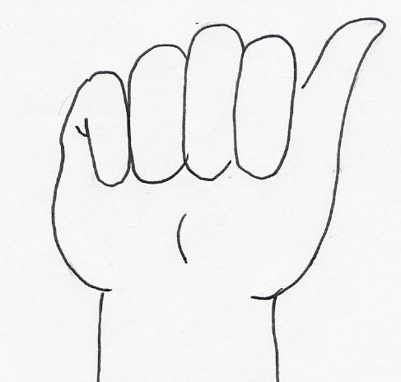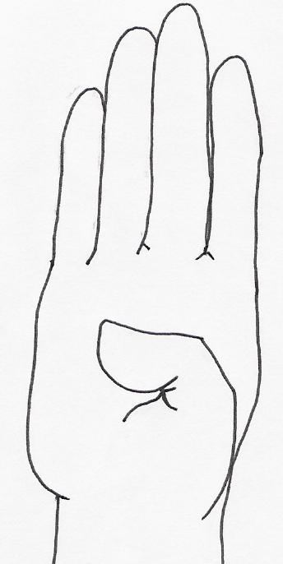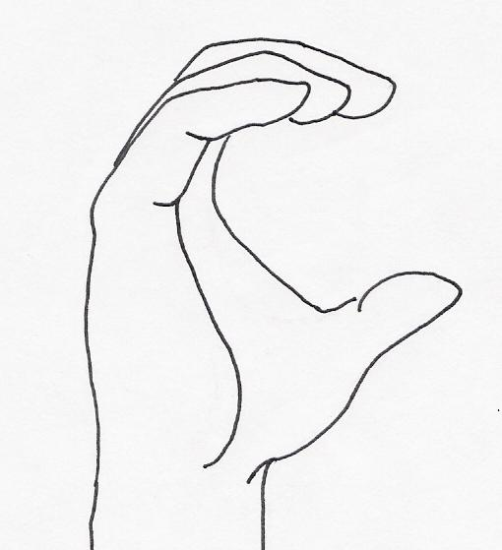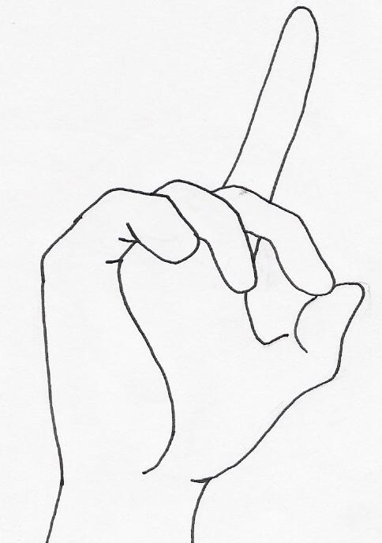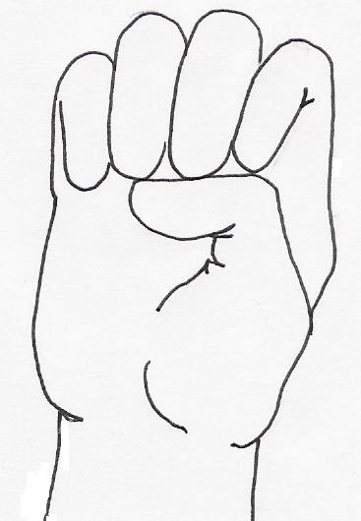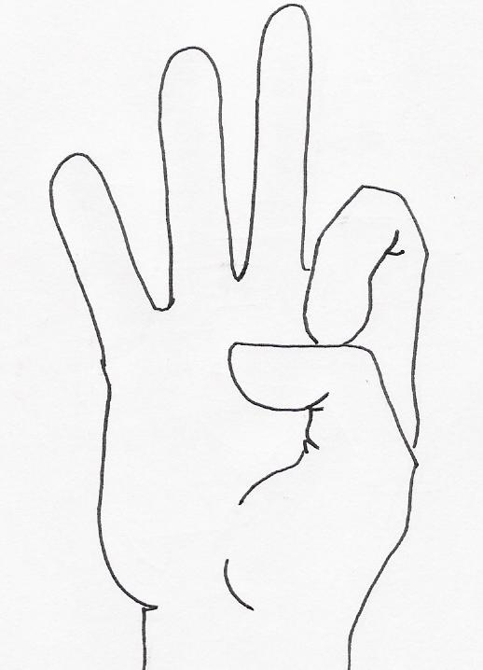
A B C D E F

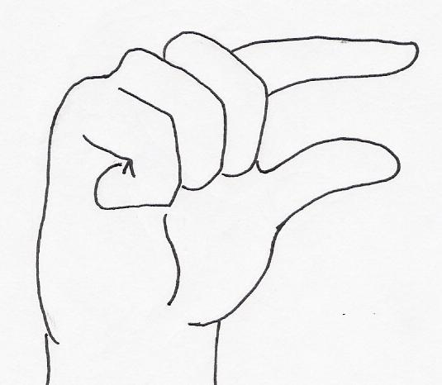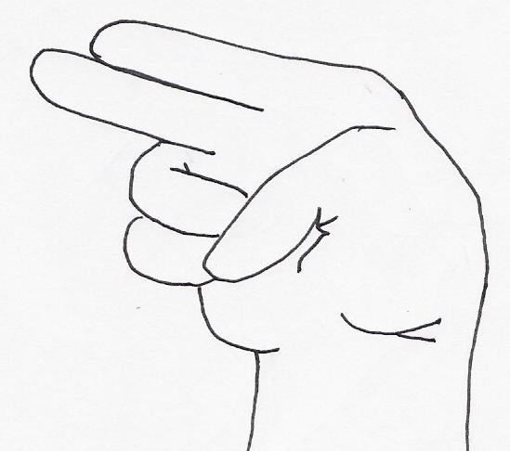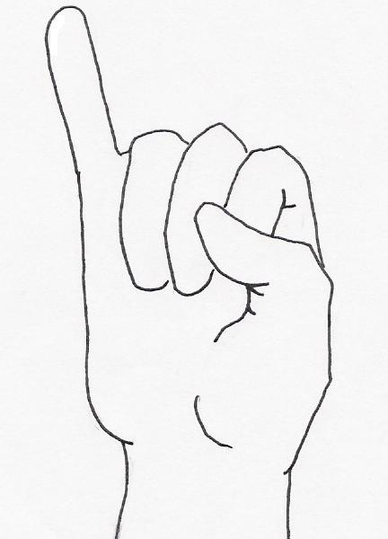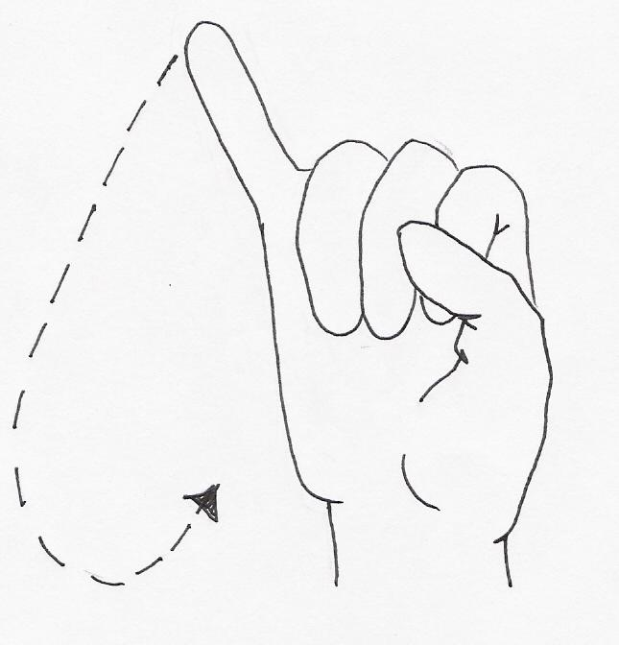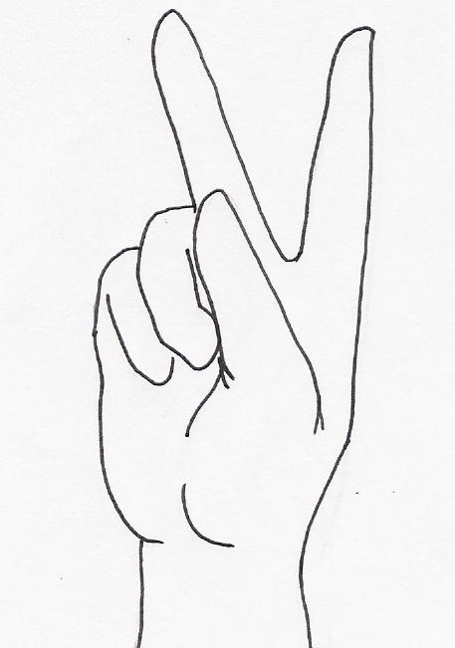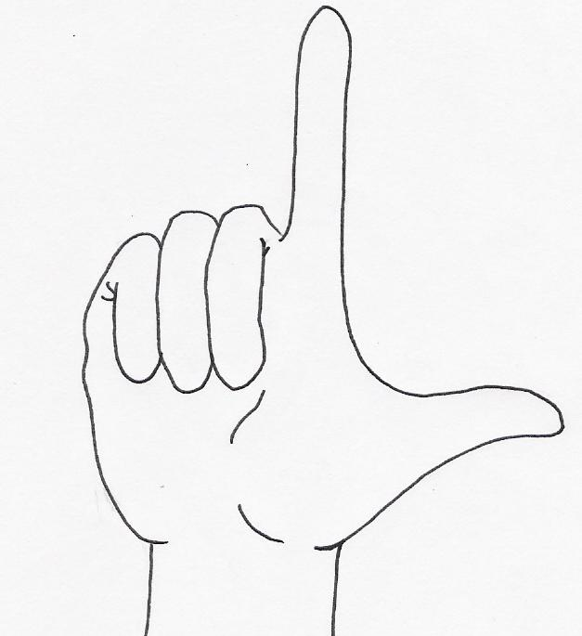
G H I J K L

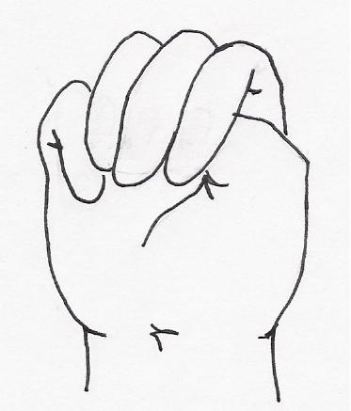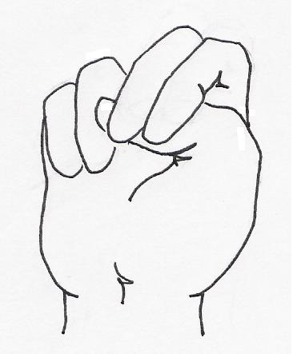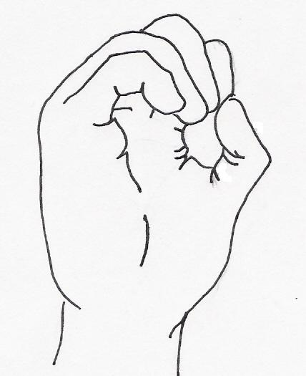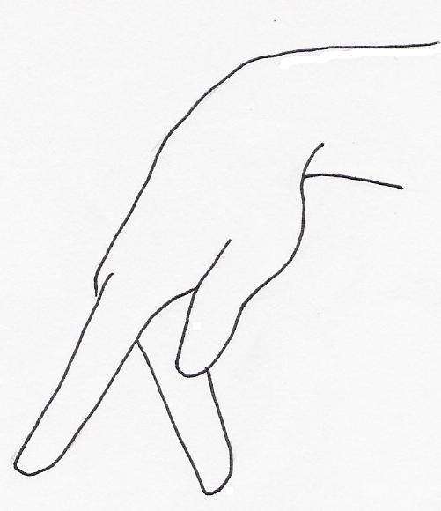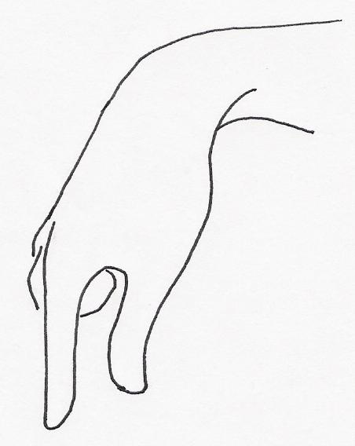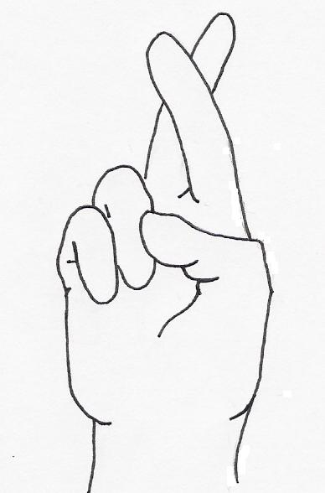
M N O P Q R

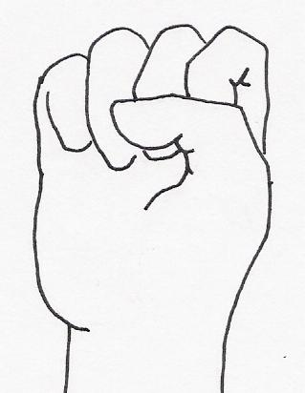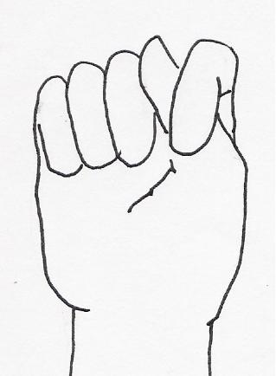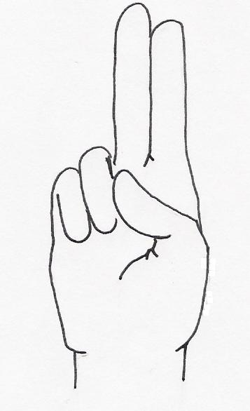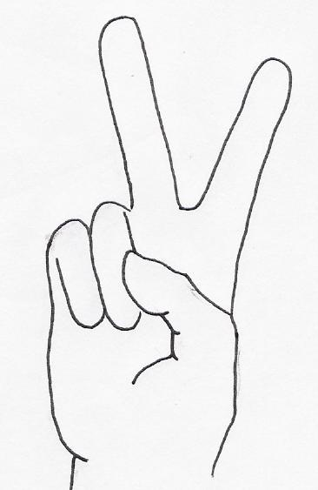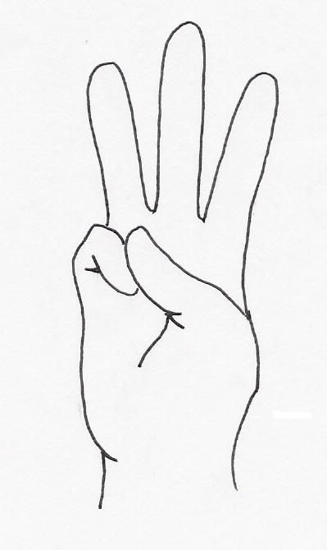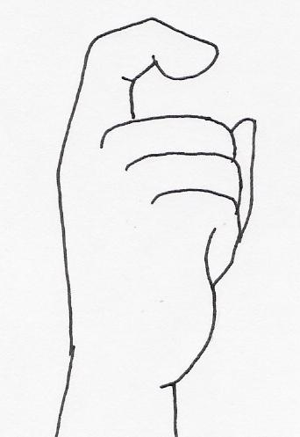
S T U V W X
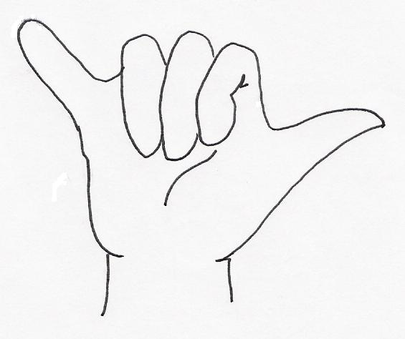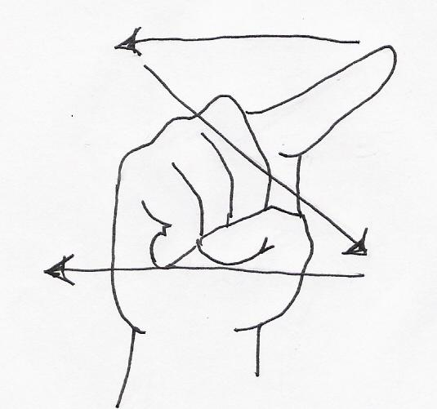
Y Z

Number Signs
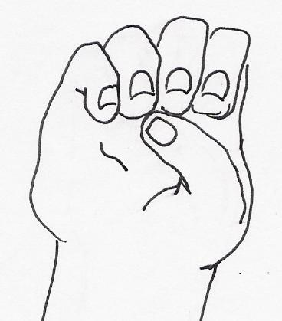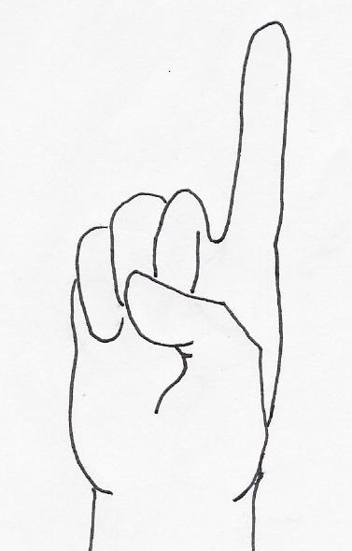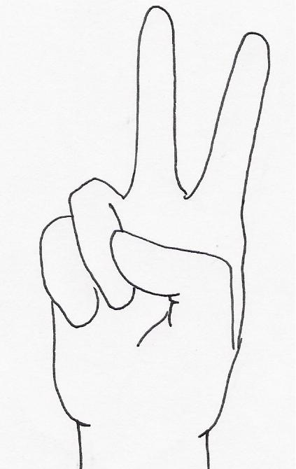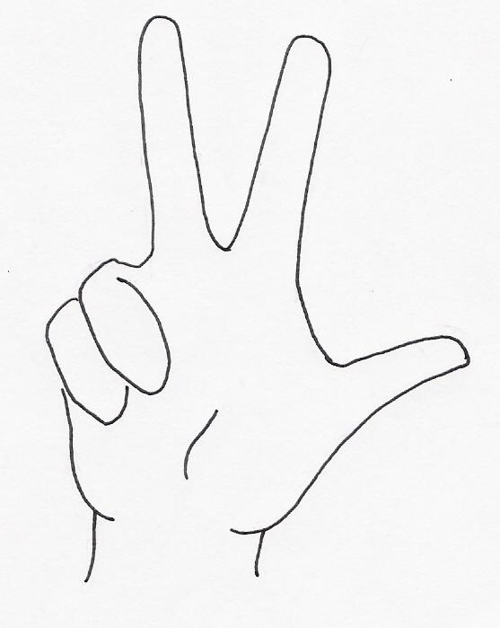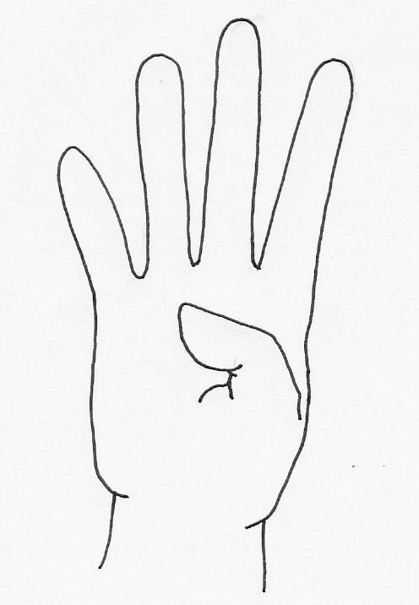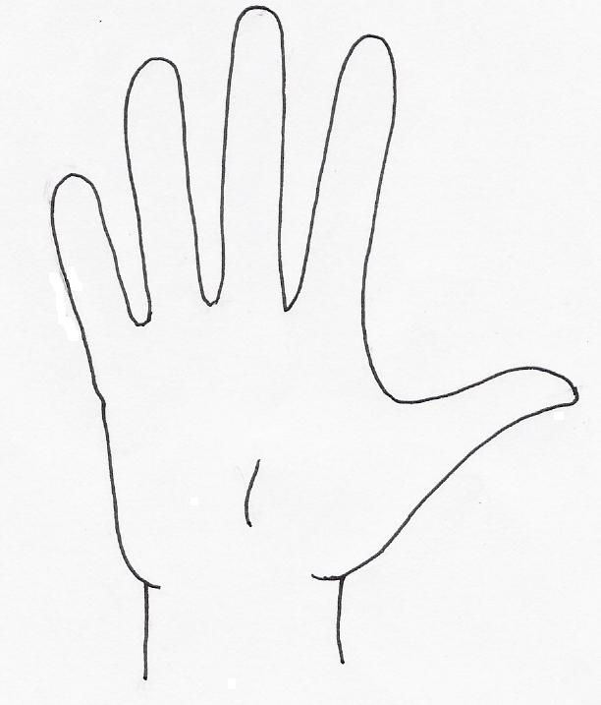
0 1 2 3 4 5

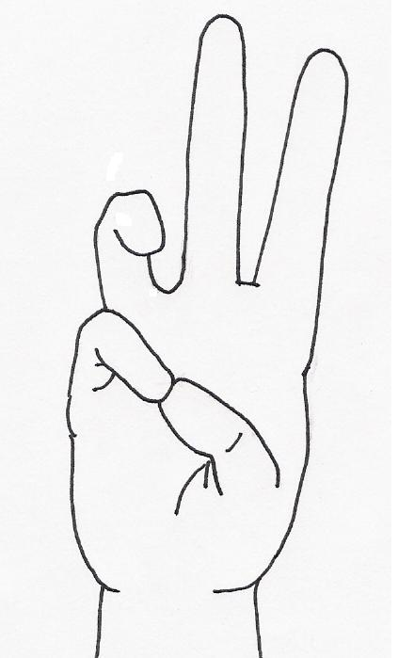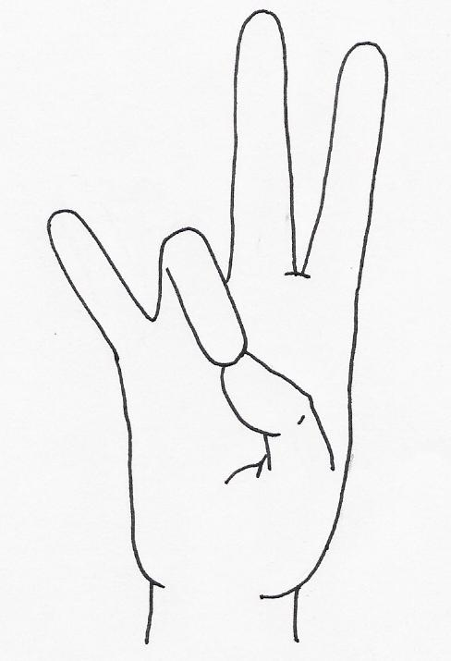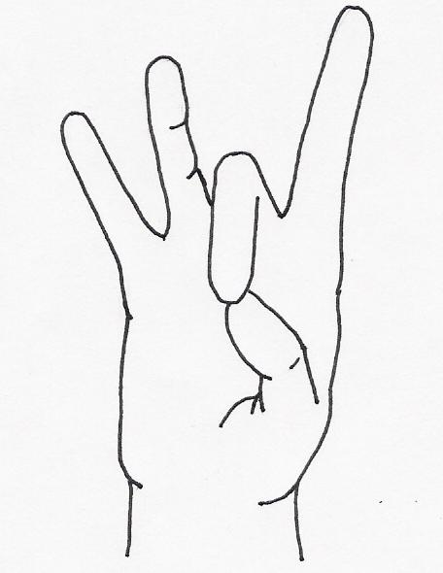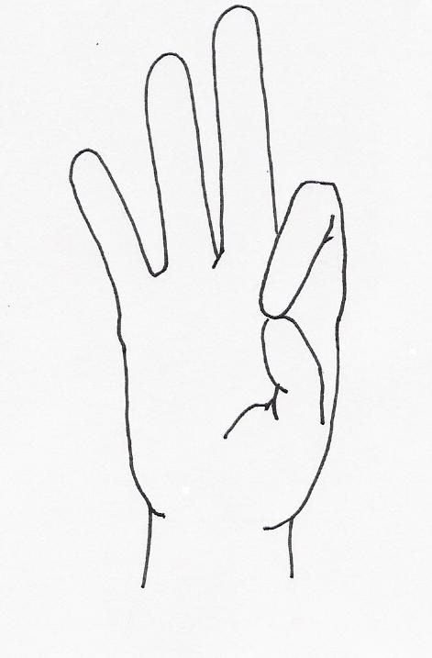
6 7 8 9 10

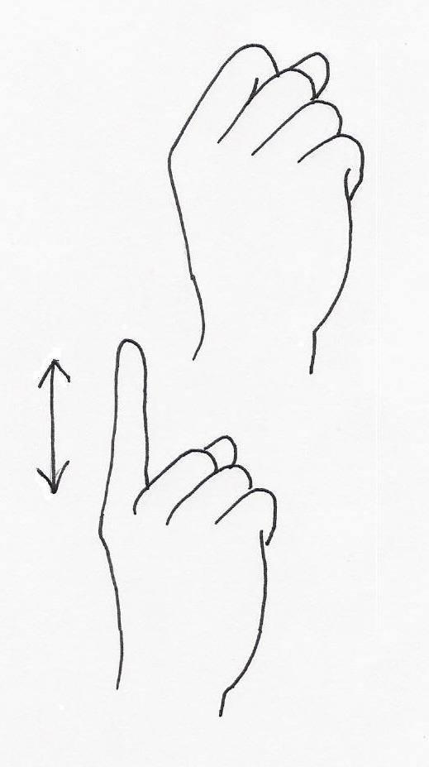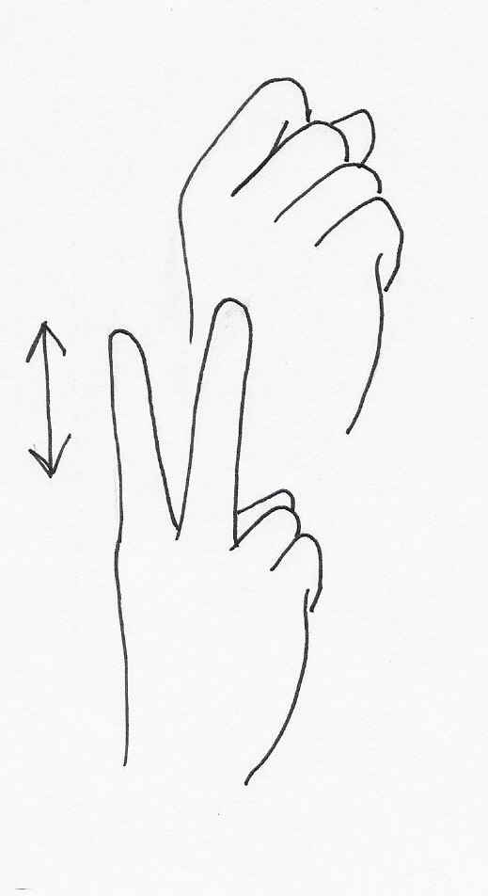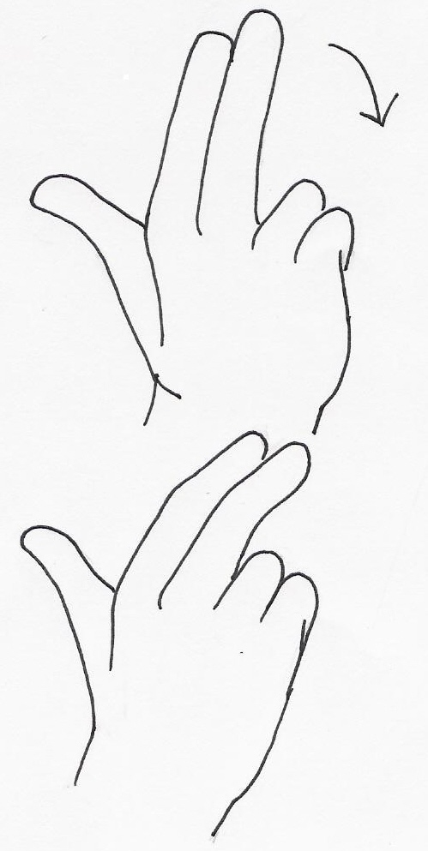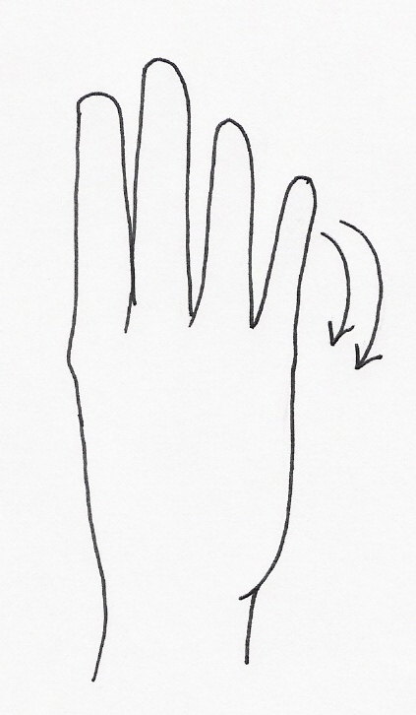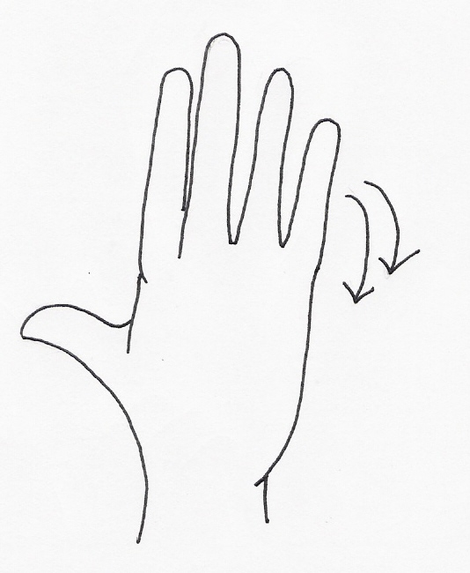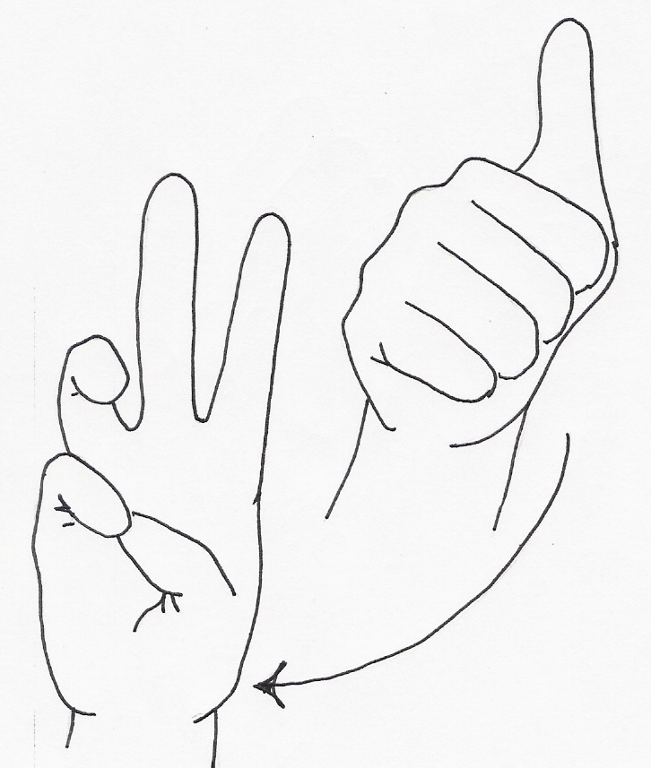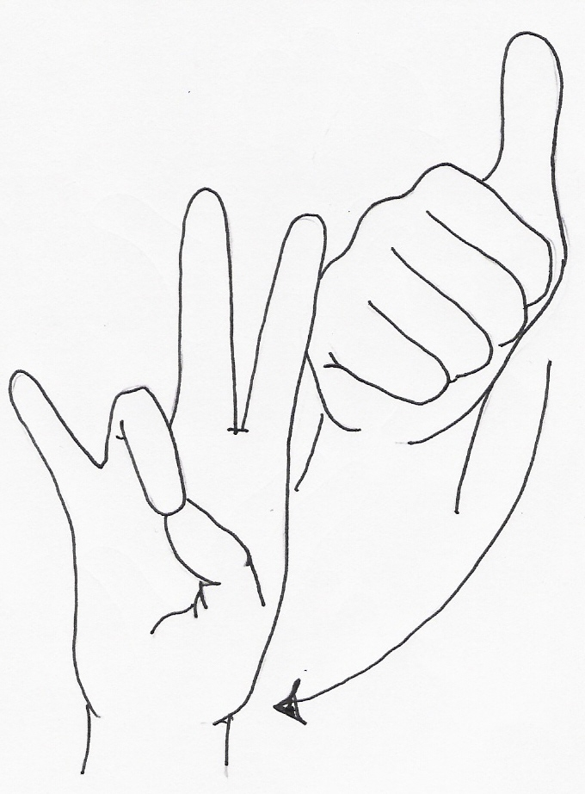
11 12 13 14 15 16 17

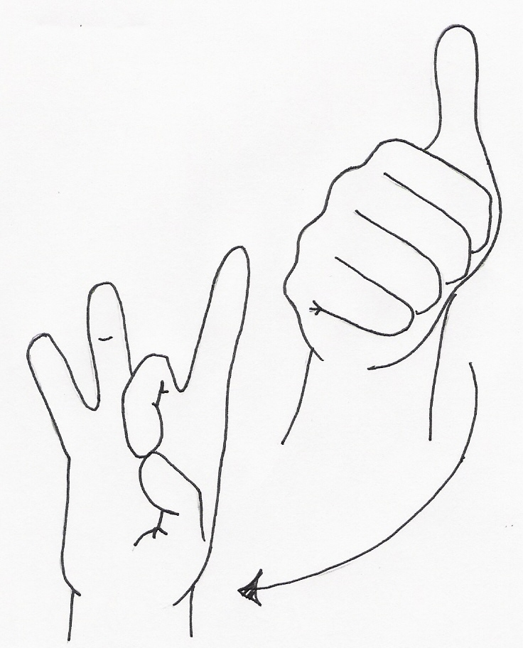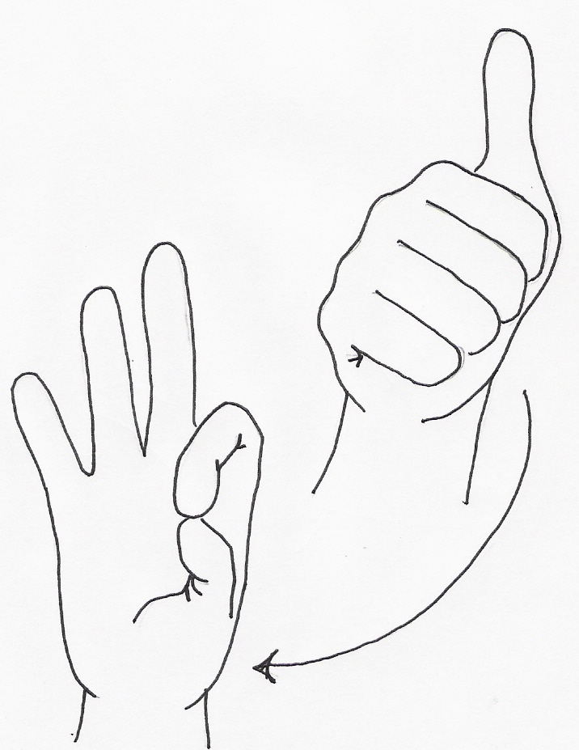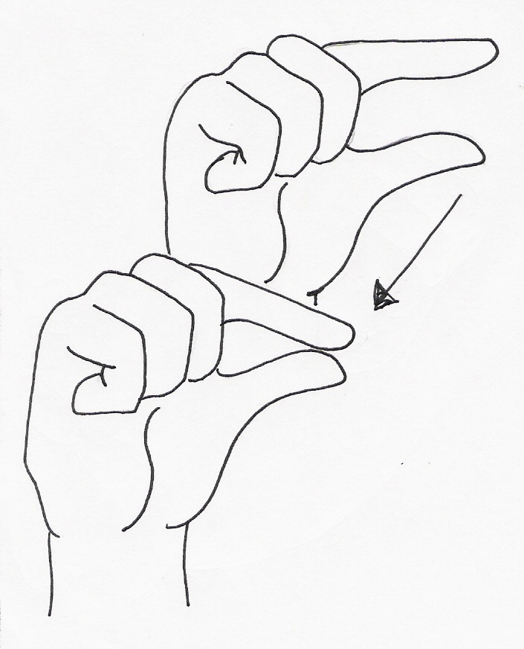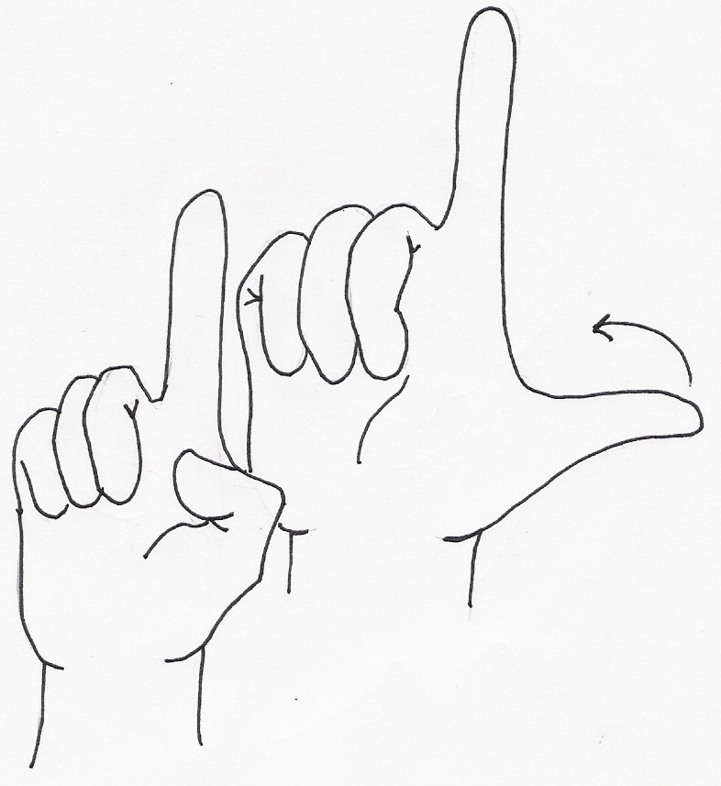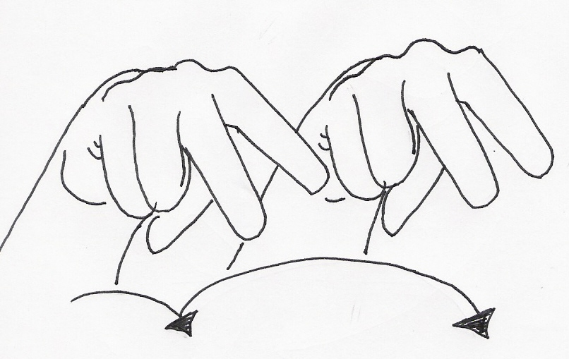
18 19 20 21 22

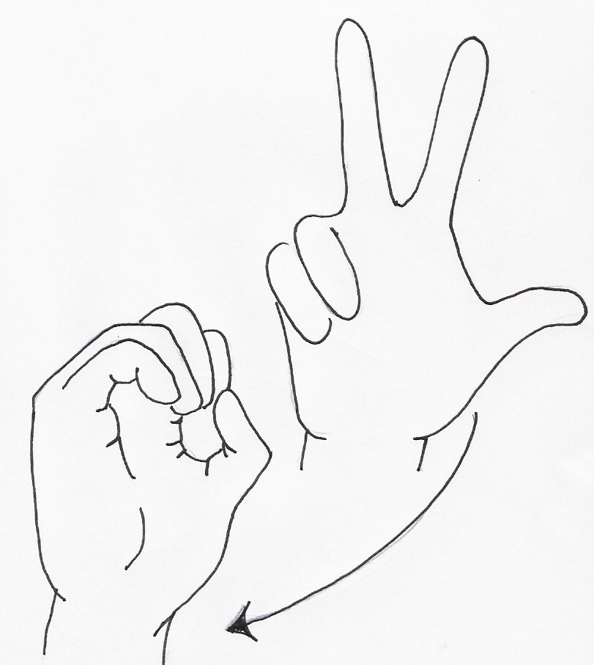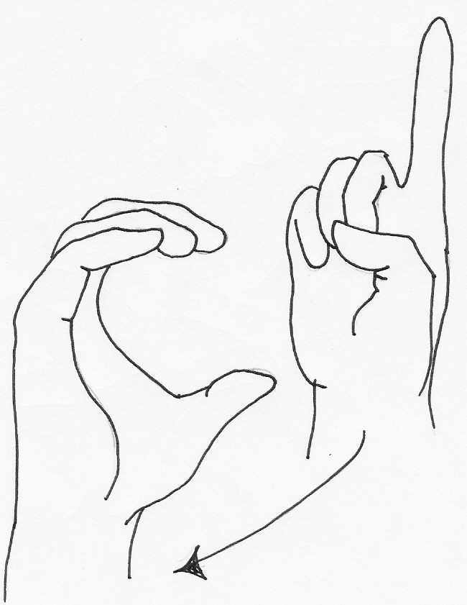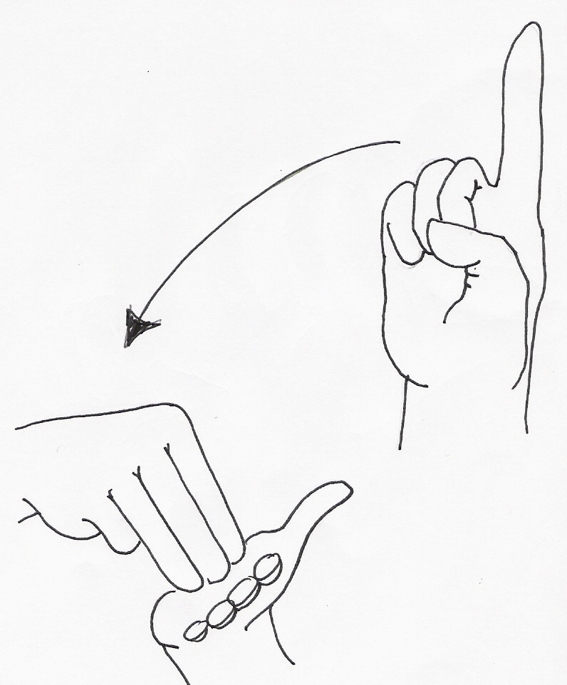
30 100 1000

Basic Greeting Signs
Signed English | ASL
Hi! My name is | Hi! Me
Pleased to meet you. | Happy meet you.
What's your name? | You name what?
Are you deaf or hearing? | You deaf hearing what?
Where did you learn to sign? | You learn sign where?
I am learning to sign. | Me learn sign.
Slowly, please. | Slow please.
Thank you. | Thank you.

Signs | Word Descriptions of Actions
am | Touch an A handshape to the lips and arc forward and upward
are | Place right R handshape to bottom lip. Move sign outward, arcing slightly upward
fine | Touch the thumb of the right hand (fingers spread) to the center of the chest area
happy | Touch chest with flat fingers of both hands in a forward circular motion, as if “stirring” emotions of joy
hello | Place hand on forehead as if to salute (but not as rigid). Move hand outward, ending up with palm facing forward in the air just a few inches from the forehead
how | Place hands back to back in front of the chest area, hands slightly bent, palms downward. Knuckles will slightly touch. Revolve hands in and then upward until hands end in a position where palms are flat and turned upward
I, me (asl) | Point to self, touching the center of the chest
I (se) | Touch the I handshape to the center of the chest
meet | Bring the D handshapes together, palm to palm
to | Move the right index finger to touch the left index finger
welcome | Using a W handshape with the right hand, touch the forehead and then the middle of the chest, arcing the movement to indicate you are welcoming someone to you (This mimes a man taking off his hat/cap and bowing)
who | Place the right hand in an L handshape on the chin, touching with the thumb. Slightly move the index finger twice
you | Point in the direction where someone is located. If no one is there, point to an imaginary person.
slow | One flattened hand moves slowly up the back of the other flattened hand.
please | The open, flattened, hand circles over the heart to indicate pleasure
thank you | The hand moves out and down. This sign is similar to the gesture of kissing one’s hand and extending the hand towards someone else in order to show your gratitude

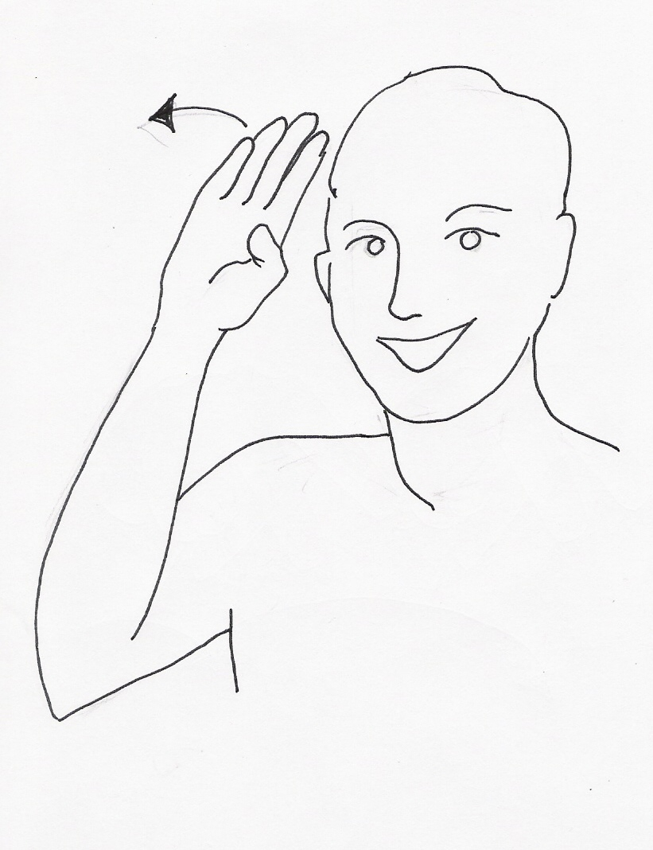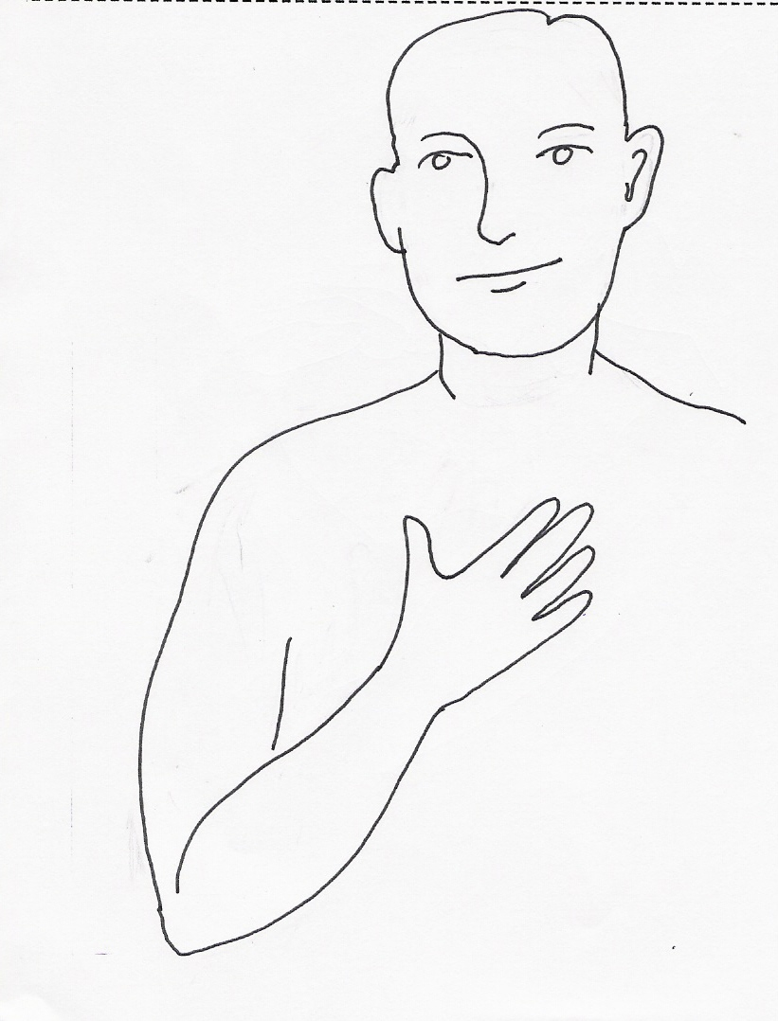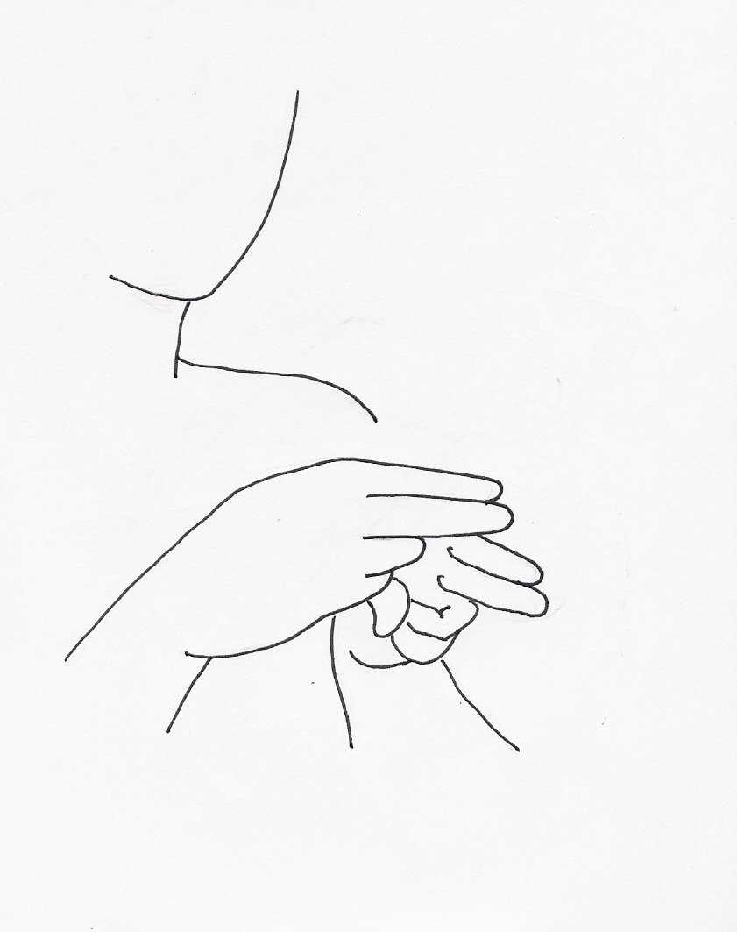
HI MY NAME

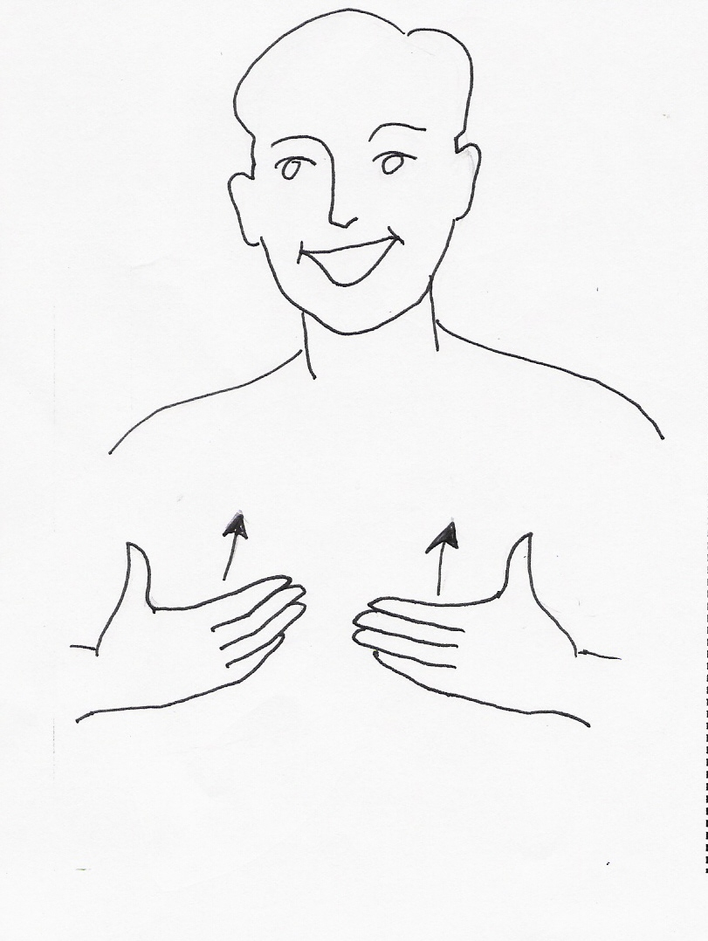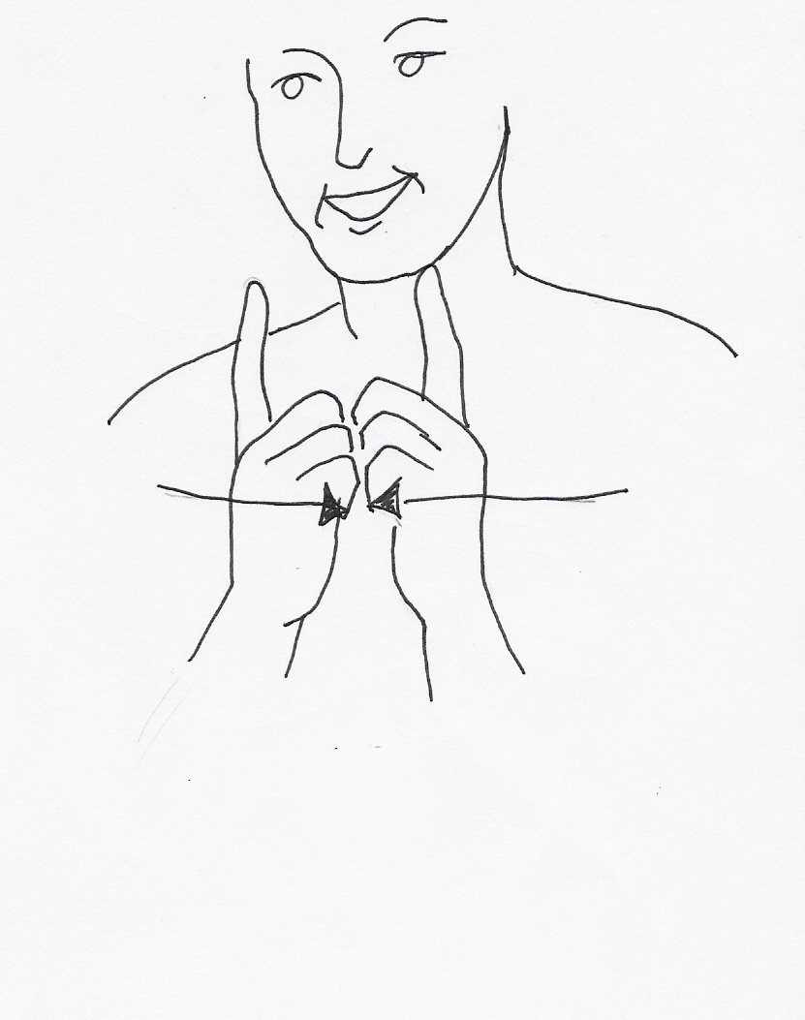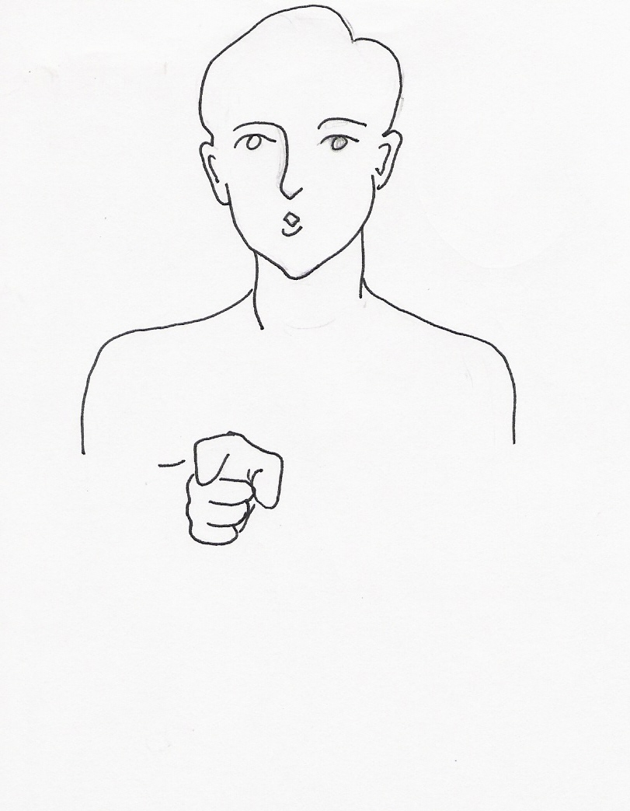
HAPPY MEET YOU

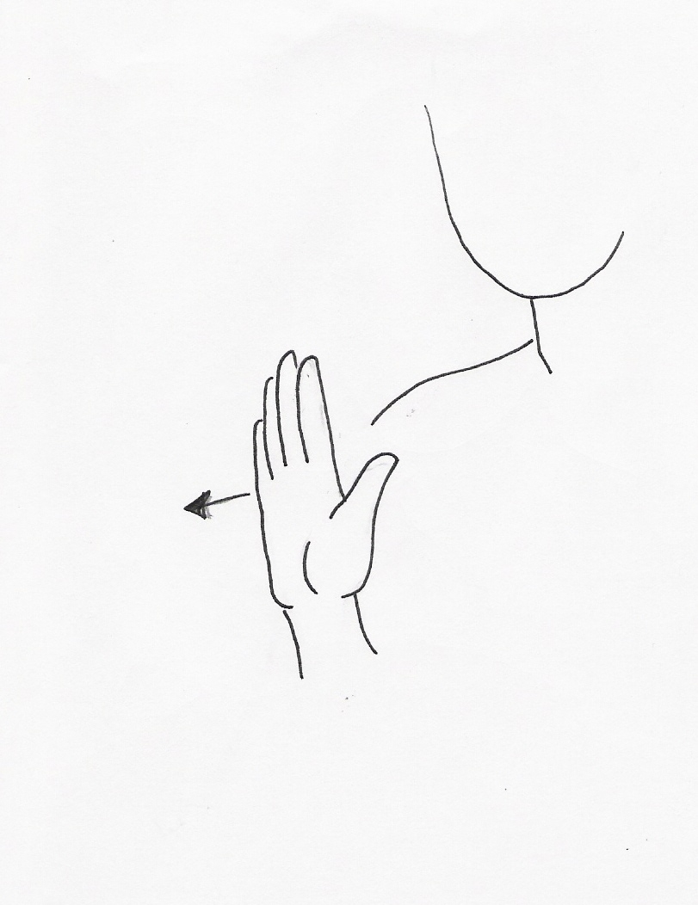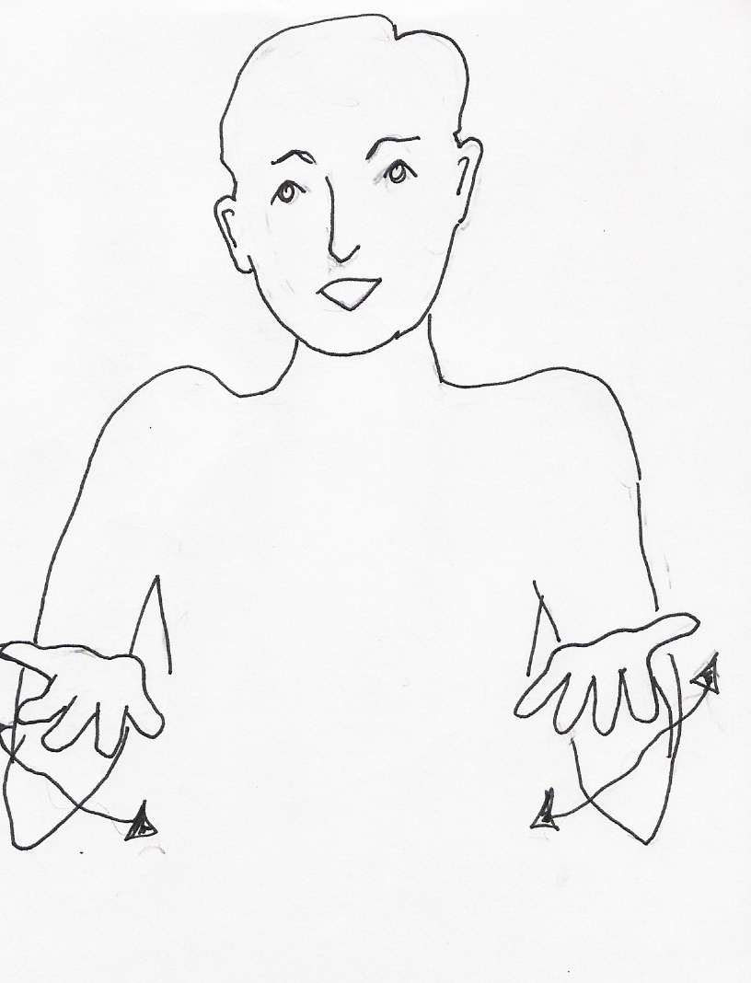
YOUR NAME ??

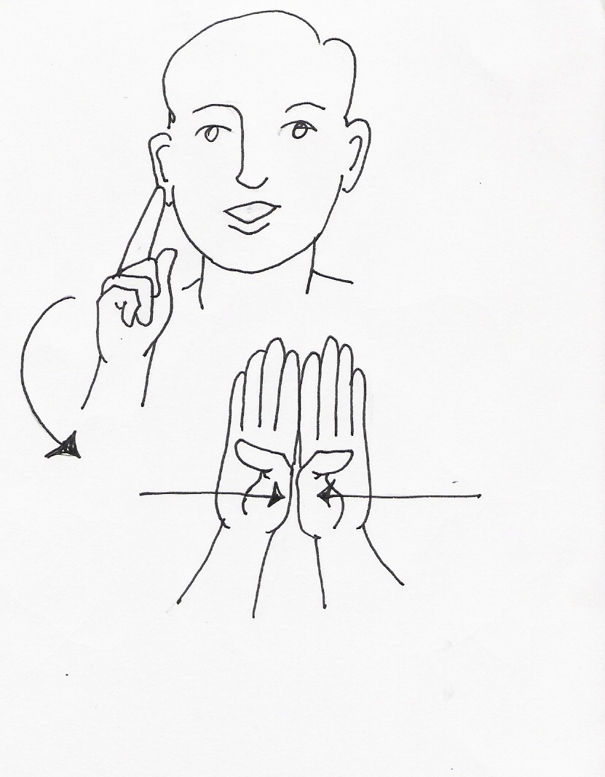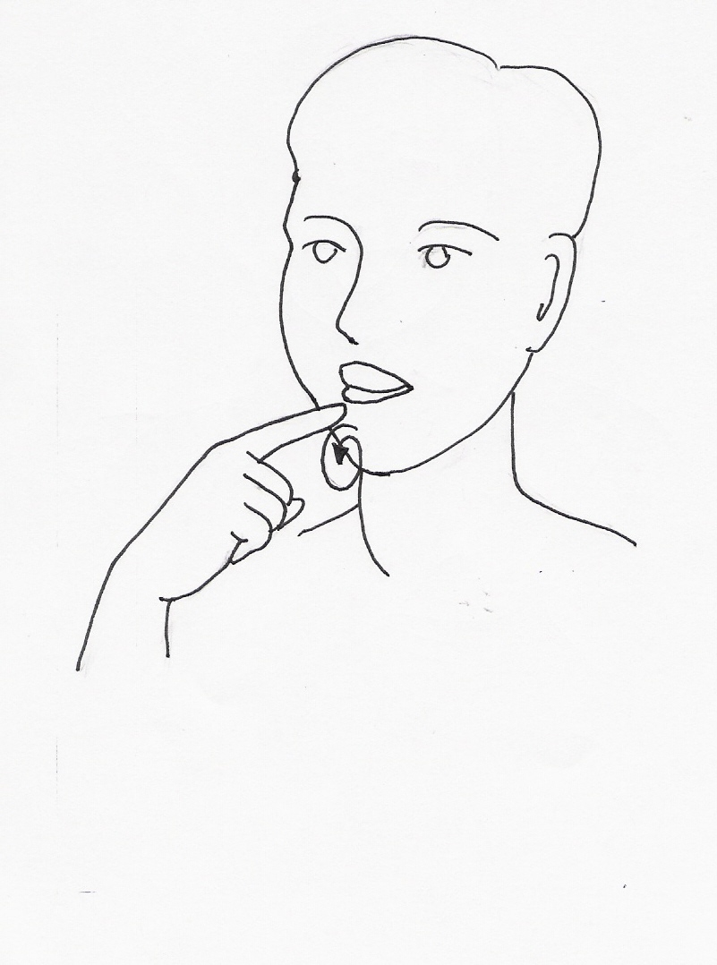
YOU DEAF HEARING ??

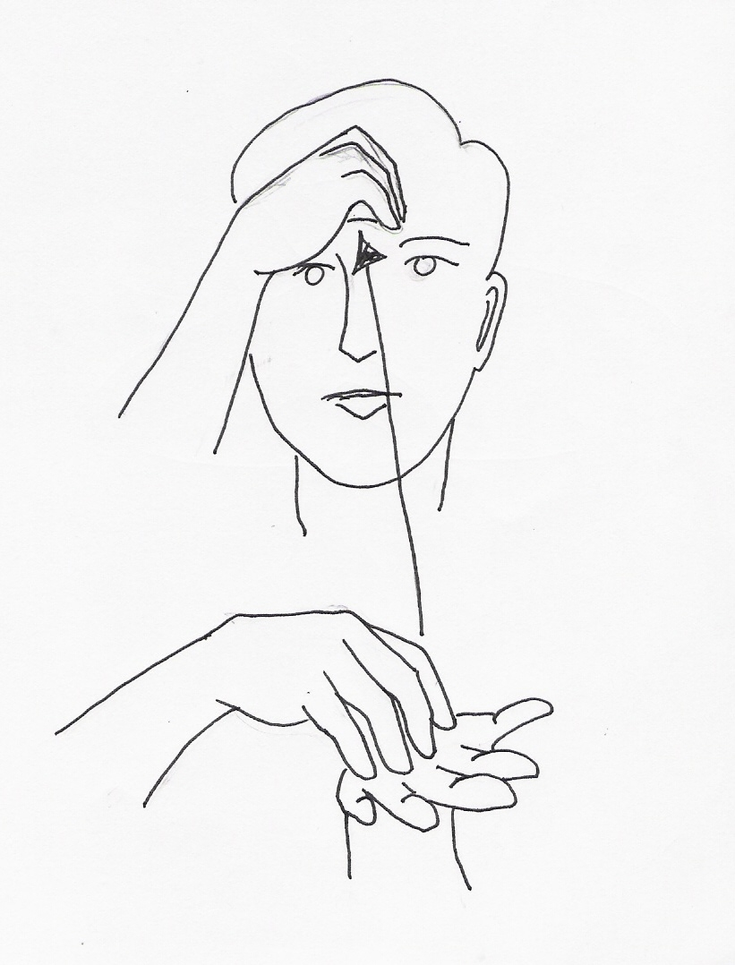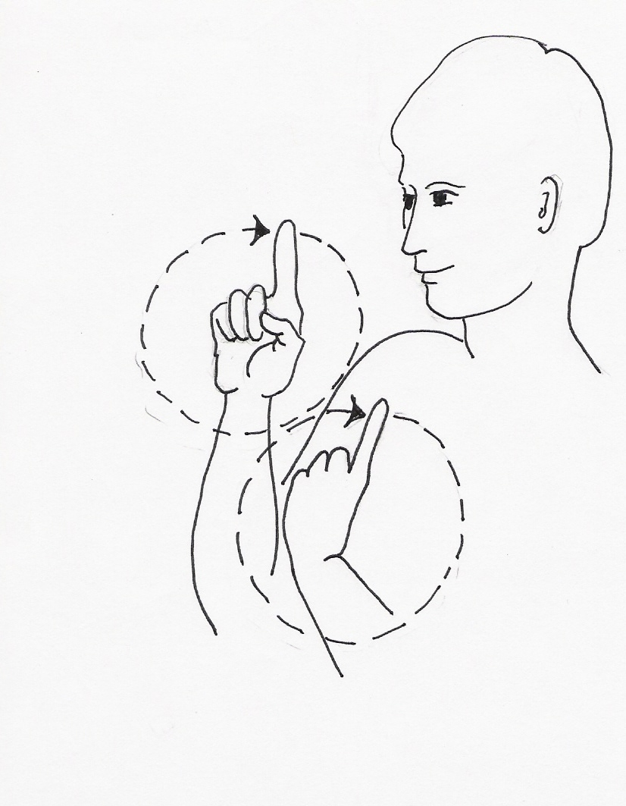
YOU LEARN SIGN WHERE ??

ME (I) LEARN SIGN

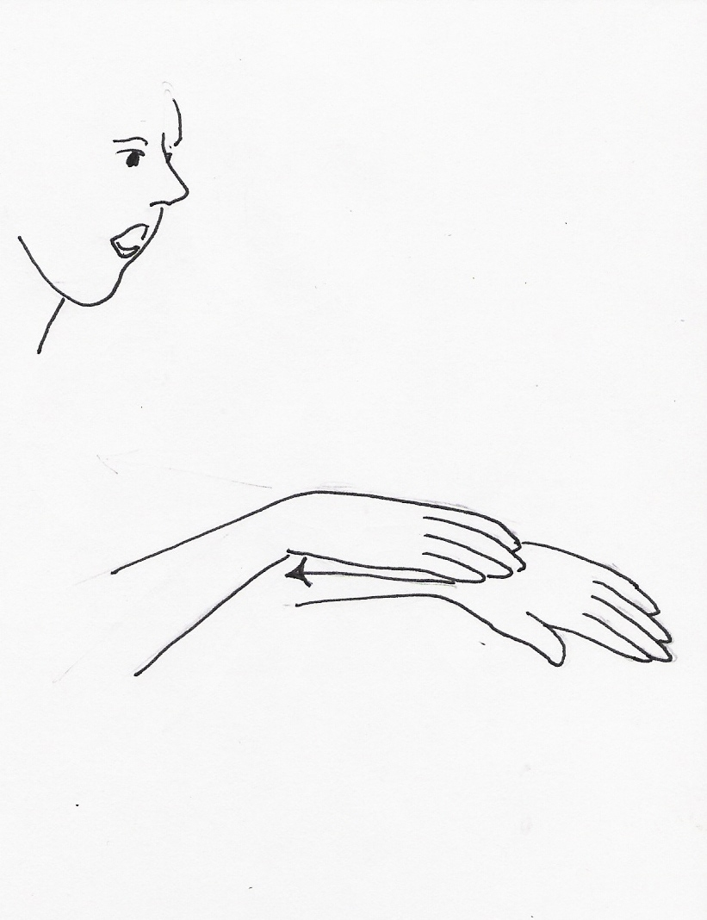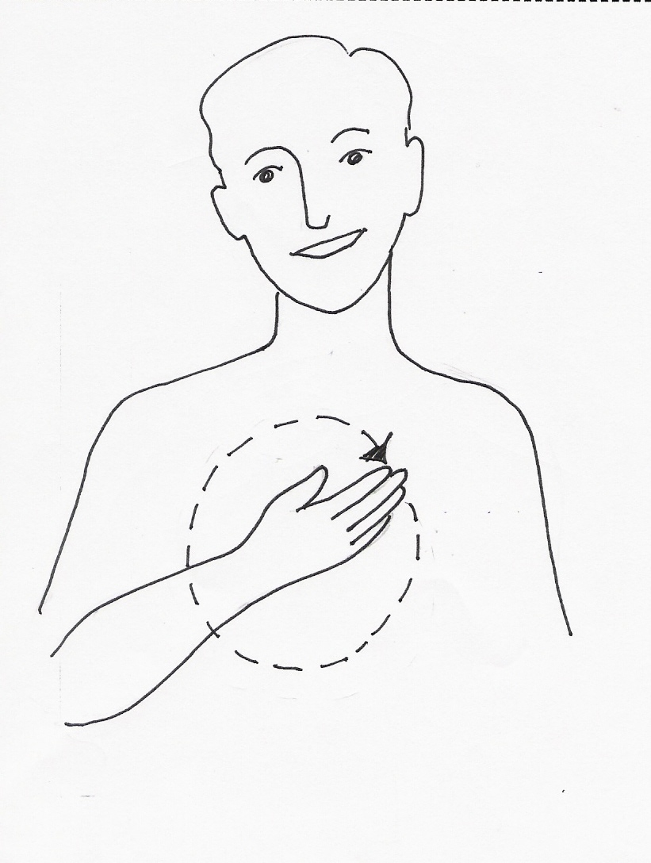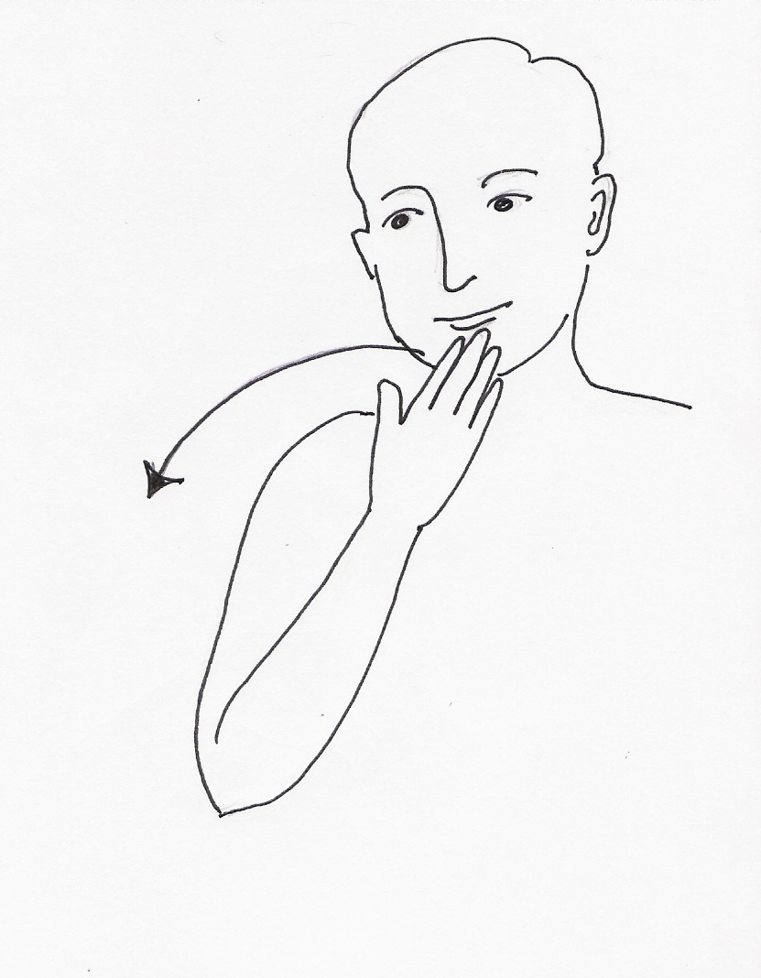
SLOW PLEASE THANK YOU

